**Joseph Cryer**

**Planetary Simulation**

**Project**

**Candidate Number: 2115**

**Centre Number: 15121**

Table of Contents

Analysis 4

Description 4

Research 6

Use Cases 10

Background 21

Modelling 23

Design 30

Overview 30

Packages used 30

Class Inheritance Diagram 33

User Interface 34

Initial Sketches 35

Final Sketches 38

Final Interface 42

Database Data Dictionary 48

Database Normalisation 50

Database E-R Diagram 51

Database Queries 52

Testing 60

Overview 60

White Box Testing 61

White Box Testing Evidence 71

Black Box Testing 112

Questionnaire 128

Technical Solution 131

Overview 131

Explanations 133

IcoSpheres 133

Telnet 133

Code Listing 136

Components 136

Program.cs 136

MainWindow.cs 137

RenderObject.cs 146

Telnet.cs 148

Vertex.cs 151

LineObject.cs 152

IcoSphereFactory.cs 153

GravityMethods.cs 157

Database 160

DatabaseMethods.cs 160

PlanetarySystem.cs 169

Simulation.cs 170

SolarObject.cs 173

Menus 176

MainForm.cs 176

MainForm.Designer.cs 177

SimForm.cs 179

SimForm.Designer.cs 181

PresetForm.cs 184

PresetForm.Designer.cs 186

ControlForm.cs 188

ControlForm.Designer.cs 196

ObjectForm.cs 202

ObjectForm.Designer.cs 213

SaveAsForm.cs 228

SaveAsForm.Designer.cs 229

ExistingObjectsForm.cs 232

ExistingObjectsForm.Designer.cs 234

AdvancedControlForm.cs 236

AdvancedControlForm.Designer.cs 240

Shaders 249

fragmentShader.c 249

vertexShader.c 249

Evaluation 250

Requirements Met 250

Improvements 255

Existing Feature Improvements 255

Potential Additional Features 255

# Analysis

## Description

My client is Bedford Modern School’s Physics department. This is my school, and is an HMC Independent Day School for boys and girls aged seven to eighteen.

There are 257 students in Years 7-8 doing Science (including Physics), 420 students in Years 9-11 doing GCSE Physics, and 79 students in Years 12-13 doing A-Level Physics.



A new Science block has recently been built for my school (pictured above), and each floor is designed for a different discipline (Biology, Chemistry and Physics). This means that each room is custom-built for the subject that is being taught in it, and is a massive help to the science teachers. However, for modules such as astrophysics, there are no specific facilities to assist in teaching it.

A solution has been requested by my school’s Physics department, to solve a problem encountered by their teachers in the teaching of certain sections of the Physics courses offered by the school. The program requested is a 3D simulation environment capable of displaying various planetary phenomena clearly. It will visualise a variety of different things (e.g. our solar system, a binary star system, comet orbits etc.).

Currently, a 2D online flash web application is used to show this, however it has many flaws, such as not being able to add custom objects, or modify many of the experimental values of the objects. Teachers attempt to supplement this tool with animated videos on the topic, however this is also very rigid, as any question by a student cannot immediately be followed up with a visual tool that helps to explain the answer.

The aim is to be able to provide an easy-to-use simulation program that will provide all of the same functionality as the various strategies currently in use in one place, as well as expanding upon the feature list to allow lessons to go beyond the course.

## Research

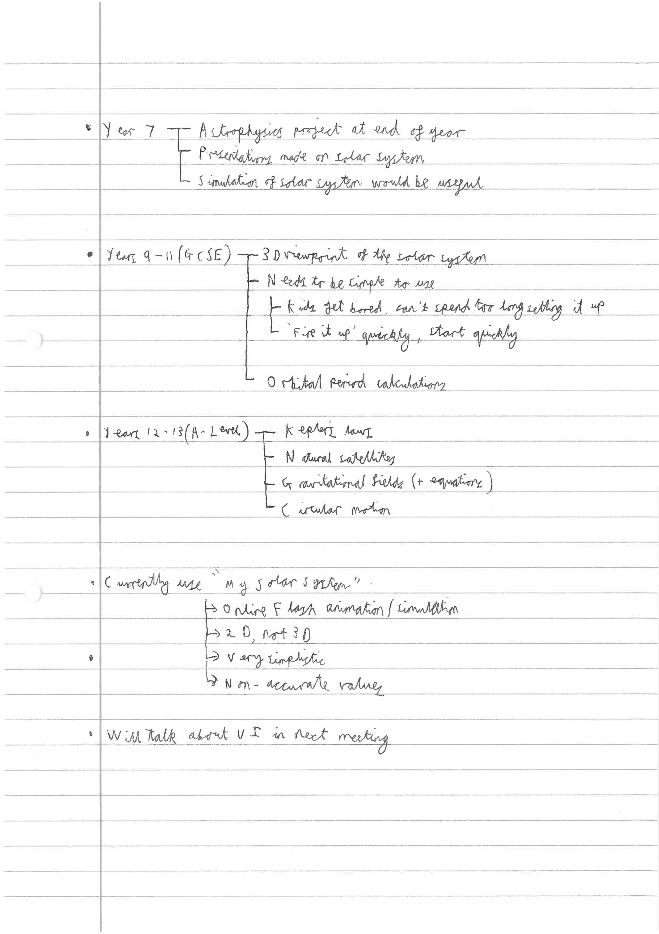These are the first notes of the meeting with Mr. Honnor I had, where he laid out potential requirements for a project of this sort.

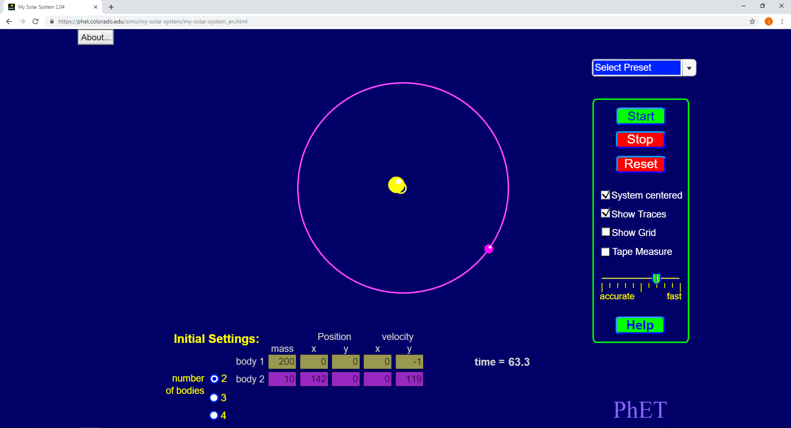

“My Solar System” (https://phet.colorado.edu/sims/my-solar-system/my-solar-system_en.html) is a Flash animation and simulation system that some Physics teachers at Bedford Modern School use as a teaching aid for teaching the GCSE and A-Level astrophysics modules.

The system is intuitive and easy to use, which was a large part of the reason that the teachers use it, however feature-wise it is lacking in some areas.

The system is strictly two-dimensional, and there is no way to change the focus of the simulation. In addition, the actual values entered into it (e.g. body 1’s mass of “200”) are arbitrary and do not actually relate to real world or experimental values that would work with the gravitational field equations that are being taught.

This project will improve on the current system by rendering various planetary systems in 3D, with a much more accurate, precise control of more conditions within the simulation, and the ability to change the viewpoint of the simulation easily. This project will also aim to keep the level of complexity of the user interface as low as possible while adding these features, as this has been stressed as being key.

A second meeting took place in December 2018, when the user interface had been prototyped.

The client had requested various changes throughout the design process at smaller meetings, and these minor changes were made as requested. However, the user interface design only changed in a major way two times: during this second meeting (see the user interface section of this document, Initial Sketches -> Final Sketches) and then again during a mid-project review of the system, in a classroom environment (see the user interface section of this document, Final Sketches -> Final Interface).

Users and Clients

The client for this project is the Physics department. Mr Honnor is the head of Physics at Bedford Modern School, and so was initially my main client. He wishes to use this project as a teaching aid in Physics lessons teaching astrophysics modules, in particular GCSE and A-Level classes. While Mr Honnor was my main client, this system would potentially be used by all teachers who teach these modules. As such, Mr Mullan (one of the other physics teachers at Bedford Modern School) was invaluable in helping me to plan, design and test various stages of the project, acting as my client when Mr Honnor was busy.

A key point that stood out early was that the interface and control mechanisms needed to be simple, intuitive and easy to understand. When the program is displayed on the interactive whiteboard, it is possible that it would be used to control the simulation, and so a majority of the keyboard controls should be replicated with buttons and mouse movements within the simulation.

The solution should also be shipped with some sort of documentation or simple user guide, as the staff must be able to use the software unaided.

### Use Cases

Use Case 1:

**User:** Teacher

**Activity:** Open and view a preset simulation

**What happens:**

* Load up the application
* Click on the “Run Simulation” option on the menu
* Click on the “Load From Presets” option
* Select a preset from the list of simulations
* Click “Confirm”
* Click “Run” at the top of the control panel
* View the preset simulation, rendered in 3D

**New parts to the system:**

* Main menu
* Simulation menu
* Preset menu
* Control menu
* Object definitions set up to store information about the simulation
* Way to load simulations from local storage as presets
* Methods to calculate the relative positions and velocities of all the objects in the simulation over a period of time
* Way to render objects in these positions and velocities in 3D, and have them move over a period of time

**How this will be tested:**

* The application is started
  + Expected result: The main menu appears
* The “Run Simulation” option on the menu is clicked
  + Expected result: The sim menu appears
* The “Load From Presets” option on the menu is clicked
  + Expected result: The preset menu appears
  + A list of selectable presets saved within the database should load in
* A preset is selected
  + Expected result: The preset selected is now highlighted, and the “Confirm” button may be clicked.
* The “Confirm” button is clicked
  + Expected result: The control menu appears, with information about the simulation.
* The “Run” button is clicked
  + Expected result: A window opens with the simulation inside, rendering moving 3D spheres representing objects in the simulation.

Use Case 2:

**User:** Teacher

**Activity:** Create a new custom simulation of the Sun and the Earth

**What happens:**

* Load up the application
* Click on the “Run Simulation” option on the menu
* Click on the “New Custom Simulation” option
* Click on the “Add” option on the control menu
* Click on the “Copy from Existing” option, and select the Sun
* Click the “Confirm” button, and then the “Save” button
* Click on the “Add” option on the control menu
* Click on the “Copy from Existing” option, and select the Earth
* Click the “Confirm” button, and then the “Save” button
* Click “Run” at the top of the control panel
* View the custom simulation, rendered in 3D

**New parts to the system:**

* Object edit menu
* List of standard solar objects menu
* Way to add new objects to a simulation
* Way to modify the values of a solar object
* Way to get a list of the Sun and the planets in the solar system, and accurate values for them (Mass, initial velocity, initial position, radius)

**How this will be tested:**

* The application is started
  + Expected result: The main menu appears
* The “Run Simulation” option on the menu is clicked
  + Expected result: The sim menu appears
* The “New Custom Simulation” option on the menu is clicked
  + Expected result: The control menu appears
* The “Add” option on the menu is clicked
  + Expected result: A form appears with all of the editable values of a planetary body.
* The “Copy from Existing” option is clicked
  + Expected result: A selectable list of the Sun and the planets appears
* The Sun is selected, and “Confirm” is pressed
  + Expected result: The selectable list closes. The form has its values filled in with accurate values for the Sun
* The “Save” option is clicked
  + The form closes, and the Sun is added to a list of objects in the simulation on the control form.
* The “Add” option on the menu is clicked
  + Expected result: A form appears with all of the editable values of a planetary body.
* The “Copy from Existing” option is clicked
  + Expected result: A selectable list of the Sun and the planets appears
* The Earth is selected, and “Confirm” is pressed
  + Expected result: The selectable list closes. The form has its values filled in with accurate values for the Earth
* The “Save” option is clicked
  + The form closes, and the Earth is added to a list of objects in the simulation on the control form.
* The “Run” button is clicked
  + Expected result: A window opens with the simulation inside, rendering moving 3D spheres representing the Sun and the Earth in the simulation.

Use Case 3:

**User:** Teacher

**Activity:** Save a new custom simulation of the Sun and the Earth as a new preset

**What happens:**

* Load up the application
* Click on the “Run Simulation” option on the menu
* Click on the “New Custom Simulation” option
* Click on the “Add” option on the control menu
* Click on the “Copy from Existing” option, and select the Sun
* Click the “Confirm” button, and then the “Save” button
* Click on the “Add” option on the control menu
* Click on the “Copy from Existing” option, and select the Earth
* Click the “Confirm” button, and then the “Save” button
* Click the “Save as Preset” option on the control menu
* Give the new preset simulation a name and a description
* Click the “Confirm” button

**New parts to the system:**

* Way to save simulations to local storage as new presets
* New preset menu

**How this will be tested:**

* The application is started
  + Expected result: The main menu appears
* The “Run Simulation” option on the menu is clicked
  + Expected result: The sim menu appears
* The “New Custom Simulation” option on the menu is clicked
  + Expected result: The control menu appears
* The “Add” option on the menu is clicked
  + Expected result: A form appears with all of the editable values of a planetary body.
* The “Copy from Existing” option is clicked
  + Expected result: A selectable list of the Sun and the planets appears
* The Sun is selected, and “Confirm” is pressed
  + Expected result: The selectable list closes. The form has its values filled in with accurate values for the Sun
* The “Save” option is clicked
  + The form closes, and the Sun is added to a list of objects in the simulation on the control form.
* The “Add” option on the menu is clicked
  + Expected result: A form appears with all of the editable values of a planetary body.
* The “Copy from Existing” option is clicked
  + Expected result: A selectable list of the Sun and the planets appears
* The Earth is selected, and “Confirm” is pressed
  + Expected result: The selectable list closes. The form has its values filled in with accurate values for the Earth
* The “Save” option is clicked
  + The form closes, and the Earth is added to a list of objects in the simulation on the control form.
* The “Run” button is clicked
  + Expected result: A window opens with the simulation inside, rendering moving 3D spheres representing the Sun and the Earth in the simulation.

Use Case 4:

**User:** Teacher

**Activity:** Modify values for an object inside a custom simulation of the Sun and the Earth, as the simulation is running

**What happens:**

* Load up the application
* Click on the “Run Simulation” option on the menu
* Click on the “New Custom Simulation” option
* Click on the “Add” option on the control menu
* Click on the “Copy from Existing” option, and select the Sun
* Click the “Confirm” button, and then the “Save” button
* Click on the “Add” option on the control menu
* Click on the “Copy from Existing” option, and select the Earth
* Click the “Confirm” button, and then the “Save” button
* Click the “Confirm” button
* Click “Run” at the top of the control panel
* View the custom simulation, rendered in 3D
* Click on the object labelled “Sun” on the control form, and then click the “Edit” button
* Change the colour of the Sun to be yellow, and then increase the mass of the Sun by 10x
* Click the “Save” button
* See the Sun change colour, and the Earth collide with the Sun

**New parts to the system:**

* Way to recalculate the positions and velocities of the objects in the simulation after changing values

**How this will be tested:**

* The application is started
  + Expected result: The main menu appears
* The “Run Simulation” option on the menu is clicked
  + Expected result: The sim menu appears
* The “New Custom Simulation” option on the menu is clicked
  + Expected result: The control menu appears
* The “Add” option on the menu is clicked
  + Expected result: A form appears with all of the editable values of a planetary body.
* The “Copy from Existing” option is clicked
  + Expected result: A selectable list of the Sun and the planets appears
* The Sun is selected, and “Confirm” is pressed
  + Expected result: The selectable list closes. The form has its values filled in with accurate values for the Sun
* The “Save” option is clicked
  + The form closes, and the Sun is added to a list of objects in the simulation on the control form.
* The “Add” option on the menu is clicked
  + Expected result: A form appears with all of the editable values of a planetary body.
* The “Copy from Existing” option is clicked
  + Expected result: A selectable list of the Sun and the planets appears
* The Earth is selected, and “Confirm” is pressed
  + Expected result: The selectable list closes. The form has its values filled in with accurate values for the Earth
* The “Save” option is clicked
  + The form closes, and the Earth is added to a list of objects in the simulation on the control form.
* The “Run” button is clicked
  + Expected result: A window opens with the simulation inside, rendering moving 3D spheres representing the Sun and the Earth in the simulation.
* The object labelled “Sun” on the control form is clicked, and the “Edit” button is then clicked
  + Expected result: A form appears with all of the editable values for the Sun
* The “Object Colour” button is pressed
  + Expected result: A form appears to select a colour for the object
* A yellow colour is selected, and the “OK” button is pressed
  + Expected result: The form closes, and the larger object form’s colour indicator changes to the new colour
* The mass of the Sun is increased by ten times, and the “Save” button is clicked
  + Expected result: The simulation will continue from where it was previously, with the new values set. The Sun should change colour, and the Earth should collide with it.

Use Case 5:

**User:** Teacher

**Activity:** Delete an object inside a custom simulation of the Sun and the Earth, as the simulation is running

**What happens:**

* Load up the application
* Click on the “Run Simulation” option on the menu
* Click on the “New Custom Simulation” option
* Click on the “Add” option on the control menu
* Click on the “Copy from Existing” option, and select the Sun
* Click the “Confirm” button, and then the “Save” button
* Click on the “Add” option on the control menu
* Click on the “Copy from Existing” option, and select the Earth
* Click the “Confirm” button, and then the “Save” button
* Click the “Confirm” button
* Click “Run” at the top of the control panel
* View the custom simulation, rendered in 3D
* Click on the object labelled “Sun” on the control form, and then click the “Delete” button
* See the Sun disappear, and the Earth travel in a straight line

**New parts to the system:**

* Way to recalculate the positions and velocities of the objects in the simulation after removing an object

**How this will be tested:**

* The application is started
  + Expected result: The main menu appears
* The “Run Simulation” option on the menu is clicked
  + Expected result: The sim menu appears
* The “New Custom Simulation” option on the menu is clicked
  + Expected result: The control menu appears
* The “Add” option on the menu is clicked
  + Expected result: A form appears with all of the editable values of a planetary body.
* The “Copy from Existing” option is clicked
  + Expected result: A selectable list of the Sun and the planets appears
* The Sun is selected, and “Confirm” is pressed
  + Expected result: The selectable list closes. The form has its values filled in with accurate values for the Sun
* The “Save” option is clicked
  + The form closes, and the Sun is added to a list of objects in the simulation on the control form.
* The “Add” option on the menu is clicked
  + Expected result: A form appears with all of the editable values of a planetary body.
* The “Copy from Existing” option is clicked
  + Expected result: A selectable list of the Sun and the planets appears
* The Earth is selected, and “Confirm” is pressed
  + Expected result: The selectable list closes. The form has its values filled in with accurate values for the Earth
* The “Save” option is clicked
  + The form closes, and the Earth is added to a list of objects in the simulation on the control form.
* The “Run” button is clicked
  + Expected result: A window opens with the simulation inside, rendering moving 3D spheres representing the Sun and the Earth in the simulation.
* The object labelled “Sun” on the control form is clicked, and the “Delete” button is then clicked
  + Expected result: The “Sun” object disappears from the control form list, and the simulation updates itself to remove the Sun. The Earth travels onwards in a straight line.

Use Case 6:

**User:** Teacher

**Activity:** Save a new custom simulation of the Sun and the Earth to a file

**What happens:**

* Load up the application
* Click on the “Run Simulation” option on the menu
* Click on the “New Custom Simulation” option
* Click on the “Add” option on the control menu
* Click on the “Copy from Existing” option, and select the Sun
* Click the “Confirm” button, and then the “Save” button
* Click on the “Add” option on the control menu
* Click on the “Copy from Existing” option, and select the Earth
* Click the “Confirm” button, and then the “Save” button
* Click the “Export” button on the control menu
* Select a location to save the exported simulation, and a file name
* Click “Save”

**New parts to the system:**

* Way to save simulations to a file

**How this will be tested:**

* The application is started
  + Expected result: The main menu appears
* The “Run Simulation” option on the menu is clicked
  + Expected result: The sim menu appears
* The “New Custom Simulation” option on the menu is clicked
  + Expected result: The control menu appears
* The “Add” option on the menu is clicked
  + Expected result: A form appears with all of the editable values of a planetary body.
* The “Copy from Existing” option is clicked
  + Expected result: A selectable list of the Sun and the planets appears
* The Sun is selected, and “Confirm” is pressed
  + Expected result: The selectable list closes. The form has its values filled in with accurate values for the Sun
* The “Save” option is clicked
  + The form closes, and the Sun is added to a list of objects in the simulation on the control form.
* The “Add” option on the menu is clicked
  + Expected result: A form appears with all of the editable values of a planetary body.
* The “Copy from Existing” option is clicked
  + Expected result: A selectable list of the Sun and the planets appears
* The Earth is selected, and “Confirm” is pressed
  + Expected result: The selectable list closes. The form has its values filled in with accurate values for the Earth
* The “Save” option is clicked
  + The form closes, and the Earth is added to a list of objects in the simulation on the control form.
* The “Export” option is clicked
  + Expected result: A dialog appears to allow the user to select a file name for the exported file, and the location to save the file
* The “Save” button is clicked
  + Expected result: The simulation is exported to a file in that location with that name.

Use Case 7:

**User:** Teacher

**Activity:** Load a custom simulation of the Sun and the Earth from a file

**What happens:**

* Load up the application
* Click on the “Run Simulation” option on the menu
* Click on the “Load from File” option
* Select a file with a file dialog (the one made in Use Case 6), and then press the “OK” button
* Click the “Run” button on the control form

**New parts to the system:**

* Way to load simulations from a file

**How this will be tested:**

* The application is started
  + Expected result: The main menu appears
* The “Run Simulation” option on the menu is clicked
  + Expected result: The sim menu appears
* The “Load from File” option on the menu is clicked
  + Expected result: A file selection dialog appears
* Select a previously exported simulation file (from Use Case 6), and then click the “OK” button
  + Expected result: The control menu appears with all of the simulation information contained within it
* The “Run” button is clicked
  + Expected result: A window opens with the simulation inside, rendering moving 3D spheres representing the Sun and the Earth in the simulation.

## Background

Currently, the Bedford Modern School Physics department does not have a suitable visual aid to help in teaching the astrophysics sections of their A-Level or GCSE courses, or the years seven to nine introduction lessons.

While objects moving through three-dimensional space is easily understood by us in our everyday lives, when people attempt to consider that we are on a planet moving at 30 kilometres a second relative to our Sun, while also rotating around our axis at high speeds. If we were to then consider that the Sun itself is also moving at high speeds through our galaxy, and that our galaxy in turn is moving relative to other galaxies, it all becomes too much to comprehend. So, this system is attempting to represent these difficult to grasp concepts in simple three-dimensional animations. The idea is that with the ability to change things within the simulation and see how it affects the other objects in the simulation, students will begin to grasp these complex concepts.

A-Level:

For the OCR Physics course chosen by the school, there are three chapters dedicated to astrophysics and cosmology. These are named “Gravitational Fields”, “Stars” and “Cosmology”. There are a few key things that the Physics department want to be able to do with a visual aid, these being:

* To show how every object in a system affects every other object in the system,
* To be able to modify objects in a simulation as it is running
  + In order to show how small changes affect the simulation massively
* To be able to introduce a new object (for example, a comet, or another planet) into the simulation and see how much it affects the other objects in the simulation
* To be able to have preset simulations showing:
  + Comets
  + Binary star systems
  + Our solar system

GCSE:

For the Edexcel Physics course chosen by the school, the astrophysics sections are minor. The emphasis in the course is therefore instead to give students a basic understanding of the solar system and the planetary bodies within it, without needing to go into the same level of detail as the A-Level simulations.

Years 7 - 9:

Here, the main request was that the sheer scale of the solar system can be displayed in a way that lets younger students comprehend it well.

Objectives

1. The system must be a simulation of planetary systems that will be used in Physics classrooms to assist the teaching of astrophysics modules, using the gravitational field equations taught in the A-Level Physics course
2. It must be suitable to be displayed on a projector in a classroom
3. The system must be easily navigable and intuitive to use
4. The system must be able to run on the Windows 10 laptops used by the Science Department staff
5. There must be a way to distinguish between the different objects (e.g. using colours)
6. There must be some way to show the path that the object has taken through space
7. The system must show an animated three-dimensional representation of the simulation being ran
8. The speed of the simulation should be variable
9. There must be a way of easily navigating around the three-dimensional simulation environment
10. There must be a way to view the simulation from the perspective of any object in the simulation (centering around that object)
11. The system should come with a preset showing the Earth and Moon
12. The system should come with a preset showing the Earth and Sun
13. The system should come with a preset showing the Earth, Moon and Sun
14. The system should come with a preset showing the entire Solar System
15. The system should come with a preset showing a Binary Star system
16. There must be a way of quickly and efficiently loading up preset simulations
17. There must be a way of easily setting up and saving new permanent presets
18. There must be a way of creating a new custom simulation
19. There must be a way of adding, removing and editing celestial objects to the simulation as requested
20. There must be a way to modify the Initial Position for each celestial object in a simulation
21. There must be a way to modify the Initial Velocity for each celestial object in a simulation
22. There must be a way to modify the Mass for each celestial object in a simulation
23. There must be a way to modify the Radius for each celestial object in a simulation
24. There must be a way of saving a custom simulation to a portable file
25. There must be a way of loading a custom simulation from a portable file
26. The system must allow users to save custom simulations as preset simulations

## Modelling

I made the decision to create a desktop application early on in the project. I initially considered the potential of creating a web application, or a mobile app. However, these came with their own limitations.

While a web application would allow for more versatility (by being able to be shown on most devices more easily), it would be much more difficult to create. Three-dimensional rendering in-browser is in its infancy, with only limited functionality currently existing. In addition, I would be relying heavily on open source libraries that are still early in their development cycles (such as WebGL, or Google’s O3D). Finally, a program such as this requires a relatively large amount of processing power as well as a good ability to leverage low level graphics commands, while web browsers tend to limit the processing power available.

A mobile application was quickly discounted as a possibility as it defeats the main goal of the brief given to me – to use the system in classrooms on the projector to show key astrophysics concepts. A mobile device screen is simply too small to suitably show this kind of thing to a class, and while it would be an interesting idea to allow students themselves to experiment with the simulations, it is not a requirement for the project.

I am making the project render the running simulation in three dimensions rather than two dimensions for two reasons. Firstly, it allows for a much more accurate, more comprehensive simulation, as it more closely mimics what it is attempting to simulate. Secondly, it allows me to use the accurate, real-life data from NASA’s Horizons database, meaning that students and teachers would be working with real figures when using the solution.

NASA’s Horizons “on-line solar system data and ephemeris computation service” provides access to key solar system data and the production of ephemerides (coordinates of a celestial body at a specific time) for solar system objects. It provides highly accurate position and velocity coordinates for a requested planetary body at a given time, as well as the mass, average radius, obliquity, spin rate and much more. There is an interactive web interface, as well as a telnet interface (which I plan to interface with).

There are a few main challenges for this project that I am currently aware of, these being:

* Changing the view of the simulation in an intuitive, user-friendly way
* Calculating the physical interactions between all objects in a given simulation
* Rendering the objects in a three-dimensional environment, and moving and transforming them as needed

Simulation Navigation

Interactive manipulation of a three-dimensional environment is a complex field, and there are multiple different methods in use across various fields in order to do this. As I am using a mouse input (rather than some sort of three-dimensional sensor), I must therefore map a two-dimensional input (x, y) to a three-dimensional world (x, y, z). A system called a ‘trackball’ seemed the most intuitive to the problem, and so this is what I implemented. Essentially, the camera has two changeable values – its location, and what it is focused on. I can set the ‘focus’ x, y and z coordinates to the coordinates of the object currently focused, however the movement of the camera around the object being focused on is what the trackball is used for.

The X, Y and Z coordinates for the camera are calculated based on the mouse input’s X and Y values, using Sin and Cos to define the surface of a sphere and then extrapolate the X, Y and Z coordinates based on that. A zoom value would then be used to define the radius of this trackball sphere around the object being focused, and the simplest way to modify the zoom value would be to use the scroll wheel found on mouse modern mice.

Calculating Physical Interactions

Every object in my simulation will be modelled as point masses. I considered having each type of celestial object as a different object type, however the gravitational field equations being used and taught in A-Level Physics model all objects as point masses, and therefore I decided to follow suit, in order to follow the course structure this is a teaching aid for as closely as possible.

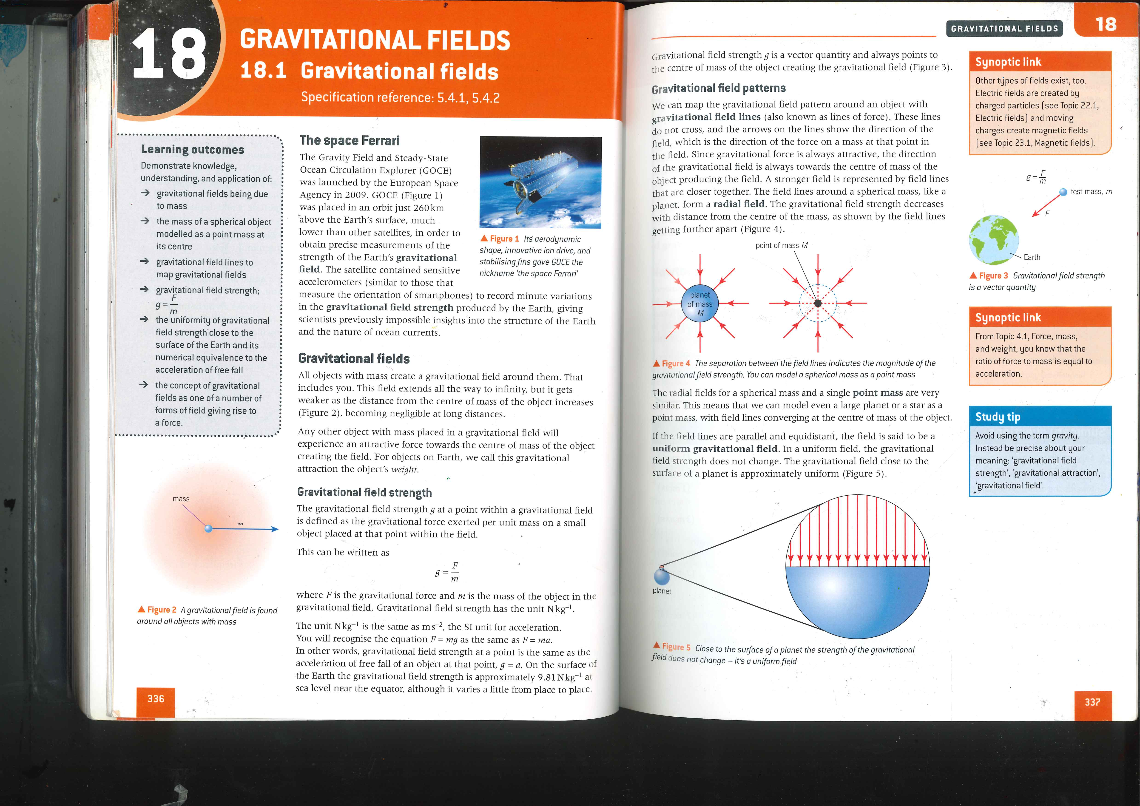

Modelling all objects as point masses allows for the simulation to be made more efficient in many ways, as the calculations required for each step of the process are reduced.

There is no closed-form solution to the three or more-body problem. However, I am able to calculate the resultant acceleration of any one body (point mass) due to any and all other point masses if their relative positions and masses are known, by calculating in time “jumps”, or “skips”. This is known as a periodic solution to the N-body problem, and is the most commonly accepted and used solution in practical applications of space-related calculations – the smaller the time period between two calculations, the closer to approximating the true movement of objects within the universe we can get.

This is the A-Level OCR Physics textbook used at our school, quoted here ^

Gravitational Equations:

Gravitational field strength decreases in a radial field as the distance from the centre of mass of the object creating the field increases. Thus, we can calculate the gravitational field strength due to an object at a certain distance from that object.

**g:** Gravitational field strength in a radial field

**G:** Universal Gravitational Constant (6.67x10-11)

**M:** Mass of the object

**R:** Distance from the centre of the object

$g= \frac{-GM}{R^{2}}$

We can calculate the distance between two objects in three-dimensional space relatively easily:

**Point A: $\left({X1 \atop \begin{aligned}Y1 \\ Z1\end{aligned}}\right)$** **Point B: $\left({X2 \atop \begin{aligned}Y2 \\ Z2\end{aligned}}\right)$**

**Scalar difference between two points:**

$$\sqrt{{(X2-X1)}^{2}+{(Y2-Y1)}^{2}+{(Z2-Z1)}^{2}}$$

Therefore, given the positions and masses of two objects, we can calculate the resultant acceleration (g) due to one object’s effect on the other, at a specific point in time.

However, this acceleration calculated is a scalar quantity, and not a vector. Therefore, we do not yet know what direction this acceleration is acting in. So, we need to calculate a three-dimensional vector that stores the vector difference between the two points:

**Vector difference between two points: $\left({X2-X1 \atop \begin{aligned}Y2-Y1 \\ Z2-Z1\end{aligned}}\right)$**

This vector difference must be converted into a unit vector. This is done by calculating the magnitude of the vector and then dividing the vector by this magnitude:

**Magnitude of the vector: $\sqrt{X^{2}+Y^{2}+Z^{2}}$**

**Unit vector of position difference: $\left({\frac{X}{mag} \atop \begin{aligned}\frac{Y}{mag} \\ \frac{Z}{mag}\end{aligned}}\right)$**

We can then calculate an acceleration vector by multiplying the vector by the previously calculated gravitational field strength (scalar acceleration value):

**Acceleration vector: $\left(\begin{aligned}X*g \\ Y*g \\ Z*g\end{aligned}\right)$**

We have now calculated the acceleration vector of one object due to a second object, at a specific point in time. We must then repeat this process for each object in the simulation (relative to the first object still) and use vector addition to calculate a resultant acceleration vector for this first object.

Change in velocity over a specific amount of time is acceleration multiplied by the time period. Therefore, we can convert our resultant acceleration vector into a resultant velocity vector:

**T:** Time elapsed

**AX:** X-value of the acceleration vector

**AY:** Y-value of the acceleration vector

**AZ:** Z-value of the acceleration vector

**Resultant velocity vector: $\left(\begin{aligned}VX+(AX*T) \\ VY+(AY*T) \\ VZ+(AZ*T)\end{aligned}\right)$**

Change in position over a specific amount of time is velocity multiplied by the time period. Therefore, we can convert our resultant velocity vector into a resultant position vector:

**T:** Time elapsed

**AX:** X-value of the velocity vector

**AY:** Y-value of the velocity vector

**AZ:** Z-value of the velocity vector

**Resultant position vector: $\left(\begin{aligned}PX+(VX*T) \\ PY+(VY*T) \\ PZ+(VZ*T)\end{aligned}\right)$**

This process must be repeated for every object, to calculate all forces being acted on it.

Each object in the simulation should then have its position and velocity vector values updated, before re-rendering the simulation’s next frame.

The simulation will then step forwards by one step, and the entire process should start again.

Icosahedrons and IcoSpheres:

Rendering a perfect sphere is impossible, however there are various methods of generating complex polygons that can closely resemble spheres in simulations such as these. An IcoSphere is one of these methods and is the one I decided to use.

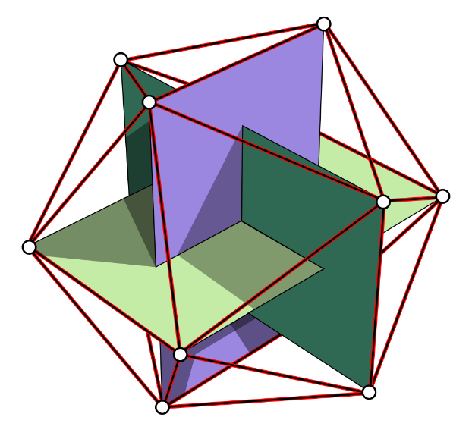The vertices of an icosahedron form three orthogonal golden rectangles. In this instance, I attempt to draw an icosahedron by starting with the three rectangles and then forming an icosahedron from the corners of the rectangles (as shown in the image to the right).

The icosahedron can then be increased in complexity by replacing each triangle with four smaller triangles, more closely approximating a sphere.

In an early testing phase, I managed to create an IcoSphere, and then gradually increase its complexity through recursion. Below are the different levels of complexity I managed to achieve:

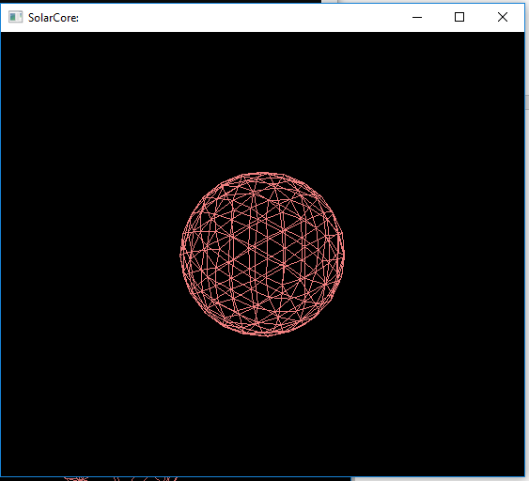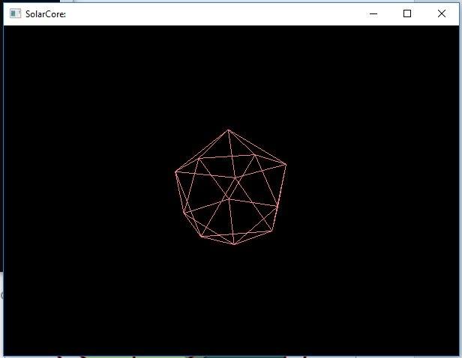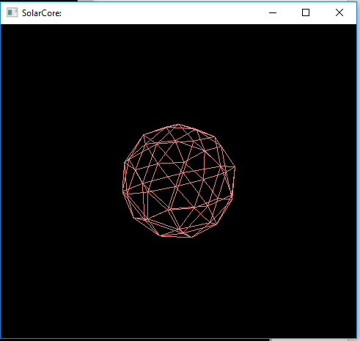

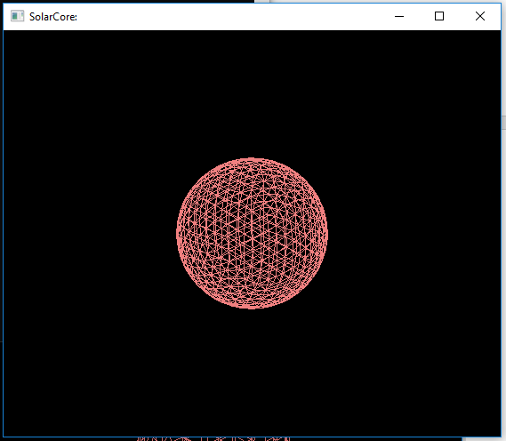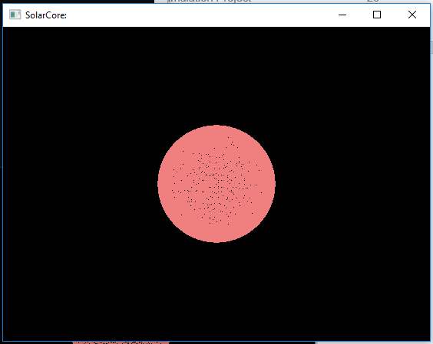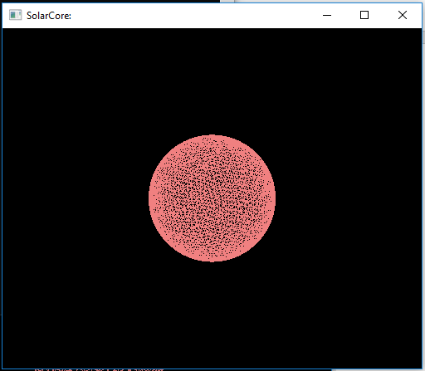

While it is true that the higher the level of recursion the more accurately the icosphere represents a true sphere, it also exponentially increases the processing power required for each sphere. As such, I shall keep the level of recursion low enough to not cause high strain, while keeping it high enough to closely resemble a sphere.

# Design

## Overview

## Packages used

OpenTK (OpenGL)

OpenGL (Open Graphics Library) is a cross-platform API for rendering 2D and 3D vector graphics. It is written in C, and is one of the most widely used libraries for this purpose. I decided to use this API as it is one of the most widely known 3D rendering libraries, and therefore there is a large amount of support for it, both online and in reference books.

OpenTK (Open Toolkit Library) is a set of low-level C# bindings for the OpenGL API.

I decided to use this library as it seemed to be the most up-to-date C# binding library for the OpenGL API. I also looked at other C# binding libraries such as the Tao framework, but it didn’t seem to be as intuitive or feature-complete as OpenTK.  In addition, I have had some personal experience of using OpenGL via OpenTK in other smaller projects prior to creating this solution.

SQLite

SQLite is a lightweight relational database management system (RDBMS). The entirety of the database is stored in a single flat-file with the application, and there is no client-server model. Rather, the application itself runs function calls to SQLite in order to perform SQL queries (eg. SELECT, INSERT, DELETE).

I decided to use SQLite for various reasons. The main reason is that this project will likely never be storing a large amount of data (large in this case would be over 1000 records), and so using a lightweight database solution such as SQLite is still feasible and practical. For this project, queries are actually serviced more quickly than with a standard client-server SQL solution (for example, MySQL) due to faster read/write speeds when only one person is accessing the database. Solutions like MySQL excel in projects where many concurrent users are attempting to query the database, however in this situation only one user will ever be accessing the SQL database at a time. Overall, SQLite is easier to implement than the alternatives, and is self-contained, which plays well into the project having a simple initial setup procedure.

Telnet (TentacleSoftware.Telnet)

The primary method of accessing NASA’s Horizons solar system data and ephemeris calculation service is using a Telnet connection. As such, I picked a simple C# library that supported basic connections. The library I chose is a minimalistic event-driven library, which suited my purposes perfectly as the interface with NASA’s system was only intended to be a small, minor part of the overall solution.

I used the library to write a series of methods that issued a series of Telnet commands and reads the response to a string, before terminating the connection and parsing the response string using various Regular Expression statements I created to pull out only the required relevant information from the returned values.

Metro UI Framework

MetroFramework is a library that extends .NET Windows Forms applications and implements an easy way to modernise the look and feel of the User Interfaces. I used this as I liked the style choices made in the library, and it was quick and simple to implement and use.

Newtonsoft.Json

Newtonsoft.Json (also known as Json.NET) is a high-performance JSON framework for .NET that allows easy serialisation and deserialisation of .NET objects into and from strings. I used it as I’ve had extensive experience with it, and it is considered the most popular .NET library (as such, it is very stable and reliable).

I used these features to export and import my Simulation object to and from a file, and it made this process incredibly simple compared to how difficult it cold have otherwise potentially been.

## Class Inheritance Diagram

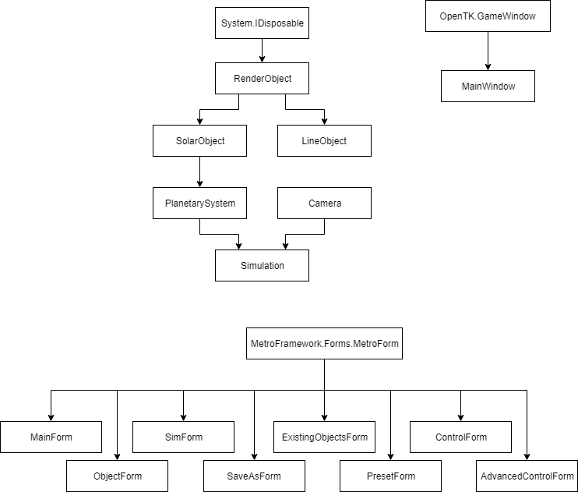Shown below is the class inheritance diagram for my project. All of my Windows Form menus inherit from the MetroFramework library that I previously mentioned, in order to allow them to be styled better than the default style settings.

My MainWindow class inherits from the OpenTK GameWindow class, in order to be able to use the OpenTK base methods and hook into the base events.

My RenderObject class inherits from System.IDisposable, implementing the Dispose() method to release unmanaged resources.

My SolarObject and LineObject classes both inherit from my RenderObject class, in order to be able to use the methods built into the RenderObject class to generate a sphere.

My PlanetarySystem class inherits from my SolarObject class, in order to easily store data about each object within the system.

My Simulation class inherits from my PlanetarySystem and Camera classes. This is an aggregation association, meaning that PlanetarySystem and Camera can both exist independently of Simulation,

and instances of them are defined within Simulation.

## User Interface

Something that stood out immediately during meetings with my client to discuss the project was just how important it was to them that the system be incredibly intuitive and easy to use. For this section of the course, they currently use multiple different programs and methods, each with their own limitations and downsides. So, having easily accessible within a single package was essential. As such, I spent a lot of time planning out the user interface, and had various meetings with teachers from the Physics department to discuss and tweak the interface designs.

### Initial Sketches

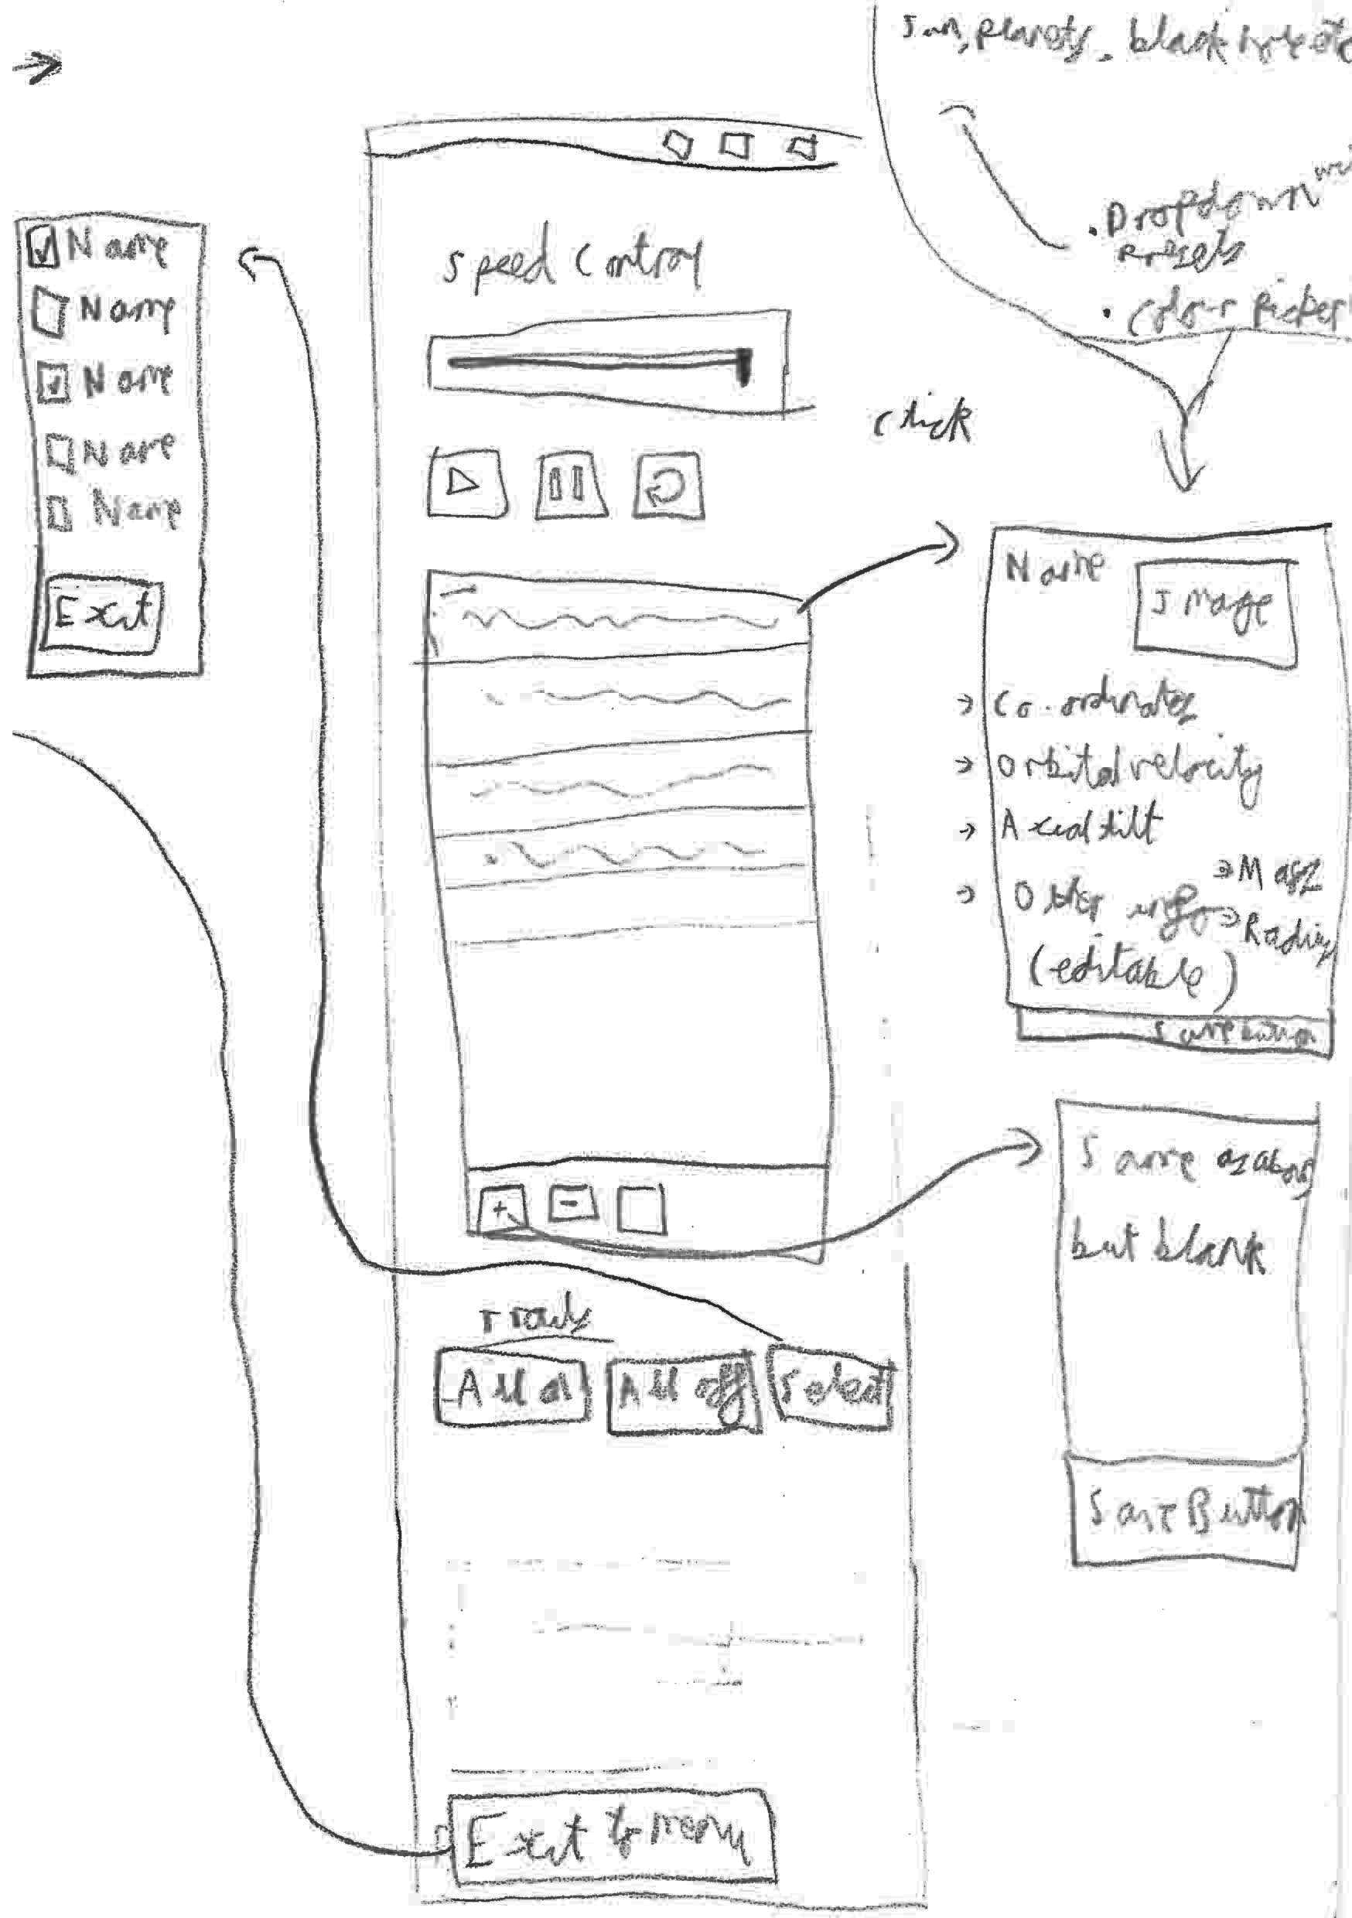

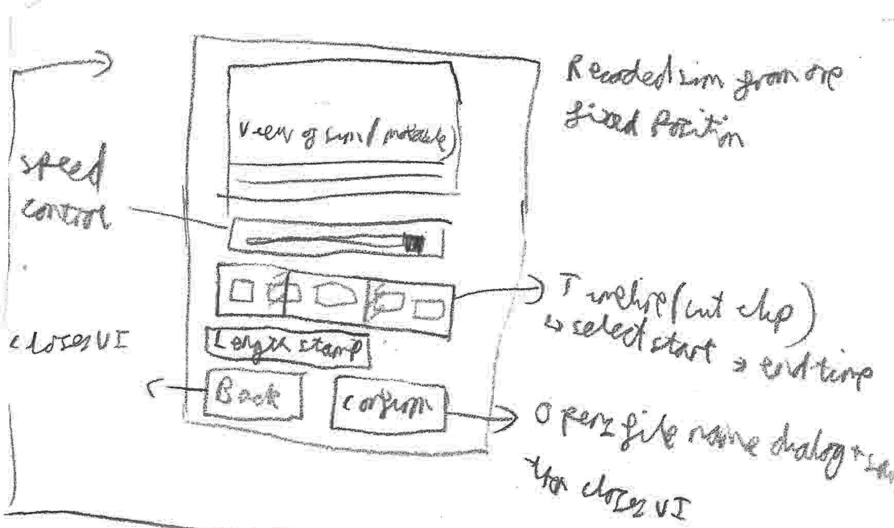

### Final Sketches

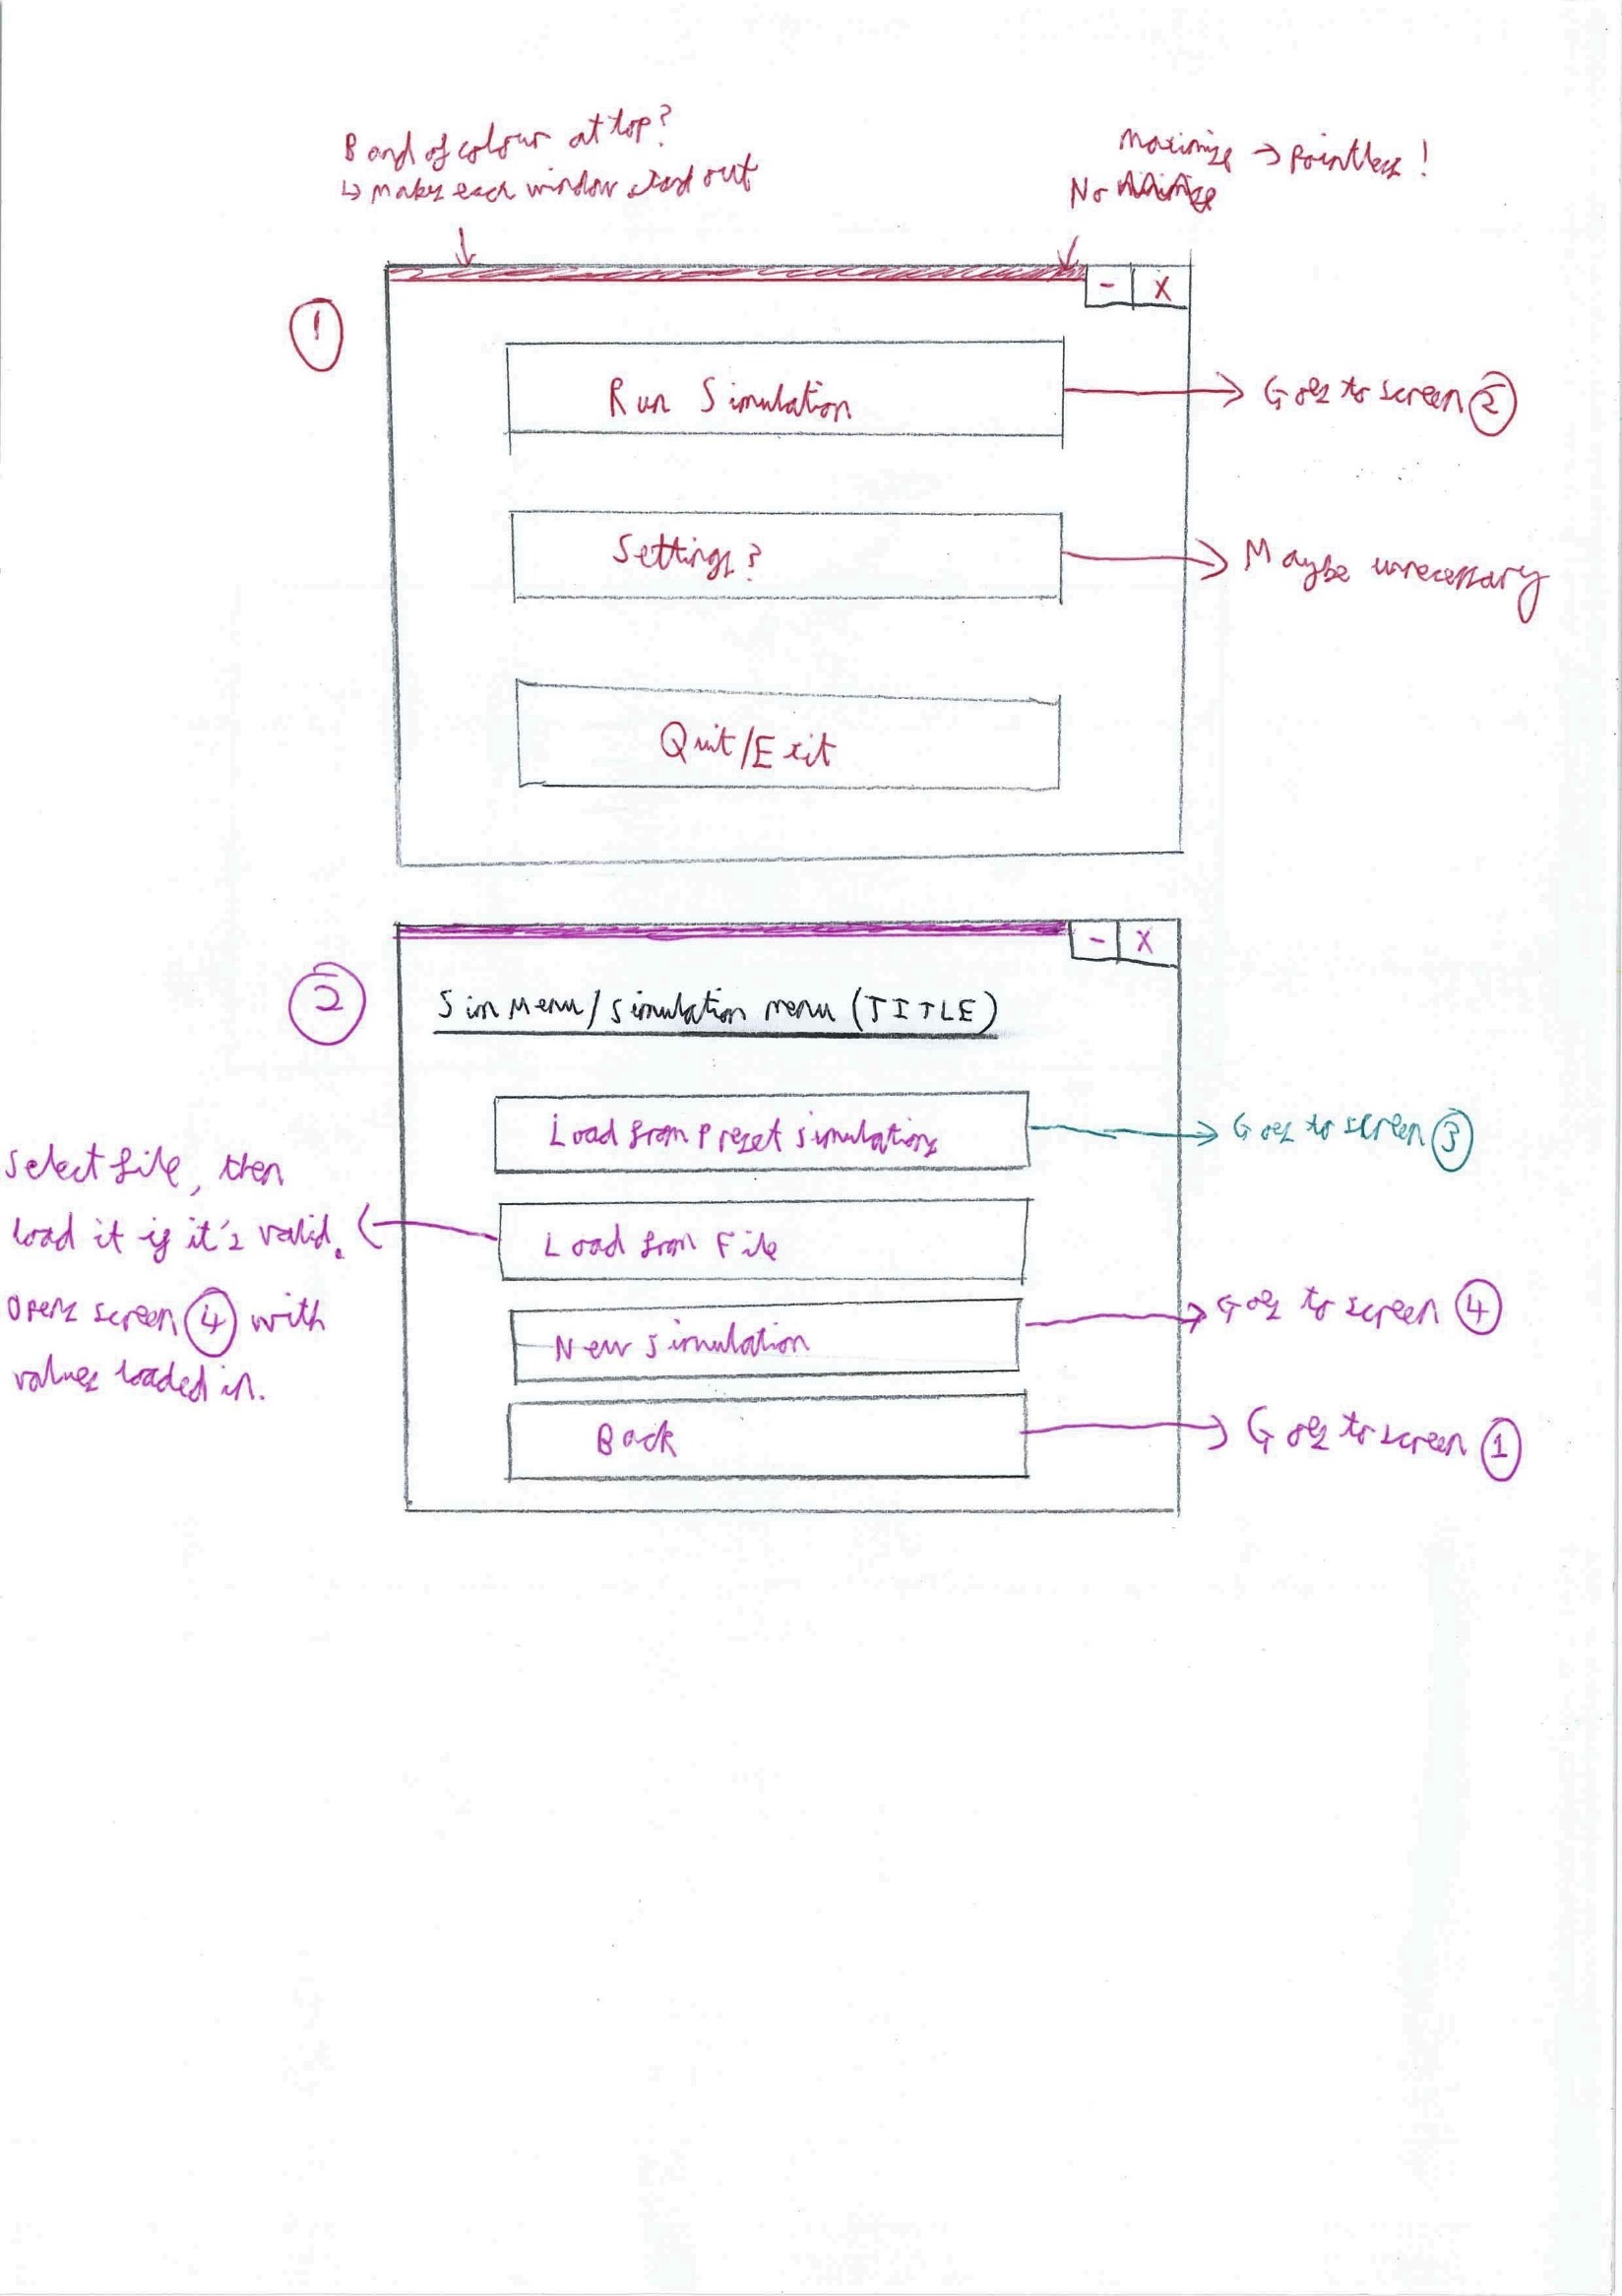

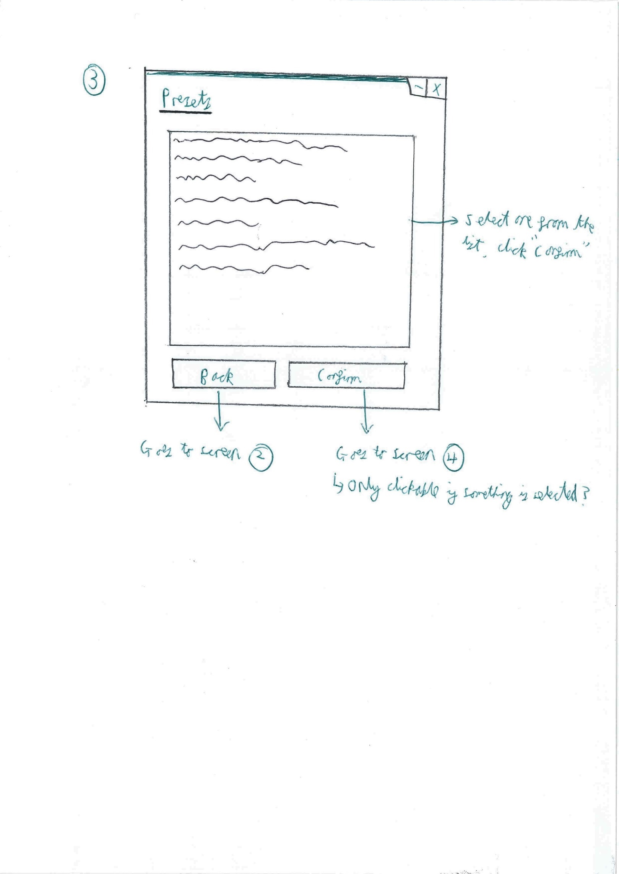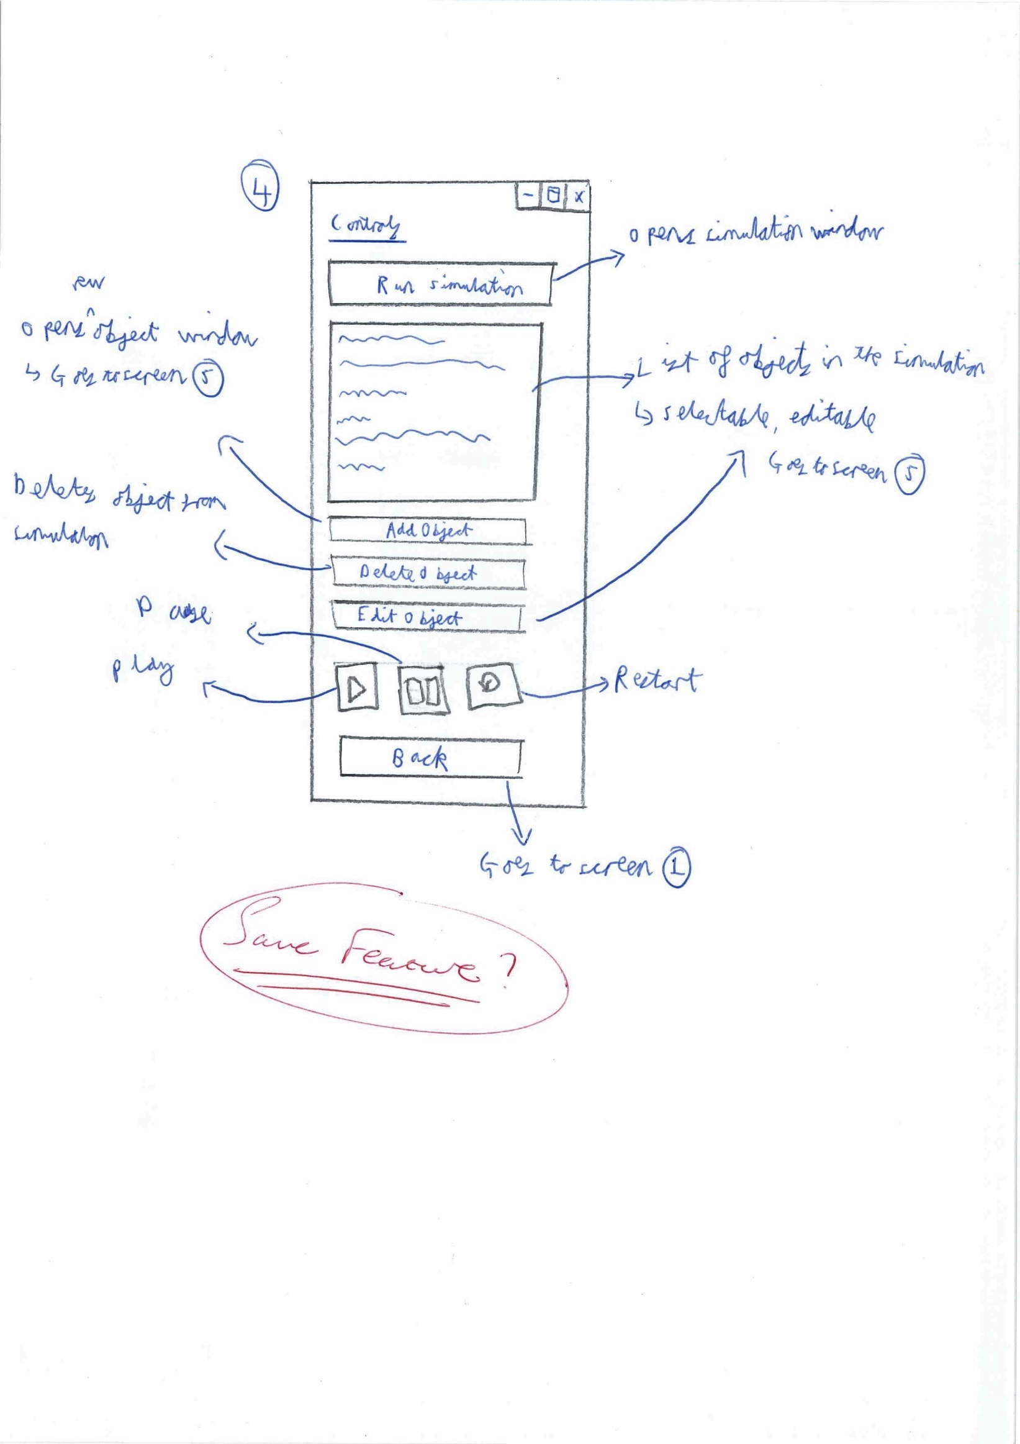

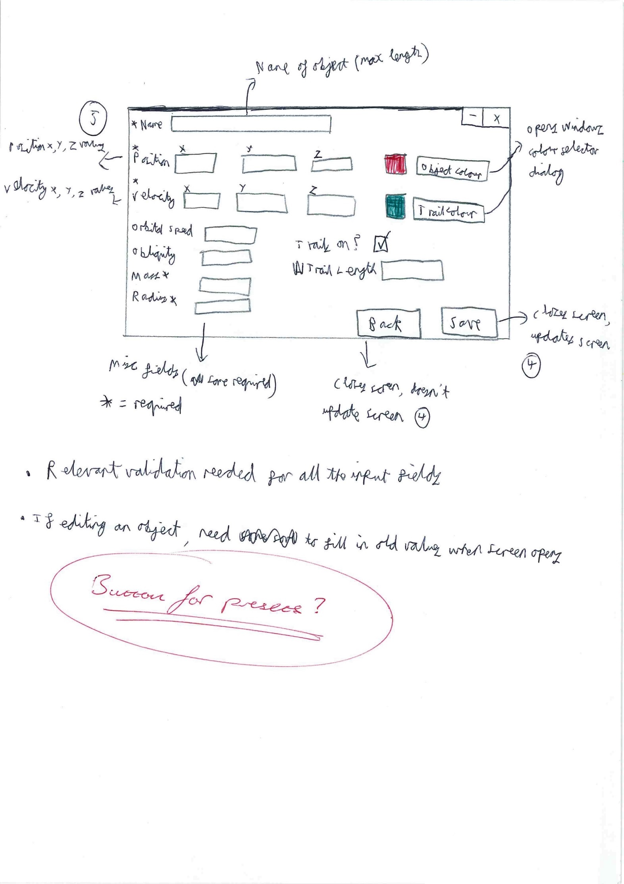

### Final Interface

About halfway through the development process, I had the opportunity to take what I had made so far into a classroom situation with one of the Physics department teachers and attempt a demo with them – a mid-project review of sorts. This caused me to make some modifications to the control screens – in particular, the main control form.

The main changes were:

* The play/pause/restart buttons were moved within the screen
* The play/pause/restart icons were changed to text
* The object form was restructured significantly to flow better
* “Preset” buttons were added to the object form to allow for preset objects (e.g. Sun, Earth, Mars) to be pulled from the database and easily added to a custom simulation.

**MainForm:**

The Main Menu had the Settings button removed, as it was decided that there were no global settings required for the system – only settings within each simulation.

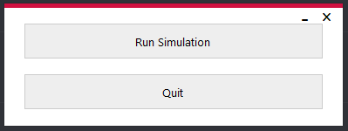

**SimForm:**

The Simulation Menu had very little change – the title of the form was finalised as “Sim Menu” and the button text was confirmed.

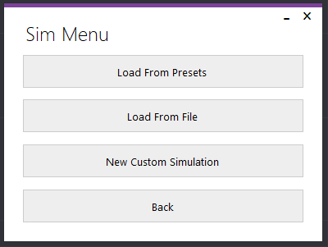

**PresetForm:**

The Preset Menu also had very little change – the title of the form was finalised as “Preset Menu”.

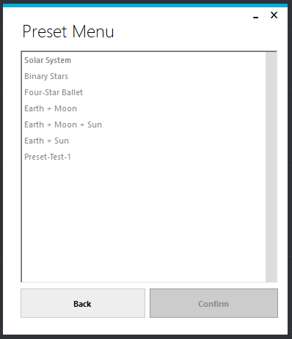

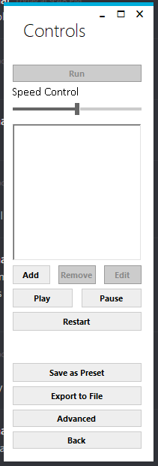**ControlForm:**

The Simulation Control Menu had various changes made to it.

The Add, Remove and Edit buttons were minified and put next to each other, below the object table – this was agreed upon with the client, as it seemed to flow much better.

The Play, Pause and Restart buttons were also moved below the object table, and their icons were changed to text to facilitate easier understanding of the user interface.

During the development phase, both the “Save as Preset” and “Export to File” buttons were added to the Simulation Control Menu, at the bottom. This allows easy access to these features, while also preventing the form from feeling cluttered while teachers are simply trying to show a simulation.

The “Advanced” button was also added, to allow for usually-hidden database values to be modified (e.g. the maximum speed of the simulation, the accuracy of the simulation etc.).

The “Run” button at the top starts the simulation itself. This button is at the top to draw attention to it immediately, as without pressing it the simulation will not start.

**ObjectForm:**

On the Object Menu, a few important changes were made.

Firstly, the form itself was neatened up to allow a much more intuitive flow through the form – rather than having a jumbled mess of different fields, it now quite obviously highlighted the top fields (name, speed, velocity) as the most important, with the more basic fields (orbital speed, obliquity, mass, radius) along the left and the object colour and trail information on the right.

In addition, the “Copy from Existing” button and “Presets” buttons were added, to allow for specific values to be pulled from preset objects within the solution’s database. Each preset button is next to the relevant fields (Top “Preset” button pulls in an object’s initial position preset, while the bottom “Preset” button pulls in an object’s initial velocity preset), and the “Copy from Existing” button is at the top right to pull the user’s focus towards it (as it pulls in all information about a preset object, replacing anything already in the Object Menu).

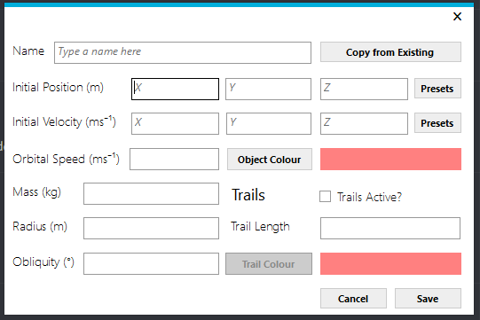

**ExistingObjectsForm:**

This form didn’t exist on any of the previous sketches, as it was added late in the development phase. However, it is a very simple form, simply listing all preset objects within the database and allowing one to be selected before the “Confirm” button can be clicked. This form is opened from the new “Copy from Existing” and “Presets” buttons from the ObjectForm.

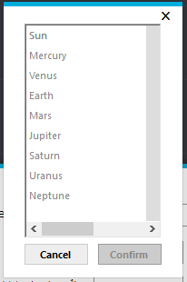

**SaveAsForm:**

This form didn’t exist on any of the previous sketches either, as it was added late in the development phase. However, it is a very simple form, simply a text box to allow the user to enter a name for the simulation being saved as a preset simulation. It is opened from the “Save to Preset” button on the Simulation Control Menu.

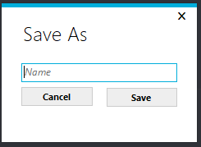

## Database Data Dictionary

|  |  |  |  |  |  |
| --- | --- | --- | --- | --- | --- |
| **Table** | **PK/FK** | **Column** | **Data Type** | **References** | **Description** |
| Object | PK | ObjectID | Integer |  | Unique number ID of object |
| Object |  | Name | Text |  | Name of object |
| Object |  | Mass | Real |  | Mass of object |
| Object |  | Radius | Real |  | Radius of object |
| Object |  | Obliquity | Real |  | Obliquity of object |
| Object |  | OrbitalSpeed | Real |  | Orbital speed of object |
| InitialValues | FK | ObjectID | Integer | Object | References unique object |
| InitialValues | FK | PlanetarySystemID | Integer | PlanetarySystem | References unique planetary system |
| InitialValues |  | PositionX | Real |  | Initial X co-ordinate of object position in a specific planetary system |
| InitialValues |  | PositionY | Real |  | Initial Y co-ordinate of object position in a specific planetary system |
| InitialValues |  | PositionZ | Real |  | Initial Z co-ordinate of object position in a specific planetary system |
| InitialValues |  | VelocityX | Real |  | Initial X vector of object velocity in a specific planetary system |
| InitialValues |  | VelocityY | Real |  | Initial Y vector of object velocity in a specific planetary system |
| InitialValues |  | VelocityZ | Real |  | Initial Z vector of object velocity in a specific planetary system |
| ObjectView | FK | ObjectID | Integer | Object | References unique object |
| ObjectView | FK | SimulationID | Integer | Simulation | References unique simulation |
| ObjectView |  | TrailActive | Integer |  | Boolean value stored as integer (1: true, 0: false)  States whether the trail is active for a specific object in a specific simulation |
| ObjectView |  | TrailLength | Integer |  | Length of trail for a specific object in a specific simulation |
| ObjectView |  | TrailColour | Text |  | Hex string of colour of a specific object’s trail in a specific simulation |
| ObjectView |  | ObjectColour | Text |  | Hex string of colour of a specific object in a specific simulation |
| PlanetarySystem | PK | PlanetarySystemID | Integer |  | Unique number ID of planetary system |
| PlanetarySystem |  | Name | Text |  | Name of planetary system |
| PlanetarySystem |  | Description | Text |  | Description for planetary system |
| Simulation | PK | SimulationID | Integer |  | Unique number ID of simulation |
| Simulation | FK | PlanetarySystemID | Integer | PlanetarySystem | References unique planetary system |
| Simulation |  | Zoom | Real |  | Zoom value for a specific simulation |
| Simulation |  | ZoomModifier | Real |  | Zoom modifier for a specific simulation |
| Simulation |  | Focus | Integer |  | Focus value for a specific simulation – references object ID |
| Simulation |  | Fixed | Integer |  | Boolean value stored as integer (1: true, 0: false)  States whether the camera position is fixed to a specific set of co-ordinates |
| Simulation |  | Speed | Integer |  | Speed value for a specific simulation |
| Simulation |  | SpeedModifier | Integer |  | Speed modifier for a specific simulation |
| Simulation |  | Scale | Integer |  | Scale value for a specific simulation |

## Database Normalisation

Requirements for First Normal Form:

* The values in each column of the table are atomic

Requirements for Second Normal Form:

* Must be in First Normal Form
* Every non-key attribute must depend upon the whole key

Requirements for Third Normal Form:

* Must be in Second Normal Form
* Must contain only columns that are non-transitively dependent on the primary key

Every value in my database is atomic (i.e. cannot be broken down into smaller parts). Therefore, it satisfies the requirement for it to be in First Normal Form.

There are three primary keys throughout my database – ObjectID for the Object table, PlanetarySystemID for the PlanetarySystem table and SimulationID for the Simulation table – and for each of these tables, every non-key attribute depends entirely on the key. In the ObjectView linking table a compound key is used, combining the foreign keys ObjectID and SimulationID. Likewise, in the InitialValues linking table a compound key is used, combining the foreign keys ObjectID and PlanetarySystemID. For these tables, every non-key attribute also depends entirely on the compound key.

No tables within my database contain columns that are transitively dependent on each other, and all tables within my database are comprised entirely of columns that depend on the primary key or compound key (as stated in the previous paragraph). Therefore, my database is in third normal form, as all of the above requirements have been satisfied.

## Database E-R Diagram

A Planetary System is a collection of objects, each with its own set of initial values (position and velocity X, Y, Z values). So, the InitialValues table acts as a linking table between PlanetarySystem and Object. One planetary system can have many objects, each of which has a specific set of initial values for that specific planetary system.

A Simulation is a Planetary System being displayed in a specific way. The simulation record contains base information on the simulation – speed of playback, whether or not the camera is fixed, the current focus of the camers and the scale of the simulation. It also links to the ObjectView table, which contains display information for each object within the simulation – colour of object and trail, and the trail length. So, the ObjectView table acts as a linking table between Simulation and Object. One simulation can have many objects, each of which has a specific look for that specific simulation.

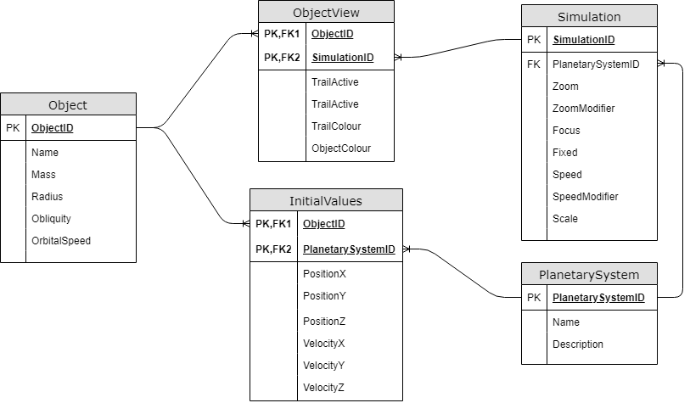

TrailLength

## Database Queries

Setup SQL statements (first-time run):

Pseudocode:

Create a table called “Object” if it doesn’t already exist, with these fields:

* Object ID (number)
* Object’s name (text)
* Object’s mass (number)
* Object’s radius (number)
* Object’s obliquity (number)
* Object’s orbital speed (number)

Create a table called “InitialValues” if it doesn’t already exist, with these fields:

* Object ID (number)
* Planetary System ID (number)
* Position (stored as x, y and z numbers)
* Velocity (stored as x, y and z numbers)

Create a table called “PlanetarySystem” if it doesn’t already exist, with these fields:

* Planetary System ID (number)
* Name (text)
* Description (text)

Create a table called “Simulation” if it doesn’t already exist, with these fields:

* Simulation ID (number)
* Planetary System ID (number)
* Zoom level of camera (number)
* Zoom Modifier of camera (number)
* Object to focus on (number)
* Whether or not the camera is fixed (true/false)
* Speed of simulation (number)
* Speed modifier of simulation (number)
* Scale of simulation (number)

Create a table called “ObjectView” if it doesn’t already exist, with these fields:

* Simulation ID (number)
* Object ID (number)
* Whether or not the trail is active (true/false)
* Length of the trail in frames (number)
* Colour of the trail (text - hex value)
* Colour of the object (text - hex value)

Final SQL:

CREATE TABLE IF NOT EXISTS `Object` (

`ObjectID` INTEGER PRIMARY KEY AUTOINCREMENT,

"`Name` TEXT NOT NULL,

`Mass` REAL NOT NULL,

`Radius` REAL NOT NULL,

`Obliquity` REAL NOT NULL,

`OrbitalSpeed` REAL NOT NULL);

CREATE TABLE IF NOT EXISTS `InitialValues` (

`ObjectID` INTEGER NOT NULL,

`PlanetarySystemID` INTEGER NOT NULL,

`PositionX` REAL NOT NULL,

`PositionY` REAL NOT NULL,

`PositionZ` REAL NOT NULL,

`VelocityX` REAL NOT NULL,

`VelocityY` REAL NOT NULL,

`VelocityZ` REAL NOT NULL,

FOREIGN KEY(ObjectID) REFERENCES Object(ObjectID),

FOREIGN KEY(PlanetarySystemID) REFERENCES PlanetarySystem(PlanetarySystemID));

CREATE TABLE IF NOT EXISTS `PlanetarySystem` (

`PlanetarySystemID` INTEGER PRIMARY KEY AUTOINCREMENT,

`Name` TEXT NOT NULL,

`Description` TEXT NOT NULL);

CREATE TABLE IF NOT EXISTS `Simulation` (

`SimulationID` INTEGER PRIMARY KEY AUTOINCREMENT,

`PlanetarySystemID` INTEGER NOT NULL,

`Zoom` REAL NOT NULL,

`ZoomModifier` REAL NOT NULL,

`Focus` INTEGER NOT NULL,

`Fixed` INTEGER NOT NULL,

`Speed` INTEGER NOT NULL,

'SpeedModifier' INTEGER NOT NULL,

`Scale` INTEGER NOT NULL,

FOREIGN KEY(`PlanetarySystemID`) REFERENCES `PlanetarySystem`(`PlanetarySystemID`));

CREATE TABLE IF NOT EXISTS `ObjectView` (

`SimulationID` INTEGER NOT NULL,

`ObjectID` INTEGER NOT NULL,

`TrailActive` INTEGER NOT NULL,

`TrailLength` INTEGER NOT NULL,

`TrailColour` TEXT NOT NULL,

`ObjectColour` TEXT NOT NULL,

FOREIGN KEY(SimulationID) REFERENCES Simulation(SimulationID),

FOREIGN KEY(ObjectID) REFERENCES Object(ObjectID));

Get Simulation IDs:

Pseudocode:

Select all Simulation IDs from the Simulation table.

Final SQL:

SELECT Simulation.SimulationID FROM Simulation;

Get a specific Simulation:

Pseudocode:

Select all details from the Simulation and PlanetarySystem tables where SimulationID matches the simulation being looked for.

Then, select all details from the Object, ObjectView and InitialValues tables where the SimulationID matches the simulation being looked for.

Final SQL:

**SimulationID:** ID of Simulation being requested.

SELECT Simulation.SimulationID, Simulation.Zoom, Simulation.ZoomModifier, Simulation.Focus, Simulation.Fixed, Simulation.Speed, Simulation.Scale, PlanetarySystem.PlanetarySystemID, PlanetarySystem.Name, PlanetarySystem.Description

FROM Simulation

INNER JOIN PlanetarySystem ON PlanetarySystem.PlanetarySystemID = Simulation.PlanetarySystemID

WHERE Simulation.SimulationID = {**SimulationID**};

SELECT Object.ObjectID, ObjectView.TrailActive, ObjectView.TrailLength, ObjectView.TrailColour, ObjectView.ObjectColour, Object.Name, Object.Mass, Object.Radius, Object.Obliquity, Object.OrbitalSpeed, InitialValues.PositionX, InitialValues.PositionY, InitialValues.PositionZ, InitialValues.VelocityX, InitialValues.VelocityY, InitialValues.VelocityZ

FROM Simulation

LEFT JOIN InitialValues ON InitialValues.PlanetarySystemID = Simulation.PlanetarySystemID

LEFT JOIN Object ON Object.ObjectID = InitialValues.ObjectID

LEFT JOIN ObjectView ON ObjectView.ObjectID = Object.ObjectID

WHERE Simulation.SimulationID = {**SimulationID**} AND ObjectView.SimulationID = {**SimulationID**};

Get all Objects:

Pseudocode:

Gets all details from the Objects table.

Final SQL:

SELECT * FROM Object;

Get Position Presets:

Pseudocode:

Get all object names and position X, Y and Z values from the InitialValues and Object tables where the Planetary System ID is 0.

(All objects pulled from NASA are given the Planetary System ID 0, and so all preset objects have this ID)

Final SQL:

SELECT PositionX, PositionY, PositionZ, Object.Name

FROM InitialValues

INNER JOIN Object ON Object.ObjectID = InitialValues.ObjectID

WHERE InitialValues.PlanetarySystemID = 0;

Get Velocity Presets:

Pseudocode:

Get all object names and velocity X, Y and Z values from the InitialValues and Object tables where the Planetary System ID is 0.

(All objects pulled from NASA are given the Planetary System ID 0, and so all preset objects have this ID)

Final SQL:

SELECT VelocityX, VelocityY, VelocityZ, Object.Name

FROM InitialValues

INNER JOIN Object ON Object.ObjectID = InitialValues.ObjectID

WHERE InitialValues.PlanetarySystemID = 0;

Add Object from NASA:

Pseudocode:

Add new record to the Object table, specifying the Name, Mass and Radius (and setting the other values to 0).

Add new record to the InitialValues table, specifying the position and velocity values, and setting the PlanetarySystemID to 0.

Final SQL:

**Name:** Name of object pulled from NASA

**Mass:** Mass of object pulled from NASA

**Radius:** Radius of object pulled from NASA

**PositionX:** X-coordinate of object position at a specific point in time

**PositionY:** Y-coordinate of object position at a specific point in time

**PositionZ:** Z-coordinate of object position at a specific point in time

**VelocityX:** X-coordinate of object velocity at a specific point in time

**VelocityY:** Y-coordinate of object velocity at a specific point in time

**VelocityZ:** Z-coordinate of object velocity at a specific point in time

INSERT INTO Object (Name, Mass, Radius, Obliquity, Orbital Speed)

VALUES(‘{**Name**}’, '{**Mass**}', '{**Radius**}', 0, 0);

INSERT INTO InitialValues

(PlanetarySystemID, PositionX, PositionY, PositionZ, VelocityX, VelocityY, VelocityZ)

VALUES('{'0', '{**PositionX**}', '{**PositionY**}', '{**PositionZ**}', '{**VelocityX**}', '{**VelocityY**}', '{**VelocityZ**}');

Set or Update Simulation (from Simulation class object):

Pseudocode:

Check if the PlanetarySystem class object has a database ID. If it doesn’t, insert a new record into the PlanetarySystem table. If it does, update the existing record.

Check if the Simulation class object has a database ID. If it doesn’t, insert a new record into the Simulation table. If it does, update the existing record.

For each object in the simulation that has a database ID and was deleted while loaded into the program, delete the object from the Object, ObjectView and InitialValues tables.

For each remaining object in the simulation, check if the Object has a database ID. If it doesn’t, insert a new record into the Object, ObjectView and InitialValues tables respectively. If it does, update each relevant record in the Object, ObjectView and InitialValues tables respectively.

Final SQL:

**SimulationID:** ID for the simulation being edited

**PlanetarySystemID:** ID for the planetary system being edited

**Name:** Name of planetary system

**Description:** Description of the planetary system

**Zoom:** Zoom value for the simulation

**ZoomModifier:** Zoom modifier for the simulation

**Focus:** Object currently in focus for the simulation

**Fixed:** Whether or not the camera is fixed in the simulation

**Speed:** Speed of the simulation

**SpeedModifier:** Speed modifier for the simulation

**Scale:** Scale factor for the simulation

INSERT INTO PlanetarySystem (Name, Description)

VALUES ('{**Name**}', '{**Description**}');

**OR**

UPDATE PlanetarySystem SET Name = '{**Name**}',

Description = '{**Description**}'

WHERE PlanetarySystemID = {**PlanetarySystemID**};

INSERT INTO Simulation (PlanetarySystemID, Zoom, ZoomModifier, Focus, Fixed, Speed, SpeedModifier, Scale)

VALUES ({**PlanetarySystemID**}, {**Zoom**}, {**ZoomModifier**}, {**Focus**}, {**Fixed**}, {**Speed**},

{**SpeedModifier**}, {**Scale**});

**OR**

UPDATE Simulation SET PlanetarySystemID = {**PlanetarySystemID**}, " +

                   $"Zoom = {**Zoom**}, " +

                   $"ZoomModifier = {**ZoomModifier**}, " +

                   $"Focus = {**Focus**}, " +

                   $"Fixed = {**Fixed**}, " +

                   $"Speed = {**Speed**}, " +

                   $"SpeedModifier = {**SpeedModifier**}, " +

                   $"Scale = {**Scale**} " +

                   $"WHERE SimulationID = {**SimulationID**};

**ObjectID:** ID for the object being edited

**ObjectName:** Name of the object

**Mass:** Mass of the object

**Radius:** Radius of the object

**Obliquity:** Obliquity of the object

**OrbitalSpeed:** Orbital speed of the object

INSERT INTO Object (Name, Mass, Radius, Obliquity, OrbitalSpeed)

VALUES ('{**ObjectName**}', {**Mass**}, {**Radius**}, {**Obliquity**}, {**OrbitalSpeed**});

**OR**

UPDATE Object SET

Name = '{**ObjectName**}',

"Mass = {**Mass**},

Radius = {**Radius**},

Obliquity = {**Obliquity**},

OrbitalSpeed = {**OrbitalSpeed**}

WHERE ObjectID = {**ObjectID**};

**TrailActive:** Whether or not the trails are active for the object

**TrailLength:** Length of the trail (in frames)

**TrailColour:** Colour of the trail (Hex string)

**ObjectColour:** Colour of the object (Hex string)

INSERT INTO ObjectView(SimulationID, ObjectID, TrailActive, TrailLength, TrailColour, ObjectColour)

VALUES ({**SimulationID**}, {**ObjectID**}, {**TrailsActive**}, {**TrailLength**}, {**TrailColour**}, {**ObjectColour**});

**OR**

UPDATE ObjectView SET

TrailActive = {**TrailsActive**},

TrailLength = {**TrailLength**},

TrailColour = {**TrailColour**},

ObjectColour = {**ObjectColour**},

WHERE ObjectID = {**ObjectID**} AND SimulationID = {**SimulationID**};

**PositionX:** X-coordinate of object position

**PositionY:** Y-coordinate of object position

**PositionZ:** Z-coordinate of object position

**VelocityX:** X-coordinate of object velocity

**VelocityY:** Y-coordinate of object velocity

**VelocityZ:** Z-coordinate of object velocity

INSERT INTO InitialValues(ObjectID, PlanetarySystemID, PositionX, PositionY, PositionZ, VelocityX, VelocityY, VelocityZ)

VALUES ({**ObjectID**}, {**PlanetarySystemID**}, {**PositionX**}, {**PositionY**}, {**PositionZ**}, {**VelocityX**}, {**VelocityY**}, {**VelocityZ**});

**OR**

UPDATE InitialValues SET

PositionX = {**PositionX**},

"PositionY = {**PositionY**},

PositionZ = {**PositionZ**},

VelocityX = {**VelocityX**},

VelocityY = {**VelocityY**},

VelocityZ = {**VelocityZ**}

WHERE ObjectID = {**ObjectID**} AND PlanetarySystemID = {**PlanetarySystemID**};

# Testing

## Overview

White box testing is a testing method in which the internal structure of the project is known to the tester. In my project, it is carried out by me, and I test each individual component of the project in isolation. This part of testing is done to catch programming bugs, such as not having validation on input fields.

Black box testing is a testing method in which the internal structure of the project is not known to the tester. In my project, black box testing was carried out by Mr Mullan, my client. He has little to no technical experience, and does not have an understanding of how the internal implementation works. He was given a series of basic instructions to carry out, building up to complex tasks that fulfil the initial objectives and use cases of the project. This can often show issues that are not brought up by white box testing, as while something may not necessarily be a bug, there are likely improvements that could be made. Having the client carry out the testing allows for them to request final changes to the system, as well as point out workflow issues within the user interface.

I plan to run detailed white box testing of each individual component of my project, before then asking my client (Mr Mullan) to do the black box testing on the project. As some parts of my project cannot adequately be displayed using screenshots, I recorded multiple small videos showing different aspects of the program being tested during the white box testing, and uploaded them to YouTube (the videos are hidden, and only accessible from the links provided). These videos are related to specific tests, and the links are provided in the White Box Testing Evidence.

## White Box Testing

|  |  |  |  |  |  |  |  |
| --- | --- | --- | --- | --- | --- | --- | --- |
| **Test No.** | **Relevant Objective (s)** | **View** | **Type** | **Purpose** | **Action** | **Expected Result** | **Outcome** |
| 1 | 2, 3 | MainForm  SimForm | Normal | Test navigation | Click “Run Simulation” button | SimForm is opened, current form is closed. | Pass |
| 2 | 3 | MainForm | Normal | Test navigation | Click “Quit” button | Application is closed. | Pass |
| 3 | 3, 11, 12, 13, 14, 15, 16 | SimForm  PresetForm | Normal | Test navigation | Click “Load From Presets” button | PresetForm is opened, current form is closed. | Pass |
| 4 | 3, 26 | SimForm  ControlForm | Normal | Test navigation  Test file parsing | Click “Load From File” button.  Select valid simulation file.  Click “OK” button | File selection dialog is opened.  File is selected.  File is read, and ControlForm is opened with the simulation loaded from the file.  Current form is closed. | Pass |
| 5 | 3, 18 | SimForm  ControlForm | Normal | Test navigation | Click “New Custom Simulation” button | ControlForm is opened with a new blank simulation loaded, current form is closed. | Pass |
| 6 | 3 | SimForm  MainForm | Normal | Test navigation | Click “Back” button | MainForm is opened, current form is closed. | Pass |
| 7 | 3, 14, 16 | PresetForm  ControlForm | Normal | Test navigation  Test database methods | Select the “Solar System” preset, and then click “Confirm” button | ControlForm is opened with the “Solar System” simulation loaded, current form is closed. | Pass |
| 8 | 3 | PresetForm | Normal | Test navigation | Click “Back” button | SimForm is opened, current form is closed. | Pass |
| 9 | 3, 19 | ControlForm | Normal | Test navigation | Click “Add” button | ObjectForm is opened, fields are blank. | Pass |
| 10 | 3, 19 | ObjectForm | Erroneous | Test input fields & validation | Enter nothing for the name of the object and click Save. | Error message displays:  ’Name’ field must not be empty | Pass |
| 11 | 3, 19 | ObjectForm | Boundary | Test input fields & validation | Enter the name “Name that won't fit...........” for the object | Error message displays:  ‘Name’ field must be less than 30 chars. | Pass |
| 12 | 3, 19 | ObjectForm | Boundary | Test input fields & validation | Enter the name “Name that will fit...........” for the object | Value accepted. | Pass |
| 13 | 3, 19 | ObjectForm | Normal | Test input fields & validation | Enter the name “Moon” for the object and click Save. | Value accepted.  Other error messages for other fields appear. | Pass |
| 14 | 3, 19, 20 | ObjectForm | Erroneous | Test input fields & validation | Enter nothing for any one of the three position  co-ordinate textboxes | Error message displays:  ’Position’ fields must not be empty | Pass |
| 15 | 3, 19, 20 | ObjectForm | Erroneous | Test input fields & validation | Enter any combination of characters in any one of the three position  co-ordinate textboxes. | Field validation doesn’t allow illegal characters into the fields. | Fail |
| 16 | 3, 19, 20 | ObjectForm | Normal | Test input fields & validation | Enter position co-ordinates (x, y, z) (“100”, “-1000”, “3E+20”) | Value accepted. | Pass |
| 17 | 3, 19, 21 | ObjectForm | Erroneous | Test input fields & validation | Enter nothing for any one of the three velocity  vector textboxes | Error message displays:  ‘Velocity’ fields must not be empty. | Pass |
| 18 | 3, 19, 21 | ObjectForm | Erroneous | Test input fields & validation | Enter any combination of characters in any one of the three velocity vector textboxes. | Field validation doesn’t allow illegal characters into the fields. | Pass |
| 19 | 3, 19, 21 | ObjectForm | Normal | Test input fields & validation | Enter velocity vector (x, y, z)  (“-10”, “6E-2”, “0”) | Value accepted. | Pass |
| 20 | 3, 19, 22 | ObjectForm | Erroneous | Test input fields & validation | Enter nothing for the mass | Error message displays:  ‘Mass’ field must not be empty. | Pass |
| 21 | 3, 19, 22 | ObjectForm | Erroneous | Test input fields & validation | Enter mass of  “-10” | Error message displays:  ‘Mass’ field must be greater than 0. | Pass |
| 22 | 3, 19, 22 | ObjectForm | Boundary | Test input fields & validation | Enter mass of  “0” | Error message displays:  ‘Mass’ field must be greater than 0. | Fail |
| 23 | 3, 19, 22 | ObjectForm | Erroneous | Test input fields & validation | Enter any combination of characters for the mass. | Field validation doesn’t allow illegal characters into the field. | Pass |
| 24 | 3, 19, 22 | ObjectForm | Normal | Test input fields & validation | Enter mass of “1E+25” | Value accepted. | Pass |
| 25 | 3, 19, 23 | ObjectForm | Erroneous | Test input fields & validation | Enter nothing for the radius | Error message displays:  ‘Radius field must not be empty. | Pass |
| 26 | 3, 19, 23 | ObjectForm | Erroneous | Test input fields & validation | Enter radius of  “-1000” | Error message displays:  ‘Radius field must be greater than 0. | Pass |
| 27 | 3, 19, 23 | ObjectForm | Boundary | Test input fields & validation | Enter radius of  “0” | Error message displays:  ‘Radius field must be greater than 0. | Pass |
| 28 | 3, 19, 23 | ObjectForm | Erroneous | Test input fields & validation | Enter any combination of characters for the radius. | Field validation doesn’t allow illegal characters into the field. | Pass |
| 29 | 3, 19, 23 | ObjectForm | Normal | Test input fields & validation | Enter radius of “1000” | Value accepted. | Pass |
| 30 | 3, 19 | ObjectForm | Normal | Test input fields & validation | Enter nothing for the orbital speed | Value accepted, defaults to 0. | Pass |
| 31 | 3, 19 | ObjectForm | Erroneous | Test input fields & validation | Enter any combination of characters for the orbital speed. | Field validation doesn’t allow illegal characters into the field. | Pass |
| 32 | 3, 19 | ObjectForm | Normal | Test input fields & validation | Enter orbital speed of “100” | Value accepted. | Pass |
| 33 | 3, 19 | ObjectForm | Normal | Test input fields & validation | Enter nothing for the obliquity. | Value accepted, defaults to 0. | Pass |
| 34 | 3, 19 | ObjectForm | Erroneous | Test input fields & validation | Enter any combination of characters for the obliquity. | Field validation doesn’t allow illegal characters into the field. | Pass |
| 35 | 3, 19 | ObjectForm | Normal | Test input fields & validation | Enter obliquity of 10 degrees. | Value accepted. | Pass |
| 36 | 3, 6, 19 | ObjectForm | Normal | Test input fields & validation | Check the “Trails Active?” checkbox. | Checkbox is ticked, Trail Length and Trail Colour fields become editable. | Pass |
| 37 | 3, 6, 19 | ObjectForm | Normal | Test input fields & validation | Uncheck the “Trails Active?” checkbox. | Checkbox is unticked, Trail Length and Trail Colour fields are no longer editable. | Pass |
| 38 | 3, 6, 19 | ObjectForm | Normal | Test input fields & validation | Enter nothing for the trail length. | Value accepted, defaults to 1000. | Pass |
| 39 | 3, 6, 19 | ObjectForm | Normal | Test input fields & validation | Enter “-1” for the trail length. | Field validation doesn’t allow illegal characters into the field. | Pass |
| 40 | 3, 6, 19 | ObjectForm | Erroneous | Test input fields & validation | Enter any combination of characters for the trail length. | Field validation doesn’t allow illegal characters into the field. | Pass |
| 41 | 3, 6, 19 | ObjectForm | Normal | Test input fields & validation | Enter Trail Length of “1000” | Value accepted. | Pass |
| 42 | 3, 5, 6, 19 | ObjectForm | Normal | Test input fields & validation | Click “Trail Colour” button, set the colour to light blue and click ok. | Value accepted, trail colour box displays the colour chosen. | Pass |
| 43 | 3, 5, 6, 19 | ObjectForm | Normal | Test input fields & validation | Click “Object Colour” button, set the colour to light blue and click ok. | Value accepted, object colour box displays the colour chosen. | Pass |
| 44 | 3, 19, 20, 21, 22, 23 | ObjectForm  Existing  Objects  Form | Normal | Test input fields & validation  Test database methods  Test navigation | Click “Copy from Existing” button.  Select “Sun”  Click “Confirm”. button. | System pulls a list of objects from database, displays the names in a list.  When confirm button clicked, the data is copied into the object form fields. | Pass |
| 45 | 3, 19, 20 | ObjectForm | Normal | Test input fields & validation  Test database methods  Test navigation | Click “Presets” button next to “Initial Position” fields.  Select “Mercury”  Click “Confirm”. button. | System pulls a list of objects from database, displays the names in a list.  When confirm button clicked, the data is copied into the position X, Y and Z fields. | Pass |
| 46 | 3, 19, 21 | ObjectForm | Normal | Test input fields & validation  Test database methods  Test navigation | Click “Presets” button next to “Initial Velocity” fields.  Select “Mars”  Click “Confirm”. button. | System pulls a list of objects from database, displays the names in a list.  When confirm button clicked, the data is copied into the velocity X, Y and Z fields. | Pass |
| 47 | 3, 6, 7, 19, 20, 21, 22, 23 | ControlForm  ObjectForm | Normal | Test navigation | Click “Add” button  Fill in form with valid values.  Click “Confirm”. button. | ObjectForm opens, valid values are filled in, and ObjectForm is closed. New object appears in list on ControlForm. | Pass |
| 48 | 3, 6, 7, 19, 20, 21, 22, 23 | ControlForm  ObjectForm | Normal | Test navigation | Select an object from the list.  Click “Edit” button  Fill in form with valid values.  Click “Confirm”. button. | ObjectForm opens, values are changed (to still be within valid values), and ObjectForm is closed. Object’s data has changed. If the name of the object was changed, name changes in list on ControlForm. | Pass |
| 49 | 3, 19 | ControlForm | Normal | Test navigation | Select an object from the list.  Click “Remove” button | Selected object is removed from list on ControlForm. | Pass |
| 50 | 3, 19, 26 | ControlForm  SaveAs  Form | Normal | Test navigation | Create new simulation, add objects to it.  Click “Save as Preset” button.  Enter “Preset-Test-1” and click “Save” button. | SaveAsForm opens. Name is entered, and simulation is saved.  Saved simulation can now be opened from the PresetForm. | Pass |
| 51 | 3, 19, 24 | ControlForm | Normal | Test navigation | Create new simulation, add objects to it.  Click “Export to File” button.  Choose a location and enter “Export-Test-1” and click “Save” button. | File saving dialog is opened. Name is entered, and file is saved. | Pass |
| 52 | 3, 7, 9, 16 | Main  Window  ControlForm | Normal | Test simulation rendering  Test simulation view controls | Load the “Solar System” preset simulation.  Left click and drag with the mouse over the view window to change the camera view. | OpenGL view window opens.  3D representations of the major bodies in our Solar System are displayed and are moving in orbits.  Camera view changes work seamlessly. | Pass |
| 53 | 3, 7, 16 | Main  Window  ControlForm | Normal | Test simulation view controls  Test simulation rendering | Load the “Solar System” preset simulation.  Click “Pause” button.  Click “Play” button. | OpenGL view window opens.  3D representations of the major bodies in our Solar System are displayed and are moving in orbits. Simulation pauses and plays when told to. | Pass |
| 54 | 3, 7, 16 | Main  Window  ControlForm | Normal | Test simulation view controls  Test simulation rendering | Load the “Solar System” preset simulation.  Press spacebar.  Press spacebar again. | OpenGL view window opens.  Simulation displays.  Simulation pauses and plays on spacebar press. | Pass |
| 55 | 3, 7, 8, 9, 16 | Main  Window  ControlForm | Normal | Test simulation view controls  Test simulation rendering | Load the “Solar System” preset simulation.  Move the “Speed Control” slider to the right. | OpenGL view window opens.  Simulation displays.  Speed of simulation increases. | Pass |
| 56 | 3, 7, 8, 9, 16 | Main  Window  ControlForm | Normal | Test simulation view controls  Test simulation rendering | Load the “Solar System” preset simulation.  Move the “Speed Control” slider to the right.  Move the “Speed Control” slider to the left. | OpenGL view window opens.  Simulation displays.  Speed of simulation increases.  Simulation plays in reverse, to the beginning of the simulation where it pauses. | Pass |
| 57 | 3, 7, 16 | Main  Window  ControlForm | Normal | Test simulation view controls  Test simulation rendering | Load the “Solar System” preset simulation.  Press “Restart” button. | OpenGL view window opens.  Simulation displays.  Simulation returns to the beginning and starts again. | Pass |
| 58 | 3, 7, 16 | Main  Window  ControlForm | Normal | Test simulation view controls  Test simulation rendering | Load the “Solar System” preset simulation.  Press the “R” key. | OpenGL view window opens.  Simulation displays.  Simulation returns to the beginning and starts again. | Pass |
| 59 | 3, 6, 7, 9, 16 | Main  Window  ControlForm  ObjectForm | Normal | Test simulation rendering  Test object control form | Load the “Solar System” preset simulation.  View the trails behind the objects. | OpenGL view window opens.  Simulation displays.  Trails should display in the path of the objects. | Pass |
| 60 | 3, 6, 7, 9, 16, 19 | Main  Window  ControlForm  ObjectForm | Normal | Test simulation rendering  Test object control form | Load the “Solar System” preset simulation.  Disable trail for “Earth”. | OpenGL view window opens.  Simulation displays.  Simulation updates and no longer renders a trail behind the Earth. | Pass |
| 61 | 3, 5, 6, 7, 9, 16, 19 | Main  Window  ControlForm  ObjectForm | Normal | Test simulation Test simulation rendering  Test object control form | Load the “Solar System” preset simulation.  Change the colour of the trail for “Mercury” to red. | OpenGL view window opens.  Simulation displays.  Simulation updates and the colour of Mercury’s trail changes to red. | Pass |
| 62 | 3, 6, 7, 9, 16, 19 | Main  Window  ControlForm  ObjectForm | Normal | Test simulation rendering  Test object control form | Load the “Solar System” preset simulation.  Reduce trail length of Earth’s trail to “1500” | OpenGL view window opens.  Simulation displays.  Simulation updates and trail behind the Earth is half as long. | Pass |
| 63 | 3, 7, 9, 16 | Main  Window  ControlForm | Normal | Test simulation rendering  Test simulation view controls | Load the “Solar System” preset simulation.  Use the mouse scroll wheel to zoom in and out of the simulation. | OpenGL view window opens. Simulation displays. Simulation zooms in and out as told to. | Pass |
| 64 | 3, 7, 9, 10, 16 | Main  Window  ControlForm | Normal | Test simulation rendering  Test simulation view controls | Load the “Solar System” preset simulation.  Use the ControlForm menu to select the current focus of the simulation. | OpenGL view window opens. Simulation displays. Simulation focus changes as requested. | Pass |

## White Box Testing Evidence

Below are screenshots from each test, along with a description of what happened, and what was changed if the test failed.

Where relevant, videos have been recorded of the test taking place and uploaded to YouTube. The video will be linked with the individual test, however will also be listed here:

**Test 52:** https://youtu.be/lmW73UAqAjo

**Test 53**: https://youtu.be/_XleaTKUlBY

**Test 54:** https://youtu.be/oUzT_Hdp-Io

**Tests 55 & 56:** https://youtu.be/XNnRGANL4Lk

**Test 57:** https://youtu.be/dCxbOyNGdic

**Test 58:** https://youtu.be/5GI8sxKO1YY

**Tests 59 & 60:** https://youtu.be/Q4JtV-ypBdI

**Test 61:** https://youtu.be/oz-B3ddN1vg

**Test 62:** https://youtu.be/W6yv8mwcdIQ

**Test 63:** https://youtu.be/NpFVJgtORhI

These recordings show the simulation itself being ran, as well as the interface for the simulation (ControlForm) being used in conjunction with it. Within the test evidence itself, screenshots will also be provided, as well as a basic description of what happened. All tests were also carried out on one of the Physics Department’s laptops, satisfying both objectives 2 and 4.

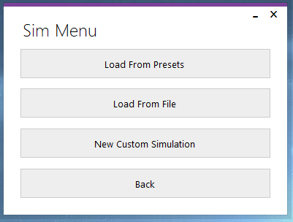Test 1:

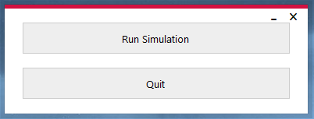

The “Run Simulation” button was pressed, SimForm opened and MainForm closed.

Test 2:



The “Quit” button was pressed, and the application exited.

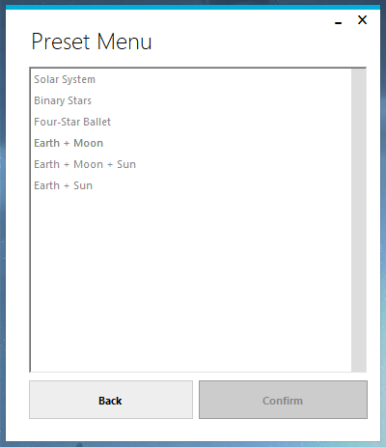Test 3:



The “Load from Presets” button was pressed, PresetForm opened and MainForm closed.

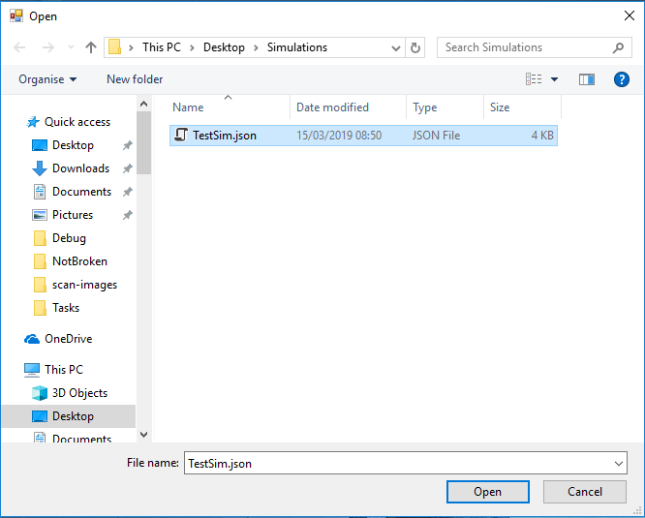Test 4:



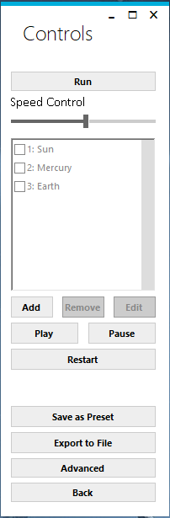

The “Load From File” button was pressed, and a file selection dialog opened.

“TestSim.json” was selected, and the “Open” button was pressed. ControlForm opened (with the information from the file loaded), and SimForm closed.

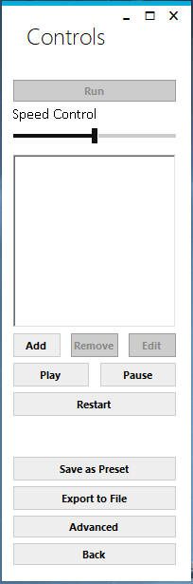Test 5:



The “New Custom Simulation” button was pressed.

ControlForm opened, and SimForm closed.

Test 6:





The “Back” button was pressed.

MainForm opened, and SimForm closed.

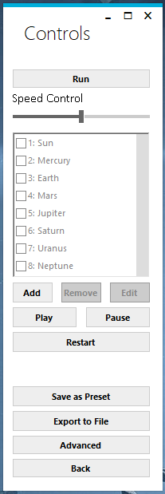Test 7:

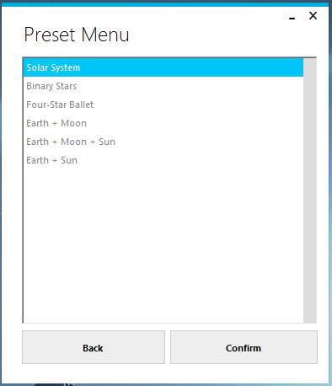

The “Solar System” preset is selected, and the “Confirm” button

is pressed. PresetForm closes, and ControlForm opens with the

“Solar System” preset loaded.

Test 8:





The “Back” button was pressed. SimForm opened, and PresetForm closed.

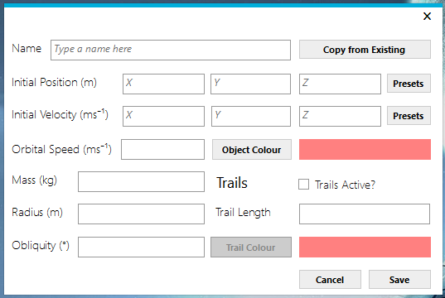Test 9:



The “Add” button is pressed on the ControlForm, in a new

custom simulation. ObjectForm opens, with blank editable

fields.

Test 10:

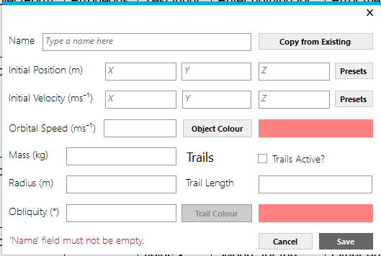

No name was entered into the “Name” textbox. When the “Save” button is pressed, an error appears for the “Name” textbox stating that the name must not be blank.

Test 11:

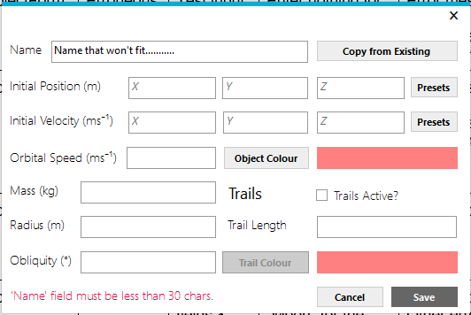

The name “Name that won't fit...........” was entered into the “Name” textbox. When the “Save” button is pressed, an error appears for the “Name” textbox stating that the name is too long.

Test 12:

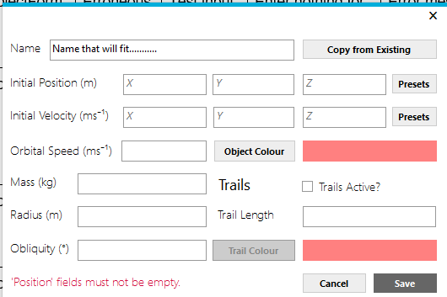

The name “Name that will fit...........” was entered into the “Name” textbox. When the “Save” button is pressed, no error appears for the “Name” textbox.

Test 13:

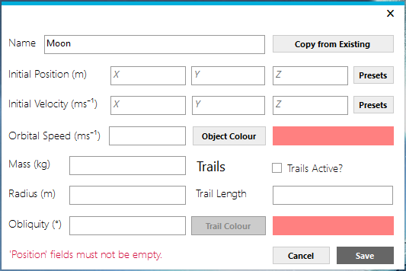

The name “Moon” was entered into the “Name” textbox. When the “Save” button is pressed, no error appears for the “Name” textbox.

Test 14:

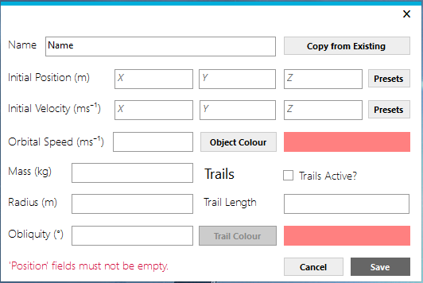

No values were entered into any of the position textboxes. When the “Save” button was pressed, an error appeared stating that values must be entered.

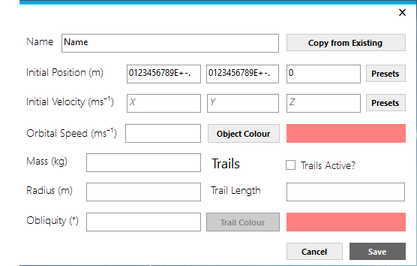Test 15 (FAIL):

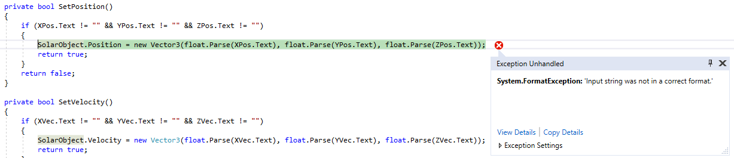

While the field validation written for the position fields worked (i.e. Only a specific character set could be entered into the text boxes, comprising of the numbers 0-9, E, full stop, + and -), there was no final validation to check whether or not the text could actually be converted into a valid number.

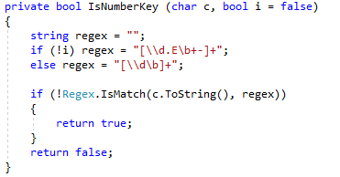

To fix this, I changed the SetPosition method to return different values depending on the error returned. I also surrounded the code block in a try/catch statement, in order to handle the potential exception gracefully.

I therefore also had to update the code inside the “Save” button click event to return a different error message depending on the error that occurred.

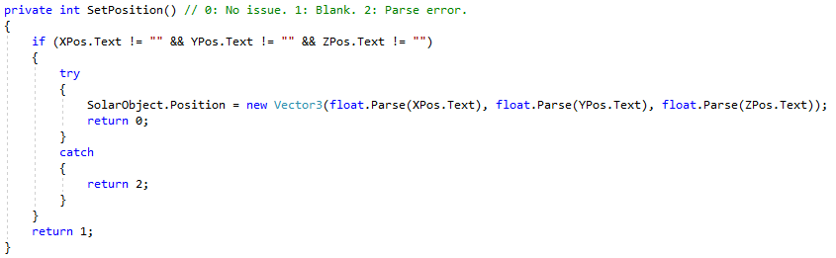New Code:

New code:

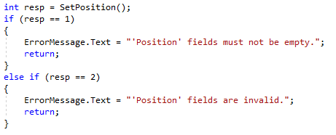

I re-did Test 15, and it passed:

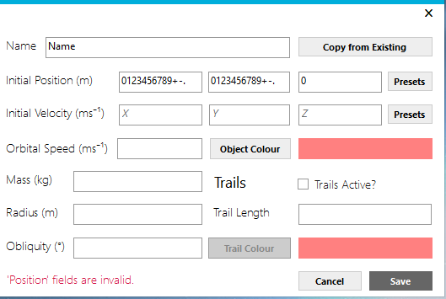

While fixing this error, I realised that it the same situation would apply to all fields in this form, and so I modified the code to fix all of these issues at the same time.

Test 16:

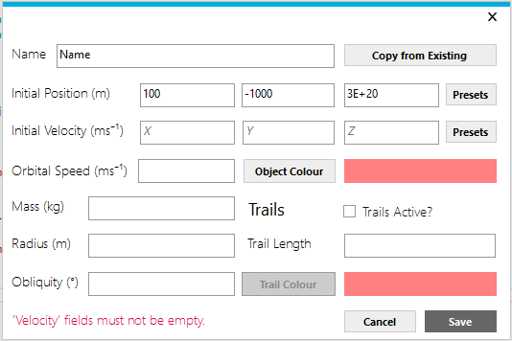

The values “100”,

“-1000”, “3E+20” were entered into the relevant position textboxes.

When the “Save” button was pressed, no error appeared for the “Position” textboxes.

Test 17:

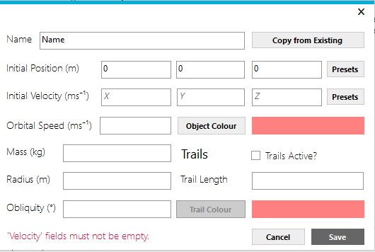

No values were entered into any of the velocity textboxes.

When the “Save” button was pressed, an error message appeared stating that the fields must not be empty.

Test 18:

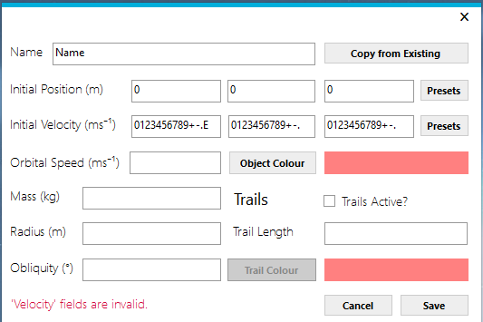

Only a specific set of characters were allowed into the fields, and this functioned correctly.

However, there was not initially any check to see whether the value entered could actually be converted properly. This bug was fixed during Test 15, and is documented there. Therefore, this test passed, and when the “Save” button was pressed, an error appeared stating that the fields were invalid.

Test 19:

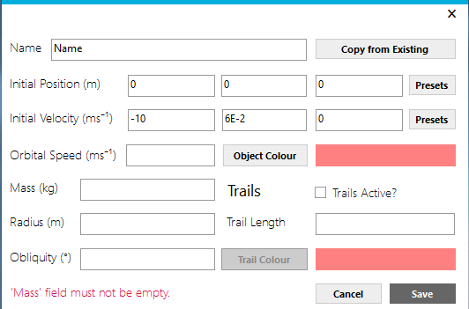

The values “-10”, “6E-2”, “0” were entered into the relevant velocity textboxes.

When the “Save” button was pressed, no error appeared for the “Velocity” textboxes.

Test 20:

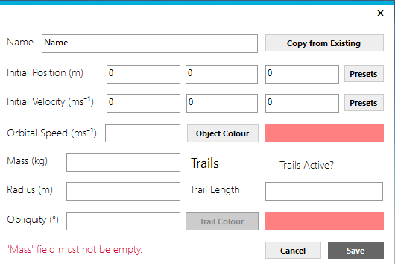

No value was entered into the mass textbox.

When the “Save” button was pressed, an error message appeared stating that the field must not be empty.

Test 21:

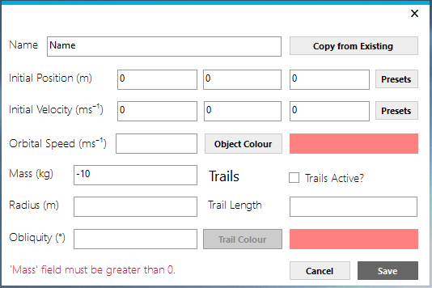

“-10” was entered into the mass textbox.

When the “Save” button was pressed, an error message appeared stating that the value must be greater than 0.

Test 22:

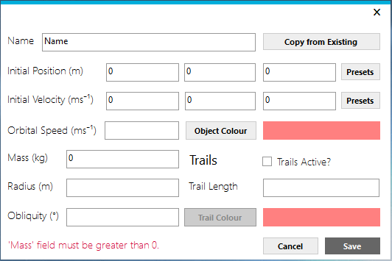

“0” was entered into the mass textbox.

When the “Save” button was pressed, an error message appeared stating that the value must be greater than 0.

Test 23:

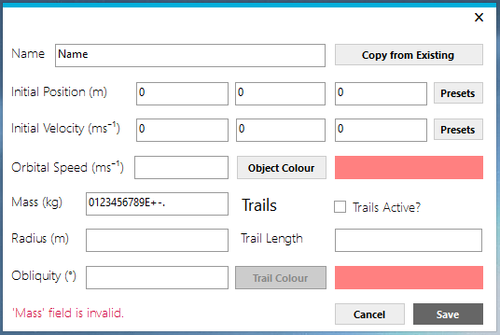

Only a specific set of characters was allowed into the field, and this functioned correctly.

However, there was not initially any check to see whether the value entered could actually be converted properly. This bug was fixed during Test 15, and is documented there. Therefore, this test passed, and when the “Save” button was pressed, an error appeared stating that the field was invalid.

Test 24:

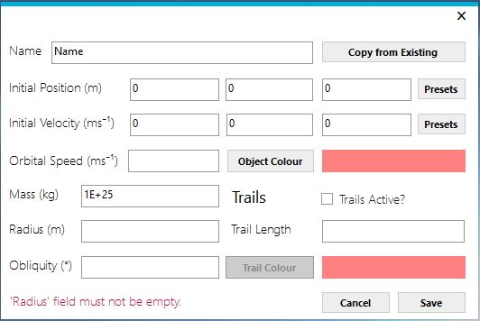

The value 1E+25” was entered into the mass textbox.

When the “Save” button was pressed, no error appeared for the “Mass” textbox.

Test 25:



No value was entered into the radius textbox.

When the “Save” button was pressed, an error message appeared stating that the field must not be empty.

Test 26:

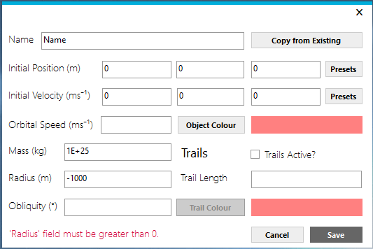

“-1000” was entered into the radius textbox.

When the “Save” button was pressed, an error message appeared stating that the value must be greater than 0.

Test 27:

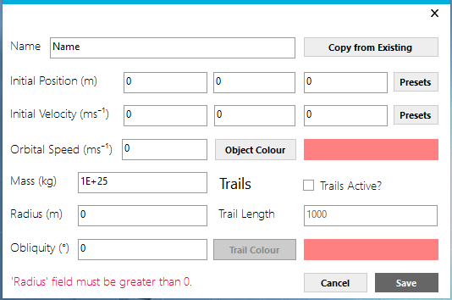

“0” was entered into the radius textbox.

When the “Save” button was pressed, an error message appeared stating that the value must be greater than 0.

Test 28:

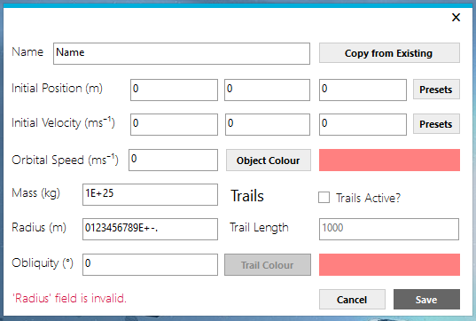

Only a specific set of characters was allowed into the field, and this functioned correctly.

However, there was not initially any check to see whether the value entered could actually be converted properly. This bug was fixed during Test 15, and is documented there. Therefore, this test passed, and when the “Save” button was pressed, an error appeared stating that the field was invalid.

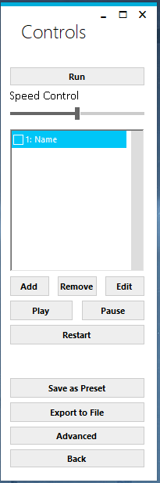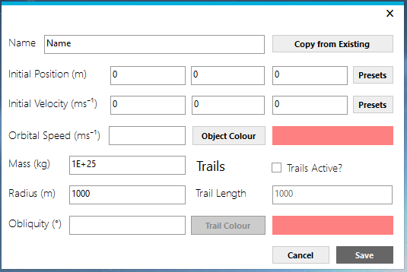Test 29:

“1000” was entered into the radius textbox.

When the “Save” button was pressed, no errors appeared as in this case all required fields were filled in. Therefore, the object was saved, and ObjectForm exited out to the ControlForm, which had the object in the list.

Test 30:

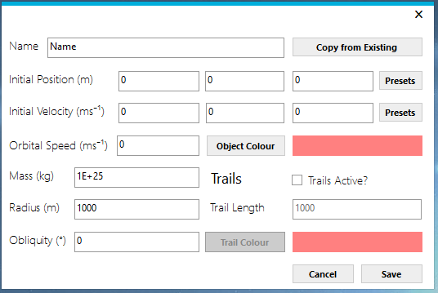

As stated in Test 29, the ObjectForm exited out to the ControlForm despite the orbital speed not being filled in. When I went to edit the object again, the orbital speed’s field had the value “0” in it. This shows that the speed defaulted to “0”, as expected.

Test 31:

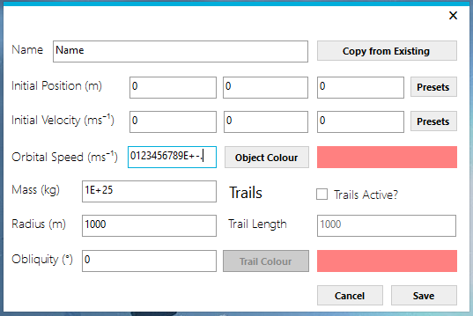

Only a specific set of characters was allowed into the field, and this functioned correctly.

However, there was not initially any check to see whether the value entered could actually be converted properly. This bug was fixed during Test 15, and is documented there. Therefore, this test passed. When the “Save” button is pressed, the orbital speed defaulted to “0” (as it is not a required field), and the ObjectForm exited out to the ControlForm. When I went to edit the object again, the orbital speed had the value “0”, showing that the speed did indeed default to “0” as expected.

Test 32:

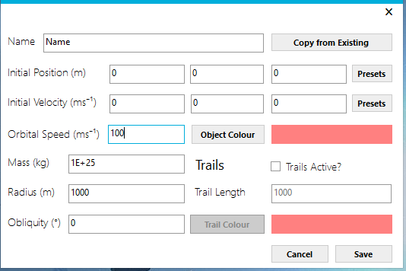

The value was accepted, and the form closed. When the object was opened back up, the value remained.

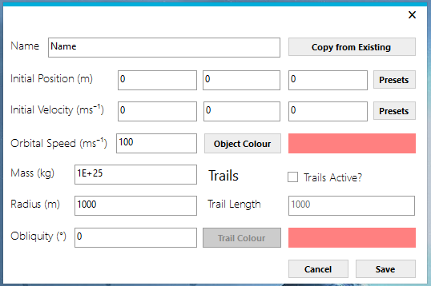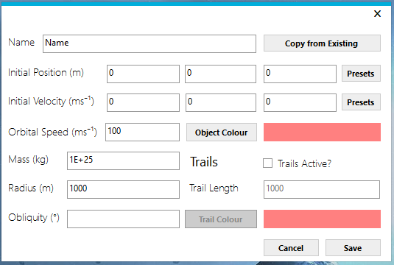Test 33:

As stated in Test 29, the ObjectForm exited out to the ControlForm despite the obliquity not being filled in. When I went to edit the object again, the obliquity’s field had the value “0” in it. This shows that the obliquity defaulted to “0”, as expected.

Test 34:

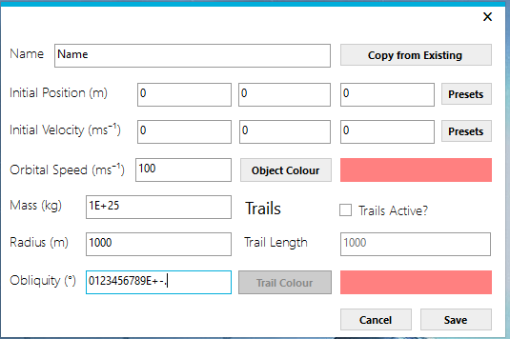

Only a specific set of characters was allowed into the field, and this functioned correctly.

However, there was not initially any check to see whether the value entered could actually be converted properly. This bug was fixed during Test 15, and is documented there. Therefore, this test passed. When the “Save” button is pressed, the obliquity defaulted to “0” (as it is not a required field), and the ObjectForm exited out to the ControlForm. When I went to edit the object again, the obliquity had the value “0”, showing that it did indeed default to “0” as expected.

Test 35:

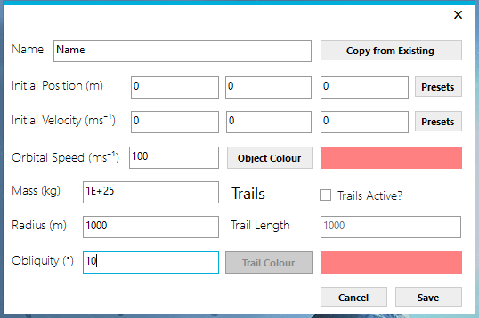

The value was accepted, and the form closed. When the object was opened back up, the value remained.

Test 36:

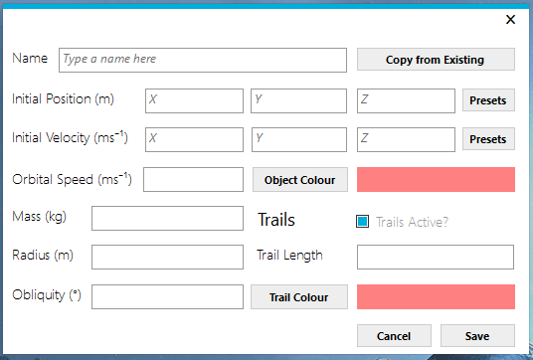

Tickbox checked, other fields become activated.

Test 37:

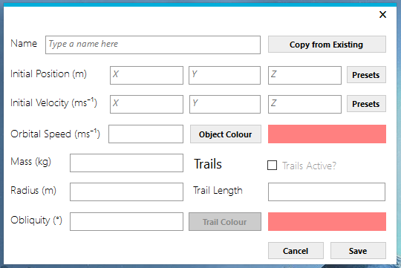

Tickbox unchecked, other fields deactivate.

Test 38:

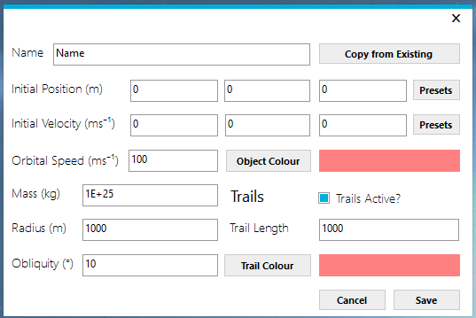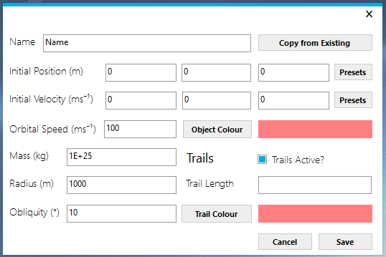

As stated in Test 29, the ObjectForm exited out to the ControlForm despite the trail length not being filled in. When I went to edit the object again, the trail length’s field had the value “1000” in it. This shows that the trail length defaulted to “1000”, as expected.

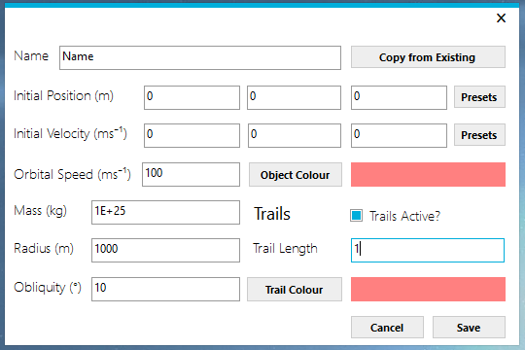Test 39:

When attempting to type in “-1” for the trail length, I was not allowed to type in the “-“ sign. Therefore, the trail length is 1.

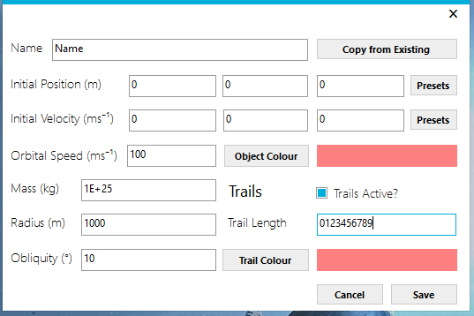Test 40:

When attempting to type in “ABC0123456789” for the trail length, I was not allowed to type in the letters. Therefore, the trail length is 123456789.

Test 41:

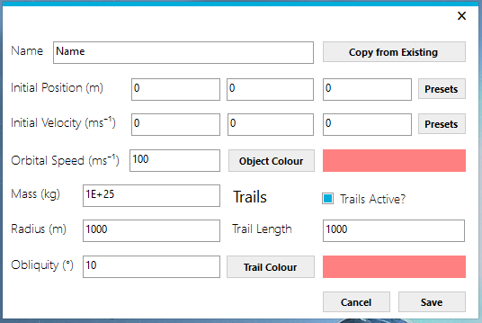

The value was accepted, and the form closed. When the object was opened back up, the value remained.

Test 42:

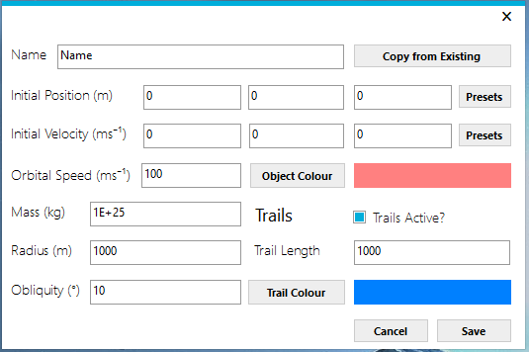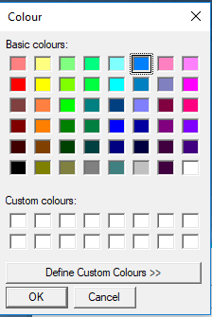

The colour was chosen, and the trail colour box displayed the colour chosen.

Test 43:

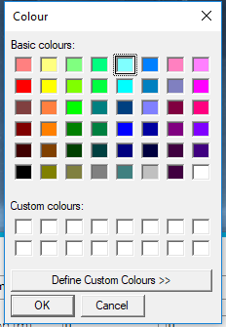

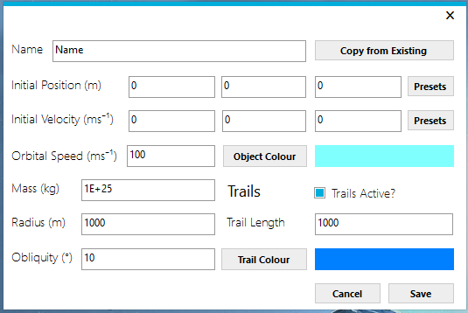

The colour was chosen, and the object colour box displayed the colour chosen.

Test 44:

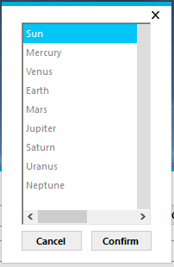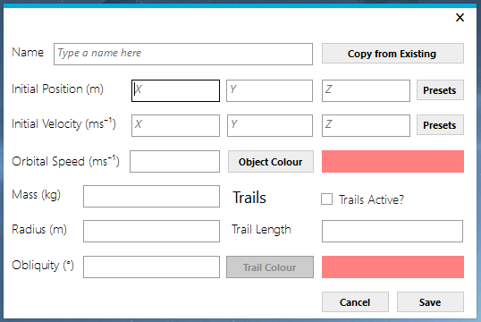

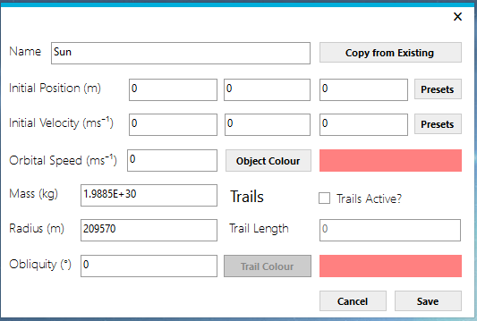

The “Copy from Existing” button was pressed, and ExistingObjectsForm opened. “Sun” was selected, and “Confirm” was clicked. The data for the “Sun” object was copied into the object form successfully.

Test 45:



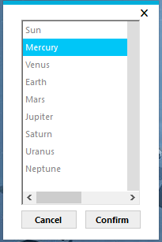

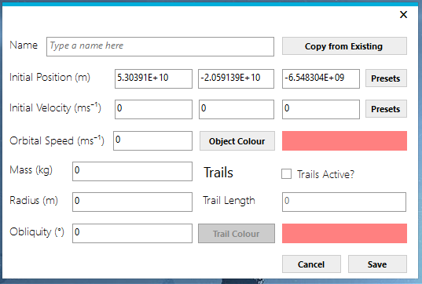

The Position “Preset” button was pressed, and ExistingObjectsForm opened. “Mercury” was selected, and “Confirm” was clicked. The data for the “Mercury” object was copied into the position fields successfully.

Test 46:

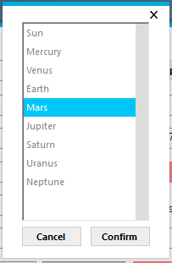



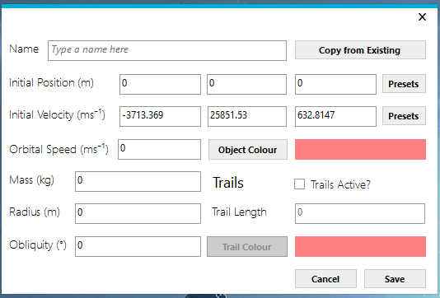

The velocity “Preset” button was pressed, and ExistingObjectsForm opened. “Mars” was selected, and “Confirm” was clicked. The data for the “Mercury” object was copied into the velocity fields successfully.

Test 47:



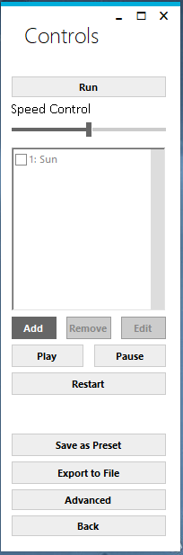



The “Add” button was pressed, and ObjectForm opened. The “Copy from Existing” button was pressed, and ExistingObjectsForm opened. “Sun” was selected, and “Confirm” was clicked. The data for the “Sun” object was copied into the velocity fields successfully. The “Save” button was pressed, and the form closed. The “Sun” object appears in the ControlForm list of objects successfully.

Test 48:

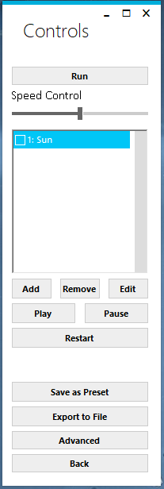

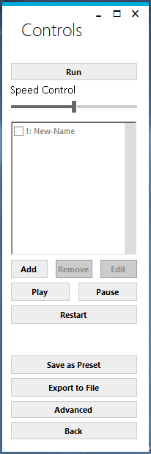

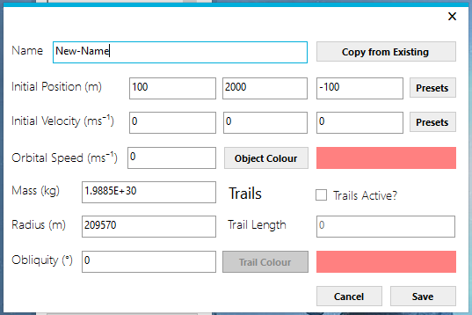

The “Edit” button was pressed when the “Sun” object was selected. ObjectForm opened up, and values were changed (“Sun” was changed to “New-Name”, and the Position values were changed). The “Save” button was pressed, and ObjectForm closed. The object’s name changed in the object list on ControlForm, from “Sun” to “New-Name”.

Test 49:

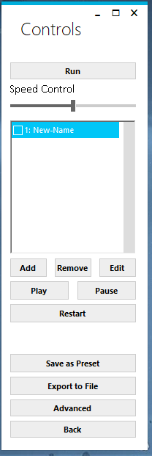

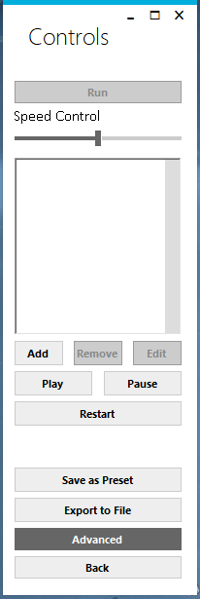

The “New-Name” object was selected in the object list, and the “Delete” button was pressed. The “New-Name” object was removed from the object list successfully.

Test 50:

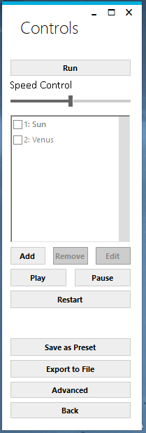

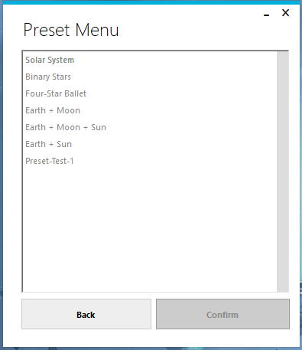

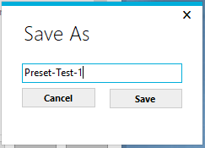

Objects were added to a new custom simulation, and the “Save as Preset” button was pressed. The name “Preset-Test-1” was typed into SaveAsForm, and the “Save” button was pressed. SaveAsForm closed itself, and returned to ControlForm.

When checked, the “Preset-Test-1” simulation was in the PresetForm list of simulations.

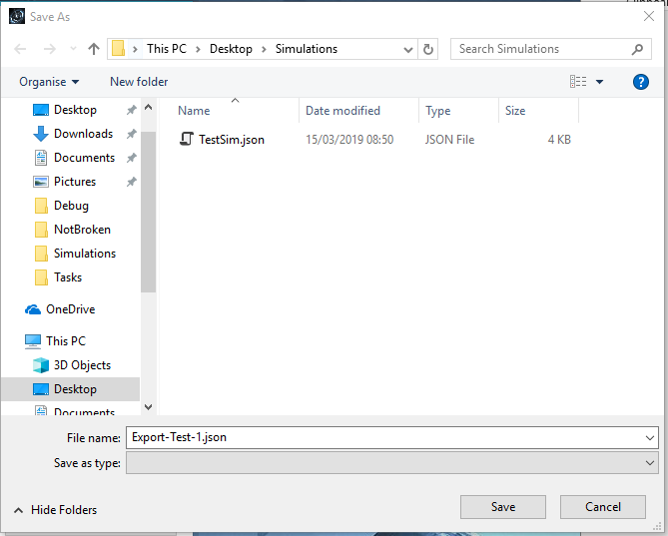Test 51:



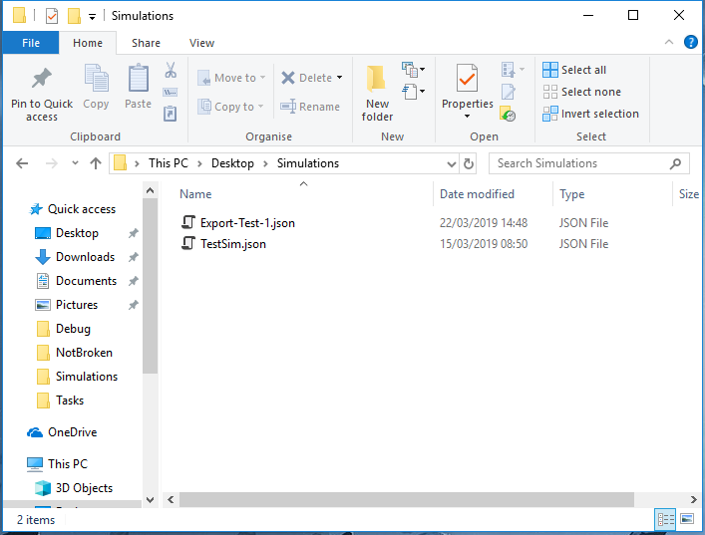

Objects were added to a new custom simulation, and the “Export to File” button was pressed. The name “Export-Test-1” was typed into the file save dialog, and the “Save” button was pressed.

When checked, the “Export-Test-1” simulation was found in the location it had been saved.

Test 52 (https://youtu.be/lmW73UAqAjo):

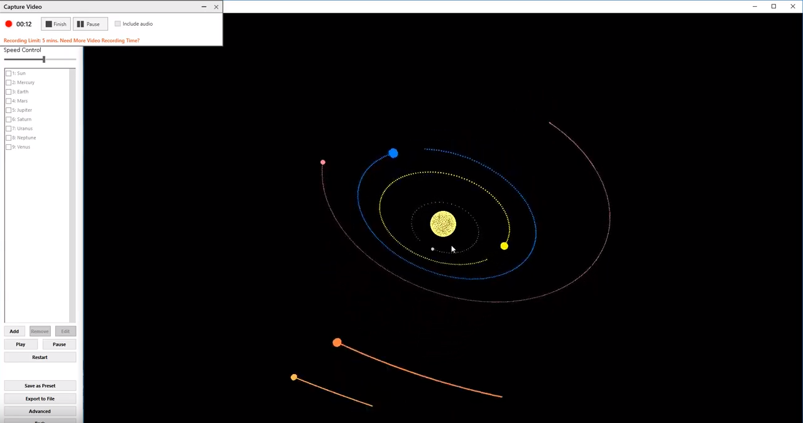

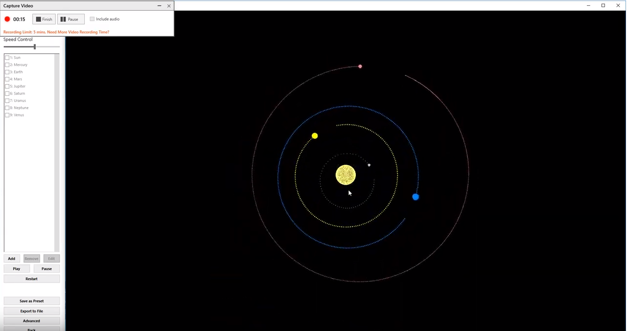

The simulation successfully loaded, and the mouse was used to change the view within the simulation.

Test 53 (https://youtu.be/XleaTKUlBY):

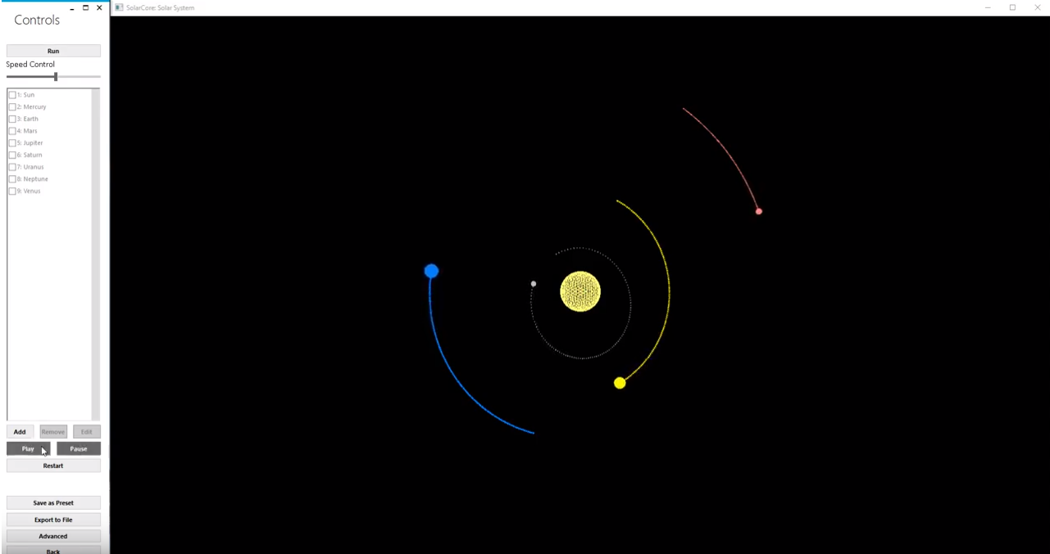

The simulation successfully loaded, and the mouse was used to press the “Pause” and “Play” buttons on the Control Form.

Test 54 (https://youtu.be/oUzTHdp-Io):

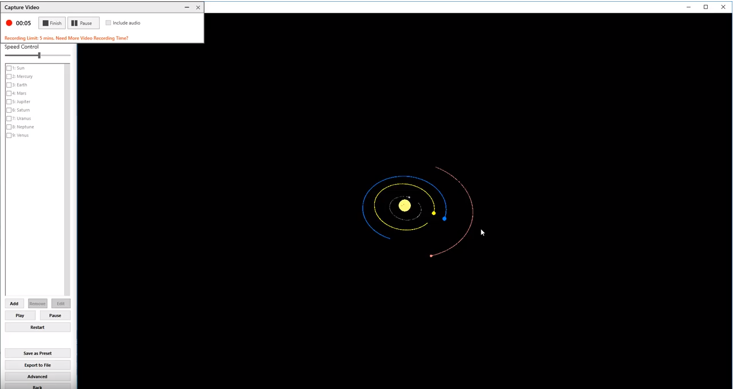

The simulation successfully loaded, and the spacebar was used to toggle pause/play for the simulation.

Tests 55 & 56 (https://youtu.be/XNnRGANL4Lk):

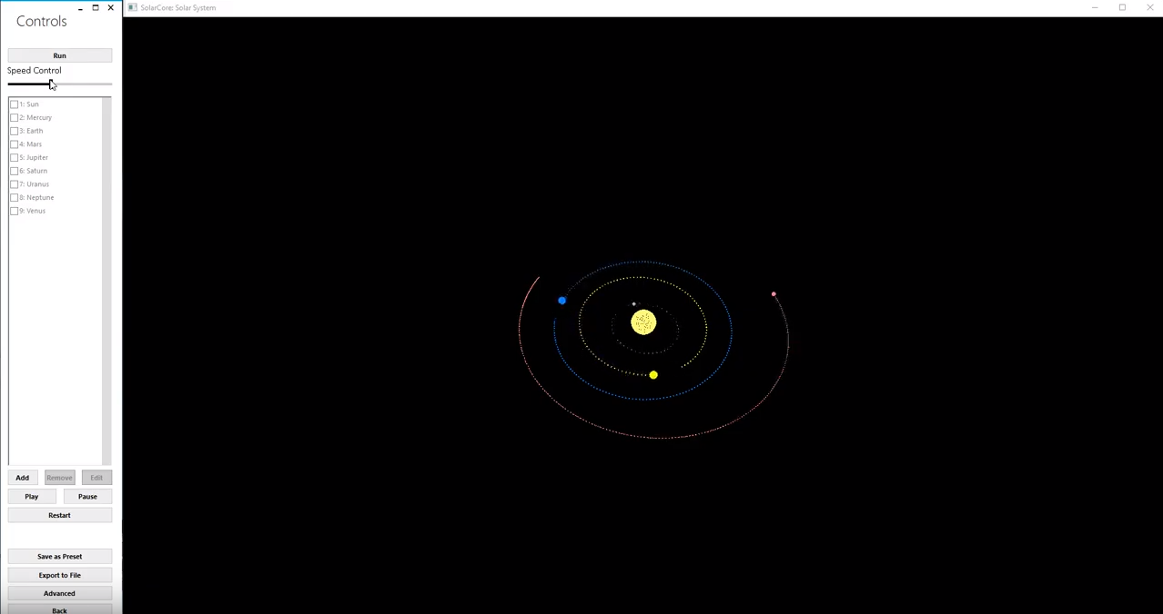

The simulation successfully loaded, and the mouse was used to drag the speed control slider to both the left and right, affecting the simulation depending on where the slider was.

Test 57 (https://youtu.be/dCxbOyNGdic):

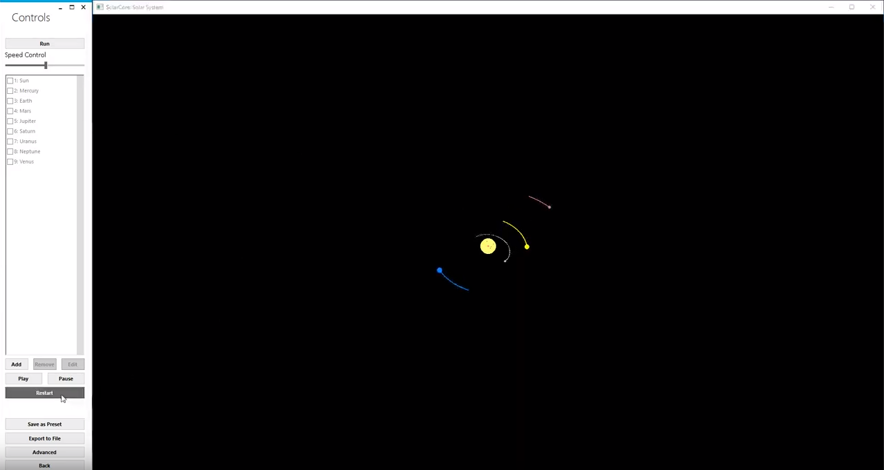

The simulation successfully loaded, and the mouse was used to press the “Restart” button, to restart the simulation.

Test 58 (https://youtu.be/5GI8sxKO1YY):

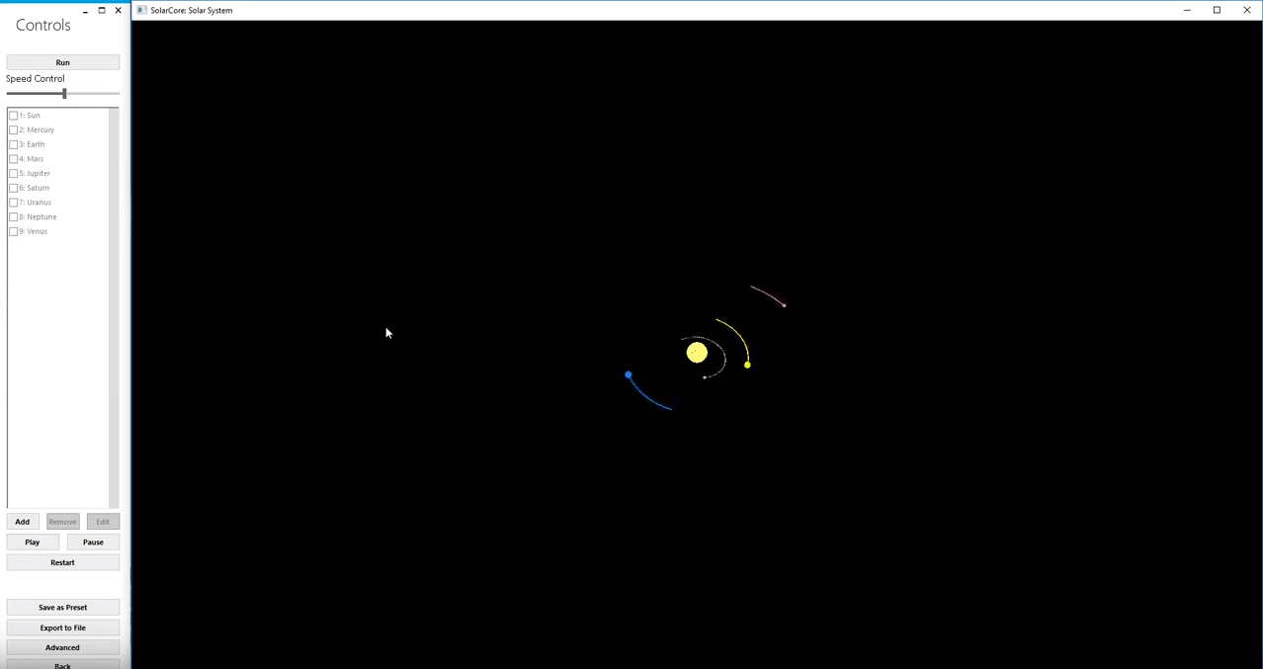

The simulation successfully loaded, and the “R” key was used to restart the simulation.

Tests 59 & 60 (https://youtu.be/Q4JtV-ypBdI):

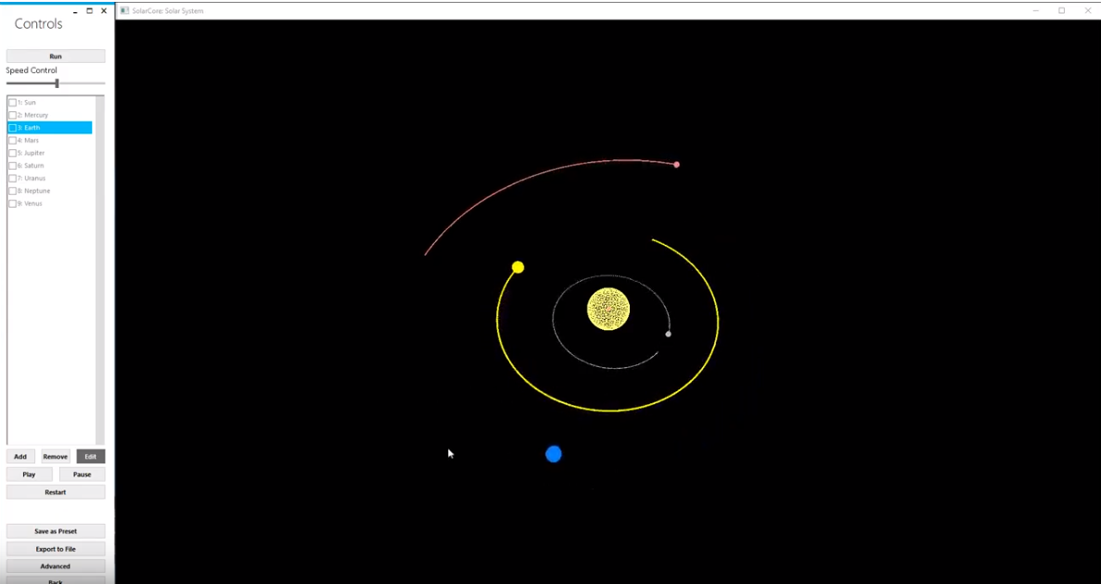

The simulation successfully loaded, and the trails behind the planets displayed. The Earth’s trail was disabled in the ObjectForm menu for that object, and it no longer displayed the Earth’s trail.

Test 61 (https://youtu.be/oz-B3ddN1vg):

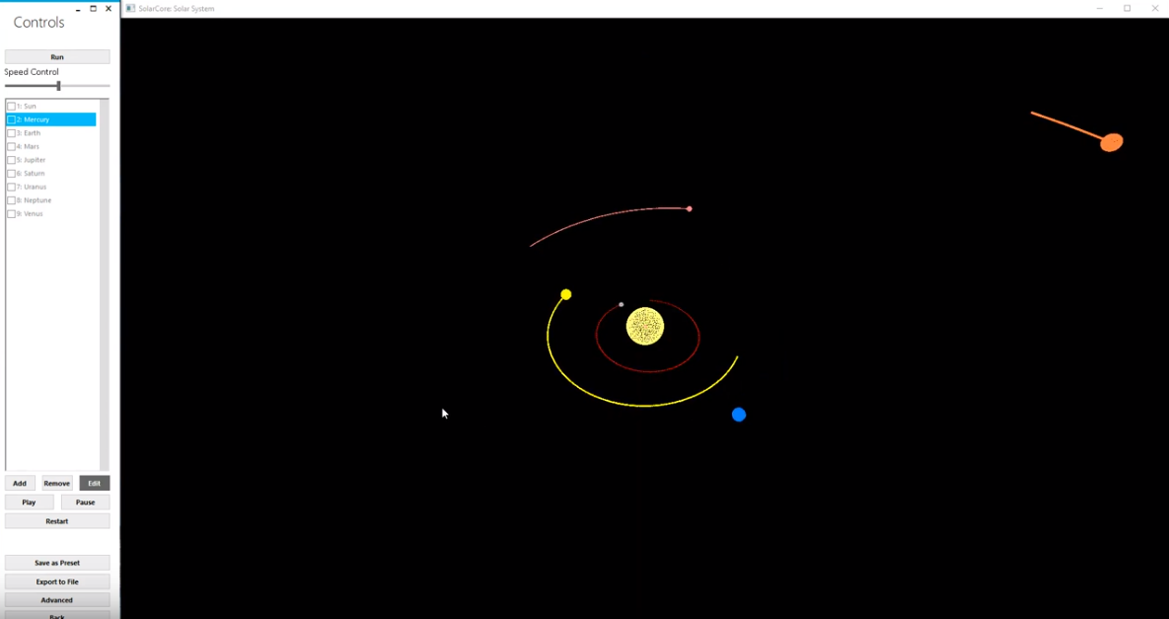

The simulation successfully loaded, and the trails behind the planets displayed. Mercury’s trail colour was changed in the ObjectForm menu for that object, and the colour changed to red in the display window successfully.

Test 62 (https://youtu.be/W6yv8mwcdIQ):

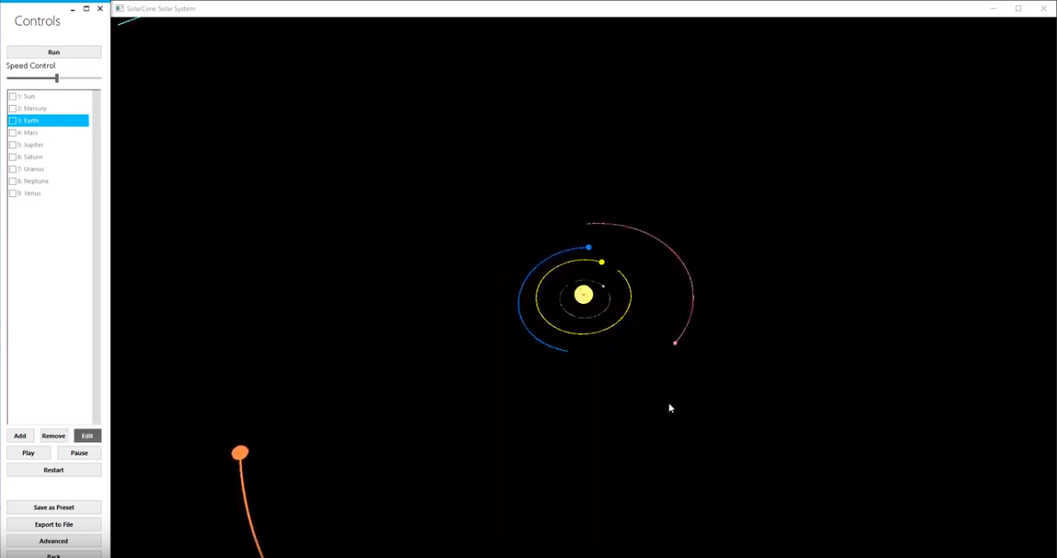

The simulation successfully loaded, and the trails behind the planets displayed. The Earth’s trail length was changed in the ObjectForm menu for that object, and the trail then only swept out half of its orbit around the Sun, as expected.

Test 63 (https://youtu.be/NpFVJgtORhI):

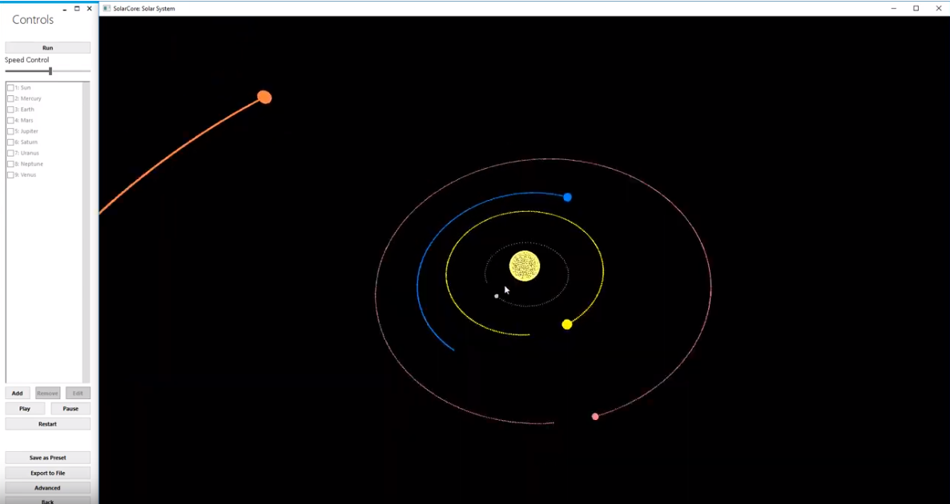

The simulation successfully loaded. The mouse scroll wheel was used, and the simulation zoomed in and out with the focus on the Sun as expected.

Test 64 (https://youtu.be/QhCfP8wVGtY):

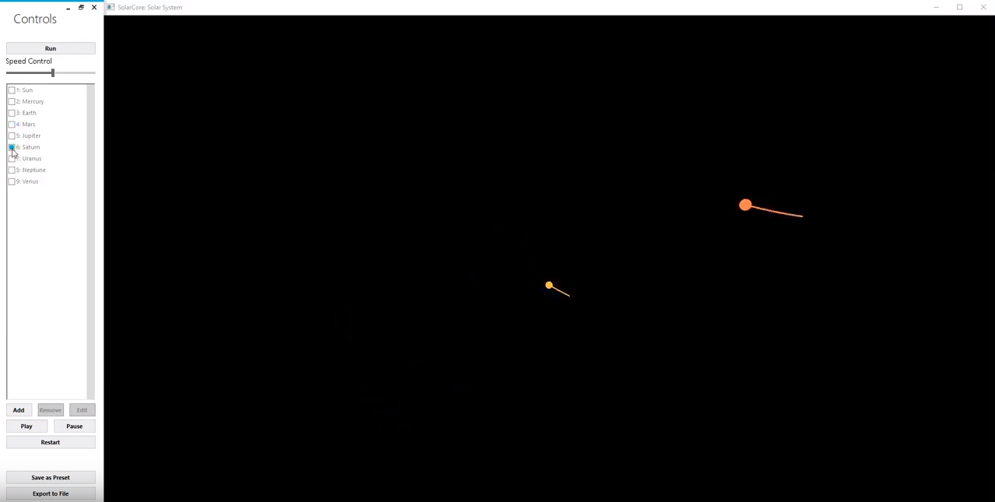

The simulation successfully loaded. The ControlForm menu was used to change the focus of the simulation, centering it around different objects within the simulation.

## Black Box Testing

My Black Box testing phase consisted of two stages. Firstly, I got my client (in this case, Mr Mullan) to use the system, directing him through a series of tasks with the system in order to familiarise him with it. These tasks were primarily based around the initial use cases of the system, laid out in the Analysis section of this document. Secondly, I gave my client a questionnaire, essentially outlining each of the objectives initially laid out, and asking how satisfactorily the system I created fulfilled each objective.

**Task List:**

* Create a new simulation
* Add preset objects to a simulation
* Change the colour of an object in a simulation
* Modify an object’s trail
* Modify an object’s mass
* Modify an object’s position
* Modify an object’s velocity
* Modify an object’s radius
* Modify an object’s position to be a preset
* Modify an object’s velocity to be a preset
* Run a simulation
* Save a simulation
* Load a simulation
* Change focus of simulation
* Zoom in and out of simulation
* Change view in simulation
* Pause / play simulation
* Restart simulation
* Change speed of simulation
* Add object to running simulation
* Remove object from running simulation
* Export a simulation to a file
* Import a simulation from a file

**Question List:**

* Does the system satisfactorily approximate the movement of celestial objects within the solar system?
* Does the system come with the agreed upon preset simulations?
* Can the objects be distinguished between easily enough?
* Is the interface to alter the colours of the objects intuitive?
* Are the trails that the objects leave behind theme a sound enough visual representation of the path through three-dimensional space the objects have travelled?
* Is it easy enough to move around the simulation?
* Does the import/export feature behave adequately?
* How well does the system help to convey the concepts it has been built for?
* Are there any improvements to existing features that you would like to see in a later version of the system?
* Are there any potential additional features you would like to see included in a later version of the system?
* Overall, how easy was the system to use?

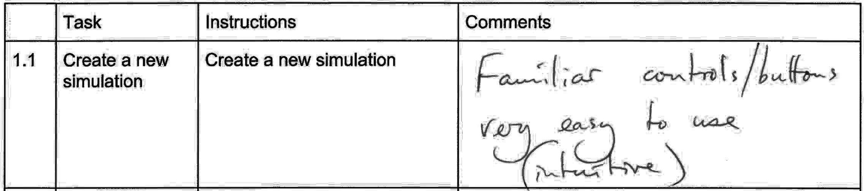

**Comment transcript:**

Familiar controls/buttons.

Very easy to use (intuitive).

**What has been changed as a result:** N/A

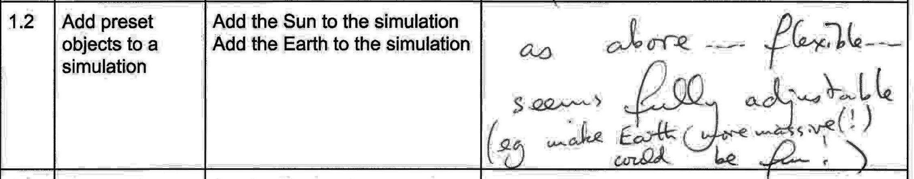

**Comment transcript:**

As above…

Flexible…

Seems fully adjustable (e.g. make Earth more massive(!) could be fun!)

**What has been changed as a result:** N/A

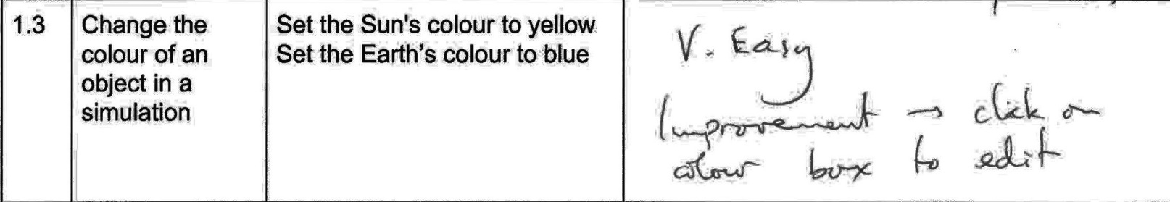

**Comment transcript:**

V. Easy.

Improvement – Click on colour box to edit.

**What has been changed as a result:**

I agreed with Mr. Mullan’s suggestion, and it was relatively simple to implement. So, I set up two more event triggers for the colour widget boxes being clicked. When clicked, the same code that ran for the button clicks now also runs when the colour boxes are clicked.

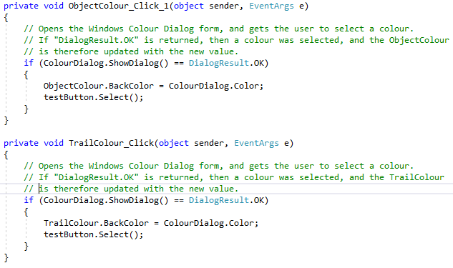

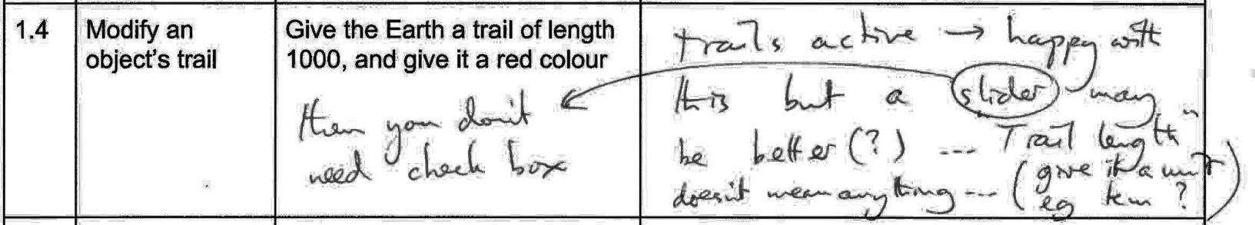

**Comment transcript:**

Trails Active:

* Happy with this but a slider may be better(?)
* Then you don’t need a check box.

Trail Length:

* Doesn’t mean anything
* Give it a unit e.g. KM?

**What has been changed as a result:**

Due to time constraints, nothing has been changed here.

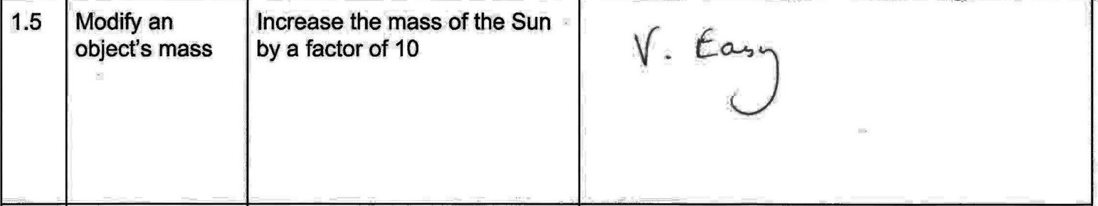

**Comment transcript:**

V. Easy.

**What has been changed as a result:** N/A

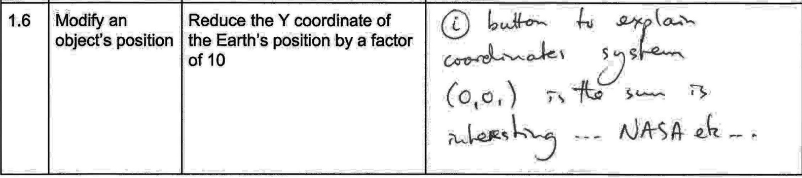

**Comment transcript:**

i button to explain the co-ordinates system

* E.g. Co-ordinates relative to the Sun, which is at (0,0,0)
* Talk about NASA etc.

**What has been changed as a result:**

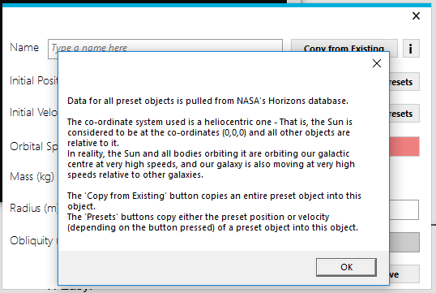I implemented a small [ i ] button on the ObjectForm screen, which detailed how the co-ordinates system worked and where the data came from (NASA’s Horizons system).

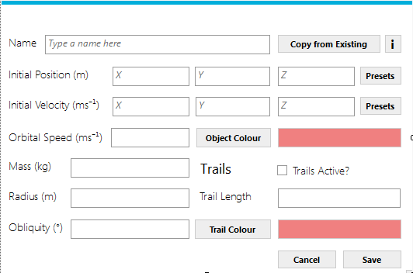

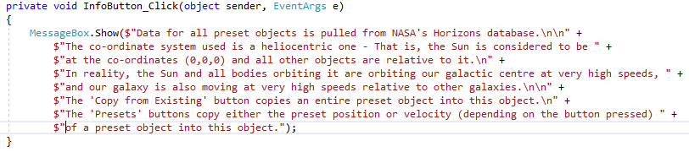

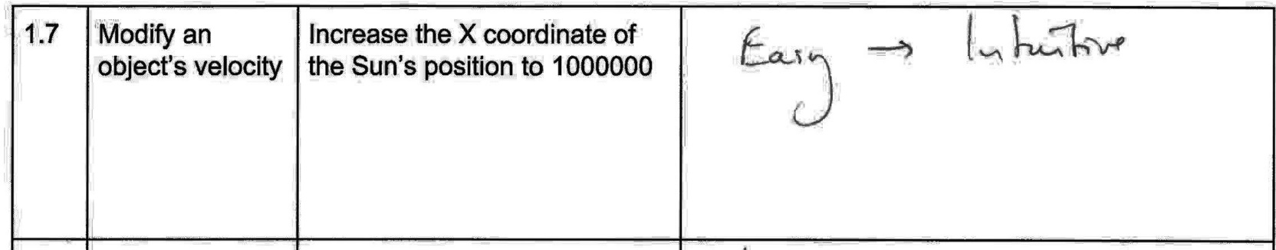

**Comment transcript:**

Easy - Intuitive

**What has been changed as a result:** N/A

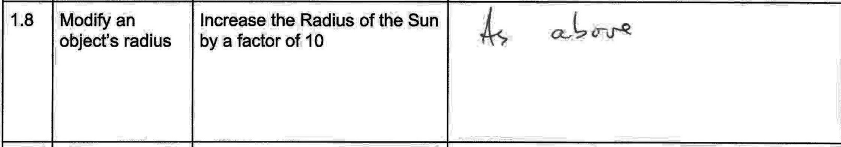

**Comment transcript:**

As above

**What has been changed as a result:** N/A

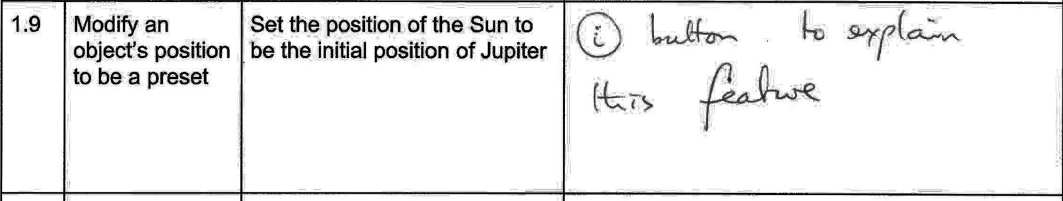

**Comment transcript:**

i button to explain this feature

**What has been changed as a result:**

The change made due to Test 1.6 also covers this test’s potential change.

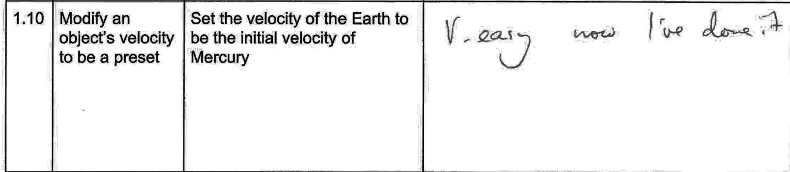

**Comment transcript:**

V. Easy now I’ve done it

**What has been changed as a result:** N/A

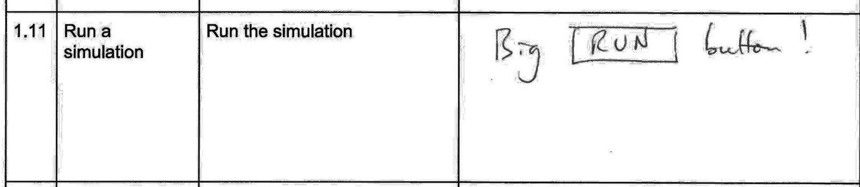

**Comment transcript:**

Big RUN Button!

**What has been changed as a result:** N/A

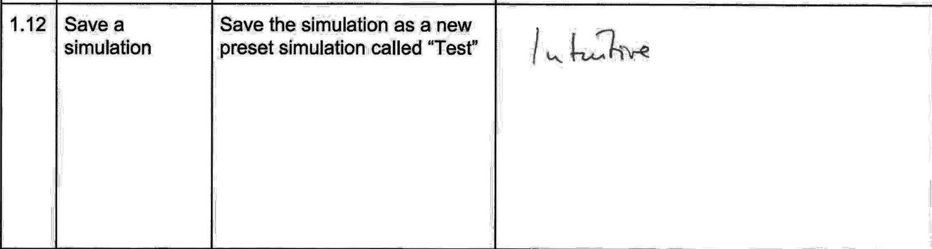

**Comment transcript:**

Intuitive.

**What has been changed as a result:** N/A

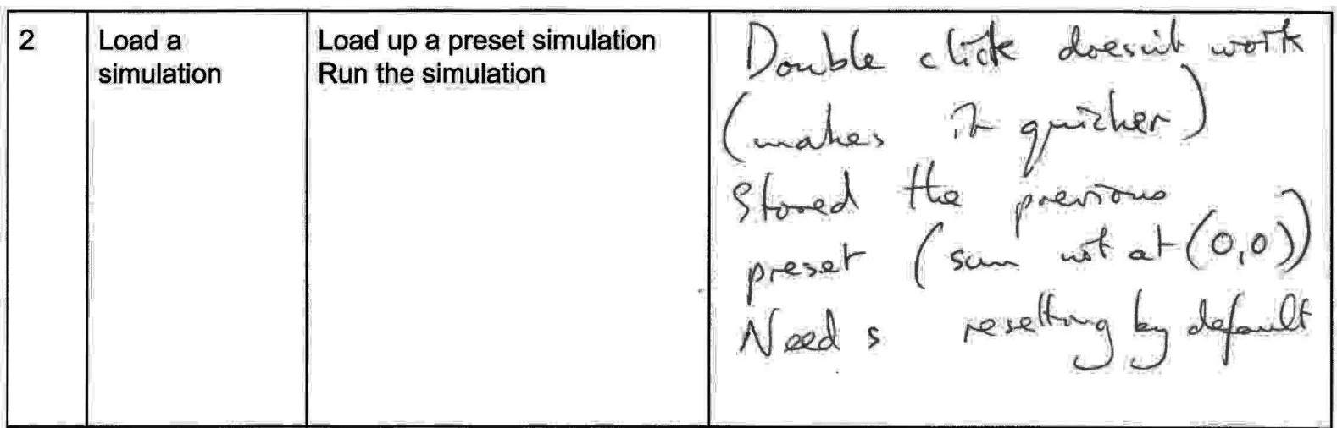

**Comment transcript:**

Double click doesn’t work (makes it quicker)

Stored the previous preset (Sun not at (0,0,0)) – Needs resetting by default

**What has been changed as a result:**

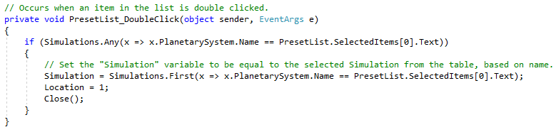I implemented and tested a double click feature on the PresetForm simulation list, which worked successfully.

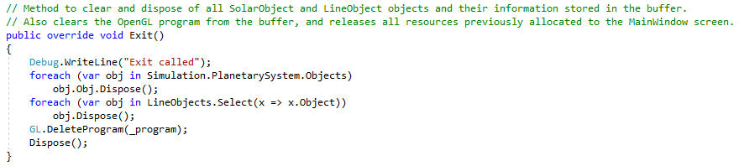I also fixed the bug found during this test. If one simulation was loaded up and then closed, and then another simulation (which shared any objects with the first simulation) was then loaded up and ran, the values for those shared objects persisted in the memory address. To combat this, I now make sure to clear all object lists and dispose of the RenderObjects as the Simulation window and ControlForm close.

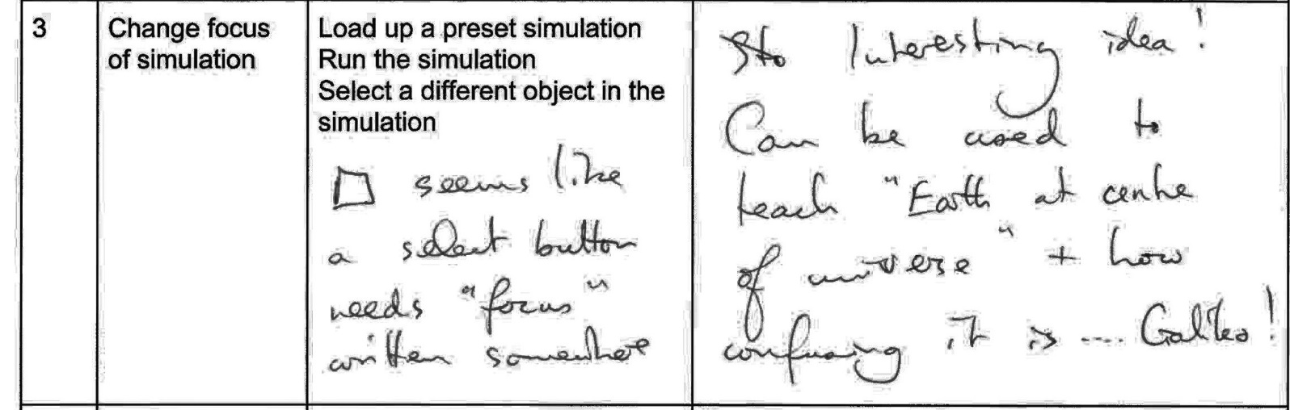

**Comment transcript:**

Interesting idea!

Can be used to teach “Earth at centre of universe” and how confusing it is – Galileo!

Seems like a select button. Needs “focus” written somewhere.

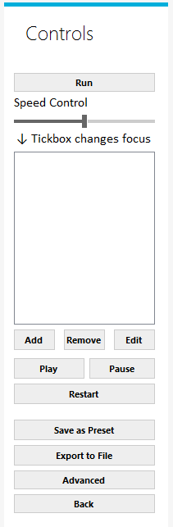

**What has been changed as a result:**

I added a label stating the purpose of the tickbox after this suggestion.

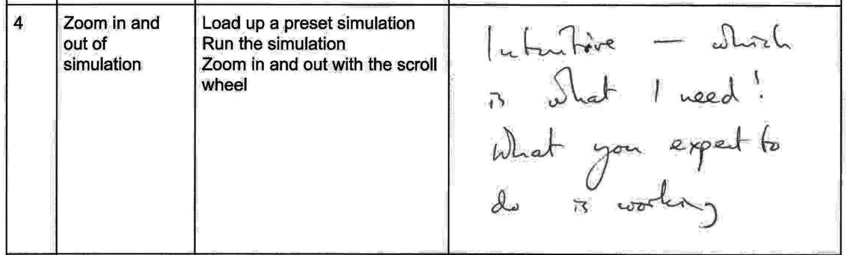

**Comment transcript:**

Intuitive – Which is what I need!

What you expect to do is working.

**What has been changed as a result:** N/A

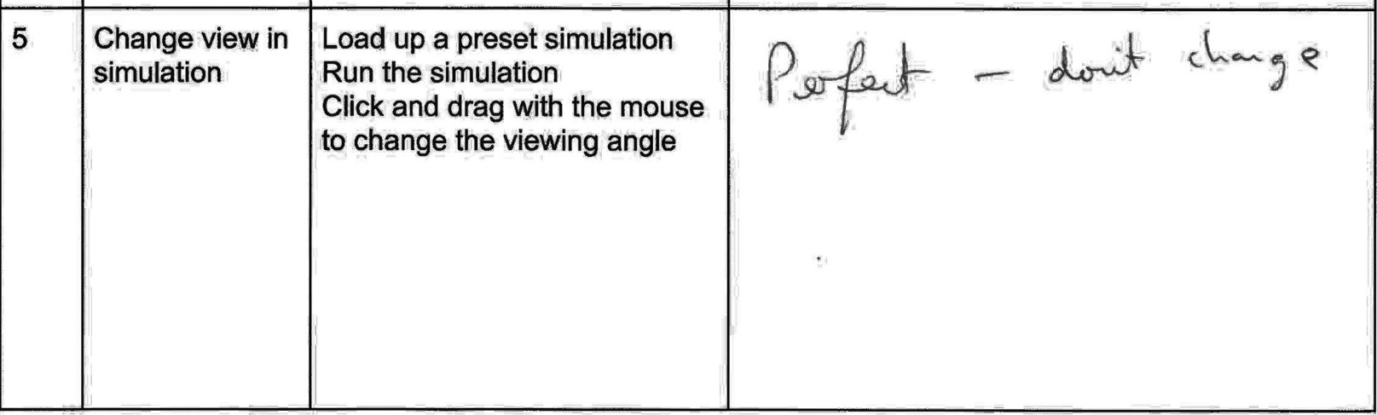

**Comment transcript:**

Perfect – Don’t change

**What has been changed as a result:** N/A

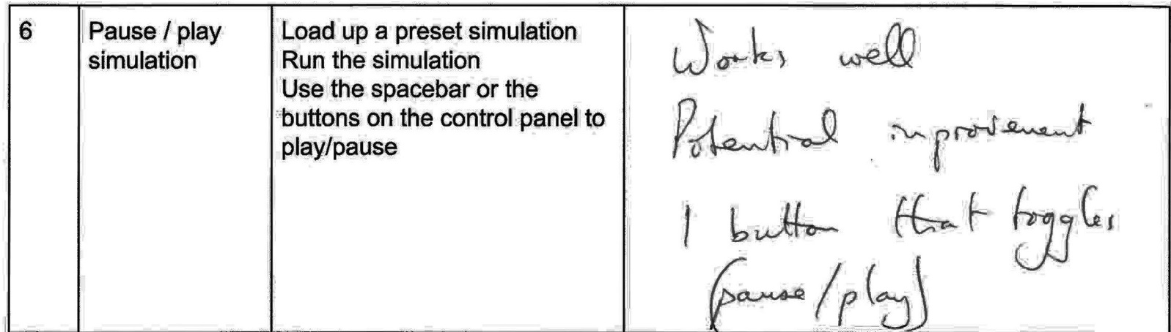

**Comment transcript:**

Works well

Potential improvement: One button that toggles between pause and play

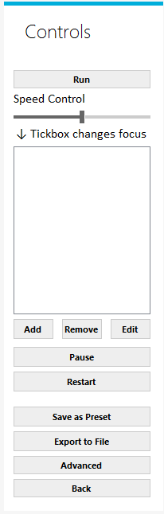**What has been changed as a result:**

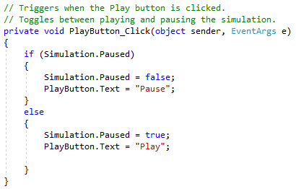I replaced the Play and Pause buttons with a single button that toggles between the two, as suggested.

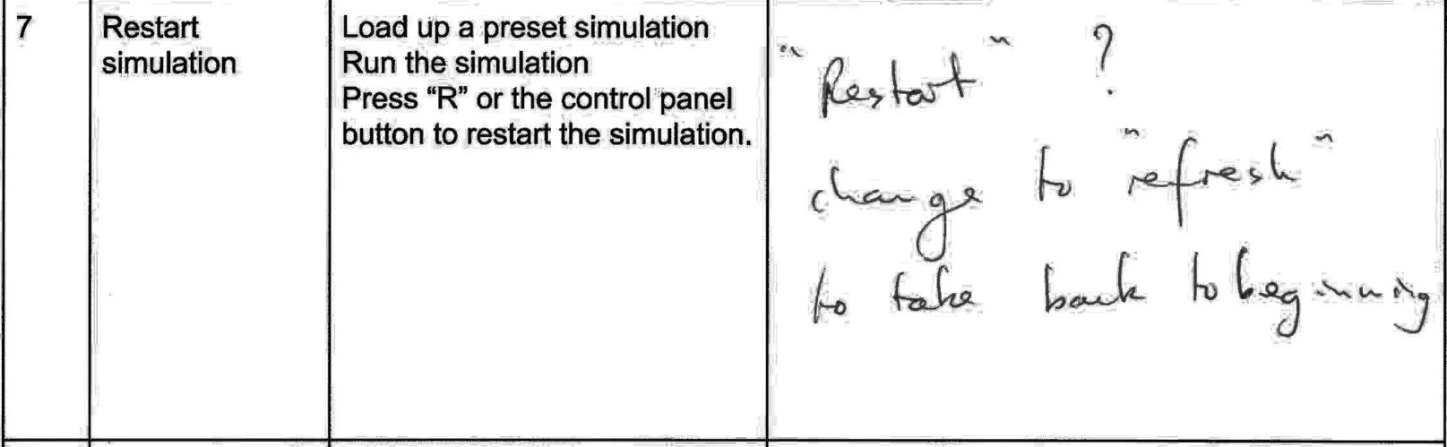

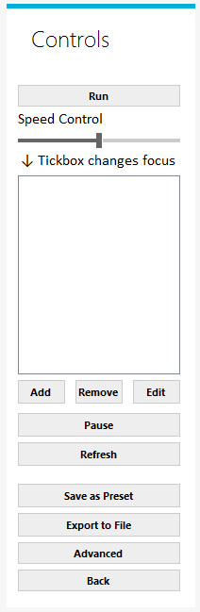**Comment transcript:**

“Restart”?

Change to “Refresh” to take back to beginning

**What has been changed as a result:**

I changed the wording of the “Restart” button to say “Refresh” as suggested.

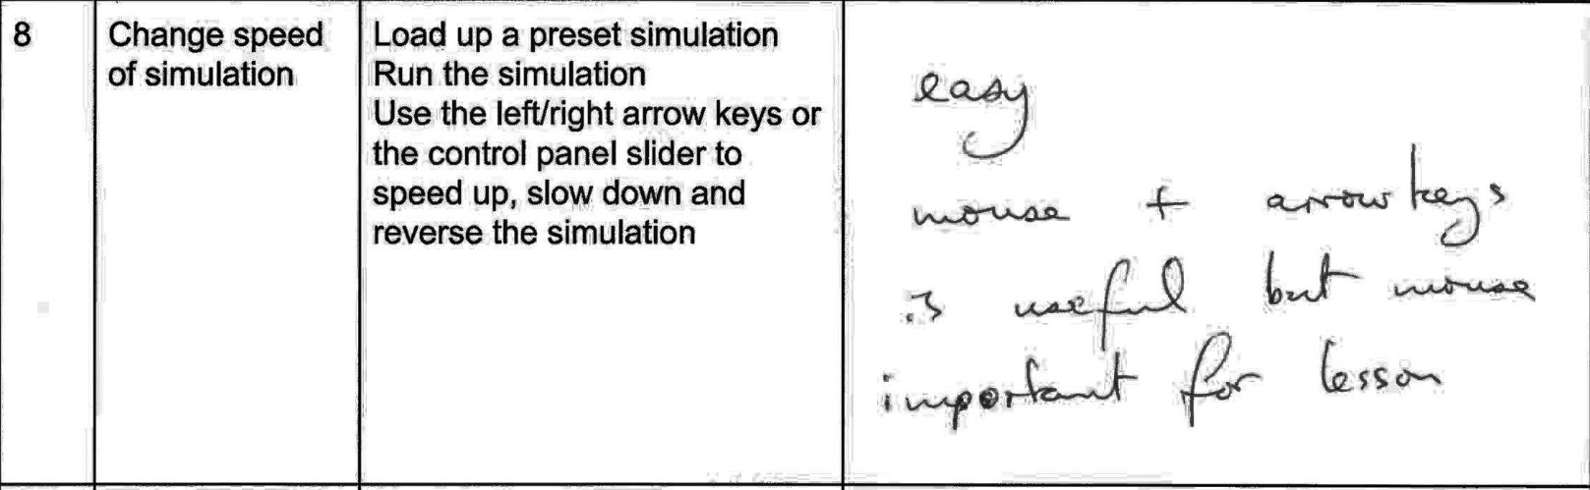

**Comment transcript:**

Easy.

Mouse & Arrow keys is useful but mouse important for lesson.

**What has been changed as a result:** N/A

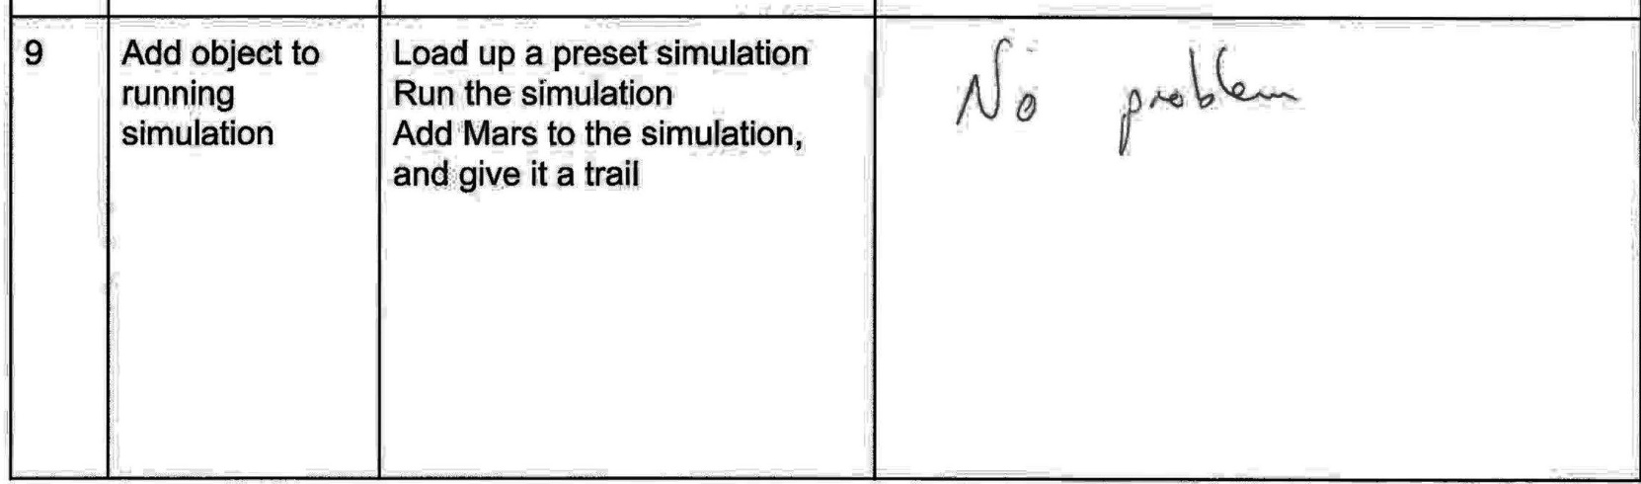

**Comment transcript:**

No problem.

**What has been changed as a result:** N/A

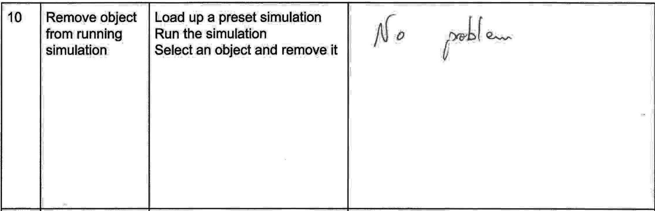

**Comment transcript:**

No problem.

**What has been changed as a result:** N/A

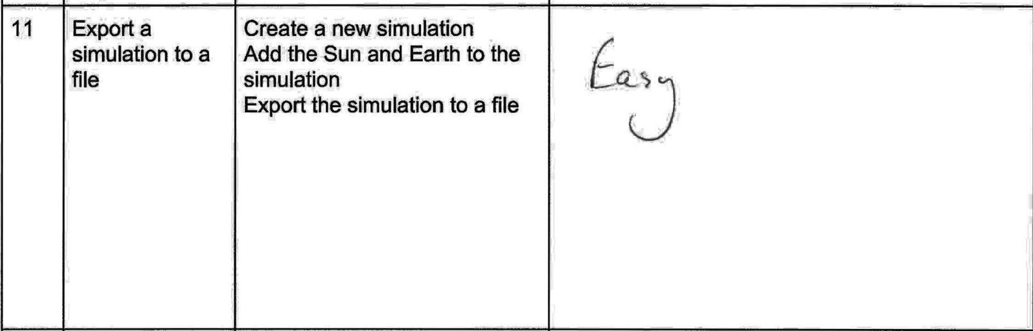

**Comment transcript:**

Easy

**What has been changed as a result:** N/A

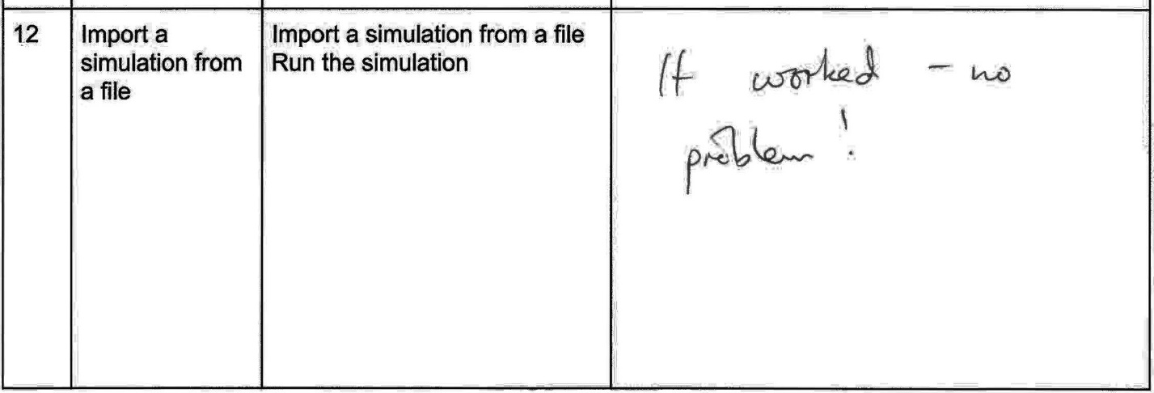

**Comment transcript:**

It worked – No problem!

**What has been changed as a result:** N/A

## Questionnaire

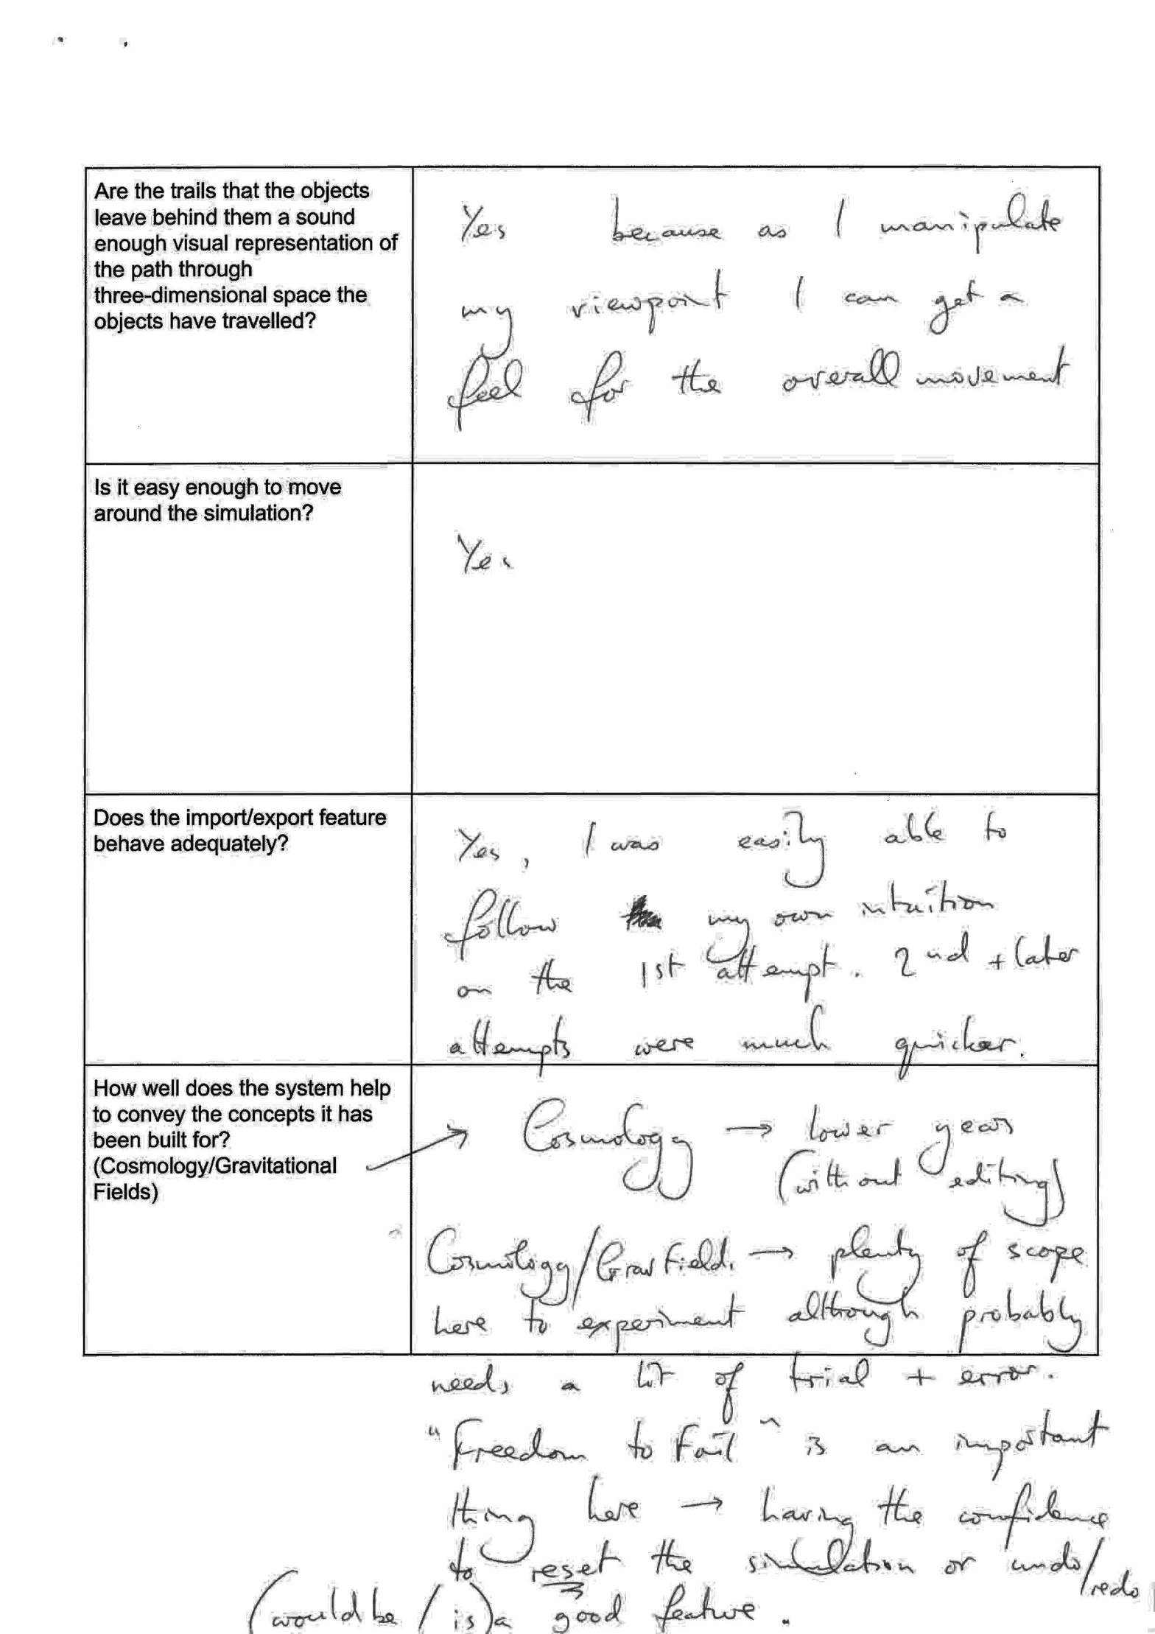

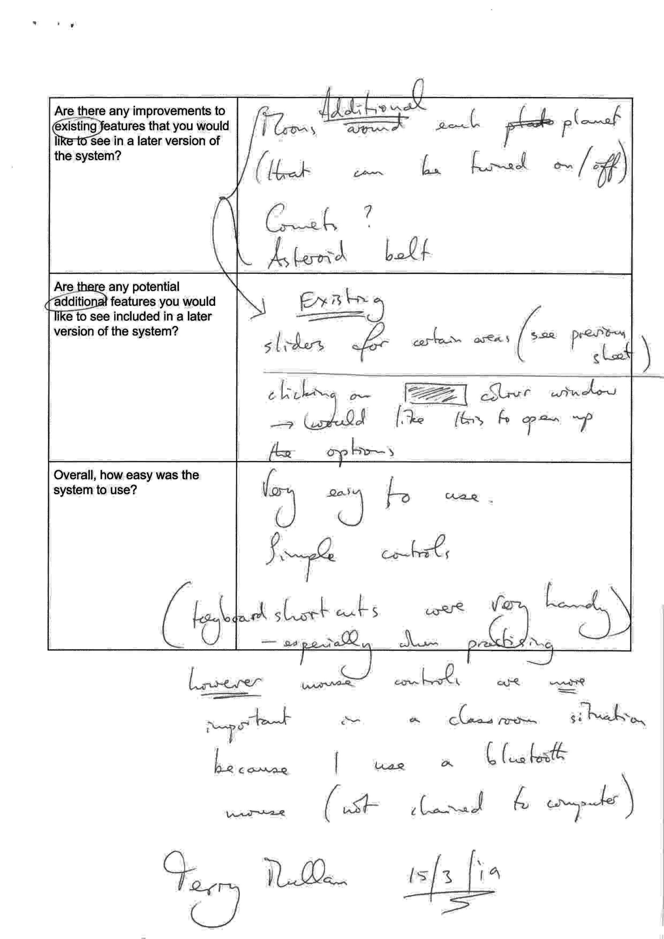

# Technical Solution

## Overview

The following pages contain a full code listing of the final product of this project, broken down into a few sections, called “Components” (contains miscellaneous classes, such as the gravity calculation class, and the render window class), “Database” (contains the database methods and class object structures), “Menus” (contains all code for the Windows Form interfaces) and “Shaders” (contains the simple shader programs written in C that are then compiled during runtime).







|  |  |  |
| --- | --- | --- |
| **Class Name** | **Page No.** | **Description** |
| Program | 136 | Base class of the C# project |
| MainWindow | 137 | Contains all code for the RenderWindow of the project |
| RenderObject | 146 | Defines the methods that render the objects (the spheres) |
| Telnet | 148 | Contains all code for interfacing with NASA’s Horizons Telnet service |
| Telnet.ReturnObject | 148 | Allows values to easily be returned to another class |
| LineObject | 152 | Contains all code for each object within an object’s trail |
| Sphere | 153 | Contains all methods to construct a Vertex array that defines a sphere |
| GravityMethods | 157 | Contains all code for calculating the interactions between different planetary bodies in the simulation |
| GravityMethods.AggregateObject | 157 | Allows values to easily be returned to another class |
| DatabaseMethods | 160 | Contains all code for interfacing with the SQLite database for the project |
| PlanetarySystem | 169 | Constructor for a new PlanetarySystem object |
| Simulation | 170 | Constructor for a new Simulation object, contains method to run the gravity methods. |
| Camera | 170 | Constructor for a new Camera object |
| SolarObject | 173 | Constructor for a new SolarObject object |
| MainForm | 176 | Contains all code defining the “MainForm” Windows Form |
| SimForm | 179 | Contains all code defining the “SimForm” Windows Form |
| PresetForm | 184 | Contains all code defining the “PresetForm” Windows Form |
| ControlForm | 188 | Contains all code defining the “ControlForm” Windows Form |
| ObjectForm | 202 | Contains all code defining the “ObjectForm” Windows Form |
| SaveAsForm | 228 | Contains all code defining the “SaveAsForm” Windows Form |
| ExistingObjectsForm | 232 | Contains all code defining the “ExistingObjectsForm” Windows Form |
| AdvancedControlForm | 236 | Contains all code defining the “AdvancedControl Form” Windows Form |

## Explanations

### IcoSpheres

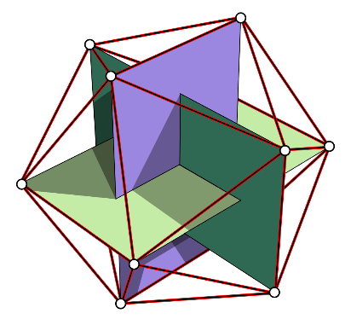The code written to generate IcoSpheres (contained within the IcoSphereFactory class) was one of the most interesting and complex parts of the project.

I started by defining three intersecting orthogonal rectangles, hardcoding the twelve vertices (three intersecting golden rectangles) into the class. I then hardcoded in the twenty triangular faces that are formed from the the twelve vertices, which forms a twenty-sided roughly spherical shape around the orthogonal rectangles.

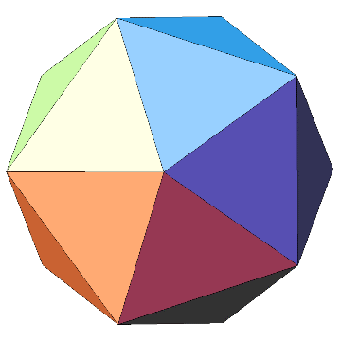

Refining the triangular faces allows the icosohedron to become an icosphere, massively increasing the number of faces that the polygon is made up of, in doing so making the polygon appear much more spherical in shape. Each edge of each triangle is split in half, and one triangle is formed by the three points sitting in the middle of these edges and three triangles surrounding it. These four triangles are also displaced slightly in order to create the more spherical shape, as otherwise it would simply become a more refined icosohedron.

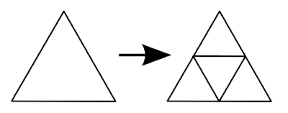

I also implemented a caching process, in order to simply pull a midpoint from the cache if the same edge has previously been calculated (as one vertex is shared by two triangles, this will roughly halve the number of midpoint calculations needed).

### Telnet

The code written to communicate with NASA’s Horizons system is relatively minimal, however the difficulties come from using a legacy interface. All values are transmitted and received as strings, which then need to be parsed by my program.

A connection is set up, and upon receiving a connection confirmation message, transmit a series of commands:

**“{PLANET ID}”:** Selects a specific planetary object based on NASA’s unique ID system

**“E”:** Selects the ‘Ephemeris data’ option

**“v”:** Selects the ‘Vectors’ option  
**“@sun”:** Sets the coordinate centre for all position and velocity vectors to be the Sun

**“eclip”:** Sets the reference plane to be the ecliptic plane.

**“2018AD-Nov-11 00:00”:** Sets the start point for data returned (arbitrary)

**“2018AD-Nov-11 00:01”:** Sets the end point for data returned (arbitrary)

**“1d”:** Sets the interval – We only need one data point, and 1 day exceeds the end point

**“y”:** Accepts the default output

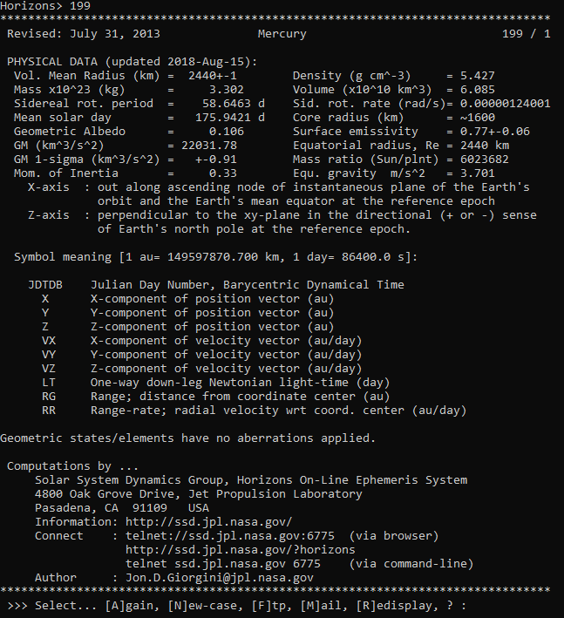

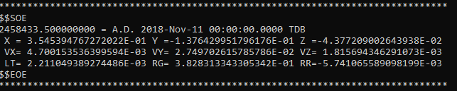

A large amount of data is returned, and I then use Regular Expressions to parse through it all to get the object’s name, mass, radius, position and velocity vectors.

Regex nameRegex = new Regex(" {2}(\\w+) +" + Planet);

var nameMatches = nameRegex.Match(data).Groups;

Regex massRegex = new Regex("Mass,* x*10\\^(.+) \\(*kg\\)* *= *~*([\\d.]+)[\n +-]");

var massMatches = massRegex.Match(data).Groups;

Regex radiusRegex = new Regex("Vol\\. [Mm]ean [Rr]adius,* \\(*km[\\)]* *= *([\\d.]+)[\n +-]");

var radiusMatches = radiusRegex.Match(data).Groups;

Regex ephemerisRegex = new Regex(" X {0,1}= {0,1}(.+) Y {0,1}= {0,1}(.+) Z {0,1}= {0,1}(.+)\n VX {0,1}= {0,1}(.+) VY {0,1}= {0,1}(.+) VZ {0,1}= {0,1}(.+)");

var ephemerisMatches = ephemerisRegex.Match(ephemeris).Groups;

I then parse these values into their required data types (e.g. floats, strings etc.) as needed, and return a new instance of the “ReturnObject” class containing this data. This data is then inserted into my database as a preset object.

## Code Listing

### Components

#### Program.cs

using System;

using System.Windows.Forms;

namespace SolarForms

{

static class Program

{

[STAThread]

static void Main()

{

// Runs initial database setup SQL statements if the database doesn't exist

Database.DatabaseMethods.Setup();

// Code to pull data down from NASA's Horizons system, using a Telnet interface.

/*

int[] test = new int[] { 10, 199, 299, 399, 499, 599, 699, 799, 899, 999 };

foreach (int i in test)

{

Database.DatabaseMethods.AddObject(i);

}

*/

// Opens up the Main Form

new Components.Menus.MainForm().Show();

Application.Run();

}

}

}

#### MainWindow.cs

using OpenTK;

using OpenTK.Graphics;

using OpenTK.Graphics.OpenGL;

using OpenTK.Input;

using SolarForms.Database;

using System;

using System.Collections.Generic;

using System.Diagnostics;

using System.IO;

using System.Linq;

namespace SolarForms.Components

{

public class MainWindow : GameWindow

{

private int _program;

public Simulation Simulation;

private Matrix4 _projectionMatrix;

private List<LineObject> LineObjects = new List<LineObject>();

public MainWindow(Simulation simulation) : base(1000, // Initial window width

1000, // Initial window height

GraphicsMode.Default, "SolarCore", // Window title

GameWindowFlags.Default,

DisplayDevice.Default,

4, // OpenGL Major version

0, // OpenGL Minor version

GraphicsContextFlags.ForwardCompatible)

{

Simulation = simulation;

}

public bool LocalIsDisposed

{

get { return IsDisposed; }

}

// This triggers when the MainWindow is resized.

// It resizes the viewport, meaning that the aspect ratio is maintained.

protected override void OnResize(EventArgs e)

{

GL.MatrixMode(MatrixMode.Projection);

GL.LoadIdentity();

GL.Viewport(0, 0, Width, Height);

CreateProjection();

}

// This triggers when the MainWindow initially starts up.

protected override void OnLoad(EventArgs e)

{

Simulation.OldMouseState = Mouse.GetState();

Simulation.OldKeyState = Keyboard.GetState();

VSync = VSyncMode.Off;

CreateProjection();

// Creates a new RenderObject (sphere) for each object within the Simulation, and saves their initial positions.

foreach (var x in Simulation.PlanetarySystem.Objects)

{

x.Obj = new RenderObject(new Sphere().CreateSphere(3, x.ObjectColour));

x.InitialPosition = x.Position;

x.InitialVelocity = x.Velocity;

}

// Calculates the first 300 positions for each object within the Simulation.

Simulation.Run(300, false, 0);

CursorVisible = true;

// Low level OpenGL methods to open the MainWindow screen and set it up to display the generated polygons as required.

_program = CreateProgram();

GL.PolygonMode(MaterialFace.FrontAndBack, PolygonMode.Line);

GL.PatchParameter(PatchParameterInt.PatchVertices, 3);

GL.Enable(EnableCap.DepthTest);

// Setting up event handlers for when the MainWindow closes, and for the OnRenderFrame event (occurs 60 times a second).

Closed += OnClosed;

RenderFrame += (sender, f) => OnRenderFrame(f);

}

// This method is also triggered 60 times a second, before each OnRenderFrame event being triggered.

protected override void OnUpdateFrame(FrameEventArgs e)

{

// Deletes all SolarObject that have been deleted from the simulation via the ControlForm, and disposes of them from the OpenGL buffers.

// Also disposes of all LineObjects connected to each deleted SolarObject.

var deleteList = new List<LineObject>();

foreach (var obj in LineObjects)

{

if (obj.DeleteBy < 0)

{

deleteList.Add(obj);

}

}

foreach (var obj in deleteList)

{

obj.Object.Dispose();

LineObjects.Remove(obj);

}

// Checks to see whether or not there are any new SolarObjects in the simulation, that haven't yet had their initial positions and velocities saved.

// If there are, save their initial positions and velocities.

bool newObjects = false;

foreach (var obj in Simulation.PlanetarySystem.Objects)

{

if (obj.Obj == null)

{

obj.InitialPosition = obj.Position;

obj.InitialVelocity = obj.Velocity;

newObjects = true;

break;

}

}

// Triggers if a new object has been added to the simulation, or any other values have been changed using the ControlForm.

if (newObjects || Simulation.Changed)

{

// Foreach loop iterates through each SolarObject in the Simulation, and recreates the RenderObject information for that SolarObject.

// Also clears all LineObjects, and any already calculated frames in the Simulation.

foreach (var obj in Simulation.PlanetarySystem.Objects)

{

obj.Obj = new RenderObject(new Sphere().CreateSphere(3, obj.ObjectColour));

LineObjects.ForEach(x => x.Object.Dispose());

LineObjects.Clear();

obj.Positions.Clear();

obj.Velocities.Clear();

}

if (!Simulation.PlanetarySystem.Objects.Any())

return;

// Calculates more frames of the Simulation backwards if the direction of the Simulation is backwards.

if (Simulation.Speed < 0)

{

Simulation.Run(300, true, Simulation.CurrentFrame);

Simulation.CurrentFrame = Simulation.MaximumSpeed-1;

}

else

{

// Calculates more frames of the Simulation going forwards if the direction of the Simulation is forwards.

Simulation.Run(300, false, Simulation.CurrentFrame);

Simulation.CurrentFrame = 0;

}

Simulation.Changed = false;

}

// Method that checks all keyboard and mouse states

HandleKeyboard();

}

private void HandleKeyboard()

{

// Gets current states of keyboard and mouse (key presses, clicks etc.)

var mouseState = Mouse.GetState();

var keyState = Keyboard.GetState();

// Only uses the keyboard and mouse states if the MainWindow currently has focus

if (Focused)

{

// Compares the old mouse scroll position to the new mouse scroll position.

// If there is a difference, zoom in/out of the simulation accordingly.

if (Simulation.OldMouseState.Scroll.Y != mouseState.Scroll.Y)

{

Simulation.Camera.Zoom -= Simulation.Camera.ZoomModifier * (mouseState.Scroll.Y - Simulation.OldMouseState.Scroll.Y);

}

// Checks to see if the left mouse button is currently held down, and if it was previously held down.

if (mouseState.IsButtonDown(MouseButton.Left))

{

if (Simulation.OldMouseState.IsButtonDown(MouseButton.Left))

{

// Changes the camera position X and Y values based on the difference in mouse positions between last run and this one.

Simulation.Camera.XVal += 0.01f * (mouseState.X - Simulation.OldMouseState.X);

Simulation.Camera.YVal += 0.01f * (Simulation.OldMouseState.Y - mouseState.Y);

}

}

// Closes the simulation if the Escape key is pressed.

if (keyState.IsKeyDown(Key.Escape))

{

Exit();

}

// Reduces the speed if the left arrow key is pressed.

if (keyState.IsKeyDown(Key.Left))

{

Simulation.Speed = Simulation.Speed <= -Simulation.MaximumSpeed ? -Simulation.MaximumSpeed : Simulation.Speed - 1;

}

// Increases the speed if the right arrow key is pressed.

if (keyState.IsKeyDown(Key.Right))

{

Simulation.Speed = Simulation.Speed >= Simulation.MaximumSpeed ? Simulation.MaximumSpeed : Simulation.Speed + 1;

}

// Increases the Camera X-value when the S key is pressed.

if (keyState.IsKeyDown(Key.S))

{

Simulation.Camera.XVal += 0.01;

}

// Reduces the Camera X-value when the W key is pressed.

if (keyState.IsKeyDown(Key.W))

{

Simulation.Camera.XVal -= 0.01;

}

// Increases the Camera Y-value when the A key is pressed.

if (keyState.IsKeyDown(Key.A))

{

Simulation.Camera.YVal += 0.01;

}

// Reduces the Camera Y-value when the D key is pressed.

if (keyState.IsKeyDown(Key.D))

{

Simulation.Camera.YVal -= 0.01;

}

// Resets the simulation if the R key is pressed.

if (keyState.IsKeyDown(Key.R))

{

ResetSim();

}

// Changes the focus of the simulation (to one lower down the list) if the comma key is pressed.

if (keyState.IsKeyDown(Key.Comma))

{

if (!Simulation.OldKeyState.IsKeyDown(Key.Comma))

{

Simulation.Camera.Focus -= 1;

if (Simulation.Camera.Focus < 0)

Simulation.Camera.Focus = 0;

}

}

// Changes the focus of the simulation (to one higher up the list) if the period key is pressed.

if (keyState.IsKeyDown(Key.Period))

{

if (!Simulation.OldKeyState.IsKeyDown(Key.Period))

{

Simulation.Camera.Focus += 1;

if (Simulation.Camera.Focus >= Simulation.PlanetarySystem.Objects.Count)

Simulation.Camera.Focus -= 1;

}

}

// Toggles play/pause when the space key is pressed.

if (keyState.IsKeyDown(Key.Space))

{

if (!Simulation.OldKeyState.IsKeyDown(Key.Space))

{

Simulation.Paused = !Simulation.Paused;

}

}

// Sets X and Y value limits (-0.49 to 0.49).

if (Simulation.Camera.YVal > 0.49) Simulation.Camera.YVal = 0.49;

if (Simulation.Camera.YVal < -0.49) Simulation.Camera.YVal = -0.49;

// Sets Zoom limits (10000 to 10000000).

if (Simulation.Camera.Zoom < 10000) Simulation.Camera.Zoom = 10000;

if (Simulation.Camera.Zoom > 10000000) Simulation.Camera.Zoom = 10000000;

var pi180 = Math.PI;

Vector3 initialPosition;

// Checks to see if the camera should be focused on a fixed position. If it shouldn't, focus on the currently focused object. Otherwise, focus on a Vector3 co-ordinate object.

if (!Simulation.Camera.Fixed)

initialPosition = Simulation.PlanetarySystem.Objects[Simulation.Camera.Focus].RenderPosition;

else

initialPosition = new Vector3(0, 0, 0);

// Uses Vector maths and the previously set Camera X and Y values to create a "trackball" effect for the camera pan around the focused co-ordinates.

Simulation.Camera.Position.X = initialPosition.X + (float)Simulation.Camera.Zoom * (float)(Math.Sin(Simulation.Camera.XVal * pi180) * Math.Cos(Simulation.Camera.YVal * pi180));

Simulation.Camera.Position.Y = initialPosition.Y + (float)Simulation.Camera.Zoom * (float)(Math.Sin(Simulation.Camera.YVal * pi180));

Simulation.Camera.Position.Z = initialPosition.Z + (float)Simulation.Camera.Zoom * -(float)(Math.Cos(Simulation.Camera.XVal * pi180) * Math.Cos(Simulation.Camera.YVal * pi180));

// Sets the old key and mouse state variables to be the current key and mouse state variables, for next time.

Simulation.OldKeyState = keyState;

Simulation.OldMouseState = mouseState;

}

}

// This method is triggered 60 times a second.

protected override void OnRenderFrame(FrameEventArgs e)

{

if (!Simulation.PlanetarySystem.Objects.Any())

return;

// Sets the title of the window to be the name of the Simulation.

Title = $"SolarCore: {Simulation.PlanetarySystem.Name}";

// Clears the screen from the last frame.

GL.ClearColor(Color4.Black);

GL.Clear(ClearBufferMask.ColorBufferBit | ClearBufferMask.DepthBufferBit);

// Checks to see if the camera is fixed.

// If it isn't, set the camera focus to be the currently focused SolarObject in the Simulation.

if (!Simulation.Camera.Fixed)

{

if (Simulation.PlanetarySystem.Objects.Any())

Simulation.Camera.LookAt = Simulation.PlanetarySystem.Objects[Simulation.Camera.Focus].RenderPosition;

}

// Builds a world space to camera space matrix.

// Generates a camera view relative to the position of the camera and the focus of the camera.

var translationMatrix = Matrix4.LookAt(Simulation.Camera.Position, Simulation.Camera.LookAt, Vector3.UnitY);

// Calculate more frames of the simulation (either going forwards or backwards).

while (true) {

if (Simulation.CurrentFrame >= Simulation.PlanetarySystem.Objects.First().Positions.Count)

{

Simulation.Run(300, false, Simulation.PlanetarySystem.Objects.First().Positions.Count - 1);

}

else if (Simulation.CurrentFrame < 0)

{

Simulation.Run(300, true, Simulation.CurrentFrame);

}

else

{

break;

}

}

// Foreach loop iterates through each object in the Simulation

foreach (var obj in Simulation.PlanetarySystem.Objects)

{

// Low level OpenGL methods bind the previously created projection matrix to the buffer.

GL.UseProgram(_program);

GL.UniformMatrix4(20, false, ref _projectionMatrix);

// If the simulation isn't paused, change the currently rendered location for the object to the next frame andd add a new LineObject at the same location.

if (!Simulation.Paused)

{

obj.RenderPosition = obj.Positions[Simulation.CurrentFrame] / Simulation.Scale;

if (obj.TrailsActive)

{

LineObjects.Add(new LineObject(obj.RenderPosition, obj.TrailColour, obj.TrailLength, obj.Radius / (Simulation.TrailScale * 10)));

}

}

// Render the SolarObject, scaled down by TrailScale and translated with translationMatrix.

obj.Render(translationMatrix, Simulation.TrailScale);

}

// For loop iterates through each LineObject in the Simulation.

for (int i = 0; i < LineObjects.Count; i++)

{

// If the simulation isn't paused, reduce the amount of time until the currently selected LineObject is deleted.

if (!Simulation.Paused)

{

LineObjects[i].DeleteBy -= Math.Abs(Simulation.Speed);

}

// Low level OpenGL methods bind the previously created projection matrix to the buffer.

GL.UseProgram(_program);

GL.UniformMatrix4(20, false, ref _projectionMatrix);

// Render the LineObject, translated with translationMatrix.

LineObjects[i].Render(translationMatrix);

}

// Low level OpenGL methods specify the diamater of rasterised points, and then swaps the front and back buffers (presenting the rendered scene to the user).

GL.PointSize(10);

SwapBuffers();

// If the simulation isn't paused, advance the simulation by the current speed value.

// If at the beginning of the simulation, stay on frame 0.

if (!Simulation.Paused)

{

Simulation.CurrentFrame += Simulation.Speed;

if (Simulation.CurrentFrame < 0) Simulation.CurrentFrame = 0;

}

}

// Method to reset the Simulation, clearing and disposing of all LineObject objects and their information stored in the buffer.

// Also unpauses the Simulation, and sets the CurrentFrame value to the beginning.

public void ResetSim()

{

LineObjects.ForEach(x => x.Object.Dispose());

LineObjects.Clear();

Simulation.CurrentFrame = 0;

Simulation.Paused = false;

}

// Sets the _projectionMatrix Matrix4 value that dictates the field of view of the camera in all simulations.

private void CreateProjection()

{

_projectionMatrix = Matrix4.CreatePerspectiveFieldOfView(60 * ((float)Math.PI / 180f), (float)Width / Height, 0.1f, 4000000000000000f);

}

// Triggered when the MainWindow screen is closed.

private void OnClosed(object sender, EventArgs eventArgs)

{

Exit();

}

// Method to clear and dispose of all SolarObject and LineObject objects and their information stored in the buffer.

// Also clears the OpenGL program from the buffer, and releases all resources previously allocated to the MainWindow screen.

public override void Exit()

{

Debug.WriteLine("Exit called");

foreach (var obj in Simulation.PlanetarySystem.Objects)

obj.Obj.Dispose();

foreach (var obj in LineObjects.Select(x => x.Object))

obj.Dispose();

GL.DeleteProgram(_program);

Dispose();

}

// Compiles the OpenGL shaders (written in C - See vertexShader.c) for later use.

private int CompileShader(ShaderType type, string path)

{

var shader = GL.CreateShader(type);

var src = File.ReadAllText(path);

GL.ShaderSource(shader, src);

GL.CompileShader(shader);

var info = GL.GetShaderInfoLog(shader);

if (!string.IsNullOrWhiteSpace(info))

Debug.WriteLine($"GL.CompileShader [{type}] had info log: {info}");

return shader;

}

// This method creates an OpenGL Program object, and compiles and attaches each shader to this Program object before returning an integer that

// relates to the program ID in memory.

private int CreateProgram()

{

var program = GL.CreateProgram();

var shaders = new List<int>();

shaders.Add(CompileShader(ShaderType.VertexShader, @"Components\Shaders\vertexShader.c"));

shaders.Add(CompileShader(ShaderType.FragmentShader, @"Components\Shaders\fragmentShader.c"));

foreach (var shader in shaders)

GL.AttachShader(program, shader);

GL.LinkProgram(program);

var info = GL.GetProgramInfoLog(program);

if (!string.IsNullOrWhiteSpace(info))

Debug.WriteLine($"GL.LinkProgram had info log: {info}");

foreach (var shader in shaders)

{

GL.DetachShader(program, shader);

GL.DeleteShader(shader);

}

return program;

}

}

}

#### RenderObject.cs

using OpenTK.Graphics.OpenGL;

using System;

namespace SolarForms.Components

{

public class RenderObject : IDisposable

{

private bool _initialized;

private readonly int _vertexArray;

private readonly int _buffer;

private readonly int _verticeCount;

// Method to setup the RenderObject as a renderable object for the rest of the simulation, given a Vertex Array.

public RenderObject(Vertex[] vertices)

{

_verticeCount = vertices.Length;

_vertexArray = GL.GenVertexArray();

_buffer = GL.GenBuffer();

// Low level OpenGL method that binds the vertex array to a buffer.

GL.BindVertexArray(_vertexArray);

GL.BindBuffer(BufferTarget.ArrayBuffer, _vertexArray);

// Create Vertex buffer, setting up the size required and passing it the Vertex array that specifies the IcoSphere.

GL.NamedBufferStorage(_buffer, Vertex.Size * vertices.Length, vertices, BufferStorageFlags.MapWriteBit);

// Low level OpenGL methods that request that the vertex array is rendered with a certain shader (Shader 0: see vertexShader.c)

GL.VertexArrayAttribBinding(_vertexArray, 0, 0);

GL.EnableVertexArrayAttrib(_vertexArray, 0);

GL.VertexArrayAttribFormat(_vertexArray, 0, 4, VertexAttribType.Float, false, 0);

// Low level OpenGL methods that request that the vertex array is rendered with a certain shader (Shader 1: see vertexShader.c)

GL.VertexArrayAttribBinding(_vertexArray, 1, 0);

GL.EnableVertexArrayAttrib(_vertexArray, 1);

GL.VertexArrayAttribFormat(_vertexArray, 1, 4, VertexAttribType.Float, false, 16);

// Links the vertex array in memory to the previously setup buffer in memory

GL.VertexArrayVertexBuffer(_vertexArray, 0, _buffer, IntPtr.Zero, Vertex.Size);

_initialized = true;

}

// Method that binds the current vertex array object to a buffer.

public void Bind()

{

GL.BindVertexArray(_vertexArray);

}

// Method that triggers a render event of the RenderObject to the Simulation window.

public void Render()

{

GL.DrawArrays(PrimitiveType.Triangles, 0, _verticeCount);

}

// Method that disposes of the RenderObject and all of its information from the buffers.

public void Dispose()

{

Dispose(true);

GC.SuppressFinalize(this);

}

// Method that disposes of the RenderObject and all of its information from the buffers.

protected virtual void Dispose(bool disposing)

{

if (disposing)

{

if (_initialized)

{

GL.DeleteVertexArray(_vertexArray);

GL.DeleteBuffer(_buffer);

_initialized = false;

}

}

}

}

}

#### Telnet.cs

using Newtonsoft.Json;

using Newtonsoft.Json.Serialization;

using OpenTK;

using System;

using System.Collections.Generic;

using System.Linq;

using System.Reflection;

using System.Text.RegularExpressions;

using System.Threading;

using TentacleSoftware.Telnet;

namespace SolarForms.Components

{

class Telnet

{

public ReturnObject RetVal;

public bool Done;

public TelnetClient telnetClient;

public int Planet;

public List<string> output = new List<string>();

public ReturnObject Run(int planet)

{

Planet = planet;

// Creates a telnet connection to NASA's Horizons database, on port 6775.

telnetClient = new TelnetClient("horizons.jpl.nasa.gov", 6775, TimeSpan.FromSeconds(5), default(CancellationToken));

// Event handler methods are setup for the Telnet connection being closed and for a message being received.

telnetClient.ConnectionClosed += HandleConnectionClosed;

telnetClient.MessageReceived += HandleMessageReceived;

// This starts the Telnet connection.

telnetClient.Connect();

// Wait until completed.

while (!Done)

{

continue;

}

return RetVal;

}

// This method uses multiple different RegEx statements to parse the returned information from NASA's system and get the required information:

// - Name of the object

// - Mass of the object

// - Radius of the object

// - Position vector (x, y, z) at a specific point in time

// - Velocity vector (x, y, z) at the same specific point in time

private void HandleConnectionClosed(object sender, EventArgs e)

{

string ephemeris = "";

string data = "";

for (int i = 0; i < output.Count; i++)

{

if (output[i].Contains("*******************************************************************************"))

{

for (int j = i; j < output.Count; j++)

{

data += $"{output[j+1]}\n";

if (output[j+2].Contains("*******************************************************************************"))

{

break;

}

}

break;

}

}

Console.WriteLine(data);

for (int i = 0; i < output.Count; i++)

{

if (output[i].Contains("$$SOE"))

ephemeris = $"{output[i + 2]}\n{output[i + 3]}";

}

Regex nameRegex = new Regex(" {2}(\\w+) +" + Planet);

var nameMatches = nameRegex.Match(data).Groups;

Regex massRegex = new Regex("Mass,* x*10\\^(.+) \\(*kg\\)* *= *~*([\\d.]+)[\n +-]");

var massMatches = massRegex.Match(data).Groups;

Regex radiusRegex = new Regex("Vol\\. [Mm]ean [Rr]adius,* \\(*km[\\)]* *= *([\\d.]+)[\n +-]");

var radiusMatches = radiusRegex.Match(data).Groups;

Regex ephemerisRegex = new Regex(" X {0,1}= {0,1}(.+) Y {0,1}= {0,1}(.+) Z {0,1}= {0,1}(.+)\n VX {0,1}= {0,1}(.+) VY {0,1}= {0,1}(.+) VZ {0,1}= {0,1}(.+)");

var ephemerisMatches = ephemerisRegex.Match(ephemeris).Groups;

RetVal = new ReturnObject(ephemerisMatches[1].Value, ephemerisMatches[2].Value, ephemerisMatches[3].Value, ephemerisMatches[4].Value, ephemerisMatches[5].Value, ephemerisMatches[6].Value, massMatches[2].Value, massMatches[1].Value, radiusMatches[1].Value, nameMatches[1].Value);

Done = true;

}

// This method transmits a series of instructions to NASA's Horizons system, requesting the name, mass and radius values of a specific object

// as well as the specific position and velocity vectors at a specific point in time.

// This request is done in relation to the Sun, meaning that the Sun is at 0,0,0 in this co-ordinate system.

private void HandleMessageReceived(object sender, string message)

{

Console.WriteLine(message);

output.Add(message);

if (message.Contains("System news updated"))

{

telnetClient.Send(Planet.ToString());

Thread.Sleep(50);

telnetClient.Send("E");

Thread.Sleep(50);

telnetClient.Send("v");

Thread.Sleep(50);

telnetClient.Send("@sun");

Thread.Sleep(50);

telnetClient.Send("eclip");

Thread.Sleep(50);

telnetClient.Send("2018AD-Nov-11 00:00");

Thread.Sleep(50);

telnetClient.Send("2018AD-Nov-11 00:01");

Thread.Sleep(50);

telnetClient.Send("1d");

Thread.Sleep(50);

telnetClient.Send("y");

}

else if (message.Contains("$$EOE"))

{

telnetClient.Disconnect();

}

}

}

// Simple object created to be able to return all values in a format that can then be worked with more easily later on.

// It also contains methods that convert the six individual position/velocity values returned into a position Vector3 and a velocity Vector3.

class ReturnObject

{

public string Name;

public double Mass;

public double Radius;

private float px;

private float py;

private float pz;

private float vx;

private float vy;

private float vz;

public ReturnObject(string posx, string posy, string posz, string vecx, string vecy, string vecz, string mass, string power, string radius, string name)

{

px = float.Parse(posx) * 1.496e+11f;

py = float.Parse(posy) * 1.496e+11f;

pz = float.Parse(posz) * 1.496e+11f;

vx = float.Parse(vecx) * 1731456.83681f;

vy = float.Parse(vecy) * 1731456.83681f;

vz = float.Parse(vecz) * 1731456.83681f;

Mass = double.Parse($"{mass}E{power}");

Radius = double.Parse(radius);

Name = name;

}

public Vector3 GetPosition()

{

return new Vector3(px, py, pz);

}

public Vector3 GetVelocity()

{

return new Vector3(vx, vy, vz);

}

}

}

#### Vertex.cs

using OpenTK;

using OpenTK.Graphics;

namespace SolarForms.Components

{

// Vertex strut. Stores position and colour of a vertex.

public struct Vertex

{

public const int Size = (4 + 4) * 4;

private readonly Vector4 _position;

private readonly Color4 _color;

public Vertex(Vector4 position, Color4 color)

{

_position = position;

_color = color;

}

}

}

#### LineObject.cs

using OpenTK;

using OpenTK.Graphics;

using OpenTK.Graphics.OpenGL;

namespace SolarForms.Components

{

public class LineObject

{

// Radius of the LineObject

public double Radius;

// Position of the LineObject

public Vector3 Position;

// RenderObject as a child class of LineObject.

public RenderObject Object;

// Number of frames before the LineObject will be destroyed.

public int DeleteBy;

// LineObject constructor

public LineObject(Vector3 position, Color4 colour,int deleteBy, double radius = 1)

{

Position = position;

Object = new RenderObject(new Sphere().CreateSphere(2, colour));

DeleteBy = deleteBy;

Radius = radius;

}

public void Render(Matrix4 projectionMatrix)

{

// Low level OpenGL method to bind the current vertex array object.

Object.Bind();

// Matrix4 translation of the object to its new position in the simulation

// (based on its calculated position, scaled down using a consistent scale factor).

var t = Matrix4.CreateTranslation(Position);

// Matrix4 scaling of the object to its correct relative size.

var s = Matrix4.CreateScale((float)Radius);

// Matrix4 multiplication combining the previous set of translations/rotations/scalings into one.

var _modelView = s * t * projectionMatrix;

// Low level OpenGL method to load the created _modelView variable into the OpenGL buffer before then rendering the object.

GL.UniformMatrix4(21, false, ref _modelView);

Object.Render();

}

}

}

#### IcoSphereFactory.cs

using OpenTK;

using OpenTK.Graphics;

using System;

using System.Collections.Generic;

namespace SolarForms.Components

{

public class Sphere

{

private List<Vector3> pointList;

private int indexInt;

// Stores previously calculated middle points between two Vector3's, as this calculation is a very resource intensive operation.

private Dictionary<long, int> middlePointCache = new Dictionary<long, int>();

// In this case, a "Face" holds the three Vector3 co-ordinate sets that make up each triangular section of the outside of the sphere.

private struct Face

{

public Vector3 Vertex1;

public Vector3 Vertex2;

public Vector3 Vertex3;

// Face struct constructor

public Face(Vector3 vertex1, Vector3 vertex2, Vector3 vertex3)

{

Vertex1 = vertex1;

Vertex2 = vertex2;

Vertex3 = vertex3;

}

}

// Method that generates a Vertex array resembling a sphere

public Vertex[] CreateSphere(int recursionLevel, Color4 colour)

{

pointList = new List<Vector3>();

indexInt = 0;

var t = (float)((1.0 + Math.Sqrt(5.0)) / 2.0);

var s = 1;

// Sets up a regular icosahedron (three intersecting planes).

AddVertex(new Vector3(-s, t, 0));

AddVertex(new Vector3(s, t, 0));

AddVertex(new Vector3(-s, -t, 0));

AddVertex(new Vector3(s, -t, 0));

AddVertex(new Vector3(0, -s, t));

AddVertex(new Vector3(0, s, t));

AddVertex(new Vector3(0, -s, -t));

AddVertex(new Vector3(0, s, -t));

AddVertex(new Vector3(t, 0, -s));

AddVertex(new Vector3(t, 0, s));

AddVertex(new Vector3(-t, 0, -s));

AddVertex(new Vector3(-t, 0, s));

var faces = new List<Face>

{

// Sets up faces from the corners of the planes as needed.

new Face(pointList[0], pointList[11], pointList[5]),

new Face(pointList[0], pointList[5], pointList[1]),

new Face(pointList[0], pointList[1], pointList[7]),

new Face(pointList[0], pointList[7], pointList[10]),

new Face(pointList[0], pointList[10], pointList[11]),

new Face(pointList[1], pointList[5], pointList[9]),

new Face(pointList[5], pointList[11], pointList[4]),

new Face(pointList[11], pointList[10], pointList[2]),

new Face(pointList[10], pointList[7], pointList[6]),

new Face(pointList[7], pointList[1], pointList[8]),

new Face(pointList[3], pointList[9], pointList[4]),

new Face(pointList[3], pointList[4], pointList[2]),

new Face(pointList[3], pointList[2], pointList[6]),

new Face(pointList[3], pointList[6], pointList[8]),

new Face(pointList[3], pointList[8], pointList[9]),

new Face(pointList[4], pointList[9], pointList[5]),

new Face(pointList[2], pointList[4], pointList[11]),

new Face(pointList[6], pointList[2], pointList[10]),

new Face(pointList[8], pointList[6], pointList[7]),

new Face(pointList[9], pointList[8], pointList[1])

};

// For loop iterates through to a certain recursion level.

for (int i = 0; i < recursionLevel; i++)

{

var faces2 = new List<Face>();

// Foreach loop iterates through each Face(triangle), splitting it up into four other triangles and more closely representing a sphere.

// The higher the recursion level, the closer to the sphere the Vertex array is.

foreach (var tri in faces)

{

// Gets midpoint of vertexes, and then generates four new Faces from the current Face.

int a = GetMiddlePoint(tri.Vertex1, tri.Vertex2);

int b = GetMiddlePoint(tri.Vertex2, tri.Vertex3);

int c = GetMiddlePoint(tri.Vertex3, tri.Vertex1);

faces2.Add(new Face(tri.Vertex1, pointList[a], pointList[c]));

faces2.Add(new Face(tri.Vertex2, pointList[b], pointList[a]));

faces2.Add(new Face(tri.Vertex3, pointList[c], pointList[b]));

faces2.Add(new Face(pointList[a], pointList[b], pointList[c]));

}

faces = faces2;

}

var vertices = new List<Vertex>();

// Foreach loop iterates through each Face object in the list, and adds each Vector3 to the vertex list. The colours of the vertices are specified here.

foreach (var tri in faces)

{

var uv1 = GetSphereCoord(tri.Vertex1);

var uv2 = GetSphereCoord(tri.Vertex2);

var uv3 = GetSphereCoord(tri.Vertex3);

vertices.Add(new Vertex(new Vector4(tri.Vertex1, 1), colour));

vertices.Add(new Vertex(new Vector4(tri.Vertex2, 1), colour));

vertices.Add(new Vertex(new Vector4(tri.Vertex3, 1), colour));

}

return vertices.ToArray();

}

// Calculates the midpoint between two Vector3s.

private int GetMiddlePoint(Vector3 vector1, Vector3 vector2)

{

// Checks to see whether the midpoint of these two Vector3s have been calculated beforehand.

// If they have, the value is pulled from the cache, saving processing power and speeding up the simulation.

// If they haven't, the midpoint is calculated, and then stored into the cache for future reference.

long i1 = pointList.IndexOf(vector1);

long i2 = pointList.IndexOf(vector2);

var firstIsSmaller = i1 < i2;

long smallerIndex = firstIsSmaller ? i1 : i2;

long greaterIndex = firstIsSmaller ? i2 : i1;

long key = (smallerIndex << 32) + greaterIndex;

int ret;

if (middlePointCache.TryGetValue(key, out ret))

{

return ret;

}

var middle = new Vector3(

(vector1.X + vector2.X) / 2.0f,

(vector1.Y + vector2.Y) / 2.0f,

(vector1.Z + vector2.Z) / 2.0f);

int i = AddVertex(middle);

// Stores the calculated midpoint into the cache.

middlePointCache.Add(key, i);

return i;

}

// Method to normalise a Vector3 and add it to the pointList Vector3 list.

private int AddVertex(Vector3 p)

{

pointList.Add(p.Normalized());

return indexInt++;

}

// Uses Vector maths to calculate the co-ordinates of the sphere.

public static Vector2 GetSphereCoord(Vector3 i)

{

var len = i.Length;

Vector2 uv;

uv.Y = (float)(Math.Acos(i.Y / len) / Math.PI);

uv.X = -(float)((Math.Atan2(i.Z, i.X) / Math.PI + 1.0f) * 0.5f);

return uv;

}

}

}

#### GravityMethods.cs

using OpenTK;

using SolarForms.Database;

using System;

using System.Collections.Generic;

using System.Linq;

namespace SolarForms.Components

{

static class GravityMethods

{

// The Universal Gravitational Constant (G)

private const double GRAV = 6.67408e-11;

public static double GetDistance(SolarObject obj1, SolarObject obj2)

{

// Calculates difference between two X co-ordinates

var x = obj1.Position.X - obj2.Position.X;

// Calculates difference between two Y co-ordinates

var y = obj1.Position.Y - obj2.Position.Y;

// Calculates difference between two Z co-ordinates

var z = obj1.Position.Z - obj2.Position.Z;

// Uses the Pythagoras Theorem to calculate the total scalar distance between Obj1's position and Obj2's position

return Math.Sqrt(x * x + y * y + z * z);

}

public static double CalculateAcceleration(SolarObject of, SolarObject by)

{

// Gets distance between two objects

var distance = GetDistance(of, by);

// Uses the Gravitational Acceleration formula to determine the acceleration of one object due to another object (a = GM/r^2)

return (GRAV * by.Mass) / (Math.Pow(distance, 2));

}

public static Vector3 GetPositionDifference(Vector3 vec1, Vector3 vec2)

{

// Returns the difference between two vectors in vector form

return new Vector3(vec1.X - vec2.X, vec1.Y - vec2.Y, vec1.Z - vec2.Z);

}

public static Vector3 GetUnitVector(Vector3 diff)

{

// A unit vector is a vector which has a magnitude of 1.

float multiply = (float)Math.Sqrt(diff.X * diff.X + diff.Y * diff.Y + diff.Z * diff.Z);

// So, each co-ordinate is divided by the multiplier, meaning that the total magnitude of this resultant vector will be 1.

return new Vector3(diff.X / multiply, diff.Y / multiply, diff.Z / multiply);

}

public static Vector3 GetAccelerationVector(Vector3 unitVector, float acc)

{

// Multiplies each co-ordinate of the unit position vector by the given acceleration value.

return new Vector3(unitVector.X * acc, unitVector.Y * acc, unitVector.Z * acc);

}

public static Vector3 GetVelocityVector(SolarObject obj, Vector3 accVector, float timePeriod)

{

// Change in velocity is acceleration multiplied by time, and so each velocity vector is increased by the relevant acceleration vector multiplied by the time period

return new Vector3(obj.Velocity.X + (accVector.X * timePeriod), obj.Velocity.Y + (accVector.Y * timePeriod), obj.Velocity.Z + (accVector.Z * timePeriod));

}

public static Vector3 GetPositionVector(SolarObject obj, Vector3 velVector, float timePeriod)

{

// Change in position is velocity multiplied by time, and so each position vector is increased by the relevant velocity vector multiplied by the time period

return new Vector3(obj.Position.X + (velVector.X * timePeriod), obj.Position.Y + (velVector.Y * timePeriod), obj.Position.Z + (velVector.Z * timePeriod));

}

public static AggregateObject RecalculateValues(SolarObject main, List<SolarObject> all, float timePeriod)

{

// A list of all objects other than the object being calculated for is formed (as calculating an acceleration of an object due to itself is unnecessary)

all = all.Where(x => x != main).ToList();

// Initial acceleration is 0. This value is added to throughout this method.

Vector3 totalAcceleration = new Vector3(0, 0, 0);

// Iterate through each object in the "all" list of SolarObjects.

foreach (var obj in all)

{

// Acceleration of the main object due to the object currently being iterated through is calculated

var acc = CalculateAcceleration(main, obj);

// The position difference between the main object and the object currently being iterated through is calculated

var posDiffVector = GetPositionDifference(obj.Position, main.Position);

// This position difference vector is converted to a unit position vector

var posDiffUnitVector = GetUnitVector(posDiffVector);

// The unit position vector is formed into an acceleration vector

var accVector = GetAccelerationVector(posDiffUnitVector, (float)acc);

// Vector addition occurs here, adding the three-dimensional acceleration vector to the "totalAcceleration" value set before the for loop.

// As the for loop iterated through, accelerations caused by various objects may cancel each other out,

// and a resultant acceleration vector will be reached at the end of the for loop.

totalAcceleration += accVector;

}

// The resultant acceleration vector is used to calculate a resultant velocity vector

var velVector = GetVelocityVector(main, totalAcceleration, timePeriod);

// The resultant velocity vector is used to calculate a resultant position for the object after the time elapsed (timePeriod)

var posVector = GetPositionVector(main, velVector, timePeriod);

// This calculation method is not perfect, as it is mathematically impossible to create a model that perfectly represents

// three or more bodies affecting each other at all times.

// Therefore, I am using the best method available to me, which is calculating the positions and velocities in "jumps" - time periods.

// The lower the time period, the more accurate the simulation is.

// The resultant velocity and position vectors are returned along with the SolarObject itself.

return new AggregateObject(main, velVector, posVector);

}

}

// Simple object created to be able to return three values in a format that can then be worked with more easily later on.

public class AggregateObject

{

public SolarObject Object;

public Vector3 Velocity;

public Vector3 Position;

public AggregateObject(SolarObject obj, Vector3 velocity, Vector3 position)

{

Object = obj;

Velocity = velocity;

Position = position;

}

}

}

### Database

#### DatabaseMethods.cs

using System;

using System.Collections.Generic;

using System.Data.SQLite;

using System.Drawing;

using OpenTK;

using SolarForms.Components;

using System.IO;

namespace SolarForms.Database

{

class DatabaseMethods

{

public static SQLiteConnection DBConnection;

// This method performs various SQL commands setting up the initial database if it doesn't already exist.

// It connects to the database and runs a series of table creation statements.

public static void Setup()

{

if (!File.Exists("SolarDB.sqlite"))

SQLiteConnection.CreateFile("SolarDB.sqlite");

DBConnection = new SQLiteConnection("Data Source=SolarDB.sqlite;Version=3;");

DBConnection.Open();

SQLiteCommand Object = new SQLiteCommand("" +

"CREATE TABLE IF NOT EXISTS `Object` (" +

"`ObjectID` INTEGER PRIMARY KEY AUTOINCREMENT," +

"`Name` TEXT NOT NULL," +

"`Mass` REAL NOT NULL," +

"`Radius` REAL NOT NULL," +

"`Obliquity` REAL NOT NULL," +

"`OrbitalSpeed` REAL NOT NULL); ", DBConnection);

SQLiteCommand InitialValues = new SQLiteCommand("" +

"CREATE TABLE IF NOT EXISTS `InitialValues` (" +

"`ObjectID` INTEGER NOT NULL," +

"`PlanetarySystemID` INTEGER NOT NULL," +

"`PositionX` REAL NOT NULL," +

"`PositionY` REAL NOT NULL," +

"`PositionZ` REAL NOT NULL," +

"`VelocityX` REAL NOT NULL," +

"`VelocityY` REAL NOT NULL," +

"`VelocityZ` REAL NOT NULL," +

"foreign key(ObjectID) references Object(ObjectID)," +

"foreign key(PlanetarySystemID) references PlanetarySystem(PlanetarySystemID));", DBConnection);

SQLiteCommand PlanetarySystem = new SQLiteCommand("" +

"CREATE TABLE IF NOT EXISTS `PlanetarySystem` (" +

"`PlanetarySystemID` INTEGER PRIMARY KEY AUTOINCREMENT," +

"`Name` TEXT NOT NULL," +

"`Description` TEXT NOT NULL); ", DBConnection);

SQLiteCommand Simulation = new SQLiteCommand("" +

"CREATE TABLE IF NOT EXISTS `Simulation` (" +

"`SimulationID` INTEGER PRIMARY KEY AUTOINCREMENT," +

"`PlanetarySystemID` INTEGER NOT NULL," +

"`Zoom` REAL NOT NULL," +

"`ZoomModifier` REAL NOT NULL," +

"`Focus` INTEGER NOT NULL," +

"`Fixed` INTEGER NOT NULL," +

"`Speed` INTEGER NOT NULL," +

"'SpeedModifier' INTEGER NOT NULL," +

"`Scale` INTEGER NOT NULL," +

"FOREIGN KEY(`PlanetarySystemID`) REFERENCES `PlanetarySystem`(`PlanetarySystemID`)); ", DBConnection);

SQLiteCommand ObjectView = new SQLiteCommand("" +

"CREATE TABLE IF NOT EXISTS `ObjectView` (" +

"`SimulationID` INTEGER NOT NULL," +

"`ObjectID` INTEGER NOT NULL," +

"`TrailActive` INTEGER NOT NULL," +

"`TrailLength` INTEGER NOT NULL," +

"`TrailColour` TEXT NOT NULL," +

"`ObjectColour` TEXT NOT NULL," +

"foreign key(SimulationID) references Simulation(SimulationID)," +

"foreign key(ObjectID) references Object(ObjectID)); ", DBConnection);

Object.ExecuteNonQuery();

InitialValues.ExecuteNonQuery();

PlanetarySystem.ExecuteNonQuery();

Simulation.ExecuteNonQuery();

ObjectView.ExecuteNonQuery();

}

// This method returns a list of all Simulations and related values in the database.

// It pulls all Simulations (and connected Planetary Simulations) using an inner join, and parses this into the Simulation class model.

// It then performs a series of SQL statements to pull all Object (and connected InitialValues and ObjectView) records connected to each Simulation using three left joins.

// This is then parsed and added to each relevant Simulation object.

// Each simulation is added to a List of Simulations, and this list is returned.

public static List<Simulation> GetSimulations()

{

List<int> simulationIDs = new List<int>();

string simString = "select Simulation.SimulationID FROM Simulation;";

var simQuery = new SQLiteCommand(simString, DBConnection);

var simReader = simQuery.ExecuteReader();

while (simReader.Read())

{

simulationIDs.Add(int.Parse(simReader[0].ToString()));

}

List<Simulation> simulations = new List<Simulation>();

foreach (var ID in simulationIDs)

{

simulations.Add(GetSimulation(ID));

}

return simulations;

}

// This method returns a single Simulation and all related values in the database, based on SimulationID.

// It pulls the requested Simulation (and connected Planetary Simulation) using an inner join, and parses this into the Simulation class model.

// It then performs another SQL statement to pull all Object (and connected InitialValues and ObjectView) records connected to the Simulation using three left joins.

// This is then parsed and added to the Simulation object. This Simulation object is then returned.

public static Simulation GetSimulation (int simulationId)

{

Simulation sim = new Simulation();

string simQueryString = "select Simulation.SimulationID, Simulation.Zoom, Simulation.ZoomModifier, Simulation.Focus, " +

"Simulation.Fixed, Simulation.Speed, Simulation.Scale, PlanetarySystem.PlanetarySystemID, PlanetarySystem.Name, " +

"PlanetarySystem.Description from Simulation " +

"inner join PlanetarySystem on PlanetarySystem.PlanetarySystemID = Simulation.PlanetarySystemID " +

"where Simulation.SimulationID = " + simulationId + ";";

var simQuery = new SQLiteCommand(simQueryString, DBConnection);

var simReader = simQuery.ExecuteReader();

while (simReader.Read())

{

var dict = new Dictionary<string, string>();

for (int i = 0; i < simReader.FieldCount; i++)

{

dict.Add(simReader.GetName(i), simReader[i].ToString());

}

sim = new Simulation() { DatabaseID = int.Parse(dict["SimulationID"]), PlanetarySystem = new PlanetarySystem(dict["Name"],

dict["Description"]) { DatabaseID = int.Parse(dict["PlanetarySystemID"])}, Speed = int.Parse(dict["Speed"]),

Scale = int.Parse(dict["Scale"]), Camera = new Camera(double.Parse(dict["Zoom"]), double.Parse(dict["ZoomModifier"]),

int.Parse(dict["Focus"]), Convert.ToBoolean(int.Parse(dict["Fixed"]))) };

}

string objectQueryString = "select Object.ObjectID, ObjectView.TrailActive, ObjectView.TrailLength, ObjectView.TrailColour, ObjectView.ObjectColour, " +

"Object.Name, Object.Mass, Object.Radius, Object.Obliquity, " +

"Object.OrbitalSpeed, InitialValues.PositionX, InitialValues.PositionY, InitialValues.PositionZ, " +

"InitialValues.VelocityX, InitialValues.VelocityY, InitialValues.VelocityZ " +

"from Simulation " +

"left join InitialValues on InitialValues.PlanetarySystemID = Simulation.PlanetarySystemID " +

"left join Object on Object.ObjectID = InitialValues.ObjectID " +

"left join ObjectView on ObjectView.ObjectID = Object.ObjectID " +

$"where Simulation.SimulationID = {simulationId} AND ObjectView.SimulationID = {simulationId};";

var objectQuery = new SQLiteCommand(objectQueryString, DBConnection);

var objectReader = objectQuery.ExecuteReader();

while (objectReader.Read())

{

var dict = new Dictionary<string, string>();

for (int i = 0; i < objectReader.FieldCount; i++)

{

dict.Add(objectReader.GetName(i), objectReader[i].ToString());

}

sim.PlanetarySystem.Objects.Add(new SolarObject(dict["Name"], double.Parse(dict["Mass"]), double.Parse(dict["Radius"]),

double.Parse(dict["Obliquity"]), double.Parse(dict["OrbitalSpeed"]), Convert.ToBoolean(int.Parse(dict["TrailActive"])),

int.Parse(dict["TrailLength"]), ColorTranslator.FromHtml(dict["TrailColour"]), ColorTranslator.FromHtml(dict["ObjectColour"]),

new Vector3(float.Parse(dict["PositionX"]), float.Parse(dict["PositionY"]), float.Parse(dict["PositionZ"])),

new Vector3(float.Parse(dict["VelocityX"]), float.Parse(dict["VelocityY"]),

float.Parse(dict["VelocityZ"]))) { DatabaseID = int.Parse(dict["ObjectID"]) });

}

return sim;

}

// This method returns a list of all objects in the database.

// It performs a simple SQL statement that pulls all Objects from the database, before parsing each returned record into a SolarObject.

// A list of SolarObjects is then returned.

public static List<SolarObject> GetObjects ()

{

List<SolarObject> objects = new List<SolarObject>();

string objQueryString = "select * from Object;";

var objQuery = new SQLiteCommand(objQueryString, DBConnection);

var objReader = objQuery.ExecuteReader();

while (objReader.Read())

{

var dict = new Dictionary<string, string>();

for (int i = 0; i < objReader.FieldCount; i++)

{

dict.Add(objReader.GetName(i), objReader[i].ToString());

}

objects.Add(new SolarObject(dict["Name"], double.Parse(dict["Mass"]), double.Parse(dict["Radius"]),

double.Parse(dict["Obliquity"]), double.Parse(dict["OrbitalSpeed"]),

int.Parse(dict["ObjectID"])) { DatabaseID = int.Parse(dict["ObjectID"]) });

}

return objects;

}

// This method EITHER returns a Dictionary of all preset Position OR Velocity values (along with the name of the object they have been orphaned from).

// It performs an SQL statement that pulls in all position/velocity presets (and the object name) with the PlanetarySystemID of 0 (reserved for preset objects)

// using an inner join between the Object and InitialValues tables.

public static Dictionary<string, Vector3> GetLocationPresets(int mode)

{

Dictionary<string, Vector3> results = new Dictionary<string, Vector3>();

string objQueryString = "select PositionX, PositionY, PositionZ, Object.Name from InitialValues " +

"inner join Object on Object.ObjectID = InitialValues.ObjectID WHERE InitialValues.PlanetarySystemID = 0;";

if (mode == 1)

objQueryString = "select VelocityX, VelocityY, VelocityZ, Object.Name from InitialValues " +

"inner join Object on Object.ObjectID = InitialValues.ObjectID WHERE InitialValues.PlanetarySystemID = 0;";

var objQuery = new SQLiteCommand(objQueryString, DBConnection);

var objReader = objQuery.ExecuteReader();

while (objReader.Read())

{

var dict = new Dictionary<string, string>();

for (int i = 0; i < objReader.FieldCount; i++)

{

dict.Add(objReader.GetName(i), objReader[i].ToString());

}

if (mode == 0)

{

string key = dict["Name"];

if (results.ContainsKey(dict["Name"]))

{

key += "-1";

}

results.Add(key, new Vector3(float.Parse(dict["PositionX"]), float.Parse(dict["PositionY"]), float.Parse(dict["PositionZ"])));

}

else

{

string key = dict["Name"];

if (results.ContainsKey(dict["Name"]))

{

key += "-1";

}

results.Add(key, new Vector3(float.Parse(dict["VelocityX"]), float.Parse(dict["VelocityY"]), float.Parse(dict["VelocityZ"])));

}

}

return results;

}

// This method uses the Telnet class to pull down a specific celestial body from NASA's Horizons server based on NASA's unique object ID system.

// It then adds the SolarObject object to the database, as a new record in both the InitialValues and the Object tables.

public static bool AddObject(int nasaID)

{

var t = new Telnet().Run(nasaID);

var cmd = new SQLiteCommand($"SELECT count(*) FROM Object;", DBConnection);

int countObjectView = Convert.ToInt32(cmd.ExecuteScalar());

string addString = $"insert into Object (ObjectID, Name, Mass, Radius, Obliquity, OrbitalSpeed) " +

$"values('{countObjectView}', '{t.Name}', '{t.Mass}', '{t.Radius}', 0, 0);";

var add = new SQLiteCommand(addString, DBConnection);

add.ExecuteNonQuery();

var position = t.GetPosition();

var velocity = t.GetVelocity();

string addinitvaluesString = $"insert into InitialValues (ObjectID, PlanetarySystemID, PositionX, PositionY, PositionZ, " +

$"VelocityX, VelocityY, VelocityZ) values('{countObjectView}', '0', '{position.X}', '{position.Y}', '{position.Z}', '{velocity.X}', '{velocity.Y}', '{velocity.Z}');";

var addinitValues = new SQLiteCommand(addinitvaluesString, DBConnection);

addinitValues.ExecuteNonQuery();

return true;

}

// This method adds a new Simulation to the database, or updates existing records if it already exists within the database.

// It also creates or updates the connected PlanetarySystem record, as well as all Object, InitialValues and ObjectView records connected to the Simulation

// (contained within the Simulation object).

public static bool SetSimulation(Simulation sim)

{

SQLiteCommand cmd = new SQLiteCommand(DBConnection);

int planetarySystemID = -1;

int simulationID = -1;

if (sim.PlanetarySystem.DatabaseID == -1)

{

cmd.CommandText = $"INSERT INTO PlanetarySystem (Name, Description) VALUES ('{sim.PlanetarySystem.Name}', '{sim.PlanetarySystem.Description}');"; ;

cmd.ExecuteScalar();

planetarySystemID = (int)cmd.Connection.LastInsertRowId;

sim.PlanetarySystem.DatabaseID = planetarySystemID;

}

else

{

planetarySystemID = sim.PlanetarySystem.DatabaseID;

cmd.CommandText = $"UPDATE PlanetarySystem SET Name = '{sim.PlanetarySystem.Name}', " +

$"Description = '{sim.PlanetarySystem.Description}' " +

$"WHERE PlanetarySystemID = {planetarySystemID};";

cmd.ExecuteScalar();

}

if (sim.DatabaseID == -1)

{

cmd.CommandText = $"INSERT INTO Simulation (PlanetarySystemID, Zoom, ZoomModifier, Focus, Fixed, Speed, SpeedModifier, Scale) " +

$"VALUES ({sim.PlanetarySystem.DatabaseID}, {sim.Camera.Zoom}, {sim.Camera.ZoomModifier}, {sim.Camera.Focus}, {sim.Camera.Fixed}, {sim.Speed}, " +

$"{sim.SpeedModifier}, {sim.Scale});";

cmd.ExecuteScalar();

simulationID = (int)cmd.Connection.LastInsertRowId;

sim.DatabaseID = simulationID;

}

else

{

simulationID = sim.DatabaseID;

cmd.CommandText = $"UPDATE Simulation SET PlanetarySystemID = {sim.PlanetarySystem.DatabaseID}, " +

$"Zoom = {sim.Camera.Zoom}, " +

$"ZoomModifier = {sim.Camera.ZoomModifier}, " +

$"Focus = {sim.Camera.Focus}, " +

$"Fixed = {sim.Camera.Fixed}, " +

$"Speed = {sim.Speed}, " +

$"SpeedModifier = {sim.SpeedModifier}, " +

$"Scale = {sim.Scale} " +

$"WHERE SimulationID = {sim.DatabaseID};";

cmd.ExecuteScalar();

}

foreach (var delObj in sim.PlanetarySystem.DeletedObjects)

{

if (delObj.DatabaseID > 8)

{

cmd.CommandText = $"DELETE FROM Object WHERE ObjectID = {delObj.DatabaseID};";

cmd.ExecuteScalar();

}

cmd.CommandText = $"DELETE FROM ObjectView WHERE ObjectID = {delObj.DatabaseID} AND SimulationID = {simulationID};";

cmd.ExecuteScalar();

cmd.CommandText = $"DELETE FROM InitialValues WHERE ObjectID = {delObj.DatabaseID} AND PlanetarySystemID = {planetarySystemID};";

cmd.ExecuteScalar();

}

foreach (var obj in sim.PlanetarySystem.Objects)

{

int objectID = -1;

if (obj.DatabaseID == -1)

{

cmd.CommandText = $"INSERT INTO Object (Name, Mass, Radius, Obliquity, OrbitalSpeed) VALUES ('{obj.Name}', " +

$"{obj.Mass}, {obj.Radius}, {obj.Obliquity}, {obj.OrbitalSpeed});";

cmd.ExecuteScalar();

objectID = (int)cmd.Connection.LastInsertRowId;

obj.DatabaseID = objectID;

}

else

{

objectID = obj.DatabaseID;

cmd.CommandText = $"UPDATE Object SET " +

$"Name = '{obj.Name}', " +

$"Mass = {obj.Mass}, " +

$"Radius = {obj.Radius}, " +

$"Obliquity = {obj.Obliquity}, " +

$"OrbitalSpeed = {obj.OrbitalSpeed} " +

$"WHERE ObjectID = {obj.DatabaseID};";

cmd.ExecuteScalar();

}

cmd.CommandText = $"SELECT count(*) FROM ObjectView WHERE SimulationID = {simulationID} AND ObjectID = {objectID};";

int countObjectView = Convert.ToInt32(cmd.ExecuteScalar());

if (countObjectView == 0)

{

cmd.CommandText = $"INSERT INTO ObjectView(SimulationID, ObjectID, TrailActive, TrailLength, TrailColour, ObjectColour) " +

$" VALUES ({simulationID}, {objectID}, {obj.TrailsActive}, {obj.TrailLength}, " +

$"\"{ColorTranslator.ToHtml((Color)obj.TrailColour)}\", \"{ColorTranslator.ToHtml((Color)obj.ObjectColour)}\");";

cmd.ExecuteScalar();

}

else

{

cmd.CommandText = $"UPDATE ObjectView SET " +

$"TrailActive = {obj.TrailsActive}, " +

$"TrailLength = {obj.TrailLength}, " +

$"TrailColour = \"{ColorTranslator.ToHtml((Color)obj.TrailColour)}\", " +

$"ObjectColour = \"{ColorTranslator.ToHtml((Color)obj.ObjectColour)}\" " +

$"WHERE ObjectID = {obj.DatabaseID} AND SimulationID = {simulationID};";

cmd.ExecuteScalar();

}

cmd.CommandText = $"SELECT count(*) FROM InitialValues WHERE PlanetarySystemID = {planetarySystemID} AND ObjectID = {objectID};";

int countInitialValues = Convert.ToInt32(cmd.ExecuteScalar());

if (countInitialValues == 0)

{

cmd.CommandText = $"INSERT INTO InitialValues(ObjectID, PlanetarySystemID, PositionX, PositionY, " +

$"PositionZ, VelocityX, VelocityY, VelocityZ) VALUES ({obj.DatabaseID}, {planetarySystemID}, {obj.Position.X}, " +

$"{obj.Position.Y}, {obj.Position.Z}, {obj.Velocity.X}, {obj.Velocity.Y}, {obj.Velocity.Z});";

cmd.ExecuteScalar();

}

else

{

cmd.CommandText = $"UPDATE InitialValues SET " +

$"PositionX = {obj.Position.X}, " +

$"PositionY = {obj.Position.Y}, " +

$"PositionZ = {obj.Position.Z}, " +

$"VelocityX = {obj.Velocity.X}, " +

$"VelocityY = {obj.Velocity.Y}, " +

$"VelocityZ = {obj.Velocity.Z} " +

$"WHERE ObjectID = {obj.DatabaseID} AND PlanetarySystemID = {planetarySystemID};";

cmd.ExecuteScalar();

}

}

return true;

}

}

}

#### PlanetarySystem.cs

using Newtonsoft.Json;

using System.Collections.Generic;

namespace SolarForms.Database

{

public class PlanetarySystem

{

// All fields flagged with [JsonIgnore] are only used within the context of the running simulation.

// Therefore, they have been marked so they aren't exported with the rest of the simulation if it were exported to a file.

[JsonIgnore]

public int DatabaseID;

[JsonIgnore]

public List<SolarObject> DeletedObjects = new List<SolarObject>();

public string Name = "";

public string Description = "";

public List<SolarObject> Objects;

// In some cases, new PlanetarySystems are defined (such as creating a new simulation). In these cases, this constructor is required.

public PlanetarySystem()

{

Objects = new List<SolarObject>();

DatabaseID = -1;

}

// In most cases, pre-existing PlanetarySystem records are pulled from the database and stored in the class model.

// In these cases, this constructor is required.

public PlanetarySystem(string name, string description)

{

Name = name;

Description = description;

Objects = new List<SolarObject>();

DatabaseID = -1;

}

}

}

#### Simulation.cs

using Newtonsoft.Json;

using OpenTK;

using OpenTK.Input;

using SolarForms.Components;

using System.Collections.Generic;

using System.Linq;

namespace SolarForms.Database

{

public class Simulation

{

// All fields flagged with [JsonIgnore] are only used within the context of the running simulation.

// Therefore, they have been marked so they aren't exported with the rest of the simulation if it were exported to a file.

[JsonIgnore]

public int DatabaseID;

[JsonIgnore]

public MouseState OldMouseState = Mouse.GetState();

[JsonIgnore]

public KeyboardState OldKeyState = Keyboard.GetState();

[JsonIgnore]

public int CurrentFrame;

[JsonIgnore]

public bool Paused;

[JsonIgnore]

public bool Changed = false;

[JsonIgnore]

public bool FromFile = false;

public Camera Camera;

public PlanetarySystem PlanetarySystem;

public int Speed;

public int SpeedModifier = 1;

public int Scale;

public int TrailScale;

public int MaximumSpeed = 100;

// Simulation constructor

public Simulation()

{

PlanetarySystem = new PlanetarySystem();

DatabaseID = -1;

}

// Method to calculate a certain number of frames of the simulation, for all objects within the Simulation object.

public void Run(int frames, bool backwards, int frameNum)

{

// Foreach statement iterates through each SolarObject in the Simulation

foreach (var obj in PlanetarySystem.Objects)

{

if (!obj.Positions.Any())

break;

// Sets the SolarObject's "Position" Vector3 to its current position (from the "Positions" List of Vector3 s)

obj.Position = obj.Positions[frameNum];

// Sets the SolarObject's "Velocity" Vector3 to its current velocity (from the "Velocities" List of Vector3 s)

obj.Velocity = obj.Velocities[frameNum];

}

// Number of frames in the simulation before additional frames are calculated.

int initialNumber = PlanetarySystem.Objects.First().Positions.Count;

// While loop that will iterate until "int frames" number of extra frames have been generated.

while (PlanetarySystem.Objects.First().Positions.Count < frames + initialNumber)

{

List<AggregateObject> response = new List<AggregateObject>();

// Foreach statement iterates through each SolarObject in the Simulation

// This calculates the resultant velocities and positions of each object in the simulation due to every other object in the simulation.

// It is stored into a list initially (rather than updating the relevant object immediately),

// in order to prevent one object from being recalculated multiple times.

foreach (var obj in PlanetarySystem.Objects)

{

response.Add(GravityMethods.RecalculateValues(obj, PlanetarySystem.Objects.Where(x => x != obj).ToList(), SpeedModifier));

}

// Foreach statement iterates through each resultant velocity and position of each object in the simulation.

// It updates the relevant object's position and velocity vectors to the newly calculated values (in order to facilitate further frame calculations)

// It also adds the latest frame to the "Positions" and "Velocities" frame lists.

foreach (var obj in response)

{

var currentObject = PlanetarySystem.Objects.First(y => y.Obj == obj.Object.Obj);

currentObject.Velocity = obj.Velocity;

currentObject.Position = obj.Position;

// This simply checks whether to add the frames to the beginning or end of the frame list, depending on the direction being calculated.

if (backwards)

{

currentObject.Positions.Insert(0, obj.Position);

currentObject.Velocities.Insert(0, obj.Velocity);

}

else

{

currentObject.Positions.Add(obj.Position);

currentObject.Velocities.Add(obj.Velocity);

}

}

}

}

}

public class Camera

{

// All fields flagged with [JsonIgnore] are only used within the context of the running simulation.

// Therefore, they have been marked so they aren't exported with the rest of the simulation if it were exported to a file.

[JsonIgnore]

public Vector3 Position = new Vector3(0, 0, -1);

[JsonIgnore]

public Vector3 LookAt = new Vector3(0, 0, 0);

[JsonIgnore]

public double XVal;

[JsonIgnore]

public double YVal;

public double Zoom;

public double ZoomModifier;

public int Focus;

public bool Fixed;

// Camera constructor

public Camera(double zoom, double zoomModifier, int focus, bool _fixed)

{

Zoom = zoom;

ZoomModifier = zoomModifier;

Focus = focus;

Fixed = _fixed;

}

}

}

#### SolarObject.cs

using OpenTK;

using OpenTK.Graphics;

using OpenTK.Graphics.OpenGL4;

using SolarForms.Components;

using System.Collections.Generic;

using Newtonsoft.Json;

namespace SolarForms.Database

{

public class SolarObject

{

// All fields flagged with [JsonIgnore] are only used within the context of the running simulation.

// Therefore, they have been marked so they aren't exported with the rest of the object if it were exported to a file.

[JsonIgnore]

public int DatabaseID;

[JsonIgnore]

public Vector3 Position;

[JsonIgnore]

public Vector3 RenderPosition;

[JsonIgnore]

public Vector3 Velocity;

[JsonIgnore]

public RenderObject Obj;

[JsonIgnore]

public Vector3 InitialPosition;

[JsonIgnore]

public Vector3 InitialVelocity;

[JsonIgnore]

public List<Vector3> Velocities;

[JsonIgnore]

public List<Vector3> Positions;

public int ID;

public string Name = "";

public double Mass;

public double Radius;

public double Obliquity;

public double OrbitalSpeed;

public bool TrailsActive;

public int TrailLength;

public Color4 TrailColour;

public Color4 ObjectColour;

// The Newtonsoft.Json library used to convert C# class objects into json strings cannot handle OpenTK Vector3 objects.

// As such, before a file export the position and velocity vectors are saved into six individual floats - see SetVectors().

public float PositionX;

public float PositionY;

public float PositionZ;

public float VelocityX;

public float VelocityY;

public float VelocityZ;

public void SetVectors()

{

PositionX = Position.X;

PositionY = Position.Y;

PositionZ = Position.Z;

VelocityX = Velocity.X;

VelocityY = Velocity.Y;

VelocityZ = Velocity.Z;

}

// Similarly, upon loading a simulation from a previously exported file, the six individual floats are converted back to two OpenTK Vector3 objects.

public void GetVectors()

{

Position = new Vector3(PositionX, PositionY, PositionZ);

Velocity = new Vector3(VelocityX, VelocityY, VelocityZ);

}

// In some cases, new SolarObjects are defined (such as adding a new object to a simulation). In these cases, this constructor is required.

public SolarObject()

{

Positions = new List<Vector3>();

Velocities = new List<Vector3>();

DatabaseID = -1;

}

// In most cases, pre-existing Object records are being pulled from the database and stored in the class model.

// In these cases, this constructor is required.

public SolarObject(string name, double mass, double radius, double obliquity, double orbitalSpeed, int databaseId = -1)

{

DatabaseID = databaseId;

Name = name;

Mass = mass;

Radius = radius;

Obliquity = obliquity;

OrbitalSpeed = orbitalSpeed;

Positions = new List<Vector3>();

Velocities = new List<Vector3>();

}

// In other cases, pre-existing Object records as well as all related records (the relevant InitialValues and ObjectView records)

// are being pulled from the database and stored in the class model.

// In these cases, this constructor is required.

public SolarObject(string name, double mass, double radius, double obliquity, double orbitalSpeed, bool trailsActive, int trailLength, Color4 trailColour, Color4 objectColour, Vector3 position, Vector3 velocity)

{

Name = name;

Mass = mass;

Radius = radius;

Obliquity = obliquity;

OrbitalSpeed = orbitalSpeed;

TrailsActive = trailsActive;

TrailLength = trailLength;

TrailColour = trailColour;

ObjectColour = objectColour;

Position = position;

Velocity = velocity;

Velocities = new List<Vector3>();

Positions = new List<Vector3>();

DatabaseID = -1;

}

public void Render(Matrix4 projectionMatrix, int trailScale)

{

// Low level OpenGL method to bind the current vertex array object to a buffer.

Obj.Bind();

// Matrix4 translation of the object to its new position in the simulation

// (based on its calculated position, scaled down using a consistent scale factor).

var t2 = Matrix4.CreateTranslation(RenderPosition);

// Matrix4 rotation of the object to its correct obliquity.

var r1 = Matrix4.CreateRotationZ((float)Obliquity);

// Matrix4 scaling of the object to its correct relative size.

var s = Matrix4.CreateScale((float)Radius / trailScale);

// Matrix4 multiplication combining the previous set of translations/rotations/scalings into one.

var _modelView = r1 * s * t2 * projectionMatrix;

// Low level OpenGL method to load the created _modelView variable into the OpenGL buffer before then rendering the object.

GL.UniformMatrix4(21, false, ref _modelView);

Obj.Render();

}

}

}

### Menus

#### MainForm.cs

using System;

using System.Windows.Forms;

using MetroFramework.Forms;

namespace SolarForms.Components.Menus

{

public partial class MainForm : MetroForm

{

new int Location = 0;

public MainForm()

{

StartPosition = FormStartPosition.CenterScreen;

InitializeComponent();

testButton.Select();

}

private void MainMenu_FormClosed(object sender, FormClosedEventArgs e)

{

// Navigates to the relevant form, depending on what button has been previously pressed.

if (Location == 1)

new SimForm().Show();

else if (Location == 0)

{

// Closes the application.

Application.Exit();

}

}

private void RunButton_Click(object sender, EventArgs e)

{

// If the Run button is clicked, the Location is set to 1. This means that in "MainMenu_FormClosed", the form will redirect to SimForm.

Location = 1;

// Closes the form, triggering "MainMenu_FormClosed".

Close();

}

private void QuitButton_Click(object sender, EventArgs e)

{

// If the Run button is clicked, the Location is set to 0. This means that in "MainMenu_FormClosed", the application will close.

Location = 0;

// Closes the form, triggering "MainMenu_FormClosed".

Close();

}

}

}

#### MainForm.Designer.cs

namespace SolarForms.Components.Menus

{

partial class MainForm

{

/// <summary>

/// Required designer variable.

/// </summary>

private System.ComponentModel.IContainer components = null;

/// <summary>

/// Clean up any resources being used.

/// </summary>

/// <param name="disposing">true if managed resources should be disposed; otherwise, false.</param>

protected override void Dispose(bool disposing)

{

if (disposing && (components != null))

{

components.Dispose();

}

base.Dispose(disposing);

}

#region Windows Form Designer generated code

/// <summary>

/// Required method for Designer support - do not modify

/// the contents of this method with the code editor.

/// </summary>

private void InitializeComponent()

{

this.QuitButton = new MetroFramework.Controls.MetroButton();

this.RunButton = new MetroFramework.Controls.MetroButton();

this.testButton = new MetroFramework.Controls.MetroButton();

this.SuspendLayout();

//

// QuitButton

//

this.QuitButton.FontSize = MetroFramework.MetroButtonSize.Medium;

this.QuitButton.FontWeight = MetroFramework.MetroButtonWeight.Regular;

this.QuitButton.Location = new System.Drawing.Point(23, 81);

this.QuitButton.Name = "QuitButton";

this.QuitButton.Size = new System.Drawing.Size(342, 40);

this.QuitButton.TabIndex = 15;

this.QuitButton.Text = "Quit";

this.QuitButton.UseSelectable = true;

this.QuitButton.Click += new System.EventHandler(this.QuitButton_Click);

//

// RunButton

//

this.RunButton.FontSize = MetroFramework.MetroButtonSize.Medium;

this.RunButton.FontWeight = MetroFramework.MetroButtonWeight.Regular;

this.RunButton.Location = new System.Drawing.Point(23, 23);

this.RunButton.Name = "RunButton";

this.RunButton.Size = new System.Drawing.Size(342, 40);

this.RunButton.TabIndex = 13;

this.RunButton.Text = "Run Simulation";

this.RunButton.UseSelectable = true;

this.RunButton.Click += new System.EventHandler(this.RunButton_Click);

//

// testButton

//

this.testButton.Location = new System.Drawing.Point(371, 96);

this.testButton.Name = "testButton";

this.testButton.Size = new System.Drawing.Size(10, 10);

this.testButton.TabIndex = 12;

this.testButton.UseSelectable = true;

this.testButton.Visible = false;

//

// MainMenu

//

this.AutoScaleDimensions = new System.Drawing.SizeF(6F, 13F);

this.AutoScaleMode = System.Windows.Forms.AutoScaleMode.Font;

this.ClientSize = new System.Drawing.Size(388, 140);

this.Controls.Add(this.testButton);

this.Controls.Add(this.QuitButton);

this.Controls.Add(this.RunButton);

this.MaximizeBox = false;

this.Name = "MainMenu";

this.Resizable = false;

this.Style = MetroFramework.MetroColorStyle.Red;

this.FormClosed += new System.Windows.Forms.FormClosedEventHandler(this.MainMenu_FormClosed);

this.ResumeLayout(false);

}

#endregion

private MetroFramework.Controls.MetroButton QuitButton;

private MetroFramework.Controls.MetroButton RunButton;

private MetroFramework.Controls.MetroButton testButton;

}

}

#### SimForm.cs

using MetroFramework.Forms;

using Newtonsoft.Json;

using SolarForms.Database;

using System;

using System.IO;

using System.Security;

using System.Windows.Forms;

namespace SolarForms.Components.Menus

{

public partial class SimForm : MetroForm

{

new int Location = 0;

Simulation Sim;

public SimForm()

{

StartPosition = FormStartPosition.CenterScreen;

InitializeComponent();

testButton.Select();

}

private void SimMenu_FormClosed(object sender, FormClosedEventArgs e)

{

// Navigates to the relevant form, depending on what button has been previously pressed.

if (Location == 1)

new PresetForm().Show();

else if (Location == 2)

{

if (Sim != null)

{

new ControlForm(Sim).Show();

}

}

else if (Location == 3)

{

new ControlForm().Show();

}

else if (Location == 0)

new MainForm().Show();

}

private void PresetButton_Click(object sender, EventArgs e)

{

// If the Preset button is clicked, the Location is set to 1. This means that in "SimMenu_FormClosed", the form will redirect to PresetForm.

Location = 1;

// Closes the form, triggering "SimMenu_FormClosed".

Close();

}

private void FileButton_Click(object sender, EventArgs e)

{

// Opens the Windows File Selection Dialog form, and gets the user to select a file.

// If "DialogResult.OK" is returned, then a file was selected.

if (FileDialog.ShowDialog() == DialogResult.OK)

{

// This attempts to read the selected file and deserialise the JSON object into a Simulation object.

// If this is successful, it then converts the six individual position and velocity values into the position and velocity vectors.

// The location is then set to 2. This means that in "SimMenu_FormClosed", the form will redirect to ControlForm.

try

{

var sr = new StreamReader(FileDialog.FileName);

string simString = sr.ReadToEnd();

Sim = JsonConvert.DeserializeObject<Simulation>(simString);

Sim.PlanetarySystem.Objects.ForEach(x => x.GetVectors());

Sim.FromFile = true;

// The location is then set to 2. This means that in "SimMenu_FormClosed", the form will redirect to ControlForm.

Location = 2;

// Closes the form, triggering "SimMenu_FormClosed".

Close();

}

// If this fails, an error message shows, stating that the file may not be valid. The ControlForm does not open.

catch (SecurityException ex)

{

MessageBox.Show($"Import failed. Is the file valid?");

}

}

}

private void BackButton_Click(object sender, EventArgs e)

{

// If the Back button is clicked, the Location is set to 0. This means that in "SimMenu_FormClosed", the form will redirect to MainForm.

Location = 0;

// Closes the form, triggering "SimMenu_FormClosed".

Close();

}

private void NewButton_Click(object sender, EventArgs e)

{

// If the New Simulation button is clicked, the Location is set to 3. This means that in "SimMenu_FormClosed", the form will redirect to ControlForm.

Location = 3;

// Closes the form, triggering "SimMenu_FormClosed".

Close();

}

}

}

#### SimForm.Designer.cs

namespace SolarForms.Components.Menus

{

partial class SimForm

{

/// <summary>

/// Required designer variable.

/// </summary>

private System.ComponentModel.IContainer components = null;

/// <summary>

/// Clean up any resources being used.

/// </summary>

/// <param name="disposing">true if managed resources should be disposed; otherwise, false.</param>

protected override void Dispose(bool disposing)

{

if (disposing && (components != null))

{

components.Dispose();

}

base.Dispose(disposing);

}

#region Windows Form Designer generated code

/// <summary>

/// Required method for Designer support - do not modify

/// the contents of this method with the code editor.

/// </summary>

private void InitializeComponent()

{

this.PresetButton = new MetroFramework.Controls.MetroButton();

this.FileButton = new MetroFramework.Controls.MetroButton();

this.NewButton = new MetroFramework.Controls.MetroButton();

this.BackButton = new MetroFramework.Controls.MetroButton();

this.testButton = new MetroFramework.Controls.MetroButton();

this.FileDialog = new System.Windows.Forms.OpenFileDialog();

this.SuspendLayout();

//

// PresetButton

//

this.PresetButton.FontSize = MetroFramework.MetroButtonSize.Medium;

this.PresetButton.FontWeight = MetroFramework.MetroButtonWeight.Regular;

this.PresetButton.Location = new System.Drawing.Point(23, 63);

this.PresetButton.Name = "PresetButton";

this.PresetButton.Size = new System.Drawing.Size(342, 40);

this.PresetButton.TabIndex = 10;

this.PresetButton.Text = "Load From Presets";

this.PresetButton.UseSelectable = true;

this.PresetButton.Click += new System.EventHandler(this.PresetButton_Click);

//

// FileButton

//

this.FileButton.FontSize = MetroFramework.MetroButtonSize.Medium;

this.FileButton.FontWeight = MetroFramework.MetroButtonWeight.Regular;

this.FileButton.Location = new System.Drawing.Point(23, 117);

this.FileButton.Name = "FileButton";

this.FileButton.Size = new System.Drawing.Size(342, 40);

this.FileButton.TabIndex = 11;

this.FileButton.Text = "Load From File";

this.FileButton.UseSelectable = true;

this.FileButton.Click += new System.EventHandler(this.FileButton_Click);

//

// NewButton

//

this.NewButton.FontSize = MetroFramework.MetroButtonSize.Medium;

this.NewButton.FontWeight = MetroFramework.MetroButtonWeight.Regular;

this.NewButton.Location = new System.Drawing.Point(23, 172);

this.NewButton.Name = "NewButton";

this.NewButton.Size = new System.Drawing.Size(342, 40);

this.NewButton.TabIndex = 12;

this.NewButton.Text = "New Custom Simulation";

this.NewButton.UseSelectable = true;

this.NewButton.Click += new System.EventHandler(this.NewButton_Click);

//

// BackButton

//

this.BackButton.FontSize = MetroFramework.MetroButtonSize.Medium;

this.BackButton.FontWeight = MetroFramework.MetroButtonWeight.Regular;

this.BackButton.Location = new System.Drawing.Point(23, 227);

this.BackButton.Name = "BackButton";

this.BackButton.Size = new System.Drawing.Size(342, 40);

this.BackButton.TabIndex = 13;

this.BackButton.Text = "Back";

this.BackButton.UseSelectable = true;

this.BackButton.Click += new System.EventHandler(this.BackButton_Click);

//

// testButton

//

this.testButton.Location = new System.Drawing.Point(377, 277);

this.testButton.Name = "testButton";

this.testButton.Size = new System.Drawing.Size(10, 10);

this.testButton.TabIndex = 14;

this.testButton.UseSelectable = true;

this.testButton.Visible = false;

//

// openFileDialog1

//

this.FileDialog.FileName = "openFileDialog1";

//

// SimMenu

//

this.AutoScaleDimensions = new System.Drawing.SizeF(6F, 13F);

this.AutoScaleMode = System.Windows.Forms.AutoScaleMode.Font;

this.ClientSize = new System.Drawing.Size(388, 290);

this.Controls.Add(this.testButton);

this.Controls.Add(this.BackButton);

this.Controls.Add(this.NewButton);

this.Controls.Add(this.FileButton);

this.Controls.Add(this.PresetButton);

this.MaximizeBox = false;

this.Name = "SimMenu";

this.Resizable = false;

this.Style = MetroFramework.MetroColorStyle.Purple;

this.Text = "Sim Menu";

this.FormClosed += new System.Windows.Forms.FormClosedEventHandler(this.SimMenu_FormClosed);

this.ResumeLayout(false);

}

#endregion

private MetroFramework.Controls.MetroButton PresetButton;

private MetroFramework.Controls.MetroButton FileButton;

private MetroFramework.Controls.MetroButton NewButton;

private MetroFramework.Controls.MetroButton BackButton;

private MetroFramework.Controls.MetroButton testButton;

private System.Windows.Forms.OpenFileDialog FileDialog;

}

}

#### PresetForm.cs

using MetroFramework.Forms;

using SolarForms.Database;

using System;

using System.Collections.Generic;

using System.Data;

using System.Linq;

using System.Windows.Forms;

namespace SolarForms.Components.Menus

{

public partial class PresetForm : MetroForm

{

new int Location = 0;

Simulation Simulation;

List<Simulation> Simulations = new List<Simulation>();

public PresetForm()

{

InitializeComponent();

// Pulls all simulation from the database, and returns them as a list of Simulations.

Simulations = DatabaseMethods.GetSimulations();

// Foreach loop iterates through list of Simulations, adding each name to the table of objects on the form.

foreach (var name in Simulations.Select(x => x.PlanetarySystem.Name))

{

PresetList.Items.Add(name);

}

}

private void PresetMenu_FormClosed(object sender, FormClosedEventArgs e)

{

// Navigates to the relevant form, depending on what button has been previously pressed.

if (Location == 1)

{

// Passes the selected Simulation object into the ControlForm form.

new ControlForm(Simulation).Show();

}

else if (Location == 0)

new SimForm().Show();

}

private void BackButton_Click(object sender, EventArgs e)

{

// If the Back button is clicked, the Location is set to 0. This means that in "PresetMenu_FormClosed", the form will redirect to SimForm.

Location = 0;

// Closes the form, triggering "PresetMenu_FormClosed".

Close();

}

private void ConfirmButton_Click(object sender, EventArgs e)

{

// If the Confirm button is clicked, the Location is set to 1. This means that in "PresetMenu_FormClosed", the form will redirect to ControlForm.

Location = 1;

// Closes the form, triggering "PresetMenu_FormClosed".

Close();

}

// Occurs when the item selected in the list changes.

private void PresetList_SelectedIndexChanged(object sender, EventArgs e)

{

// Check whether any objects are selected.

if (PresetList.SelectedItems.Count == 0)

{

// If they aren't, disable the Confirm button.

ConfirmButton.Enabled = false;

}

else

{

// If they are, enable the Confirm button.

ConfirmButton.Enabled = true;

if (Simulations.Any(x => x.PlanetarySystem.Name == PresetList.SelectedItems[0].Text))

{

// Set the "Simulation" variable to be equal to the selected Simulation from the table, based on name.

Simulation = Simulations.First(x => x.PlanetarySystem.Name == PresetList.SelectedItems[0].Text);

}

}

}

// Occurs when an item in the list is double clicked.

private void PresetList_DoubleClick(object sender, EventArgs e)

{

if (Simulations.Any(x => x.PlanetarySystem.Name == PresetList.SelectedItems[0].Text))

{

// Set the "Simulation" variable to be equal to the selected Simulation from the table, based on name.

Simulation = Simulations.First(x => x.PlanetarySystem.Name == PresetList.SelectedItems[0].Text);

Location = 1;

Close();

}

}

}

}

#### PresetForm.Designer.cs

namespace SolarForms.Components.Menus

{

partial class PresetForm

{

/// <summary>

/// Required designer variable.

/// </summary>

private System.ComponentModel.IContainer components = null;

/// <summary>

/// Clean up any resources being used.

/// </summary>

/// <param name="disposing">true if managed resources should be disposed; otherwise, false.</param>

protected override void Dispose(bool disposing)

{

if (disposing && (components != null))

{

components.Dispose();

}

base.Dispose(disposing);

}

#region Windows Form Designer generated code

/// <summary>

/// Required method for Designer support - do not modify

/// the contents of this method with the code editor.

/// </summary>

private void InitializeComponent()

{

this.PresetList = new MetroFramework.Controls.MetroListView();

this.columnHeader1 = ((System.Windows.Forms.ColumnHeader)(new System.Windows.Forms.ColumnHeader()));

this.BackButton = new MetroFramework.Controls.MetroButton();

this.ConfirmButton = new MetroFramework.Controls.MetroButton();

this.SuspendLayout();

//

// PresetList

//

this.PresetList.Columns.AddRange(new System.Windows.Forms.ColumnHeader[] {

this.columnHeader1});

this.PresetList.Font = new System.Drawing.Font("Segoe UI", 12F);

this.PresetList.FullRowSelect = true;

this.PresetList.Location = new System.Drawing.Point(24, 64);

this.PresetList.MultiSelect = false;

this.PresetList.Name = "PresetList";

this.PresetList.OwnerDraw = true;

this.PresetList.Size = new System.Drawing.Size(351, 318);

this.PresetList.TabIndex = 7;

this.PresetList.UseCompatibleStateImageBehavior = false;

this.PresetList.UseSelectable = true;

this.PresetList.View = System.Windows.Forms.View.List;

this.PresetList.SelectedIndexChanged += new System.EventHandler(this.PresetList_SelectedIndexChanged);

this.PresetList.DoubleClick += new System.EventHandler(this.PresetList_DoubleClick);

//

// columnHeader1

//

this.columnHeader1.Width = 1000;

//

// BackButton

//

this.BackButton.Location = new System.Drawing.Point(24, 389);

this.BackButton.Name = "BackButton";

this.BackButton.Size = new System.Drawing.Size(170, 40);

this.BackButton.TabIndex = 8;

this.BackButton.Text = "Back";

this.BackButton.UseSelectable = true;

this.BackButton.Click += new System.EventHandler(this.BackButton_Click);

//

// ConfirmButton

//

this.ConfirmButton.Enabled = false;

this.ConfirmButton.Location = new System.Drawing.Point(200, 389);

this.ConfirmButton.Name = "ConfirmButton";

this.ConfirmButton.Size = new System.Drawing.Size(175, 40);

this.ConfirmButton.TabIndex = 9;

this.ConfirmButton.Text = "Confirm";

this.ConfirmButton.UseSelectable = true;

this.ConfirmButton.Click += new System.EventHandler(this.ConfirmButton_Click);

//

// PresetForm

//

this.AutoScaleDimensions = new System.Drawing.SizeF(6F, 13F);

this.AutoScaleMode = System.Windows.Forms.AutoScaleMode.Font;

this.ClientSize = new System.Drawing.Size(388, 452);

this.Controls.Add(this.ConfirmButton);

this.Controls.Add(this.BackButton);

this.Controls.Add(this.PresetList);

this.MaximizeBox = false;

this.Name = "PresetForm";

this.Resizable = false;

this.Text = "Preset Menu";

this.FormClosed += new System.Windows.Forms.FormClosedEventHandler(this.PresetMenu_FormClosed);

this.ResumeLayout(false);

}

#endregion

private MetroFramework.Controls.MetroListView PresetList;

private MetroFramework.Controls.MetroButton BackButton;

private MetroFramework.Controls.MetroButton ConfirmButton;

private System.Windows.Forms.ColumnHeader columnHeader1;

}

}

#### ControlForm.cs

using MetroFramework.Forms;

using Newtonsoft.Json;

using SolarForms.Database;

using System;

using System.Drawing;

using System.IO;

using System.Linq;

using System.Threading;

using System.Windows.Forms;

namespace SolarForms.Components.Menus

{

public partial class ControlForm : MetroForm

{

public MainWindow Window;

public Simulation Simulation;

public ControlForm(Simulation simulation = null)

{

InitializeComponent();

Height = Screen.AllScreens[0].WorkingArea.Height;

// Disable the Save button (as it is assumed the Simulation has been opened from a Preset)

SaveSimulation.Enabled = false;

// Checks to see whether a Simulation object has been passed into the initialiser method.

if (simulation != null)

{

Simulation = simulation;

Simulation.TrailScale = 100;

Simulation.SpeedModifier = 10000;

// Checks to see whether there are any objects in the current Simulation.

if (!Simulation.PlanetarySystem.Objects.Any())

{

// If there aren't, disable the Run button

RunButton.Enabled = false;

}

else

{

// If there are, enable the Run button

RunButton.Enabled = true;

}

// Enable the Save button if the Simulation was imported from a file.

if (Simulation.FromFile)

{

SaveSimulation.Enabled = true;

}

}

else

{

// If no Simulation object was passed into the initialiser method, set default values for the Simulation object.

Simulation = new Simulation();

Simulation.Camera = new Camera(10000, 10000, 0, false);

Simulation.Scale = 10000000;

Simulation.TrailScale = 100;

Simulation.SpeedModifier = 100;

Simulation.Speed = 1;

// Disable the Run button, as no objects in the current Simulation.

RunButton.Enabled = false;

}

KeyPreview = true;

// Starts a thread that continuously checks to see whether any values have been changed by the MainWindow instance.

// If they have, updates the ControlForm.

Thread t = new Thread(() => UpdateFields());

t.Start();

// Adds each object's name to the ControlForm object list.

int id = 0;

foreach (var obj in Simulation.PlanetarySystem.Objects)

{

id++;

ObjectList.Items.Add($"{id}: {obj.Name}");

obj.ID = id;

}

}

// Triggers when the Simulation window closes.

private void Window_Closed(object sender, EventArgs e)

{

Window = null;

}

// Method that runs in a background thread. It continuously checks to see whether any values have been changed by the MainWindow instance.

// If they have, update the ControlForm.

private void UpdateFields()

{

while (true)

{

try

{

MethodInvoker mi = delegate ()

{

SpeedControl.Maximum = Simulation.MaximumSpeed;

SpeedControl.Minimum = -Simulation.MaximumSpeed;

if (SpeedControl.Value != Simulation.Speed)

{

SpeedControl.Value = Simulation.Speed;

}

if (Simulation.CurrentFrame == 0 && Simulation.Speed <= 0)

{

// Shows an error message when the simulation has reached the beginning.

// The speed is also set to 0.

Simulation.Speed = 0;

ErrorLabel.Text = "Reached Start of Sim";

}

else

{

ErrorLabel.Text = "";

}

};

Invoke(mi);

}

catch {}

Thread.Sleep(200);

}

}

// Triggers when the ControlForm is closing.

private void ControlForm_FormClosing(object sender, FormClosingEventArgs e)

{

// Closes the Simulation window as well.

if (Window != null)

{

Window.Exit();

}

}

// Triggers when the Speed Control slider value changes

private void SpeedControl_ValueChanged(object sender, EventArgs e)

{

// Sets the Simulation speed to the Speed Control slider's value.

Simulation.Speed = SpeedControl.Value;

}

// Triggers when the Play button is clicked.

// Toggles between playing and pausing the simulation.

private void PlayButton_Click(object sender, EventArgs e)

{

if (Simulation.Paused)

{

Simulation.Paused = false;

PlayButton.Text = "Pause";

}

else

{

Simulation.Paused = true;

PlayButton.Text = "Play";

}

}

// Triggers when the Restart button is clicked.

private void RestartButton_Click(object sender, EventArgs e)

{

// Resets the simulation.

Window.ResetSim();

Simulation.Speed = SpeedControl.Value;

}

// Triggers when the ControlForm is resized.

private void ControlForm_Resize(object sender, EventArgs e)

{

// Makes the Simulation window fit perfectly next to the ControlForm menu when both are maximised.

if (WindowState == FormWindowState.Maximized)

{

WindowState = FormWindowState.Normal;

Size = new Size(Size.Width, Screen.AllScreens[0].WorkingArea.Height);

Window.Height = Screen.AllScreens[0].WorkingArea.Height;

Window.Width = Screen.AllScreens[0].WorkingArea.Width - Size.Width;

Window.Location = new Point(Size.Width-10, 0);

}

}

// Triggers when the Add button is clicked.

private void AddButton_Click(object sender, EventArgs e)

{

// Opens up a new instance of the ObjectForm.

var form = new ObjectForm(Simulation);

var result = form.ShowDialog();

// Waits until the form has closed, and then checks the outcome of it. If DialogResult.OK is returned,

// the ObjectForm has returned a SolarObject successfully.

if (result == DialogResult.OK)

{

int last = 1;

if (ObjectList.Items.Count != 0)

{

last = ObjectList.Items.Count + 1;

}

form.SolarObject.ID = last;

// Adds the new SolarObject to the Simulation Object list

Simulation.PlanetarySystem.Objects.Add(form.SolarObject);

// Adds the new SolarObject's name to the ControlForm object list

ObjectList.Items.Add(form.SolarObject.ID + ": " + form.SolarObject.Name);

// Enables the Run button if it wasn't already enabled, as there are now objects in the Simulation

RunButton.Enabled = true;

// Sets the "Changed" flag to true, to indicate to the Simulation Window that a new object has been added to the Simulation.

if (Window != null) Simulation.Changed = true;

}

}

// Triggers when the Remove button is clicked.

private void RemoveButton_Click(object sender, EventArgs e)

{

// Adds the relevant SolarObject to the "DeletedObjects" list, awaiting garbage collection by the Simulation window.

Simulation.PlanetarySystem.DeletedObjects.Add(Simulation.PlanetarySystem.Objects.First(x => x.ID + ": " + x.Name == ObjectList.SelectedItems[0].Text));

// Removes the relevant SolarObject from the Simulation Object list.

Simulation.PlanetarySystem.Objects.RemoveAll(x => x.ID + ": " + x.Name == ObjectList.SelectedItems[0].Text);

// Removes the relevant SolarObject's name from the ControlForm object list

ObjectList.Items.Remove(ObjectList.SelectedItems[0]);

// Disables the Run button if there are no more objects left in the Simulation.

if (Simulation.PlanetarySystem.Objects.Count == 0)

RunButton.Enabled = false;

// Sets the "Changed" flag to true, to indicate to the Simulation Window that a new object has been added to the Simulation.

if (Window != null) Simulation.Changed = true;

}

// Triggers when the Edit button is clicked.

private void EditButton_Click(object sender, EventArgs e)

{

// Opens up a new instance of the ObjectForm. The selected object is passed into the instance.

var form = new ObjectForm(Simulation, Simulation.PlanetarySystem.Objects.First(x => x.ID + ": " + x.Name == ObjectList.SelectedItems[0].Text));

var result = form.ShowDialog();

// Waits until the form has closed, and then checks the outcome of it. If DialogResult.OK is returned,

// the ObjectForm has returned the modified successfully.

if (result == DialogResult.OK)

{

// The relevant SolarObject is updated from the form's returned SolarObject.

Simulation.PlanetarySystem.Objects[Simulation.PlanetarySystem.Objects.IndexOf(form.SolarObject)] = form.SolarObject;

// The relevant SolarObject's name is updated from the form's returned SolarObject's name.

ObjectList.SelectedItems[0].Text = form.SolarObject.ID + ": " + form.SolarObject.Name;

// Sets the "Changed" flag to true, to indicate to the Simulation Window that an object in the Simulation has been changed.

if (Window != null) Simulation.Changed = true;

}

}

// Occurs when the item selected in the list changes.

private void ObjectList_SelectedIndexChanged(object sender, EventArgs e)

{

// Check whether any objects are selected.

if (ObjectList.SelectedItems.Count == 0)

{

// If they aren't, disable the Remove and Edit buttons.

RemoveButton.Enabled = false;

EditButton.Enabled = false;

}

else

{

// If they aren't, enable the Remove and Edit buttons.

RemoveButton.Enabled = true;

EditButton.Enabled = true;

}

}

// Triggers when the Run button is clicked.

private void RunButton_Click(object sender, EventArgs e)

{

// Checks to see whether or not the Simulation window is already open.

if (Window == null || Window.LocalIsDisposed)

{

// If it isn't, create a new instance of the Simulation window, and run it.

Window = new MainWindow(Simulation);

Window.Run(60);

// Setup the Window.Closed event handler.

Window.Closed += Window_Closed;

}

}

// Occurs when the checkbox next to an item in the object list is ticked.

private void ObjectList_ItemChecked(object sender, ItemCheckedEventArgs e)

{

ListViewItem item = e.Item as ListViewItem;

// Checks to see whether or not only one object has been ticked.

if (ObjectList.CheckedItems.Count == 1)

{

// If it has, set the Simulation's focus (centre) to be that object.

Simulation.Camera.Focus = int.Parse(ObjectList.CheckedItems[0].Text.Split(':')[0]) -1;

}

else

{

// If more than one object has been ticked, untick every other object.

for (int i = 0; i < ObjectList.CheckedItems.Count; i++)

{

if (ObjectList.CheckedItems[i] != item)

{

ObjectList.CheckedItems[i].Checked = false;

}

}

}

}

// Triggers when the Save button is pressed

private void SaveSimulation_Click(object sender, EventArgs e)

{

// If the Simulation has previously been saved, update the relevant database records.

if (Simulation.PlanetarySystem.Name != "")

{

DatabaseMethods.SetSimulation(Simulation);

return;

}

// Otherwise, open a new instance of SaveAsForm.

var form = new SaveAsForm();

var result = form.ShowDialog();

// Waits until the form has closed, and then checks the outcome of it. If DialogResult.OK is returned,

// a new name for the Simulation has been successfully entered.

if (result == DialogResult.OK)

{

// Sets the Simulation name as the form's response, and create and/or update the relevant database records.

Simulation.PlanetarySystem.Name = form.Response;

DatabaseMethods.SetSimulation(Simulation);

}

}

// Triggers when the Back button is pressed

private void BackButton_Click(object sender, EventArgs e)

{

// Opens a new MainForm instance.

new MainForm().Show();

// Closes the current form.

Close();

}

// Triggers when the Advanced button is pressed.

private void AdvancedButton_Click(object sender, EventArgs e)

{

// Open a new instance of AdvancedControlForm.

var form = new AdvancedControlForm(Simulation);

var result = form.ShowDialog();

// Waits until the form has closed, and then checks the outcome of it. If DialogResult.OK is returned,

// Simulation were successfully updated.

if (result == DialogResult.OK)

{

// Updates the local Simulation object from the returned Simulation object

Simulation = form.Simulation;

// Sets the "Changed" flag to true, to indicate to the Simulation Window that some part of the Simulation has changed.

Simulation.Changed = true;

}

}

// Triggers when the Export button is pressed.

private void ExportButton_Click(object sender, EventArgs e)

{

// Opens the Windows File Save Dialog form, and gets the user to select a save location and file name for the exported Simulation.

// If "DialogResult.OK" is returned, then this was successful.

SaveFileDialog.ShowDialog();

if (SaveFileDialog.FileName != "")

{

// This converts the six individual position and velocity values into the position and velocity vectors.

// It then attempts to serialise the currently open Simulation object into a JSON string.

// If this is successful, it will then attempt to write the JSON string to the file location specified by the File Save Dialog.

try

{

Simulation.PlanetarySystem.Objects.ForEach(x => x.SetVectors());

string sim = JsonConvert.SerializeObject(Simulation);

File.WriteAllText(SaveFileDialog.FileName, sim);

}

// If this fails, an error message shows, stating that the location may not be valid.

catch

{

MessageBox.Show($"Export failed. Is the location valid?");

}

}

}

}

}

#### ControlForm.Designer.cs

namespace SolarForms.Components.Menus

{

partial class ControlForm

{

/// <summary>

/// Required designer variable.

/// </summary>

private System.ComponentModel.IContainer components = null;

/// <summary>

/// Clean up any resources being used.

/// </summary>

/// <param name="disposing">true if managed resources should be disposed; otherwise, false.</param>

protected override void Dispose(bool disposing)

{

if (disposing && (components != null))

{

components.Dispose();

}

base.Dispose(disposing);

}

#region Windows Form Designer generated code

/// <summary>

/// Required method for Designer support - do not modify

/// the contents of this method with the code editor.

/// </summary>

private void InitializeComponent()

{

System.ComponentModel.ComponentResourceManager resources = new System.ComponentModel.ComponentResourceManager(typeof(ControlForm));

this.SpeedControl = new MetroFramework.Controls.MetroTrackBar();

this.SpeedControlLabel = new System.Windows.Forms.Label();

this.RunButton = new MetroFramework.Controls.MetroButton();

this.PlayButton = new MetroFramework.Controls.MetroButton();

this.RestartButton = new MetroFramework.Controls.MetroButton();

this.ObjectList = new MetroFramework.Controls.MetroListView();

this.ColumnOne = ((System.Windows.Forms.ColumnHeader)(new System.Windows.Forms.ColumnHeader()));

this.AddButton = new MetroFramework.Controls.MetroButton();

this.RemoveButton = new MetroFramework.Controls.MetroButton();

this.EditButton = new MetroFramework.Controls.MetroButton();

this.AdvancedButton = new MetroFramework.Controls.MetroButton();

this.SaveSimulation = new MetroFramework.Controls.MetroButton();

this.BackButton = new MetroFramework.Controls.MetroButton();

this.ErrorLabel = new MetroFramework.Controls.MetroLabel();

this.ExportButton = new MetroFramework.Controls.MetroButton();

this.SaveFileDialog = new System.Windows.Forms.SaveFileDialog();

this.label1 = new System.Windows.Forms.Label();

this.SuspendLayout();

//

// SpeedControl

//

this.SpeedControl.BackColor = System.Drawing.Color.Transparent;

this.SpeedControl.LargeChange = 2;

this.SpeedControl.Location = new System.Drawing.Point(12, 134);

this.SpeedControl.Minimum = -100;

this.SpeedControl.Name = "SpeedControl";

this.SpeedControl.Size = new System.Drawing.Size(172, 23);

this.SpeedControl.TabIndex = 7;

this.SpeedControl.Text = "SpeedControl";

this.SpeedControl.Value = 0;

this.SpeedControl.ValueChanged += new System.EventHandler(this.SpeedControl_ValueChanged);

//

// SpeedControlLabel

//

this.SpeedControlLabel.AutoSize = true;

this.SpeedControlLabel.Font = new System.Drawing.Font("Calibri", 12F, System.Drawing.FontStyle.Regular, System.Drawing.GraphicsUnit.Point, ((byte)(0)));

this.SpeedControlLabel.Location = new System.Drawing.Point(8, 112);

this.SpeedControlLabel.Name = "SpeedControlLabel";

this.SpeedControlLabel.Size = new System.Drawing.Size(99, 19);

this.SpeedControlLabel.TabIndex = 1;

this.SpeedControlLabel.Text = "Speed Control";

//

// RunButton

//

this.RunButton.Location = new System.Drawing.Point(12, 86);

this.RunButton.Name = "RunButton";

this.RunButton.Size = new System.Drawing.Size(172, 23);

this.RunButton.TabIndex = 8;

this.RunButton.Text = "Run";

this.RunButton.UseSelectable = true;

this.RunButton.Click += new System.EventHandler(this.RunButton_Click);

//

// PlayButton

//

this.PlayButton.Anchor = ((System.Windows.Forms.AnchorStyles)(((System.Windows.Forms.AnchorStyles.Bottom | System.Windows.Forms.AnchorStyles.Left)

| System.Windows.Forms.AnchorStyles.Right)));

this.PlayButton.Location = new System.Drawing.Point(12, 434);

this.PlayButton.Name = "PlayButton";

this.PlayButton.Size = new System.Drawing.Size(172, 25);

this.PlayButton.TabIndex = 9;

this.PlayButton.Text = "Pause";

this.PlayButton.UseSelectable = true;

this.PlayButton.Click += new System.EventHandler(this.PlayButton_Click);

//

// RestartButton

//

this.RestartButton.Anchor = ((System.Windows.Forms.AnchorStyles)(((System.Windows.Forms.AnchorStyles.Bottom | System.Windows.Forms.AnchorStyles.Left)

| System.Windows.Forms.AnchorStyles.Right)));

this.RestartButton.Location = new System.Drawing.Point(12, 465);

this.RestartButton.Name = "RestartButton";

this.RestartButton.Size = new System.Drawing.Size(172, 25);

this.RestartButton.TabIndex = 11;

this.RestartButton.Text = "Refresh";

this.RestartButton.UseSelectable = true;

this.RestartButton.Click += new System.EventHandler(this.RestartButton_Click);

//

// ObjectList

//

this.ObjectList.AllowSorting = true;

this.ObjectList.Anchor = ((System.Windows.Forms.AnchorStyles)((((System.Windows.Forms.AnchorStyles.Top | System.Windows.Forms.AnchorStyles.Bottom)

| System.Windows.Forms.AnchorStyles.Left)

| System.Windows.Forms.AnchorStyles.Right)));

this.ObjectList.AutoArrange = false;

this.ObjectList.CheckBoxes = true;

this.ObjectList.Columns.AddRange(new System.Windows.Forms.ColumnHeader[] {

this.ColumnOne});

this.ObjectList.Font = new System.Drawing.Font("Segoe UI", 12F);

this.ObjectList.FullRowSelect = true;

this.ObjectList.Location = new System.Drawing.Point(12, 182);

this.ObjectList.MultiSelect = false;

this.ObjectList.Name = "ObjectList";

this.ObjectList.OwnerDraw = true;

this.ObjectList.Scrollable = false;

this.ObjectList.Size = new System.Drawing.Size(172, 211);

this.ObjectList.TabIndex = 12;

this.ObjectList.UseCompatibleStateImageBehavior = false;

this.ObjectList.UseSelectable = true;

this.ObjectList.View = System.Windows.Forms.View.List;

this.ObjectList.ItemChecked += new System.Windows.Forms.ItemCheckedEventHandler(this.ObjectList_ItemChecked);

this.ObjectList.SelectedIndexChanged += new System.EventHandler(this.ObjectList_SelectedIndexChanged);

//

// ColumnOne

//

this.ColumnOne.Text = "Objects";

this.ColumnOne.Width = 147;

//

// AddButton

//

this.AddButton.Anchor = ((System.Windows.Forms.AnchorStyles)(((System.Windows.Forms.AnchorStyles.Bottom | System.Windows.Forms.AnchorStyles.Left)

| System.Windows.Forms.AnchorStyles.Right)));

this.AddButton.Location = new System.Drawing.Point(12, 399);

this.AddButton.Name = "AddButton";

this.AddButton.Size = new System.Drawing.Size(50, 25);

this.AddButton.TabIndex = 13;

this.AddButton.Text = "Add";

this.AddButton.UseSelectable = true;

this.AddButton.Click += new System.EventHandler(this.AddButton_Click);

//

// RemoveButton

//

this.RemoveButton.Anchor = ((System.Windows.Forms.AnchorStyles)(((System.Windows.Forms.AnchorStyles.Bottom | System.Windows.Forms.AnchorStyles.Left)

| System.Windows.Forms.AnchorStyles.Right)));

this.RemoveButton.Enabled = false;

this.RemoveButton.Location = new System.Drawing.Point(73, 399);

this.RemoveButton.Name = "RemoveButton";

this.RemoveButton.Size = new System.Drawing.Size(50, 25);

this.RemoveButton.TabIndex = 14;

this.RemoveButton.Text = "Remove";

this.RemoveButton.UseSelectable = true;

this.RemoveButton.Click += new System.EventHandler(this.RemoveButton_Click);

//

// EditButton

//

this.EditButton.Anchor = ((System.Windows.Forms.AnchorStyles)(((System.Windows.Forms.AnchorStyles.Bottom | System.Windows.Forms.AnchorStyles.Left)

| System.Windows.Forms.AnchorStyles.Right)));

this.EditButton.Enabled = false;

this.EditButton.Location = new System.Drawing.Point(134, 399);

this.EditButton.Name = "EditButton";

this.EditButton.Size = new System.Drawing.Size(50, 25);

this.EditButton.TabIndex = 15;

this.EditButton.Text = "Edit";

this.EditButton.UseSelectable = true;

this.EditButton.Click += new System.EventHandler(this.EditButton_Click);

//

// AdvancedButton

//

this.AdvancedButton.Anchor = ((System.Windows.Forms.AnchorStyles)(((System.Windows.Forms.AnchorStyles.Bottom | System.Windows.Forms.AnchorStyles.Left)

| System.Windows.Forms.AnchorStyles.Right)));

this.AdvancedButton.Location = new System.Drawing.Point(12, 571);

this.AdvancedButton.Name = "AdvancedButton";

this.AdvancedButton.Size = new System.Drawing.Size(172, 23);

this.AdvancedButton.TabIndex = 19;

this.AdvancedButton.Text = "Advanced";

this.AdvancedButton.UseSelectable = true;

this.AdvancedButton.Click += new System.EventHandler(this.AdvancedButton_Click);

//

// SaveSimulation

//

this.SaveSimulation.Anchor = ((System.Windows.Forms.AnchorStyles)(((System.Windows.Forms.AnchorStyles.Bottom | System.Windows.Forms.AnchorStyles.Left)

| System.Windows.Forms.AnchorStyles.Right)));

this.SaveSimulation.Location = new System.Drawing.Point(12, 509);

this.SaveSimulation.Name = "SaveSimulation";

this.SaveSimulation.Size = new System.Drawing.Size(172, 25);

this.SaveSimulation.TabIndex = 20;

this.SaveSimulation.Text = "Save as Preset";

this.SaveSimulation.UseSelectable = true;

this.SaveSimulation.Click += new System.EventHandler(this.SaveSimulation_Click);

//

// BackButton

//

this.BackButton.Anchor = ((System.Windows.Forms.AnchorStyles)(((System.Windows.Forms.AnchorStyles.Bottom | System.Windows.Forms.AnchorStyles.Left)

| System.Windows.Forms.AnchorStyles.Right)));

this.BackButton.Location = new System.Drawing.Point(12, 600);

this.BackButton.Name = "BackButton";

this.BackButton.Size = new System.Drawing.Size(172, 23);

this.BackButton.TabIndex = 21;

this.BackButton.Text = "Back";

this.BackButton.UseSelectable = true;

this.BackButton.Click += new System.EventHandler(this.BackButton_Click);

//

// ErrorLabel

//

this.ErrorLabel.AutoSize = true;

this.ErrorLabel.Location = new System.Drawing.Point(12, 60);

this.ErrorLabel.Name = "ErrorLabel";

this.ErrorLabel.Size = new System.Drawing.Size(0, 0);

this.ErrorLabel.Style = MetroFramework.MetroColorStyle.Red;

this.ErrorLabel.TabIndex = 22;

this.ErrorLabel.UseStyleColors = true;

//

// ExportButton

//

this.ExportButton.Anchor = ((System.Windows.Forms.AnchorStyles)(((System.Windows.Forms.AnchorStyles.Bottom | System.Windows.Forms.AnchorStyles.Left)

| System.Windows.Forms.AnchorStyles.Right)));

this.ExportButton.Location = new System.Drawing.Point(12, 540);

this.ExportButton.Name = "ExportButton";

this.ExportButton.Size = new System.Drawing.Size(172, 25);

this.ExportButton.TabIndex = 23;

this.ExportButton.Text = "Export to File";

this.ExportButton.UseSelectable = true;

this.ExportButton.Click += new System.EventHandler(this.ExportButton_Click);

//

// label1

//

this.label1.AutoSize = true;

this.label1.Font = new System.Drawing.Font("Calibri", 12F, System.Drawing.FontStyle.Regular, System.Drawing.GraphicsUnit.Point, ((byte)(0)));

this.label1.Location = new System.Drawing.Point(11, 156);

this.label1.Name = "label1";

this.label1.Size = new System.Drawing.Size(173, 19);

this.label1.TabIndex = 24;

this.label1.Text = "↓ Tickbox changes focus";

//

// ControlForm

//

this.AutoScaleDimensions = new System.Drawing.SizeF(6F, 13F);

this.AutoScaleMode = System.Windows.Forms.AutoScaleMode.Font;

this.ClientSize = new System.Drawing.Size(200, 640);

this.Controls.Add(this.label1);

this.Controls.Add(this.ExportButton);

this.Controls.Add(this.ErrorLabel);

this.Controls.Add(this.BackButton);

this.Controls.Add(this.SaveSimulation);

this.Controls.Add(this.AdvancedButton);

this.Controls.Add(this.EditButton);

this.Controls.Add(this.RemoveButton);

this.Controls.Add(this.AddButton);

this.Controls.Add(this.ObjectList);

this.Controls.Add(this.RestartButton);

this.Controls.Add(this.PlayButton);

this.Controls.Add(this.RunButton);

this.Controls.Add(this.SpeedControl);

this.Controls.Add(this.SpeedControlLabel);

this.Icon = ((System.Drawing.Icon)(resources.GetObject("$this.Icon")));

this.Name = "ControlForm";

this.Resizable = false;

this.StartPosition = System.Windows.Forms.FormStartPosition.Manual;

this.Text = "Controls";

this.FormClosing += new System.Windows.Forms.FormClosingEventHandler(this.ControlForm_FormClosing);

this.Resize += new System.EventHandler(this.ControlForm_Resize);

this.ResumeLayout(false);

this.PerformLayout();

}

#endregion

private MetroFramework.Controls.MetroTrackBar SpeedControl;

private System.Windows.Forms.Label SpeedControlLabel;

private MetroFramework.Controls.MetroButton RunButton;

private MetroFramework.Controls.MetroButton PlayButton;

private MetroFramework.Controls.MetroButton RestartButton;

private MetroFramework.Controls.MetroListView ObjectList;

private System.Windows.Forms.ColumnHeader ColumnOne;

private MetroFramework.Controls.MetroButton AddButton;

private MetroFramework.Controls.MetroButton RemoveButton;

private MetroFramework.Controls.MetroButton EditButton;

private MetroFramework.Controls.MetroButton AdvancedButton;

private MetroFramework.Controls.MetroButton SaveSimulation;

private MetroFramework.Controls.MetroButton BackButton;

private MetroFramework.Controls.MetroLabel ErrorLabel;

private MetroFramework.Controls.MetroButton ExportButton;

private System.Windows.Forms.SaveFileDialog SaveFileDialog;

private System.Windows.Forms.Label label1;

}

}

#### ObjectForm.cs

using MetroFramework.Forms;

using System;

using System.Drawing;

using System.Text.RegularExpressions;

using System.Windows.Forms;

using SolarForms.Database;

using OpenTK;

using KeyPressEventArgs = System.Windows.Forms.KeyPressEventArgs;

namespace SolarForms.Components.Menus

{

public partial class ObjectForm : MetroForm

{

Simulation Sim;

public SolarObject SolarObject;

public ObjectForm(Simulation sim, SolarObject s = null)

{

Sim = sim;

InitializeComponent();

if (s != null)

{

Update(s);

}

else

{

SolarObject = new SolarObject();

}

}

private void Update(SolarObject s)

{

// This method fills in all fields in the ObjectForm that already have a corresponding value in the object's related SolarObject

// This will only trigger if "Edit" was selected on a pre-existing object.

SolarObject = s;

NameTextbox.Text = s.Name;

XPos.Text = s.Position.X.ToString();

YPos.Text = s.Position.Y.ToString();

ZPos.Text = s.Position.Z.ToString();

XVec.Text = s.Velocity.X.ToString();

YVec.Text = s.Velocity.Y.ToString();

ZVec.Text = s.Velocity.Z.ToString();

Mass.Text = s.Mass.ToString();

Radius.Text = s.Radius.ToString();

OrbitalSpeed.Text = s.OrbitalSpeed.ToString();

Obliquity.Text = s.Obliquity.ToString();

TrailLength.Text = s.TrailLength.ToString();

TrailsActive.Checked = SolarObject.TrailsActive;

// Converting from OpenTK colour objects to System.Drawing colour objects in order to display the colour in the form.

if (SolarObject.ObjectColour.ToArgb() != 0)

ObjectColour.BackColor = Color.FromArgb(SolarObject.ObjectColour.ToArgb());

if (SolarObject.TrailColour.ToArgb() != 0)

TrailColour.BackColor = Color.FromArgb(SolarObject.TrailColour.ToArgb());

// Only allow the "Trail Length" and "Trail Colour" values to be modified if the "Trails Active?" checkbox is ticked.

if (TrailsActive.Checked)

{

TrailLength.Enabled = true;

TrailColour.Enabled = true;

TrailColourButton.Enabled = true;

}

// Takes focus away from any other button in the form, meaning no button is highlighted on form open.

testButton.Select();

}

private bool SetName()

{

// Returns true if the SolarObject's name has been successfully updated with the new name from the textbox. Otherwise, returns false.

if (NameTextbox.Text != "")

{

SolarObject.Name = NameTextbox.Text;

return true;

}

return false;

}

private int SetPosition()

{

// Returns "0" if the SolarObject's position has been successfully updated with the new position values from the textboxes.

// Returns "1" if any one of the position textboxes are empty.

// Returns "2" if any one of the position textboxes cannot be successfully parsed from strings into floats.

if (XPos.Text != "" && YPos.Text != "" && ZPos.Text != "")

{

try

{

SolarObject.Position = new Vector3(float.Parse(XPos.Text), float.Parse(YPos.Text), float.Parse(ZPos.Text));

return 0;

}

catch

{

return 2;

}

}

return 1;

}

private int SetVelocity()

{

// Returns "0" if the SolarObject's velocity has been successfully updated with the new velocity values from the textboxes.

// Returns "1" if any one of the velocity textboxes are empty.

// Returns "2" if any one of the velocity textboxes cannot be successfully parsed from strings into floats.

if (XVec.Text != "" && YVec.Text != "" && ZVec.Text != "")

{

try

{

SolarObject.Velocity = new Vector3(float.Parse(XVec.Text), float.Parse(YVec.Text), float.Parse(ZVec.Text));

return 0;

}

catch

{

return 2;

}

}

return 1;

}

private int SetMass()

{

// Returns "0" if the SolarObject's mass has been successfully updated with the new mass value from the textbox.

// Returns "1" if the mass textbox is empty.

// Returns "2" if the mass textbox cannot be successfully parsed from a string into a float.

if (Mass.Text != "")

{

try

{

var mass = double.Parse(Mass.Text);

SolarObject.Mass = mass;

return 0;

}

catch

{

return 2;

}

}

return 1;

}

private int SetRadius()

{

// Returns "0" if the SolarObject's radius has been successfully updated with the new radius value from the textbox.

// Returns "1" if the radius textbox is empty.

// Returns "2" if the radius textbox cannot be successfully parsed from a string into a float.

if (Radius.Text != "")

{

try

{

SolarObject.Radius = double.Parse(Radius.Text);

return 0;

}

catch

{

return 2;

}

}

return 1;

}

private void SetOther()

{

// Updates all non-mandatory values of the SolarObject.

// If the values in the textboxes cannot successfully be parsed into the relevant data types or no value is entered whatsoever,

// default values are set.

SolarObject.ObjectColour = ObjectColour.BackColor;

SolarObject.TrailsActive = TrailsActive.Checked;

SolarObject.TrailColour = TrailColour.BackColor;

if (TrailLength.Text != "")

{

// Attempts to parse the Trail Length to an int. If it fails or the resultant value is less than 0, the Trail Length is set to 0.

try

{

SolarObject.TrailLength = int.Parse(TrailLength.Text);

if (SolarObject.TrailLength < 0) SolarObject.TrailLength = 0;

}

catch

{

SolarObject.TrailLength = 0;

}

}

else

{

// If no value was entered into the Trail Length textbox, the Trail Length is set to 1000.

SolarObject.TrailLength = 1000;

}

if (Obliquity.Text != "")

{

// Attempts to parse the Obliquity to a double. If it fails, the Obliquity is set to 0.

try

{

SolarObject.Obliquity = double.Parse(Obliquity.Text);

}

catch

{

SolarObject.Obliquity = 0;

}

}

else

{

// If no value was entered into the Obliquity textbox, the Obliquity is set to 0.

SolarObject.Obliquity = 0;

}

if (OrbitalSpeed.Text != "")

{

// Attempts to parse the Orbital Speed to a double. If it fails, the Orbital Speed is set to 0.

try

{

SolarObject.OrbitalSpeed = double.Parse(OrbitalSpeed.Text);

}

catch

{

SolarObject.OrbitalSpeed = 0;

}

}

else

{

// If no value was entered into the Orbital Speed textbox, the Orbital Speed is set to 0.

SolarObject.OrbitalSpeed = 0;

}

}

private bool IsValidChar (char c, bool numbersOnly = false)

{

// Simple regex to validate character presses on the textboxes as they are pressed.

// If "numbersOnly" is true, only 0-9 is allowed.

// Otherwise, 0-9, +, -, . and E are allowed.

string regex = "";

if (!numbersOnly) regex = "[\\d.E\b+-]+";

else regex = "[\\d\b]+";

if (Regex.IsMatch(c.ToString(), regex))

{

// Returns true if the char is in the valid regex set.

return true;

}

// Otherwise, returns false.

return false;

}

private void XPos_KeyPress(object sender, KeyPressEventArgs e)

{

// Checks if the key pressed is a valid character for this field. If it isn't, prevent it from being typed.

if (!IsValidChar(e.KeyChar))

e.Handled = true;

}

private void YPos_KeyPress(object sender, KeyPressEventArgs e)

{

// Checks if the key pressed is a valid character for this field. If it isn't, prevent it from being typed.

if (!IsValidChar(e.KeyChar))

e.Handled = true;

}

private void ZPos_KeyPress(object sender, KeyPressEventArgs e)

{

// Checks if the key pressed is a valid character for this field. If it isn't, prevent it from being typed.

if (!IsValidChar(e.KeyChar))

e.Handled = true;

}

private void XVec_KeyPress(object sender, KeyPressEventArgs e)

{

// Checks if the key pressed is a valid character for this field. If it isn't, prevent it from being typed.

if (!IsValidChar(e.KeyChar))

e.Handled = true;

}

private void YVec_KeyPress(object sender, KeyPressEventArgs e)

{

// Checks if the key pressed is a valid character for this field. If it isn't, prevent it from being typed.

if (!IsValidChar(e.KeyChar))

e.Handled = true;

}

private void ZVec_KeyPress(object sender, KeyPressEventArgs e)

{

// Checks if the key pressed is a valid character for this field. If it isn't, prevent it from being typed.

if (!IsValidChar(e.KeyChar))

e.Handled = true;

}

private void OrbitalSpeed_KeyPress(object sender, KeyPressEventArgs e)

{

// Checks if the key pressed is a valid character for this field. If it isn't, prevent it from being typed.

if (!IsValidChar(e.KeyChar))

e.Handled = true;

}

private void Mass_KeyPress(object sender, KeyPressEventArgs e)

{

// Checks if the key pressed is a valid character for this field. If it isn't, prevent it from being typed.

if (!IsValidChar(e.KeyChar))

e.Handled = true;

}

private void Radius_KeyPress(object sender, KeyPressEventArgs e)

{

// Checks if the key pressed is a valid character for this field. If it isn't, prevent it from being typed.

if (!IsValidChar(e.KeyChar))

e.Handled = true;

}

private void Obliquity_KeyPress(object sender, KeyPressEventArgs e)

{

// Checks if the key pressed is a valid character for this field. If it isn't, prevent it from being typed.

if (!IsValidChar(e.KeyChar))

e.Handled = true;

}

private void TrailLength_KeyPress(object sender, KeyPressEventArgs e)

{

// Checks if the key pressed is a valid character for this field. If it isn't, prevent it from being typed.

if (!IsValidChar(e.KeyChar, true))

e.Handled = true;

}

private void ExistingButton_Click(object sender, EventArgs e)

{

// Opens up a new instance of the ExistingObjectsForm.

var form = new ExistingObjectsForm();

var result = form.ShowDialog();

// Waits until the form has closed, and then checks the outcome of it. If DialogResult.OK is returned,

// an object was selected and the "Confirm" button was pressed.

if (result == DialogResult.OK)

{

// The selected object's position and velocity values are pulled from the database based on the selected object's name.

// The form's SolarObject entity is then updated with these values.

form.Object.Position = DatabaseMethods.GetLocationPresets(0)[form.Object.Name];

form.Object.Velocity = DatabaseMethods.GetLocationPresets(1)[form.Object.Name];

// The ObjectForm fields are updated with the new values, to show the change in position and velocity values to the user.

Update(form.Object);

}

}

private void TrailsActive_CheckedChanged(object sender, EventArgs e)

{

// Only allows the "Trail Length" and "Trail Colour" values to be modified if the "Trails Active?" checkbox is ticked.

if (!TrailsActive.Checked)

{

TrailLength.Enabled = false;

TrailColour.Enabled = false;

TrailColourButton.Enabled = false;

}

else

{

TrailLength.Enabled = true;

TrailColour.Enabled = true;

TrailColourButton.Enabled = true;

}

}

private void ObjectColourButton_Click(object sender, EventArgs e)

{

// Opens the Windows Colour Dialog form, and gets the user to select a colour.

// If "DialogResult.OK" is returned, then a colour was selected, and the ObjectColour is therefore updated with the new value.

if (ColourDialog.ShowDialog() == DialogResult.OK)

{

ObjectColour.BackColor = ColourDialog.Color;

testButton.Select();

}

}

private void ObjectColour_Click(object sender, EventArgs e)

{

// Opens the Windows Colour Dialog form, and gets the user to select a colour.

// If "DialogResult.OK" is returned, then a colour was selected, and the ObjectColour is therefore updated with the new value.

if (ColourDialog.ShowDialog() == DialogResult.OK)

{

ObjectColour.BackColor = ColourDialog.Color;

testButton.Select();

}

}

private void TrailColourButton_Click(object sender, EventArgs e)

{

// Opens the Windows Colour Dialog form, and gets the user to select a colour.

// If "DialogResult.OK" is returned, then a colour was selected, and the TrailColour is therefore updated with the new value.

if (ColourDialog.ShowDialog() == DialogResult.OK)

{

TrailColour.BackColor = ColourDialog.Color;

testButton.Select();

}

}

private void PositionPresetButton_Click(object sender, EventArgs e)

{

// Opens up a new instance of the ExistingObjectsForm.

var form = new ExistingObjectsForm(1);

var result = form.ShowDialog();

// Waits until the form has closed, and then checks the outcome of it. If DialogResult.OK is returned,

// an object was selected and the "Confirm" button was pressed.

if (result == DialogResult.OK)

{

// The SolarObject's position value is updated with the value selected from the preset dialog.

SolarObject.Position = form.Location;

// The ObjectForm fields are updated with the new values, to show the change in position values to the user.

Update(SolarObject);

}

}

private void VelocityPresetButton_Click(object sender, EventArgs e)

{

// Opens up a new instance of the ExistingObjectsForm.

var form = new ExistingObjectsForm(2);

var result = form.ShowDialog();

// Waits until the form has closed, and then checks the outcome of it. If DialogResult.OK is returned,

// an object was selected and the "Confirm" button was pressed.

if (result == DialogResult.OK)

{

// The SolarObject's position value is updated with the value selected from the preset dialog.

SolarObject.Velocity = form.Location;

// The ObjectForm fields are updated with the new values, to show the change in position values to the user.

Update(SolarObject);

}

}

private void SaveButton_Click(object sender, EventArgs e)

{

// Performs a variety of checks as to whether the required fields are filled in and valid.

// For each field checked, relevant error messages have been written and are displayed on the form detailing the specific issue.

// This method then returns.

// If all checks pass, then something else occurs (see bottom of method).

if (!SetName())

{

ErrorMessage.Text = "'Name' field must not be empty.";

return;

}

if (SolarObject.Name.Length >= 30)

{

ErrorMessage.Text = "'Name' field must be less than 30 chars.";

return;

}

int posResp = SetPosition();

if (posResp == 1)

{

ErrorMessage.Text = "'Position' fields must not be empty.";

return;

}

else if (posResp == 2)

{

ErrorMessage.Text = "'Position' fields are invalid.";

return;

}

int velResp = SetVelocity();

if (velResp == 1)

{

ErrorMessage.Text = "'Velocity' fields must not be empty.";

return;

}

else if (velResp == 2)

{

ErrorMessage.Text = "'Velocity' fields are invalid.";

return;

}

int massResp = SetMass();

if (massResp == 1)

{

ErrorMessage.Text = "'Mass' field must not be empty.";

return;

}

else if (massResp == 2)

{

ErrorMessage.Text = "'Mass' field is invalid.";

return;

}

if (SolarObject.Mass <= 0)

{

ErrorMessage.Text = "'Mass' field must be greater than 0.";

return;

}

int radResp = SetRadius();

if (radResp == 1)

{

ErrorMessage.Text = "'Radius' field must not be empty.";

return;

}

else if (radResp == 2)

{

ErrorMessage.Text = "'Radius' field is invalid.";

return;

}

if (SolarObject.Radius <= 0)

{

ErrorMessage.Text = "'Radius' field must be greater than 0.";

return;

}

SetOther();

// Sets the DialogResult of this Dialog window to "OK", meaning the parent form of this form will know that something has changed in the SolarObject entity.

DialogResult = DialogResult.OK;

// Closes the form, after all values have been updated in the SolarObject entity.

Close();

}

private void CancelButton_Click(object sender, EventArgs e)

{

// Closes the form. The DialogResult is not changed, and so the parent form will assume that nothing has changed in the SolarObject entity.

Close();

}

private void InfoButton_Click(object sender, EventArgs e)

{

MessageBox.Show($"Data for all preset objects is pulled from NASA's Horizons database.\n\n" +

$"The co-ordinate system used is a heliocentric one - That is, the Sun is considered to be " +

$"at the co-ordinates (0,0,0) and all other objects are relative to it.\n" +

$"In reality, the Sun and all bodies orbiting it are orbiting our galactic centre at very high speeds, " +

$"and our galaxy is also moving at very high speeds relative to other galaxies.\n\n" +

$"The 'Copy from Existing' button copies an entire preset object into this object.\n" +

$"The 'Presets' buttons copy either the preset position or velocity (depending on the button pressed) " +

$"of a preset object into this object.");

}

private void ObjectColour_Click_1(object sender, EventArgs e)

{

// Opens the Windows Colour Dialog form, and gets the user to select a colour.

// If "DialogResult.OK" is returned, then a colour was selected, and the ObjectColour

// is therefore updated with the new value.

if (ColourDialog.ShowDialog() == DialogResult.OK)

{

ObjectColour.BackColor = ColourDialog.Color;

testButton.Select();

}

}

private void TrailColour_Click(object sender, EventArgs e)

{

// Opens the Windows Colour Dialog form, and gets the user to select a colour.

// If "DialogResult.OK" is returned, then a colour was selected, and the TrailColour

// is therefore updated with the new value.

if (ColourDialog.ShowDialog() == DialogResult.OK)

{

TrailColour.BackColor = ColourDialog.Color;

testButton.Select();

}

}

}

}

#### ObjectForm.Designer.cs

namespace SolarForms.Components.Menus

{

partial class ObjectForm

{

/// <summary>

/// Required designer variable.

/// </summary>

private System.ComponentModel.IContainer components = null;

/// <summary>

/// Clean up any resources being used.

/// </summary>

/// <param name="disposing">true if managed resources should be disposed; otherwise, false.</param>

protected override void Dispose(bool disposing)

{

if (disposing && (components != null))

{

components.Dispose();

}

base.Dispose(disposing);

}

#region Windows Form Designer generated code

/// <summary>

/// Required method for Designer support - do not modify

/// the contents of this method with the code editor.

/// </summary>

private void InitializeComponent()

{

this.XPos = new MetroFramework.Controls.MetroTextBox();

this.metroLabel1 = new MetroFramework.Controls.MetroLabel();

this.NameTextbox = new MetroFramework.Controls.MetroTextBox();

this.metroLabel2 = new MetroFramework.Controls.MetroLabel();

this.ZPos = new MetroFramework.Controls.MetroTextBox();

this.YPos = new MetroFramework.Controls.MetroTextBox();

this.YVec = new MetroFramework.Controls.MetroTextBox();

this.ZVec = new MetroFramework.Controls.MetroTextBox();

this.metroLabel3 = new MetroFramework.Controls.MetroLabel();

this.XVec = new MetroFramework.Controls.MetroTextBox();

this.metroLabel4 = new MetroFramework.Controls.MetroLabel();

this.Mass = new MetroFramework.Controls.MetroTextBox();

this.metroLabel5 = new MetroFramework.Controls.MetroLabel();

this.Radius = new MetroFramework.Controls.MetroTextBox();

this.SaveButton = new MetroFramework.Controls.MetroButton();

this.CancelButton = new MetroFramework.Controls.MetroButton();

this.ColourDialog = new System.Windows.Forms.ColorDialog();

this.testButton = new MetroFramework.Controls.MetroButton();

this.ExistingButton = new MetroFramework.Controls.MetroButton();

this.TrailsActive = new MetroFramework.Controls.MetroCheckBox();

this.TrailLength = new MetroFramework.Controls.MetroTextBox();

this.metroLabel8 = new MetroFramework.Controls.MetroLabel();

this.metroLabel9 = new MetroFramework.Controls.MetroLabel();

this.metroLabel10 = new MetroFramework.Controls.MetroLabel();

this.Obliquity = new MetroFramework.Controls.MetroTextBox();

this.metroLabel11 = new MetroFramework.Controls.MetroLabel();

this.OrbitalSpeed = new MetroFramework.Controls.MetroTextBox();

this.ObjectColourButton = new MetroFramework.Controls.MetroButton();

this.TrailColourButton = new MetroFramework.Controls.MetroButton();

this.ErrorMessage = new MetroFramework.Controls.MetroLabel();

this.PositionPresetButton = new MetroFramework.Controls.MetroButton();

this.VelocityPresetButton = new MetroFramework.Controls.MetroButton();

this.InfoButton = new MetroFramework.Controls.MetroButton();

this.ObjectColour = new MetroFramework.Controls.MetroButton();

this.TrailColour = new MetroFramework.Controls.MetroButton();

this.SuspendLayout();

//

// XPos

//

//

//

//

this.XPos.CustomButton.Image = null;

this.XPos.CustomButton.Location = new System.Drawing.Point(76, 1);

this.XPos.CustomButton.Name = "";

this.XPos.CustomButton.Size = new System.Drawing.Size(23, 23);

this.XPos.CustomButton.Style = MetroFramework.MetroColorStyle.Blue;

this.XPos.CustomButton.TabIndex = 1;

this.XPos.CustomButton.Theme = MetroFramework.MetroThemeStyle.Light;

this.XPos.CustomButton.UseSelectable = true;

this.XPos.CustomButton.Visible = false;

this.XPos.Lines = new string[0];

this.XPos.Location = new System.Drawing.Point(143, 85);

this.XPos.MaxLength = 32767;

this.XPos.Name = "XPos";

this.XPos.PasswordChar = '\0';

this.XPos.PromptText = "X";

this.XPos.ScrollBars = System.Windows.Forms.ScrollBars.None;

this.XPos.SelectedText = "";

this.XPos.SelectionLength = 0;

this.XPos.SelectionStart = 0;

this.XPos.ShortcutsEnabled = true;

this.XPos.Size = new System.Drawing.Size(100, 25);

this.XPos.Style = MetroFramework.MetroColorStyle.Black;

this.XPos.TabIndex = 0;

this.XPos.UseSelectable = true;

this.XPos.WaterMark = "X";

this.XPos.WaterMarkColor = System.Drawing.Color.FromArgb(((int)(((byte)(109)))), ((int)(((byte)(109)))), ((int)(((byte)(109)))));

this.XPos.WaterMarkFont = new System.Drawing.Font("Segoe UI", 12F, System.Drawing.FontStyle.Italic, System.Drawing.GraphicsUnit.Pixel);

this.XPos.KeyPress += new System.Windows.Forms.KeyPressEventHandler(this.XPos_KeyPress);

//

// metroLabel1

//

this.metroLabel1.AutoSize = true;

this.metroLabel1.Location = new System.Drawing.Point(5, 85);

this.metroLabel1.Name = "metroLabel1";

this.metroLabel1.Size = new System.Drawing.Size(112, 19);

this.metroLabel1.TabIndex = 1;

this.metroLabel1.Text = "Initial Position (m)";

//

// NameTextbox

//

//

//

//

this.NameTextbox.CustomButton.Image = null;

this.NameTextbox.CustomButton.Location = new System.Drawing.Point(267, 1);

this.NameTextbox.CustomButton.Name = "";

this.NameTextbox.CustomButton.Size = new System.Drawing.Size(23, 23);

this.NameTextbox.CustomButton.Style = MetroFramework.MetroColorStyle.Blue;

this.NameTextbox.CustomButton.TabIndex = 1;

this.NameTextbox.CustomButton.Theme = MetroFramework.MetroThemeStyle.Light;

this.NameTextbox.CustomButton.UseSelectable = true;

this.NameTextbox.CustomButton.Visible = false;

this.NameTextbox.Lines = new string[0];

this.NameTextbox.Location = new System.Drawing.Point(56, 44);

this.NameTextbox.MaxLength = 32767;

this.NameTextbox.Name = "NameTextbox";

this.NameTextbox.PasswordChar = '\0';

this.NameTextbox.PromptText = "Type a name here";

this.NameTextbox.ScrollBars = System.Windows.Forms.ScrollBars.None;

this.NameTextbox.SelectedText = "";

this.NameTextbox.SelectionLength = 0;

this.NameTextbox.SelectionStart = 0;

this.NameTextbox.ShortcutsEnabled = true;

this.NameTextbox.Size = new System.Drawing.Size(291, 25);

this.NameTextbox.TabIndex = 2;

this.NameTextbox.UseSelectable = true;

this.NameTextbox.WaterMark = "Type a name here";

this.NameTextbox.WaterMarkColor = System.Drawing.Color.FromArgb(((int)(((byte)(109)))), ((int)(((byte)(109)))), ((int)(((byte)(109)))));

this.NameTextbox.WaterMarkFont = new System.Drawing.Font("Segoe UI", 12F, System.Drawing.FontStyle.Italic, System.Drawing.GraphicsUnit.Pixel);

//

// metroLabel2

//

this.metroLabel2.AutoSize = true;

this.metroLabel2.Location = new System.Drawing.Point(5, 44);

this.metroLabel2.Name = "metroLabel2";

this.metroLabel2.Size = new System.Drawing.Size(45, 19);

this.metroLabel2.TabIndex = 3;

this.metroLabel2.Text = "Name";

//

// ZPos

//

//

//

//

this.ZPos.CustomButton.Image = null;

this.ZPos.CustomButton.Location = new System.Drawing.Point(76, 1);

this.ZPos.CustomButton.Name = "";

this.ZPos.CustomButton.Size = new System.Drawing.Size(23, 23);

this.ZPos.CustomButton.Style = MetroFramework.MetroColorStyle.Blue;

this.ZPos.CustomButton.TabIndex = 1;

this.ZPos.CustomButton.Theme = MetroFramework.MetroThemeStyle.Light;

this.ZPos.CustomButton.UseSelectable = true;

this.ZPos.CustomButton.Visible = false;

this.ZPos.Lines = new string[0];

this.ZPos.Location = new System.Drawing.Point(356, 85);

this.ZPos.MaxLength = 32767;

this.ZPos.Name = "ZPos";

this.ZPos.PasswordChar = '\0';

this.ZPos.PromptText = "Z";

this.ZPos.ScrollBars = System.Windows.Forms.ScrollBars.None;

this.ZPos.SelectedText = "";

this.ZPos.SelectionLength = 0;

this.ZPos.SelectionStart = 0;

this.ZPos.ShortcutsEnabled = true;

this.ZPos.Size = new System.Drawing.Size(100, 25);

this.ZPos.TabIndex = 4;

this.ZPos.UseSelectable = true;

this.ZPos.WaterMark = "Z";

this.ZPos.WaterMarkColor = System.Drawing.Color.FromArgb(((int)(((byte)(109)))), ((int)(((byte)(109)))), ((int)(((byte)(109)))));

this.ZPos.WaterMarkFont = new System.Drawing.Font("Segoe UI", 12F, System.Drawing.FontStyle.Italic, System.Drawing.GraphicsUnit.Pixel);

this.ZPos.KeyPress += new System.Windows.Forms.KeyPressEventHandler(this.ZPos_KeyPress);

//

// YPos

//

//

//

//

this.YPos.CustomButton.Image = null;

this.YPos.CustomButton.Location = new System.Drawing.Point(74, 1);

this.YPos.CustomButton.Name = "";

this.YPos.CustomButton.Size = new System.Drawing.Size(23, 23);

this.YPos.CustomButton.Style = MetroFramework.MetroColorStyle.Blue;

this.YPos.CustomButton.TabIndex = 1;

this.YPos.CustomButton.Theme = MetroFramework.MetroThemeStyle.Light;

this.YPos.CustomButton.UseSelectable = true;

this.YPos.CustomButton.Visible = false;

this.YPos.Lines = new string[0];

this.YPos.Location = new System.Drawing.Point(249, 85);

this.YPos.MaxLength = 32767;

this.YPos.Name = "YPos";

this.YPos.PasswordChar = '\0';

this.YPos.PromptText = "Y";

this.YPos.ScrollBars = System.Windows.Forms.ScrollBars.None;

this.YPos.SelectedText = "";

this.YPos.SelectionLength = 0;

this.YPos.SelectionStart = 0;

this.YPos.ShortcutsEnabled = true;

this.YPos.Size = new System.Drawing.Size(98, 25);

this.YPos.TabIndex = 5;

this.YPos.UseSelectable = true;

this.YPos.WaterMark = "Y";

this.YPos.WaterMarkColor = System.Drawing.Color.FromArgb(((int)(((byte)(109)))), ((int)(((byte)(109)))), ((int)(((byte)(109)))));

this.YPos.WaterMarkFont = new System.Drawing.Font("Segoe UI", 12F, System.Drawing.FontStyle.Italic, System.Drawing.GraphicsUnit.Pixel);

this.YPos.KeyPress += new System.Windows.Forms.KeyPressEventHandler(this.YPos_KeyPress);

// // YVec

//

//

//

//

this.YVec.CustomButton.Image = null;

this.YVec.CustomButton.Location = new System.Drawing.Point(73, 1);

this.YVec.CustomButton.Name = "";

this.YVec.CustomButton.Size = new System.Drawing.Size(23, 23);

this.YVec.CustomButton.Style = MetroFramework.MetroColorStyle.Blue;

this.YVec.CustomButton.TabIndex = 1;

this.YVec.CustomButton.Theme = MetroFramework.MetroThemeStyle.Light;

this.YVec.CustomButton.UseSelectable = true;

this.YVec.CustomButton.Visible = false;

this.YVec.Lines = new string[0];

this.YVec.Location = new System.Drawing.Point(250, 124);

this.YVec.MaxLength = 32767;

this.YVec.Name = "YVec";

this.YVec.PasswordChar = '\0';

this.YVec.PromptText = "Y";

this.YVec.ScrollBars = System.Windows.Forms.ScrollBars.None;

this.YVec.SelectedText = "";

this.YVec.SelectionLength = 0;

this.YVec.SelectionStart = 0;

this.YVec.ShortcutsEnabled = true;

this.YVec.Size = new System.Drawing.Size(97, 25);

this.YVec.TabIndex = 9;

this.YVec.UseSelectable = true;

this.YVec.WaterMark = "Y";

this.YVec.WaterMarkColor = System.Drawing.Color.FromArgb(((int)(((byte)(109)))), ((int)(((byte)(109)))), ((int)(((byte)(109)))));

this.YVec.WaterMarkFont = new System.Drawing.Font("Segoe UI", 12F, System.Drawing.FontStyle.Italic, System.Drawing.GraphicsUnit.Pixel);

this.YVec.KeyPress += new System.Windows.Forms.KeyPressEventHandler(this.YVec_KeyPress);

//

// ZVec

//

//

//

//

this.ZVec.CustomButton.Image = null;

this.ZVec.CustomButton.Location = new System.Drawing.Point(76, 1);

this.ZVec.CustomButton.Name = "";

this.ZVec.CustomButton.Size = new System.Drawing.Size(23, 23);

this.ZVec.CustomButton.Style = MetroFramework.MetroColorStyle.Blue;

this.ZVec.CustomButton.TabIndex = 1;

this.ZVec.CustomButton.Theme = MetroFramework.MetroThemeStyle.Light;

this.ZVec.CustomButton.UseSelectable = true;

this.ZVec.CustomButton.Visible = false;

this.ZVec.Lines = new string[0];

this.ZVec.Location = new System.Drawing.Point(356, 124);

this.ZVec.MaxLength = 32767;

this.ZVec.Name = "ZVec";

this.ZVec.PasswordChar = '\0';

this.ZVec.PromptText = "Z";

this.ZVec.ScrollBars = System.Windows.Forms.ScrollBars.None;

this.ZVec.SelectedText = "";

this.ZVec.SelectionLength = 0;

this.ZVec.SelectionStart = 0;

this.ZVec.ShortcutsEnabled = true;

this.ZVec.Size = new System.Drawing.Size(100, 25);

this.ZVec.TabIndex = 8;

this.ZVec.UseSelectable = true;

this.ZVec.WaterMark = "Z";

this.ZVec.WaterMarkColor = System.Drawing.Color.FromArgb(((int)(((byte)(109)))), ((int)(((byte)(109)))), ((int)(((byte)(109)))));

this.ZVec.WaterMarkFont = new System.Drawing.Font("Segoe UI", 12F, System.Drawing.FontStyle.Italic, System.Drawing.GraphicsUnit.Pixel);

this.ZVec.KeyPress += new System.Windows.Forms.KeyPressEventHandler(this.ZVec_KeyPress);

//

// metroLabel3

//

this.metroLabel3.AutoSize = true;

this.metroLabel3.Location = new System.Drawing.Point(5, 124);

this.metroLabel3.Name = "metroLabel3";

this.metroLabel3.Size = new System.Drawing.Size(126, 19);

this.metroLabel3.TabIndex = 7;

this.metroLabel3.Text = "Initial Velocity (ms⁻¹)";

//

// XVec

//

//

//

//

this.XVec.CustomButton.Image = null;

this.XVec.CustomButton.Location = new System.Drawing.Point(76, 1);

this.XVec.CustomButton.Name = "";

this.XVec.CustomButton.Size = new System.Drawing.Size(23, 23);

this.XVec.CustomButton.Style = MetroFramework.MetroColorStyle.Blue;

this.XVec.CustomButton.TabIndex = 1;

this.XVec.CustomButton.Theme = MetroFramework.MetroThemeStyle.Light;

this.XVec.CustomButton.UseSelectable = true;

this.XVec.CustomButton.Visible = false;

this.XVec.Lines = new string[0];

this.XVec.Location = new System.Drawing.Point(143, 124);

this.XVec.MaxLength = 32767;

this.XVec.Name = "XVec";

this.XVec.PasswordChar = '\0';

this.XVec.PromptText = "X";

this.XVec.ScrollBars = System.Windows.Forms.ScrollBars.None;

this.XVec.SelectedText = "";

this.XVec.SelectionLength = 0;

this.XVec.SelectionStart = 0;

this.XVec.ShortcutsEnabled = true;

this.XVec.Size = new System.Drawing.Size(100, 25);

this.XVec.TabIndex = 6;

this.XVec.UseSelectable = true;

this.XVec.WaterMark = "X";

this.XVec.WaterMarkColor = System.Drawing.Color.FromArgb(((int)(((byte)(109)))), ((int)(((byte)(109)))), ((int)(((byte)(109)))));

this.XVec.WaterMarkFont = new System.Drawing.Font("Segoe UI", 12F, System.Drawing.FontStyle.Italic, System.Drawing.GraphicsUnit.Pixel);

this.XVec.KeyPress += new System.Windows.Forms.KeyPressEventHandler(this.XVec_KeyPress);

//

// metroLabel4

//

this.metroLabel4.AutoSize = true;

this.metroLabel4.Location = new System.Drawing.Point(5, 203);

this.metroLabel4.Name = "metroLabel4";

this.metroLabel4.Size = new System.Drawing.Size(64, 19);

this.metroLabel4.TabIndex = 11;

this.metroLabel4.Text = "Mass (kg)";

//

// Mass

//

//

//

//

this.Mass.CustomButton.Image = null;

this.Mass.CustomButton.Location = new System.Drawing.Point(130, 1);

this.Mass.CustomButton.Name = "";

this.Mass.CustomButton.Size = new System.Drawing.Size(23, 23);

this.Mass.CustomButton.Style = MetroFramework.MetroColorStyle.Blue;

this.Mass.CustomButton.TabIndex = 1;

this.Mass.CustomButton.Theme = MetroFramework.MetroThemeStyle.Light;

this.Mass.CustomButton.UseSelectable = true;

this.Mass.CustomButton.Visible = false;

this.Mass.Lines = new string[0];

this.Mass.Location = new System.Drawing.Point(89, 203);

this.Mass.MaxLength = 32767;

this.Mass.Name = "Mass";

this.Mass.PasswordChar = '\0';

this.Mass.ScrollBars = System.Windows.Forms.ScrollBars.None;

this.Mass.SelectedText = "";

this.Mass.SelectionLength = 0;

this.Mass.SelectionStart = 0;

this.Mass.ShortcutsEnabled = true;

this.Mass.Size = new System.Drawing.Size(154, 25);

this.Mass.TabIndex = 10;

this.Mass.UseSelectable = true;

this.Mass.WaterMarkColor = System.Drawing.Color.FromArgb(((int)(((byte)(109)))), ((int)(((byte)(109)))), ((int)(((byte)(109)))));

this.Mass.WaterMarkFont = new System.Drawing.Font("Segoe UI", 12F, System.Drawing.FontStyle.Italic, System.Drawing.GraphicsUnit.Pixel);

this.Mass.KeyPress += new System.Windows.Forms.KeyPressEventHandler(this.Mass_KeyPress);

//

// metroLabel5

//

this.metroLabel5.AutoSize = true;

this.metroLabel5.Location = new System.Drawing.Point(5, 242);

this.metroLabel5.Name = "metroLabel5";

this.metroLabel5.Size = new System.Drawing.Size(71, 19);

this.metroLabel5.TabIndex = 13;

this.metroLabel5.Text = "Radius (m)";

//

// Radius

//

//

//

//

this.Radius.CustomButton.Image = null;

this.Radius.CustomButton.Location = new System.Drawing.Point(130, 1);

this.Radius.CustomButton.Name = "";

this.Radius.CustomButton.Size = new System.Drawing.Size(23, 23);

this.Radius.CustomButton.Style = MetroFramework.MetroColorStyle.Blue;

this.Radius.CustomButton.TabIndex = 1;

this.Radius.CustomButton.Theme = MetroFramework.MetroThemeStyle.Light;

this.Radius.CustomButton.UseSelectable = true;

this.Radius.CustomButton.Visible = false;

this.Radius.Lines = new string[0];

this.Radius.Location = new System.Drawing.Point(89, 242);

this.Radius.MaxLength = 32767;

this.Radius.Name = "Radius";

this.Radius.PasswordChar = '\0';

this.Radius.ScrollBars = System.Windows.Forms.ScrollBars.None;

this.Radius.SelectedText = "";

this.Radius.SelectionLength = 0;

this.Radius.SelectionStart = 0;

this.Radius.ShortcutsEnabled = true;

this.Radius.Size = new System.Drawing.Size(154, 25);

this.Radius.TabIndex = 12;

this.Radius.UseSelectable = true;

this.Radius.WaterMarkColor = System.Drawing.Color.FromArgb(((int)(((byte)(109)))), ((int)(((byte)(109)))), ((int)(((byte)(109)))));

this.Radius.WaterMarkFont = new System.Drawing.Font("Segoe UI", 12F, System.Drawing.FontStyle.Italic, System.Drawing.GraphicsUnit.Pixel);

this.Radius.KeyPress += new System.Windows.Forms.KeyPressEventHandler(this.Radius_KeyPress);

//

// SaveButton

//

this.SaveButton.Location = new System.Drawing.Point(440, 322);

this.SaveButton.Name = "SaveButton";

this.SaveButton.Size = new System.Drawing.Size(75, 23);

this.SaveButton.TabIndex = 14;

this.SaveButton.Text = "Save";

this.SaveButton.UseSelectable = true;

this.SaveButton.Click += new System.EventHandler(this.SaveButton_Click);

//

// CancelButton

//

this.CancelButton.Location = new System.Drawing.Point(356, 322);

this.CancelButton.Name = "CancelButton";

this.CancelButton.Size = new System.Drawing.Size(75, 23);

this.CancelButton.TabIndex = 15;

this.CancelButton.Text = "Cancel";

this.CancelButton.UseSelectable = true;

this.CancelButton.Click += new System.EventHandler(this.CancelButton_Click);

//

// testButton

//

this.testButton.Location = new System.Drawing.Point(521, 347);

this.testButton.Name = "testButton";

this.testButton.Size = new System.Drawing.Size(10, 10);

this.testButton.TabIndex = 17;

this.testButton.UseSelectable = true;

this.testButton.Visible = false;

//

// ExistingButton

//

this.ExistingButton.Location = new System.Drawing.Point(356, 44);

this.ExistingButton.Name = "ExistingButton";

this.ExistingButton.Size = new System.Drawing.Size(132, 23);

this.ExistingButton.TabIndex = 20;

this.ExistingButton.Text = "Copy from Existing";

this.ExistingButton.UseSelectable = true;

this.ExistingButton.Click += new System.EventHandler(this.ExistingButton_Click);

//

// TrailsActive

//

this.TrailsActive.AutoSize = true;

this.TrailsActive.FontSize = MetroFramework.MetroCheckBoxSize.Medium;

this.TrailsActive.FontWeight = MetroFramework.MetroCheckBoxWeight.Light;

this.TrailsActive.Location = new System.Drawing.Point(355, 209);

this.TrailsActive.Name = "TrailsActive";

this.TrailsActive.Size = new System.Drawing.Size(98, 19);

this.TrailsActive.TabIndex = 23;

this.TrailsActive.Text = "Trails Active?";

this.TrailsActive.UseSelectable = true;

this.TrailsActive.CheckedChanged += new System.EventHandler(this.TrailsActive_CheckedChanged);

//

// TrailLength

//

//

//

//

this.TrailLength.CustomButton.Image = null;

this.TrailLength.CustomButton.Location = new System.Drawing.Point(135, 1);

this.TrailLength.CustomButton.Name = "";

this.TrailLength.CustomButton.Size = new System.Drawing.Size(23, 23);

this.TrailLength.CustomButton.Style = MetroFramework.MetroColorStyle.Blue;

this.TrailLength.CustomButton.TabIndex = 1;

this.TrailLength.CustomButton.Theme = MetroFramework.MetroThemeStyle.Light;

this.TrailLength.CustomButton.UseSelectable = true;

this.TrailLength.CustomButton.Visible = false;

this.TrailLength.Enabled = false;

this.TrailLength.Lines = new string[0];

this.TrailLength.Location = new System.Drawing.Point(356, 242);

this.TrailLength.MaxLength = 32767;

this.TrailLength.Name = "TrailLength";

this.TrailLength.PasswordChar = '\0';

this.TrailLength.ScrollBars = System.Windows.Forms.ScrollBars.None;

this.TrailLength.SelectedText = "";

this.TrailLength.SelectionLength = 0;

this.TrailLength.SelectionStart = 0;

this.TrailLength.ShortcutsEnabled = true;

this.TrailLength.Size = new System.Drawing.Size(159, 25);

this.TrailLength.TabIndex = 24;

this.TrailLength.UseSelectable = true;

this.TrailLength.WaterMarkColor = System.Drawing.Color.FromArgb(((int)(((byte)(109)))), ((int)(((byte)(109)))), ((int)(((byte)(109)))));

this.TrailLength.WaterMarkFont = new System.Drawing.Font("Segoe UI", 12F, System.Drawing.FontStyle.Italic, System.Drawing.GraphicsUnit.Pixel);

this.TrailLength.KeyPress += new System.Windows.Forms.KeyPressEventHandler(this.TrailLength_KeyPress);

//

// metroLabel8

//

this.metroLabel8.AutoSize = true;

this.metroLabel8.Location = new System.Drawing.Point(251, 242);

this.metroLabel8.Name = "metroLabel8";

this.metroLabel8.Size = new System.Drawing.Size(75, 19);

this.metroLabel8.TabIndex = 25;

this.metroLabel8.Text = "Trail Length";

//

// metroLabel9

//

this.metroLabel9.AutoSize = true;

this.metroLabel9.FontSize = MetroFramework.MetroLabelSize.Tall;

this.metroLabel9.FontWeight = MetroFramework.MetroLabelWeight.Regular;

this.metroLabel9.Location = new System.Drawing.Point(251, 203);

this.metroLabel9.Name = "metroLabel9";

this.metroLabel9.Size = new System.Drawing.Size(50, 25);

this.metroLabel9.TabIndex = 26;

this.metroLabel9.Text = "Trails";

//

// metroLabel10

//

this.metroLabel10.AutoSize = true;

this.metroLabel10.Location = new System.Drawing.Point(5, 282);

this.metroLabel10.Name = "metroLabel10";

this.metroLabel10.Size = new System.Drawing.Size(79, 19);

this.metroLabel10.TabIndex = 28;

this.metroLabel10.Text = "Obliquity (°)";

//

// Obliquity

//

//

//

//

this.Obliquity.CustomButton.Image = null;

this.Obliquity.CustomButton.Location = new System.Drawing.Point(130, 1);

this.Obliquity.CustomButton.Name = "";

this.Obliquity.CustomButton.Size = new System.Drawing.Size(23, 23);

this.Obliquity.CustomButton.Style = MetroFramework.MetroColorStyle.Blue;

this.Obliquity.CustomButton.TabIndex = 1;

this.Obliquity.CustomButton.Theme = MetroFramework.MetroThemeStyle.Light;

this.Obliquity.CustomButton.UseSelectable = true;

this.Obliquity.CustomButton.Visible = false;

this.Obliquity.Lines = new string[0];

this.Obliquity.Location = new System.Drawing.Point(89, 282);

this.Obliquity.MaxLength = 32767;

this.Obliquity.Name = "Obliquity";

this.Obliquity.PasswordChar = '\0';

this.Obliquity.ScrollBars = System.Windows.Forms.ScrollBars.None;

this.Obliquity.SelectedText = "";

this.Obliquity.SelectionLength = 0;

this.Obliquity.SelectionStart = 0;

this.Obliquity.ShortcutsEnabled = true;

this.Obliquity.Size = new System.Drawing.Size(154, 25);

this.Obliquity.TabIndex = 27;

this.Obliquity.UseSelectable = true;

this.Obliquity.WaterMarkColor = System.Drawing.Color.FromArgb(((int)(((byte)(109)))), ((int)(((byte)(109)))), ((int)(((byte)(109)))));

this.Obliquity.WaterMarkFont = new System.Drawing.Font("Segoe UI", 12F, System.Drawing.FontStyle.Italic, System.Drawing.GraphicsUnit.Pixel);

this.Obliquity.KeyPress += new System.Windows.Forms.KeyPressEventHandler(this.Obliquity_KeyPress);

//

// metroLabel11

//

this.metroLabel11.AutoSize = true;

this.metroLabel11.Location = new System.Drawing.Point(5, 166);

this.metroLabel11.Name = "metroLabel11";

this.metroLabel11.Size = new System.Drawing.Size(130, 19);

this.metroLabel11.TabIndex = 30;

this.metroLabel11.Text = "Orbital Speed (ms⁻¹)";

//

// OrbitalSpeed

//

//

//

//

this.OrbitalSpeed.CustomButton.Image = null;

this.OrbitalSpeed.CustomButton.Location = new System.Drawing.Point(78, 1);

this.OrbitalSpeed.CustomButton.Name = "";

this.OrbitalSpeed.CustomButton.Size = new System.Drawing.Size(23, 23);

this.OrbitalSpeed.CustomButton.Style = MetroFramework.MetroColorStyle.Blue;

this.OrbitalSpeed.CustomButton.TabIndex = 1;

this.OrbitalSpeed.CustomButton.Theme = MetroFramework.MetroThemeStyle.Light;

this.OrbitalSpeed.CustomButton.UseSelectable = true;

this.OrbitalSpeed.CustomButton.Visible = false;

this.OrbitalSpeed.Lines = new string[0];

this.OrbitalSpeed.Location = new System.Drawing.Point(141, 164);

this.OrbitalSpeed.MaxLength = 32767;

this.OrbitalSpeed.Name = "OrbitalSpeed";

this.OrbitalSpeed.PasswordChar = '\0';

this.OrbitalSpeed.ScrollBars = System.Windows.Forms.ScrollBars.None;

this.OrbitalSpeed.SelectedText = "";

this.OrbitalSpeed.SelectionLength = 0;

this.OrbitalSpeed.SelectionStart = 0;

this.OrbitalSpeed.ShortcutsEnabled = true;

this.OrbitalSpeed.Size = new System.Drawing.Size(102, 25);

this.OrbitalSpeed.TabIndex = 29;

this.OrbitalSpeed.UseSelectable = true;

this.OrbitalSpeed.WaterMarkColor = System.Drawing.Color.FromArgb(((int)(((byte)(109)))), ((int)(((byte)(109)))), ((int)(((byte)(109)))));

this.OrbitalSpeed.WaterMarkFont = new System.Drawing.Font("Segoe UI", 12F, System.Drawing.FontStyle.Italic, System.Drawing.GraphicsUnit.Pixel);

this.OrbitalSpeed.KeyPress += new System.Windows.Forms.KeyPressEventHandler(this.OrbitalSpeed_KeyPress);

//

// ObjectColourButton

//

this.ObjectColourButton.Location = new System.Drawing.Point(251, 164);

this.ObjectColourButton.Name = "ObjectColourButton";

this.ObjectColourButton.Size = new System.Drawing.Size(96, 25);

this.ObjectColourButton.TabIndex = 31;

this.ObjectColourButton.Text = "Object Colour";

this.ObjectColourButton.UseSelectable = true;

this.ObjectColourButton.Click += new System.EventHandler(this.ObjectColourButton_Click);

//

// TrailColourButton

//

this.TrailColourButton.Enabled = false;

this.TrailColourButton.Location = new System.Drawing.Point(249, 282);

this.TrailColourButton.Name = "TrailColourButton";

this.TrailColourButton.Size = new System.Drawing.Size(98, 25);

this.TrailColourButton.TabIndex = 32;

this.TrailColourButton.Text = "Trail Colour";

this.TrailColourButton.UseSelectable = true;

this.TrailColourButton.Click += new System.EventHandler(this.TrailColourButton_Click);

//

// ErrorMessage

//

this.ErrorMessage.AutoSize = true;

this.ErrorMessage.ForeColor = System.Drawing.Color.Red;

this.ErrorMessage.Location = new System.Drawing.Point(6, 322);

this.ErrorMessage.Name = "ErrorMessage";

this.ErrorMessage.Size = new System.Drawing.Size(0, 0);

this.ErrorMessage.Style = MetroFramework.MetroColorStyle.Red;

this.ErrorMessage.TabIndex = 33;

this.ErrorMessage.UseStyleColors = true;

//

// PositionPresetButton

//

this.PositionPresetButton.Location = new System.Drawing.Point(462, 85);

this.PositionPresetButton.Name = "PositionPresetButton";

this.PositionPresetButton.Size = new System.Drawing.Size(53, 23);

this.PositionPresetButton.TabIndex = 34;

this.PositionPresetButton.Text = "Presets";

this.PositionPresetButton.UseSelectable = true;

this.PositionPresetButton.Click += new System.EventHandler(this.PositionPresetButton_Click);

//

// VelocityPresetButton

//

this.VelocityPresetButton.Location = new System.Drawing.Point(462, 124);

this.VelocityPresetButton.Name = "VelocityPresetButton";

this.VelocityPresetButton.Size = new System.Drawing.Size(53, 23);

this.VelocityPresetButton.TabIndex = 35;

this.VelocityPresetButton.Text = "Presets";

this.VelocityPresetButton.UseSelectable = true;

this.VelocityPresetButton.Click += new System.EventHandler(this.VelocityPresetButton_Click);

//

// InfoButton

//

this.InfoButton.FontSize = MetroFramework.MetroButtonSize.Tall;

this.InfoButton.Location = new System.Drawing.Point(494, 44);

this.InfoButton.Name = "InfoButton";

this.InfoButton.Size = new System.Drawing.Size(21, 23);

this.InfoButton.TabIndex = 36;

this.InfoButton.Text = "i";

this.InfoButton.UseSelectable = true;

this.InfoButton.Click += new System.EventHandler(this.InfoButton_Click);

//

// ObjectColour

//

this.ObjectColour.BackColor = System.Drawing.Color.LightCoral;

this.ObjectColour.Location = new System.Drawing.Point(356, 164);

this.ObjectColour.Name = "ObjectColour";

this.ObjectColour.Size = new System.Drawing.Size(159, 25);

this.ObjectColour.TabIndex = 37;

this.ObjectColour.UseCustomBackColor = true;

this.ObjectColour.UseSelectable = true;

this.ObjectColour.Click += new System.EventHandler(this.ObjectColour_Click_1);

//

// TrailColour

//

this.TrailColour.BackColor = System.Drawing.Color.LightCoral;

this.TrailColour.Enabled = false;

this.TrailColour.Location = new System.Drawing.Point(356, 282);

this.TrailColour.Name = "TrailColour";

this.TrailColour.Size = new System.Drawing.Size(159, 25);

this.TrailColour.TabIndex = 38;

this.TrailColour.UseCustomBackColor = true;

this.TrailColour.UseSelectable = true;

this.TrailColour.Click += new System.EventHandler(this.TrailColour_Click);

//

// ObjectForm

//

this.AutoScaleDimensions = new System.Drawing.SizeF(6F, 13F);

this.AutoScaleMode = System.Windows.Forms.AutoScaleMode.Font;

this.ClientSize = new System.Drawing.Size(529, 352);

this.Controls.Add(this.TrailColour);

this.Controls.Add(this.ObjectColour);

this.Controls.Add(this.InfoButton);

this.Controls.Add(this.VelocityPresetButton);

this.Controls.Add(this.PositionPresetButton);

this.Controls.Add(this.ErrorMessage);

this.Controls.Add(this.TrailColourButton);

this.Controls.Add(this.ObjectColourButton);

this.Controls.Add(this.metroLabel11);

this.Controls.Add(this.OrbitalSpeed);

this.Controls.Add(this.metroLabel10);

this.Controls.Add(this.Obliquity);

this.Controls.Add(this.metroLabel9);

this.Controls.Add(this.metroLabel8);

this.Controls.Add(this.TrailLength);

this.Controls.Add(this.TrailsActive);

this.Controls.Add(this.ExistingButton);

this.Controls.Add(this.testButton);

this.Controls.Add(this.CancelButton);

this.Controls.Add(this.SaveButton);

this.Controls.Add(this.metroLabel5);

this.Controls.Add(this.Radius);

this.Controls.Add(this.metroLabel4);

this.Controls.Add(this.Mass);

this.Controls.Add(this.YVec);

this.Controls.Add(this.ZVec);

this.Controls.Add(this.metroLabel3);

this.Controls.Add(this.XVec);

this.Controls.Add(this.YPos);

this.Controls.Add(this.ZPos);

this.Controls.Add(this.metroLabel2);

this.Controls.Add(this.NameTextbox);

this.Controls.Add(this.metroLabel1);

this.Controls.Add(this.XPos);

this.MaximizeBox = false;

this.MinimizeBox = false;

this.Name = "ObjectForm";

this.Resizable = false;

this.Text = " ";

this.ResumeLayout(false);

this.PerformLayout();

}

#endregion

private MetroFramework.Controls.MetroTextBox XPos;

private MetroFramework.Controls.MetroLabel metroLabel1;

private MetroFramework.Controls.MetroTextBox NameTextbox;

private MetroFramework.Controls.MetroLabel metroLabel2;

private MetroFramework.Controls.MetroTextBox ZPos;

private MetroFramework.Controls.MetroTextBox YPos;

private MetroFramework.Controls.MetroTextBox YVec;

private MetroFramework.Controls.MetroTextBox ZVec;

private MetroFramework.Controls.MetroLabel metroLabel3;

private MetroFramework.Controls.MetroTextBox XVec;

private MetroFramework.Controls.MetroLabel metroLabel4;

private MetroFramework.Controls.MetroTextBox Mass;

private MetroFramework.Controls.MetroLabel metroLabel5;

private MetroFramework.Controls.MetroTextBox Radius;

private MetroFramework.Controls.MetroButton SaveButton;

private new MetroFramework.Controls.MetroButton CancelButton;

private System.Windows.Forms.ColorDialog ColourDialog;

private MetroFramework.Controls.MetroButton testButton;

private MetroFramework.Controls.MetroButton ExistingButton;

private MetroFramework.Controls.MetroCheckBox TrailsActive;

private MetroFramework.Controls.MetroTextBox TrailLength;

private MetroFramework.Controls.MetroLabel metroLabel8;

private MetroFramework.Controls.MetroLabel metroLabel9;

private MetroFramework.Controls.MetroLabel metroLabel10;

private MetroFramework.Controls.MetroTextBox Obliquity;

private MetroFramework.Controls.MetroLabel metroLabel11;

private MetroFramework.Controls.MetroTextBox OrbitalSpeed;

private MetroFramework.Controls.MetroButton ObjectColourButton;

private MetroFramework.Controls.MetroButton TrailColourButton;

private MetroFramework.Controls.MetroLabel ErrorMessage;

private MetroFramework.Controls.MetroButton PositionPresetButton;

private MetroFramework.Controls.MetroButton VelocityPresetButton;

private MetroFramework.Controls.MetroButton InfoButton;

private MetroFramework.Controls.MetroButton ObjectColour;

private MetroFramework.Controls.MetroButton TrailColour;

}

}

#### SaveAsForm.cs

using MetroFramework.Forms;

using System;

namespace SolarForms.Components.Menus

{

public partial class SaveAsForm : MetroForm

{

public string Response = "";

public SaveAsForm()

{

InitializeComponent();

ErrorLabel.Hide();

}

private void CancelButton_Click(object sender, EventArgs e)

{

// Closes the form. The DialogResult is not changed, and so the parent form will assume that nothing has occured.

Close();

}

private void SaveButton_Click(object sender, EventArgs e)

{

// Checks whether or not a valid name has been entered.

if (!string.IsNullOrWhiteSpace(NameText.Text))

{

Response = NameText.Text;

// Sets the DialogResult of this Dialog window to "OK", meaning the parent form of this form will know that something has occured.

DialogResult = System.Windows.Forms.DialogResult.OK;

// Closes the form.

Close();

}

// If a valid name hasn't been entered, display an error message stating that a valid name must be entered.

ErrorLabel.Show();

}

}

}

#### SaveAsForm.Designer.cs

namespace SolarForms.Components.Menus

{

partial class SaveAsForm

{

/// <summary>

/// Required designer variable.

/// </summary>

private System.ComponentModel.IContainer components = null;

/// <summary>

/// Clean up any resources being used.

/// </summary>

/// <param name="disposing">true if managed resources should be disposed; otherwise, false.</param>

protected override void Dispose(bool disposing)

{

if (disposing && (components != null))

{

components.Dispose();

}

base.Dispose(disposing);

}

#region Windows Form Designer generated code

/// <summary>

/// Required method for Designer support - do not modify

/// the contents of this method with the code editor.

/// </summary>

private void InitializeComponent()

{

System.ComponentModel.ComponentResourceManager resources = new System.ComponentModel.ComponentResourceManager(typeof(SaveAsForm));

this.NameText = new MetroFramework.Controls.MetroTextBox();

this.SaveButton = new MetroFramework.Controls.MetroButton();

this.CancelButton = new MetroFramework.Controls.MetroButton();

this.ErrorLabel = new MetroFramework.Controls.MetroLabel();

this.SuspendLayout();

//

// NameText

//

//

//

//

this.NameText.CustomButton.Image = ((System.Drawing.Image)(resources.GetObject("resource.Image")));

this.NameText.CustomButton.Location = ((System.Drawing.Point)(resources.GetObject("resource.Location")));

this.NameText.CustomButton.Name = "";

this.NameText.CustomButton.Size = ((System.Drawing.Size)(resources.GetObject("resource.Size")));

this.NameText.CustomButton.Style = MetroFramework.MetroColorStyle.Blue;

this.NameText.CustomButton.TabIndex = ((int)(resources.GetObject("resource.TabIndex")));

this.NameText.CustomButton.Theme = MetroFramework.MetroThemeStyle.Light;

this.NameText.CustomButton.UseSelectable = true;

this.NameText.CustomButton.Visible = ((bool)(resources.GetObject("resource.Visible")));

this.NameText.Lines = new string[0];

resources.ApplyResources(this.NameText, "NameText");

this.NameText.MaxLength = 32767;

this.NameText.Name = "NameText";

this.NameText.PasswordChar = '\0';

this.NameText.PromptText = "Name";

this.NameText.ScrollBars = System.Windows.Forms.ScrollBars.None;

this.NameText.SelectedText = "";

this.NameText.SelectionLength = 0;

this.NameText.SelectionStart = 0;

this.NameText.ShortcutsEnabled = true;

this.NameText.UseSelectable = true;

this.NameText.WaterMark = "Name";

this.NameText.WaterMarkColor = System.Drawing.Color.FromArgb(((int)(((byte)(109)))), ((int)(((byte)(109)))), ((int)(((byte)(109)))));

this.NameText.WaterMarkFont = new System.Drawing.Font("Segoe UI", 12F, System.Drawing.FontStyle.Italic, System.Drawing.GraphicsUnit.Pixel);

//

// SaveButton

//

resources.ApplyResources(this.SaveButton, "SaveButton");

this.SaveButton.Name = "SaveButton";

this.SaveButton.UseSelectable = true;

this.SaveButton.Click += new System.EventHandler(this.SaveButton_Click);

//

// CancelButton

//

resources.ApplyResources(this.CancelButton, "CancelButton");

this.CancelButton.Name = "CancelButton";

this.CancelButton.UseSelectable = true;

this.CancelButton.Click += new System.EventHandler(this.CancelButton_Click);

//

// ErrorLabel

//

resources.ApplyResources(this.ErrorLabel, "ErrorLabel");

this.ErrorLabel.ForeColor = System.Drawing.Color.Red;

this.ErrorLabel.Name = "ErrorLabel";

this.ErrorLabel.Style = MetroFramework.MetroColorStyle.Red;

this.ErrorLabel.UseCustomForeColor = true;

//

// SaveAsForm

//

resources.ApplyResources(this, "$this");

this.AutoScaleMode = System.Windows.Forms.AutoScaleMode.Font;

this.Controls.Add(this.ErrorLabel);

this.Controls.Add(this.CancelButton);

this.Controls.Add(this.SaveButton);

this.Controls.Add(this.NameText);

this.MaximizeBox = false;

this.MinimizeBox = false;

this.Name = "SaveAsForm";

this.Resizable = false;

this.ResumeLayout(false);

this.PerformLayout();

}

#endregion

private MetroFramework.Controls.MetroTextBox NameText;

private MetroFramework.Controls.MetroButton SaveButton;

private MetroFramework.Controls.MetroButton CancelButton;

private MetroFramework.Controls.MetroLabel ErrorLabel;

}

}

#### ExistingObjectsForm.cs

using MetroFramework.Forms;

using OpenTK;

using SolarForms.Database;

using System;

using System.Collections.Generic;

using System.Linq;

using System.Windows.Forms;

namespace SolarForms.Components.Menus

{

public partial class ExistingObjectsForm : MetroForm

{

public SolarObject Object;

public Vector3 Location;

public List<SolarObject> Objects;

public Dictionary<string, Vector3> Locations;

int Mode = 0;

public ExistingObjectsForm(int mode = 0)

{

// If mode is 0, a list of objects is pulled from the database and their names are displayed in the table.

// If mode is 1, a list of preset position values (for specific preset objects) is pulled from the database and their names are displayed in the table.

// If mode is 2, a list of preset velocity values (for specific preset objects) is pulled from the database and their names are displayed in the table.

Mode = mode;

InitializeComponent();

if (mode == 0)

{

// Pulls all objects from the database, and returns them as a list of SolarObjects.

Objects = DatabaseMethods.GetObjects();

// Foreach loop iterates through list of SolarObjects, adding each name to the table of objects on the form.

foreach (var o in Objects)

{

ObjectList.Items.Add(o.Name);

}

}

else

{

// Pulls all relevant position/velocity (depending on the mode) presets from the database, and returns them as a Dictionary made up of strings (Object names) and Vector3 s.

Locations = DatabaseMethods.GetLocationPresets(mode-1);

foreach (var o in Locations.Keys)

{

ObjectList.Items.Add(o);

}

}

}

// Occurs when the item selected in the list changes.

private void ObjectList_SelectedIndexChanged(object sender, EventArgs e)

{

// Check whether any objects are selected.

if (ObjectList.SelectedItems.Count == 0)

{

// If they aren't, disable the Confirm button.

ConfirmButton.Enabled = false;

}

else

{

// If they are, enable the Confirm button.

ConfirmButton.Enabled = true;

}

}

// Occurs when the Confirm button is clicked.

private void ConfirmButton_Click(object sender, EventArgs e)

{

if (Mode == 0)

// Set the "Object" variable to be equal to the object selected in the list.

Object = Objects.First(x => x.Name == ObjectList.SelectedItems[0].Text);

else

// Set the "Location" variable to be equal to the object position/velocity selected in the list (depending on mode)

Location = Locations[ObjectList.SelectedItems[0].Text];

// Sets the DialogResult of this Dialog window to "OK", meaning the parent form of this form will know that something has occured.

DialogResult = DialogResult.OK;

// Closes the form.

Close();

}

private void CancelButton_Click(object sender, EventArgs e)

{

// Closes the form. The DialogResult is not changed, and so the parent form will assume that nothing has occured.

Close();

}

}

}

#### ExistingObjectsForm.Designer.cs

namespace SolarForms.Components.Menus

{

partial class ExistingObjectsForm

{

/// <summary>

/// Required designer variable.

/// </summary>

private System.ComponentModel.IContainer components = null;

/// <summary>

/// Clean up any resources being used.

/// </summary>

/// <param name="disposing">true if managed resources should be disposed; otherwise, false.</param>

protected override void Dispose(bool disposing)

{

if (disposing && (components != null))

{

components.Dispose();

}

base.Dispose(disposing);

}

#region Windows Form Designer generated code

/// <summary>

/// Required method for Designer support - do not modify

/// the contents of this method with the code editor.

/// </summary>

private void InitializeComponent()

{

this.ObjectList = new MetroFramework.Controls.MetroListView();

this.ColumnOne = ((System.Windows.Forms.ColumnHeader)(new System.Windows.Forms.ColumnHeader()));

this.ConfirmButton = new MetroFramework.Controls.MetroButton();

this.CancelButton = new MetroFramework.Controls.MetroButton();

this.SuspendLayout();

//

// ObjectList

//

this.ObjectList.Anchor = ((System.Windows.Forms.AnchorStyles)((((System.Windows.Forms.AnchorStyles.Top | System.Windows.Forms.AnchorStyles.Bottom)

| System.Windows.Forms.AnchorStyles.Left)

| System.Windows.Forms.AnchorStyles.Right)));

this.ObjectList.Columns.AddRange(new System.Windows.Forms.ColumnHeader[] {

this.ColumnOne});

this.ObjectList.Font = new System.Drawing.Font("Segoe UI", 12F);

this.ObjectList.FullRowSelect = true;

this.ObjectList.Location = new System.Drawing.Point(23, 24);

this.ObjectList.MultiSelect = false;

this.ObjectList.Name = "ObjectList";

this.ObjectList.OwnerDraw = true;

this.ObjectList.Size = new System.Drawing.Size(151, 236);

this.ObjectList.TabIndex = 13;

this.ObjectList.UseCompatibleStateImageBehavior = false;

this.ObjectList.UseSelectable = true;

this.ObjectList.View = System.Windows.Forms.View.List;

this.ObjectList.SelectedIndexChanged += new System.EventHandler(this.ObjectList_SelectedIndexChanged);

//

// ColumnOne

//

this.ColumnOne.Text = "Objects";

this.ColumnOne.Width = 147;

//

// ConfirmButton

//

this.ConfirmButton.Enabled = false;

this.ConfirmButton.Location = new System.Drawing.Point(104, 266);

this.ConfirmButton.Name = "ConfirmButton";

this.ConfirmButton.Size = new System.Drawing.Size(70, 23);

this.ConfirmButton.TabIndex = 14;

this.ConfirmButton.Text = "Confirm";

this.ConfirmButton.UseSelectable = true;

this.ConfirmButton.Click += new System.EventHandler(this.ConfirmButton_Click);

//

// CancelButton

//

this.CancelButton.Location = new System.Drawing.Point(23, 266);

this.CancelButton.Name = "CancelButton";

this.CancelButton.Size = new System.Drawing.Size(70, 23);

this.CancelButton.TabIndex = 15;

this.CancelButton.Text = "Cancel";

this.CancelButton.UseSelectable = true;

this.CancelButton.Click += new System.EventHandler(this.CancelButton_Click);

//

// ExistingObjectsForm

//

this.AutoScaleDimensions = new System.Drawing.SizeF(6F, 13F);

this.AutoScaleMode = System.Windows.Forms.AutoScaleMode.Font;

this.ClientSize = new System.Drawing.Size(197, 303);

this.Controls.Add(this.CancelButton);

this.Controls.Add(this.ConfirmButton);

this.Controls.Add(this.ObjectList);

this.MaximizeBox = false;

this.MinimizeBox = false;

this.Name = "ExistingObjectsForm";

this.Resizable = false;

this.ResumeLayout(false);

}

#endregion

private MetroFramework.Controls.MetroListView ObjectList;

private System.Windows.Forms.ColumnHeader ColumnOne;

private MetroFramework.Controls.MetroButton ConfirmButton;

private MetroFramework.Controls.MetroButton CancelButton;

}

}

#### AdvancedControlForm.cs

using MetroFramework.Forms;

using OpenTK;

using SolarForms.Database;

using System;

using System.Text.RegularExpressions;

using System.Windows.Forms;

namespace SolarForms.Components.Menus

{

public partial class AdvancedControlForm : MetroForm

{

public Simulation Simulation;

public AdvancedControlForm(Simulation s)

{

Simulation = s;

InitializeComponent();

Update(Simulation);

}

private void Update(Simulation s)

{

// This method fills in all fields in the AdvancedControlForm that already have a corresponding value in the related Simulation object.

Scale.Text = s.Scale.ToString();

ObjectScale.Text = s.TrailScale.ToString();

SpeedModifier.Text = s.SpeedModifier.ToString();

ZoomModifier.Text = s.Camera.ZoomModifier.ToString();

FixedCamera.Checked = s.Camera.Fixed;

XPos.Text = s.Camera.LookAt.X.ToString();

YPos.Text = s.Camera.LookAt.Y.ToString();

ZPos.Text = s.Camera.LookAt.Z.ToString();

MaximumSpeed.Text = s.MaximumSpeed.ToString();

// Only allow the Camera position fields to be modified if the "Fixed Camera?" checkbox is ticked.

if (FixedCamera.Checked)

{

XPos.Enabled = true;

YPos.Enabled = true;

ZPos.Enabled = true;

}

// Takes focus away from any other button in the form, meaning no button is highlighted on form open.

metroButton1.Select();

}

private bool IsValidChar(char c, bool numbersOnly = false)

{

// Simple regex to validate character presses on the textboxes as they are pressed.

// If "numbersOnly" is true, only 0-9 is allowed.

// Otherwise, 0-9, +, -, . and E are allowed.

string regex = "";

if (!numbersOnly) regex = "[\\d.E\b+-]+";

else regex = "[\\d\b]+";

if (!Regex.IsMatch(c.ToString(), regex))

{

// Returns true if the char is in the valid regex set.

return true;

}

// Otherwise, returns false.

return false;

}

private void Set()

{

// Attempts to update the Simulation object with the new values from the various fields.

// As this form is primarily designed for experienced users on initial setup, no major validation was deemed necessary.

// Therefore, only basic error catching has been implemented.

try

{

if (Scale.Text != "")

{

Simulation.Scale = int.Parse(Scale.Text);

}

if (ObjectScale.Text != "")

{

Simulation.TrailScale = int.Parse(ObjectScale.Text);

}

if (ZoomModifier.Text != "")

{

Simulation.Camera.ZoomModifier = int.Parse(ZoomModifier.Text);

}

if (SpeedModifier.Text != "")

{

Simulation.SpeedModifier = int.Parse(SpeedModifier.Text);

}

if (MaximumSpeed.Text != "")

{

Simulation.MaximumSpeed = int.Parse(MaximumSpeed.Text);

}

if (XPos.Text != "" && YPos.Text != "" && ZPos.Text != "")

{

Simulation.Camera.LookAt = new Vector3(float.Parse(XPos.Text), float.Parse(YPos.Text), float.Parse(ZPos.Text));

}

Simulation.Camera.Fixed = FixedCamera.Checked;

}

catch

{

}

}

private void ZoomModifier_KeyPress(object sender, System.Windows.Forms.KeyPressEventArgs e)

{

// Checks if the key pressed is a valid character for this field. If it isn't, prevent it from being typed.

if (!IsValidChar(e.KeyChar, true))

e.Handled = true;

}

private void Scale_KeyPress(object sender, System.Windows.Forms.KeyPressEventArgs e)

{

// Checks if the key pressed is a valid character for this field. If it isn't, prevent it from being typed.

if (!IsValidChar(e.KeyChar, true))

e.Handled = true;

}

private void ObjectScale_KeyPress(object sender, System.Windows.Forms.KeyPressEventArgs e)

{

// Checks if the key pressed is a valid character for this field. If it isn't, prevent it from being typed.

if (!IsValidChar(e.KeyChar, true))

e.Handled = true;

}

private void SpeedModifier_KeyPress(object sender, System.Windows.Forms.KeyPressEventArgs e)

{

// Checks if the key pressed is a valid character for this field. If it isn't, prevent it from being typed.

if (!IsValidChar(e.KeyChar, true))

e.Handled = true;

}

private void XPos_KeyPress(object sender, System.Windows.Forms.KeyPressEventArgs e)

{

// Checks if the key pressed is a valid character for this field. If it isn't, prevent it from being typed.

if (!IsValidChar(e.KeyChar))

e.Handled = true;

}

private void YPos_KeyPress(object sender, System.Windows.Forms.KeyPressEventArgs e)

{

// Checks if the key pressed is a valid character for this field. If it isn't, prevent it from being typed.

if (!IsValidChar(e.KeyChar))

e.Handled = true;

}

private void ZPos_KeyPress(object sender, System.Windows.Forms.KeyPressEventArgs e)

{

// Checks if the key pressed is a valid character for this field. If it isn't, prevent it from being typed.

if (!IsValidChar(e.KeyChar))

e.Handled = true;

}

private void MaximumSpeed_KeyPress(object sender, System.Windows.Forms.KeyPressEventArgs e)

{

// Checks if the key pressed is a valid character for this field. If it isn't, prevent it from being typed.

if (!IsValidChar(e.KeyChar, true))

e.Handled = true;

}

private void FixedCamera_CheckedChanged(object sender, EventArgs e)

{

// Only allows the Camera position fields to be modified if the "Fixed Camera?" checkbox is ticked.

if (!FixedCamera.Checked)

{

XPos.Enabled = false;

YPos.Enabled = false;

ZPos.Enabled = false;

}

else

{

XPos.Enabled = true;

YPos.Enabled = true;

ZPos.Enabled = true;

}

}

// Triggers when the Save button is pressed.

private void SaveButton_Click(object sender, EventArgs e)

{

// Updates values in the Simulation object from the fields on the form.

Set();

// Sets the DialogResult of this Dialog window to "OK", meaning the parent form of this form will know that something has changed in the Simulation object.

DialogResult = DialogResult.OK;

// Closes the form, after all values have been updated in the Simulation object.

Close();

}

// Triggers when the Cancel button is pressed.

private void CancelButton_Click(object sender, EventArgs e)

{

// Closes the form. The DialogResult is not changed, and so the parent form will assume that nothing has changed in the Simulation object.

Close();

}

}

}

#### AdvancedControlForm.Designer.cs

namespace SolarForms.Components.Menus

{

partial class AdvancedControlForm

{

/// <summary>

/// Required designer variable.

/// </summary>

private System.ComponentModel.IContainer components = null;

/// <summary>

/// Clean up any resources being used.

/// </summary>

/// <param name="disposing">true if managed resources should be disposed; otherwise, false.</param>

protected override void Dispose(bool disposing)

{

if (disposing && (components != null))

{

components.Dispose();

}

base.Dispose(disposing);

}

#region Windows Form Designer generated code

/// <summary>

/// Required method for Designer support - do not modify

/// the contents of this method with the code editor.

/// </summary>

private void InitializeComponent()

{

this.ScaleLabel = new MetroFramework.Controls.MetroLabel();

this.Scale = new MetroFramework.Controls.MetroTextBox();

this.metroLabel1 = new MetroFramework.Controls.MetroLabel();

this.ObjectScale = new MetroFramework.Controls.MetroTextBox();

this.metroLabel2 = new MetroFramework.Controls.MetroLabel();

this.ZoomModifier = new MetroFramework.Controls.MetroTextBox();

this.metroLabel4 = new MetroFramework.Controls.MetroLabel();

this.SpeedModifier = new MetroFramework.Controls.MetroTextBox();

this.YPos = new MetroFramework.Controls.MetroTextBox();

this.ZPos = new MetroFramework.Controls.MetroTextBox();

this.metroLabel5 = new MetroFramework.Controls.MetroLabel();

this.XPos = new MetroFramework.Controls.MetroTextBox();

this.FixedCamera = new MetroFramework.Controls.MetroCheckBox();

this.CancelButton = new MetroFramework.Controls.MetroButton();

this.SaveButton = new MetroFramework.Controls.MetroButton();

this.metroButton1 = new MetroFramework.Controls.MetroButton();

this.metroLabel3 = new MetroFramework.Controls.MetroLabel();

this.MaximumSpeed = new MetroFramework.Controls.MetroTextBox();

this.SuspendLayout();

//

// ScaleLabel

//

this.ScaleLabel.AutoSize = true;

this.ScaleLabel.Location = new System.Drawing.Point(23, 73);

this.ScaleLabel.Name = "ScaleLabel";

this.ScaleLabel.Size = new System.Drawing.Size(65, 19);

this.ScaleLabel.TabIndex = 13;

this.ScaleLabel.Text = "Scale (int)";

//

// Scale

//

//

//

//

this.Scale.CustomButton.Image = null;

this.Scale.CustomButton.Location = new System.Drawing.Point(93, 1);

this.Scale.CustomButton.Name = "";

this.Scale.CustomButton.Size = new System.Drawing.Size(23, 23);

this.Scale.CustomButton.Style = MetroFramework.MetroColorStyle.Blue;

this.Scale.CustomButton.TabIndex = 1;

this.Scale.CustomButton.Theme = MetroFramework.MetroThemeStyle.Light;

this.Scale.CustomButton.UseSelectable = true;

this.Scale.CustomButton.Visible = false;

this.Scale.Lines = new string[0];

this.Scale.Location = new System.Drawing.Point(155, 73);

this.Scale.MaxLength = 32767;

this.Scale.Name = "Scale";

this.Scale.PasswordChar = '\0';

this.Scale.ScrollBars = System.Windows.Forms.ScrollBars.None;

this.Scale.SelectedText = "";

this.Scale.SelectionLength = 0;

this.Scale.SelectionStart = 0;

this.Scale.ShortcutsEnabled = true;

this.Scale.Size = new System.Drawing.Size(117, 25);

this.Scale.TabIndex = 12;

this.Scale.UseSelectable = true;

this.Scale.WaterMarkColor = System.Drawing.Color.FromArgb(((int)(((byte)(109)))), ((int)(((byte)(109)))), ((int)(((byte)(109)))));

this.Scale.WaterMarkFont = new System.Drawing.Font("Segoe UI", 12F, System.Drawing.FontStyle.Italic, System.Drawing.GraphicsUnit.Pixel);

this.Scale.KeyPress += new System.Windows.Forms.KeyPressEventHandler(this.Scale_KeyPress);

//

// metroLabel1

//

this.metroLabel1.AutoSize = true;

this.metroLabel1.Location = new System.Drawing.Point(23, 108);

this.metroLabel1.Name = "metroLabel1";

this.metroLabel1.Size = new System.Drawing.Size(108, 19);

this.metroLabel1.TabIndex = 15;

this.metroLabel1.Text = "Object Scale (int)";

//

// ObjectScale

//

//

//

//

this.ObjectScale.CustomButton.Image = null;

this.ObjectScale.CustomButton.Location = new System.Drawing.Point(93, 1);

this.ObjectScale.CustomButton.Name = "";

this.ObjectScale.CustomButton.Size = new System.Drawing.Size(23, 23);

this.ObjectScale.CustomButton.Style = MetroFramework.MetroColorStyle.Blue;

this.ObjectScale.CustomButton.TabIndex = 1;

this.ObjectScale.CustomButton.Theme = MetroFramework.MetroThemeStyle.Light;

this.ObjectScale.CustomButton.UseSelectable = true;

this.ObjectScale.CustomButton.Visible = false;

this.ObjectScale.Lines = new string[0];

this.ObjectScale.Location = new System.Drawing.Point(155, 104);

this.ObjectScale.MaxLength = 32767;

this.ObjectScale.Name = "ObjectScale";

this.ObjectScale.PasswordChar = '\0';

this.ObjectScale.ScrollBars = System.Windows.Forms.ScrollBars.None;

this.ObjectScale.SelectedText = "";

this.ObjectScale.SelectionLength = 0;

this.ObjectScale.SelectionStart = 0;

this.ObjectScale.ShortcutsEnabled = true;

this.ObjectScale.Size = new System.Drawing.Size(117, 25);

this.ObjectScale.TabIndex = 14;

this.ObjectScale.UseSelectable = true;

this.ObjectScale.WaterMarkColor = System.Drawing.Color.FromArgb(((int)(((byte)(109)))), ((int)(((byte)(109)))), ((int)(((byte)(109)))));

this.ObjectScale.WaterMarkFont = new System.Drawing.Font("Segoe UI", 12F, System.Drawing.FontStyle.Italic, System.Drawing.GraphicsUnit.Pixel);

this.ObjectScale.KeyPress += new System.Windows.Forms.KeyPressEventHandler(this.ObjectScale_KeyPress);

//

// metroLabel2

//

this.metroLabel2.AutoSize = true;

this.metroLabel2.Location = new System.Drawing.Point(293, 73);

this.metroLabel2.Name = "metroLabel2";

this.metroLabel2.Size = new System.Drawing.Size(125, 19);

this.metroLabel2.TabIndex = 17;

this.metroLabel2.Text = "Zoom Modifier (int)";

//

// ZoomModifier

//

//

//

//

this.ZoomModifier.CustomButton.Image = null;

this.ZoomModifier.CustomButton.Location = new System.Drawing.Point(93, 1);

this.ZoomModifier.CustomButton.Name = "";

this.ZoomModifier.CustomButton.Size = new System.Drawing.Size(23, 23);

this.ZoomModifier.CustomButton.Style = MetroFramework.MetroColorStyle.Blue;

this.ZoomModifier.CustomButton.TabIndex = 1;

this.ZoomModifier.CustomButton.Theme = MetroFramework.MetroThemeStyle.Light;

this.ZoomModifier.CustomButton.UseSelectable = true;

this.ZoomModifier.CustomButton.Visible = false;

this.ZoomModifier.Lines = new string[0];

this.ZoomModifier.Location = new System.Drawing.Point(424, 73);

this.ZoomModifier.MaxLength = 32767;

this.ZoomModifier.Name = "ZoomModifier";

this.ZoomModifier.PasswordChar = '\0';

this.ZoomModifier.ScrollBars = System.Windows.Forms.ScrollBars.None;

this.ZoomModifier.SelectedText = "";

this.ZoomModifier.SelectionLength = 0;

this.ZoomModifier.SelectionStart = 0;

this.ZoomModifier.ShortcutsEnabled = true;

this.ZoomModifier.Size = new System.Drawing.Size(117, 25);

this.ZoomModifier.TabIndex = 16;

this.ZoomModifier.UseSelectable = true;

this.ZoomModifier.WaterMarkColor = System.Drawing.Color.FromArgb(((int)(((byte)(109)))), ((int)(((byte)(109)))), ((int)(((byte)(109)))));

this.ZoomModifier.WaterMarkFont = new System.Drawing.Font("Segoe UI", 12F, System.Drawing.FontStyle.Italic, System.Drawing.GraphicsUnit.Pixel);

this.ZoomModifier.KeyPress += new System.Windows.Forms.KeyPressEventHandler(this.ZoomModifier_KeyPress);

//

// metroLabel4

//

this.metroLabel4.AutoSize = true;

this.metroLabel4.Location = new System.Drawing.Point(292, 110);

this.metroLabel4.Name = "metroLabel4";

this.metroLabel4.Size = new System.Drawing.Size(61, 19);

this.metroLabel4.TabIndex = 21;

this.metroLabel4.Text = "Accuracy";

//

// SpeedModifier

//

//

//

//

this.SpeedModifier.CustomButton.Image = null;

this.SpeedModifier.CustomButton.Location = new System.Drawing.Point(93, 1);

this.SpeedModifier.CustomButton.Name = "";

this.SpeedModifier.CustomButton.Size = new System.Drawing.Size(23, 23);

this.SpeedModifier.CustomButton.Style = MetroFramework.MetroColorStyle.Blue;

this.SpeedModifier.CustomButton.TabIndex = 1;

this.SpeedModifier.CustomButton.Theme = MetroFramework.MetroThemeStyle.Light;

this.SpeedModifier.CustomButton.UseSelectable = true;

this.SpeedModifier.CustomButton.Visible = false;

this.SpeedModifier.Lines = new string[0];

this.SpeedModifier.Location = new System.Drawing.Point(424, 104);

this.SpeedModifier.MaxLength = 32767;

this.SpeedModifier.Name = "SpeedModifier";

this.SpeedModifier.PasswordChar = '\0';

this.SpeedModifier.ScrollBars = System.Windows.Forms.ScrollBars.None;

this.SpeedModifier.SelectedText = "";

this.SpeedModifier.SelectionLength = 0;

this.SpeedModifier.SelectionStart = 0;

this.SpeedModifier.ShortcutsEnabled = true;

this.SpeedModifier.Size = new System.Drawing.Size(117, 25);

this.SpeedModifier.TabIndex = 20;

this.SpeedModifier.UseSelectable = true;

this.SpeedModifier.WaterMarkColor = System.Drawing.Color.FromArgb(((int)(((byte)(109)))), ((int)(((byte)(109)))), ((int)(((byte)(109)))));

this.SpeedModifier.WaterMarkFont = new System.Drawing.Font("Segoe UI", 12F, System.Drawing.FontStyle.Italic, System.Drawing.GraphicsUnit.Pixel);

this.SpeedModifier.KeyPress += new System.Windows.Forms.KeyPressEventHandler(this.SpeedModifier_KeyPress);

//

// YPos

//

//

//

//

this.YPos.CustomButton.Image = null;

this.YPos.CustomButton.Location = new System.Drawing.Point(93, 1);

this.YPos.CustomButton.Name = "";

this.YPos.CustomButton.Size = new System.Drawing.Size(23, 23);

this.YPos.CustomButton.Style = MetroFramework.MetroColorStyle.Blue;

this.YPos.CustomButton.TabIndex = 1;

this.YPos.CustomButton.Theme = MetroFramework.MetroThemeStyle.Light;

this.YPos.CustomButton.UseSelectable = true;

this.YPos.CustomButton.Visible = false;

this.YPos.Enabled = false;

this.YPos.Lines = new string[0];

this.YPos.Location = new System.Drawing.Point(291, 172);

this.YPos.MaxLength = 32767;

this.YPos.Name = "YPos";

this.YPos.PasswordChar = '\0';

this.YPos.PromptText = "Y";

this.YPos.ScrollBars = System.Windows.Forms.ScrollBars.None;

this.YPos.SelectedText = "";

this.YPos.SelectionLength = 0;

this.YPos.SelectionStart = 0;

this.YPos.ShortcutsEnabled = true;

this.YPos.Size = new System.Drawing.Size(117, 25);

this.YPos.TabIndex = 25;

this.YPos.UseSelectable = true;

this.YPos.WaterMark = "Y";

this.YPos.WaterMarkColor = System.Drawing.Color.FromArgb(((int)(((byte)(109)))), ((int)(((byte)(109)))), ((int)(((byte)(109)))));

this.YPos.WaterMarkFont = new System.Drawing.Font("Segoe UI", 12F, System.Drawing.FontStyle.Italic, System.Drawing.GraphicsUnit.Pixel);

this.YPos.KeyPress += new System.Windows.Forms.KeyPressEventHandler(this.YPos_KeyPress);

//

// ZPos

//

//

//

//

this.ZPos.CustomButton.Image = null;

this.ZPos.CustomButton.Location = new System.Drawing.Point(93, 1);

this.ZPos.CustomButton.Name = "";

this.ZPos.CustomButton.Size = new System.Drawing.Size(23, 23);

this.ZPos.CustomButton.Style = MetroFramework.MetroColorStyle.Blue;

this.ZPos.CustomButton.TabIndex = 1;

this.ZPos.CustomButton.Theme = MetroFramework.MetroThemeStyle.Light;

this.ZPos.CustomButton.UseSelectable = true;

this.ZPos.CustomButton.Visible = false;

this.ZPos.Enabled = false;

this.ZPos.Lines = new string[0];

this.ZPos.Location = new System.Drawing.Point(424, 172);

this.ZPos.MaxLength = 32767;

this.ZPos.Name = "ZPos";

this.ZPos.PasswordChar = '\0';

this.ZPos.PromptText = "Z";

this.ZPos.ScrollBars = System.Windows.Forms.ScrollBars.None;

this.ZPos.SelectedText = "";

this.ZPos.SelectionLength = 0;

this.ZPos.SelectionStart = 0;

this.ZPos.ShortcutsEnabled = true;

this.ZPos.Size = new System.Drawing.Size(117, 25);

this.ZPos.TabIndex = 24;

this.ZPos.UseSelectable = true;

this.ZPos.WaterMark = "Z";

this.ZPos.WaterMarkColor = System.Drawing.Color.FromArgb(((int)(((byte)(109)))), ((int)(((byte)(109)))), ((int)(((byte)(109)))));

this.ZPos.WaterMarkFont = new System.Drawing.Font("Segoe UI", 12F, System.Drawing.FontStyle.Italic, System.Drawing.GraphicsUnit.Pixel);

this.ZPos.KeyPress += new System.Windows.Forms.KeyPressEventHandler(this.ZPos_KeyPress);

//

// metroLabel5

//

this.metroLabel5.AutoSize = true;

this.metroLabel5.Location = new System.Drawing.Point(24, 172);

this.metroLabel5.Name = "metroLabel5";

this.metroLabel5.Size = new System.Drawing.Size(99, 19);

this.metroLabel5.TabIndex = 23;

this.metroLabel5.Text = "Camera Centre";

//

// XPos

//

//

//

//

this.XPos.CustomButton.Image = null;

this.XPos.CustomButton.Location = new System.Drawing.Point(93, 1);

this.XPos.CustomButton.Name = "";

this.XPos.CustomButton.Size = new System.Drawing.Size(23, 23);

this.XPos.CustomButton.Style = MetroFramework.MetroColorStyle.Blue;

this.XPos.CustomButton.TabIndex = 1;

this.XPos.CustomButton.Theme = MetroFramework.MetroThemeStyle.Light;

this.XPos.CustomButton.UseSelectable = true;

this.XPos.CustomButton.Visible = false;

this.XPos.Enabled = false;

this.XPos.Lines = new string[0];

this.XPos.Location = new System.Drawing.Point(155, 172);

this.XPos.MaxLength = 32767;

this.XPos.Name = "XPos";

this.XPos.PasswordChar = '\0';

this.XPos.PromptText = "X";

this.XPos.ScrollBars = System.Windows.Forms.ScrollBars.None;

this.XPos.SelectedText = "";

this.XPos.SelectionLength = 0;

this.XPos.SelectionStart = 0;

this.XPos.ShortcutsEnabled = true;

this.XPos.Size = new System.Drawing.Size(117, 25);

this.XPos.Style = MetroFramework.MetroColorStyle.Black;

this.XPos.TabIndex = 22;

this.XPos.UseSelectable = true;

this.XPos.WaterMark = "X";

this.XPos.WaterMarkColor = System.Drawing.Color.FromArgb(((int)(((byte)(109)))), ((int)(((byte)(109)))), ((int)(((byte)(109)))));

this.XPos.WaterMarkFont = new System.Drawing.Font("Segoe UI", 12F, System.Drawing.FontStyle.Italic, System.Drawing.GraphicsUnit.Pixel);

this.XPos.KeyPress += new System.Windows.Forms.KeyPressEventHandler(this.XPos_KeyPress);

//

// FixedCamera

//

this.FixedCamera.AutoSize = true;

this.FixedCamera.FontSize = MetroFramework.MetroCheckBoxSize.Medium;

this.FixedCamera.FontWeight = MetroFramework.MetroCheckBoxWeight.Light;

this.FixedCamera.Location = new System.Drawing.Point(30, 139);

this.FixedCamera.Name = "FixedCamera";

this.FixedCamera.Size = new System.Drawing.Size(162, 19);

this.FixedCamera.TabIndex = 26;

this.FixedCamera.Text = "Fixed Camera Position?";

this.FixedCamera.UseSelectable = true;

this.FixedCamera.CheckedChanged += new System.EventHandler(this.FixedCamera_CheckedChanged);

//

// CancelButton

//

this.CancelButton.Location = new System.Drawing.Point(382, 217);

this.CancelButton.Name = "CancelButton";

this.CancelButton.Size = new System.Drawing.Size(75, 23);

this.CancelButton.TabIndex = 28;

this.CancelButton.Text = "Cancel";

this.CancelButton.UseSelectable = true;

this.CancelButton.Click += new System.EventHandler(this.CancelButton_Click);

//

// SaveButton

//

this.SaveButton.Location = new System.Drawing.Point(466, 217);

this.SaveButton.Name = "SaveButton";

this.SaveButton.Size = new System.Drawing.Size(75, 23);

this.SaveButton.TabIndex = 27;

this.SaveButton.Text = "Save";

this.SaveButton.UseSelectable = true;

this.SaveButton.Click += new System.EventHandler(this.SaveButton_Click);

//

// metroButton1

//

this.metroButton1.Location = new System.Drawing.Point(555, 245);

this.metroButton1.Name = "metroButton1";

this.metroButton1.Size = new System.Drawing.Size(10, 10);

this.metroButton1.TabIndex = 29;

this.metroButton1.Text = "Save";

this.metroButton1.UseSelectable = true;

this.metroButton1.Visible = false;

//

// metroLabel3

//

this.metroLabel3.AutoSize = true;

this.metroLabel3.Location = new System.Drawing.Point(283, 139);

this.metroLabel3.Name = "metroLabel3";

this.metroLabel3.Size = new System.Drawing.Size(135, 19);

this.metroLabel3.TabIndex = 31;

this.metroLabel3.Text = "Maximum Speed (int)";

//

// MaximumSpeed

//

//

//

//

this.MaximumSpeed.CustomButton.Image = null;

this.MaximumSpeed.CustomButton.Location = new System.Drawing.Point(93, 1);

this.MaximumSpeed.CustomButton.Name = "";

this.MaximumSpeed.CustomButton.Size = new System.Drawing.Size(23, 23);

this.MaximumSpeed.CustomButton.Style = MetroFramework.MetroColorStyle.Blue;

this.MaximumSpeed.CustomButton.TabIndex = 1;

this.MaximumSpeed.CustomButton.Theme = MetroFramework.MetroThemeStyle.Light;

this.MaximumSpeed.CustomButton.UseSelectable = true;

this.MaximumSpeed.CustomButton.Visible = false;

this.MaximumSpeed.Lines = new string[0];

this.MaximumSpeed.Location = new System.Drawing.Point(424, 135);

this.MaximumSpeed.MaxLength = 32767;

this.MaximumSpeed.Name = "MaximumSpeed";

this.MaximumSpeed.PasswordChar = '\0';

this.MaximumSpeed.ScrollBars = System.Windows.Forms.ScrollBars.None;

this.MaximumSpeed.SelectedText = "";

this.MaximumSpeed.SelectionLength = 0;

this.MaximumSpeed.SelectionStart = 0;

this.MaximumSpeed.ShortcutsEnabled = true;

this.MaximumSpeed.Size = new System.Drawing.Size(117, 25);

this.MaximumSpeed.TabIndex = 30;

this.MaximumSpeed.UseSelectable = true;

this.MaximumSpeed.WaterMarkColor = System.Drawing.Color.FromArgb(((int)(((byte)(109)))), ((int)(((byte)(109)))), ((int)(((byte)(109)))));

this.MaximumSpeed.WaterMarkFont = new System.Drawing.Font("Segoe UI", 12F, System.Drawing.FontStyle.Italic, System.Drawing.GraphicsUnit.Pixel);

this.MaximumSpeed.KeyPress += new System.Windows.Forms.KeyPressEventHandler(this.MaximumSpeed_KeyPress);

//

// AdvancedControlForm

//

this.AutoScaleDimensions = new System.Drawing.SizeF(6F, 13F);

this.AutoScaleMode = System.Windows.Forms.AutoScaleMode.Font;

this.ClientSize = new System.Drawing.Size(566, 253);

this.Controls.Add(this.metroLabel3);

this.Controls.Add(this.MaximumSpeed);

this.Controls.Add(this.metroButton1);

this.Controls.Add(this.CancelButton);

this.Controls.Add(this.SaveButton);

this.Controls.Add(this.FixedCamera);

this.Controls.Add(this.YPos);

this.Controls.Add(this.ZPos);

this.Controls.Add(this.metroLabel5);

this.Controls.Add(this.XPos);

this.Controls.Add(this.metroLabel4);

this.Controls.Add(this.SpeedModifier);

this.Controls.Add(this.metroLabel2);

this.Controls.Add(this.ZoomModifier);

this.Controls.Add(this.metroLabel1);

this.Controls.Add(this.ObjectScale);

this.Controls.Add(this.ScaleLabel);

this.Controls.Add(this.Scale);

this.Name = "AdvancedControlForm";

this.Resizable = false;

this.Style = MetroFramework.MetroColorStyle.Red;

this.Text = "Advanced Controls";

this.ResumeLayout(false);

this.PerformLayout();

}

#endregion

private MetroFramework.Controls.MetroLabel ScaleLabel;

private MetroFramework.Controls.MetroTextBox Scale;

private MetroFramework.Controls.MetroLabel metroLabel1;

private MetroFramework.Controls.MetroTextBox ObjectScale;

private MetroFramework.Controls.MetroLabel metroLabel2;

private MetroFramework.Controls.MetroTextBox ZoomModifier;

private MetroFramework.Controls.MetroLabel metroLabel4;

private MetroFramework.Controls.MetroTextBox SpeedModifier;

private MetroFramework.Controls.MetroTextBox YPos;

private MetroFramework.Controls.MetroTextBox ZPos;

private MetroFramework.Controls.MetroLabel metroLabel5;

private MetroFramework.Controls.MetroTextBox XPos;

private MetroFramework.Controls.MetroCheckBox FixedCamera;

private MetroFramework.Controls.MetroButton CancelButton;

private MetroFramework.Controls.MetroButton SaveButton;

private MetroFramework.Controls.MetroButton metroButton1;

private MetroFramework.Controls.MetroLabel metroLabel3;

private MetroFramework.Controls.MetroTextBox MaximumSpeed;

}

}

### Shaders

#### fragmentShader.c

#version 450 core

in vec4 vs_color;

out vec4 color;

void main(void)

{

color = vs_color;

}

#### vertexShader.c

#version 450 core

layout (location = 0) in vec4 position;

layout(location = 1) in vec4 color;

out vec4 vs_color;

layout(location = 20) uniform mat4 projection;

layout (location = 21) uniform mat4 modelView;

void main(void)

{

gl_Position = projection * modelView * position;

vs_color = color;

}

# Evaluation

## Requirements Met

**1: The system must use the gravitational field equations taught in the A-Level Physics course, in order to approximate the movement of celestial objects within the solar system**

The methods within my program use algorithms that have been taught to us in the A-Level Physics course. However, the Physics course taught by our school only ever requires us to resolve forces (eg. Between planetary bodies) in two dimensions. The same principles apply in three dimensions, however the maths is more complicated. So, I had to go past the A-Level Physics course in some cases in order to successfully model the movement of celestial objects.

**2: It must be suitable to be displayed on a projector in a classroom**

During both the mid-project review and the black box testing, the system was running on one of the laptops in the Science department, plugged into a projector, and there were no issues with running or viewing it.

**3: The system must be easily navigable and intuitive to use**

During the black box testing, my client (in this case Mr Mullan) repeatedly stated that the system was intuitive to use, and that the controls were easy to understand. There were a few minor areas that he flagged up (for example, the ‘preset’ buttons on the Object Form) that needed indicators or some explanation of what they do, and these suggestions were all added. So, I believe that the system is easily navigable and intuitive to use.

**4: The system must be able to run on the Windows 10 laptops used by the Science Department staff**

During both the mid-project review and the black box testing, the system was running on one of the laptops in the Science department, plugged into a projector, and there were no issues with running it or viewing it. For it to initially be installed, we required the help of an IT support technician, as installing new applications requires an administrator logon, however this was a simple process.

**5: There must be a way to distinguish between the different objects (e.g. using colours)**

Colours proved an excellent way to distinguish between the different objects in the simulation, and so that is what was implemented. I believe that it easily allows anyone to tell the difference between the objects. I intended to also have labels on the objects showing their name, however I didn’t have enough time to add that feature in the end.

**6: There must be some way to show the path that the object has taken through space**

The path is drawn out of many much smaller, simpler spheres being placed at regular intervals behind the object as the object moves through the simulation. While it is slightly more resource-intensive, I believe that it adds a good aesthetic effect to the simulation.

**7: The system must show an animated three-dimensional representation of the simulation being ran**

It does this successfully.

**8: The speed of the simulation should be variable**

The simulation speed is variable. There were two potential ways to vary the speed – by varying the time value used in all of the gravitational field calculations (in order to calculate for a longer period of time), or to ‘skip’ a variable number of frames, in order to give the impression that the speed is increasing or decreasing. The former actually alters the accuracy of the simulation, as the smaller the time value used in the calculations, the more accurate the simulation. So, if this were used, the simulation would behave differently at different speeds. This is not desirable, and so I went for the second option – running all calculations with a low, fixed time value (thereby calculating the simulation at a high accuracy), and then skipping frames out while still maintaining the impression of the objects moving smoothly.

**9: There must be a way of easily navigating around the three-dimensional simulation environment**

Interactive manipulation of a three-dimensional environment is difficult, especially when you are trying to map a mouse input (which has two degrees of freedom) to three-dimensional movement (which has three degrees of freedom). The solution I decided upon was something called a “trackball”, which essentially allows the camera to move along the surface of a sphere (a virtual sphere surrounding the object being looked at). Travelling along the surface, only up/down/left/right are required, and you are still moving in three-dimensional space. A zoom feature can then be added with the mouse wheel, giving the third degree of freedom. This feels quite intuitive when in use, and users seem to get used to it remarkably quickly.

**10: There must be a way to view the simulation from the perspective of any object in the simulation (centering around that object)**

There is. The control menu allows you to easily select an object in the simulation to centre upon.

**11: The system should come with a preset showing the Earth and Moon**

It has this simulation in its database.

**12: The system should come with a preset showing the Earth and Sun**

It has this simulation in its database.

**13: The system should come with a preset showing the Earth, Moon and Sun**

It has this simulation in its database.

**14: The system should come with a preset showing the entire Solar System**

It has this simulation in its database.

**15: The system should come with a preset showing a Binary Star system**

It has this simulation in its database.

**16: There must be a way of quickly and efficiently loading up preset simulations**

There is. The preset simulation menu can easily be navigated to from the main menu, and contains a list of all preset simulations within the database. One can be selected, and then it will load up and can be ran instantly.

**17: There must be a way of easily setting up and saving new permanent presets**

Any custom simulation can easily be saved as a preset simulation, via the use of the “Save as Preset” button on the control form of the custom simulation. A name for the preset simulation must be entered.

**18: There must be a way of creating a new custom simulation**

There is. The “New Custom Simulation” button can be easily navigated to from the main menu, and this will open up the control form allowing the user to add objects (either new or pre-existing, real objects) to the simulation.

**19: There must be a way of adding, removing and editing celestial objects to the simulation as requested**

There is.

**20: There must be a way to modify the Initial Position for each celestial object in a simulation**

There is.

**21: There must be a way to modify the Initial Velocity for each celestial object in a simulation**

There is.

**22: There must be a way to modify the Mass for each celestial object in a simulation**

There is.

**23: There must be a way to modify the Radius for each celestial object in a simulation**

There is.

**24: There must be a way of saving a custom simulation to a portable file**

There is. Simply click the “Save to File” button on the control form of the custom simulation, select a save location for the custom simulation and give it a file name.

**25: There must be a way of loading a custom simulation from a portable file**

There is. The “Load from File” button can be easily navigated to from the main menu, and this will open up a file selection dialog allowing the user to select a file containing a previously saved custom simulation. If the file is in fact a custom simulation, it will open the simulation and load all of the data into the control form, allowing it to be ran as requested.

**26: The system must allow users to save custom simulations as preset simulations**

Any custom simulation can easily be saved as a preset simulation, via the use of the “Save as Preset” button on the control form of the custom simulation. A name for the preset simulation must be entered.

## Improvements

My client (in this case, Mr Mullan) had a few good suggestions for the system, including both improvements to existing features, and potential additional features.

### Existing Feature Improvements

**Sliders:**

In some places in my program, arbitary number values were used (for example, the trail length for the objects). As mentioned in the black box testing, it doesn’t mean anything to the end user, and having either a slider to control the trail length (at the minimum value, the trail doesn’t display, and at the maximum value, the trail displays one full orbit) would be good. An alternative solution suggested in the black box testing was to relate the number values to a unit of measurement, like KM or AU (astronomical unit).

**Colour Buttons:**

My client repeated in the questionnaire his suggestion in the black box testing that the colour buttons should be clickable, however this was implemented after the black box testing.

### Potential Additional Features

**Additional Preset Objects:**

Having a much larger array of pre-existing objects to choose from would allow for a much expanded simulation environment, as well as a better sandbox tool. Right now, the program successfully fulfills all of the primary requirements, however being able to add things like all of the moons around each planet, comets, and the asteroid belt would allow for much greater depth to the simulation. There is nothing in my program preventing this from happening, and the simulation should remain stable with all of these additional objects within it, however they have not yet been downloaded from NASA’s Telnet interface. Expanding my code to interface better with NASA would allow a more complete list of objects to be downloaded and selected from, as NASA’s system contains thousands of what it classes as “major bodies”, and hundreds of thousands of what it classes as “minor bodies” – smaller, less massive objects within our galaxy.